5.

param.m
clear; close all; clc;

P.Ts = 0.01;
P.u0 = 0;
P.w0 = 0;
P.q0 = 0;
P.theta0 = 0;
P.h0 = 0;

% Pitch attitude hold
P.delta_e_max = 30*pi/180;
P.e_theta_max = 10*pi/180;
a_theta1 = 0.668;
a_theta2 = 1.27;
a_theta3 = -2.08;
P.kp_theta = P.delta_e_max / P.e_theta_max * sign(a_theta3);
omega_theta = sqrt(a_theta2 + P.delta_e_max / P.e_theta_max * abs(a_theta3));
zeta_theta = 0.707; % design parameter
P.kd_theta = (2 * zeta_theta * omega_theta - a_theta1) / a_theta3;

K_theta_dc = P.kp_theta * a_theta3 / (a_theta2 + P.kp_theta * a_theta3);

% Altitude hold using Pitch
P.Va0 = 830;
W_h = 20; % design parameter
omega_h = 1 / W_h * omega_theta;
Va = P.Va0;
zeta_h = 1; % design parameter
P.ki_h = omega_h^2 / (K_theta_dc * Va);
P.kp_h = 2 * zeta_h * omega_h / (K_theta_dc * Va);
P.theta_max = 45*pi/180;

altitude_hold_autopilot.m
function y = altitude_hold_autopilot(uu,P)

h = uu(1);
theta = uu(2);
q = uu(3);
h_c = uu(4);
t = uu(5);

if t==0
h = P.h0;
theta = P.theta0;
q = P.q0;
end

[delta, x_command] = autopilot_uavbook(h_c,h,theta,q,t,P);

y = [delta; x_command];

end

%%%%%%%%%%%%%%%%%%%%%%%%%%%%%%%%%%%%%%%%%%%%%%%%%%%%%%%%%%%%%%%%%%%%%
% autopilot_uavbook
%%%%%%%%%%%%%%%%%%%%%%%%%%%%%%%%%%%%%%%%%%%%%%%%%%%%%%%%%%%%%%%%%%%%%
function [delta, x_command] = autopilot_uavbook(h_c,h,theta,q,t,P)

%----------------------------------------------------------
% longitudinal autopilot
theta_c = altitude_hold(h_c, h, P);
delta_e = pitch_hold(theta_c, theta, q, P);

%----------------------------------------------------------
% create outputs

% control outputs
delta = delta_e;
% commanded (desired) states
x_command = theta_c;

y = [delta; x_command];

end

%%%%%%%%%%%%%%%%%%%%%%%%%%%%%%%%%%%%%%%%%%%%%%%%%%%%%%%%%%%%%%%%%%%%%
% Autopilot functions
%%%%%%%%%%%%%%%%%%%%%%%%%%%%%%%%%%%%%%%%%%%%%%%%%%%%%%%%%%%%%%%%%%%%%
function delta_e = pitch_hold(theta_c, theta, q, P)
persistent error_d1;
if isempty(error_d1) % reset (initialize) persistent variables when flag==1
error_d1 = 0; % _d1 means delayed by one time step
end
error = theta_c - theta; % compute the current error\
error_d1 = error; % update the error for next time through the loop
delta_e = sat(... % implement PID control
P.kp_theta * error - ... % proportional term
P.kd_theta * q,... % derivative term
P.delta_e_max, -P.delta_e_max ... % ensure abs(u)<=limit
);
end

function theta_c = altitude_hold(h_c, h, P)
persistent integrator;
persistent error_d1;
if isempty(integrator) % reset (initialize) persistent variables when flag==1
integrator = 0;
error_d1 = 0; % _d1 means delayed by one time step
end
error = h_c - h; % compute the current error
integrator = integrator + (P.Ts / 2) * (error + error_d1); % update integrator
error_d1 = error; % update the error for next time through the loop
theta_c = sat(... % implement PID control
P.kp_h * error + ... % proportional term
P.ki_h * integrator, ... % integral term
P.theta_max, -P.theta_max ... % ensure abs(u)<=limit
);
if P.ki_h~=0 % implement integrator anti-windup
u_unsat = P.kp_h * error + P.ki_h * integrator;
integrator = integrator + P.Ts / P.ki_h * (theta_c - u_unsat);
end
end

%%%%%%%%%%%%%%%%%%%%%%%%%%%%%%%%%%%%%%%%%%%%%%%%%%%%%%%%%%%%%%%%%%%%%
% sat
% - saturation function
%%%%%%%%%%%%%%%%%%%%%%%%%%%%%%%%%%%%%%%%%%%%%%%%%%%%%%%%%%%%%%%%%%%%%
function out = sat(in, up_limit, low_limit)
if in > up_limit,
out = up_limit;
elseif in < low_limit;
out = low_limit;
else
out = in;
end
end

Simulink Block diagram
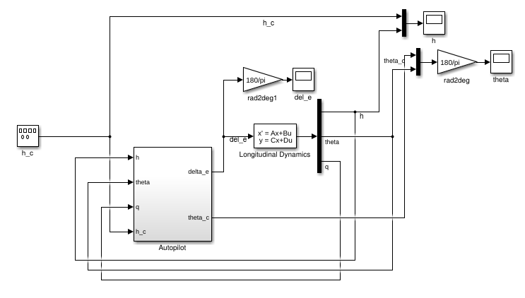

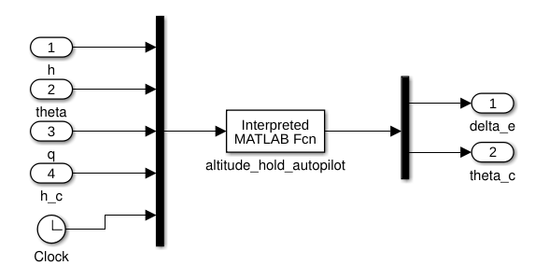

Plots
h_c – yellow
h – blue
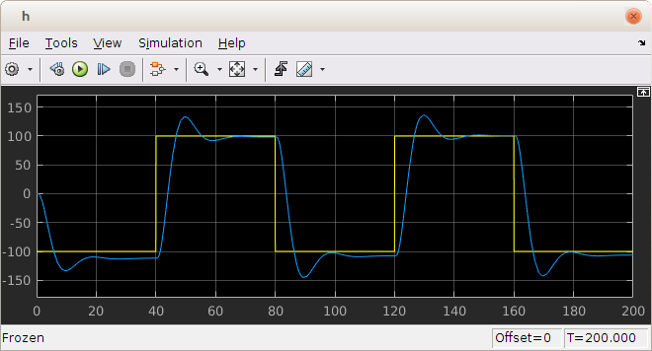

theta_c – yellow
theta – blue

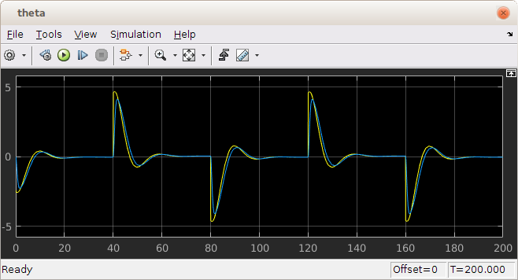
delta_e
