EE774
HW 10
Jae Lee

Helicopter
ctrl.m
function u = ctrl(in,P)
q_cmd = in(1);
q = in(2);
t = in(3);

a_ref = -4;
b_ref = 4;

persistent q_ref;
persistent k_q_hat;
persistent k_q_cmd_hat;
persistent theta_hat;
if t==0
q_ref = 0;
k_q_hat = 0;
k_q_cmd_hat = 0;
theta_hat = 0;
else
q_ref = q_ref + P.Ts * (a_ref*q_ref + b_ref*q_cmd);
e = q - q_ref;
k_q_hat = k_q_hat + P.Ts * (P.gamma_q * q * e);
k_q_cmd_hat = k_q_cmd_hat + P.Ts * (P.gamma_q_cmd * q_cmd * e);
theta_hat = theta_hat + P.Ts * (-P.gamma_theta * tanh(360/pi*q) * e);
end

u = k_q_hat*q + k_q_cmd_hat*q_cmd - theta_hat*tanh(360/pi*q);
end

param.m
clear; close all; clc;
% initial conditions
P.q0 = 0;

% sample rate for controller
P.Ts = 0.01;

P.gamma_q = 100;
P.gamma_q_cmd = 100;
P.gamma_theta = 8;

Result
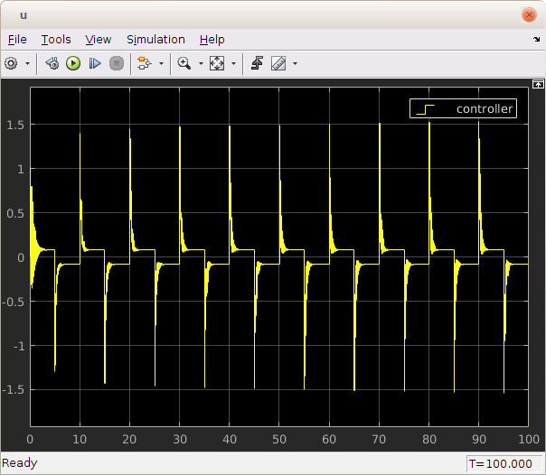

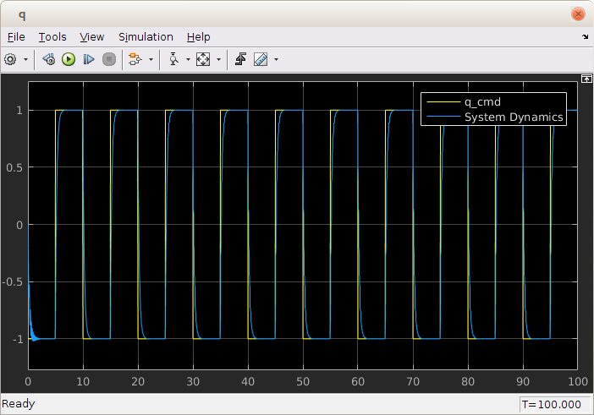

Delta Wing
ctrl.m
function u = ctrl(in,P)
phi_ref = in(1);
p_ref = in(2);
phi = in(3);
p = in(4);
phi_cmd = in(5);
t = in(6);

x = [phi; p];
x_ref = [phi_ref; p_ref];

persistent k_x_hat;
persistent k_r_hat;
persistent theta_hat;
if t==0
k_x_hat = [0; 0];
k_r_hat = 0;
theta_hat = [0; 0; 0];
else
e = x - x_ref;
k_x_hat = k_x_hat + P.Ts * (-P.gamma_x * x * e' * P.P * P.B);
k_r_hat = k_r_hat + P.Ts * (-P.gamma_r * phi_cmd * e' * P.P * P.B);
theta_hat = theta_hat + P.Ts * (P.gamma_theta * [abs(phi)*p abs(p)*p phi^3]' * e' * P.P * P.B);
end
tellme = [k_x_hat'*x k_r_hat*phi_cmd -theta_hat'*[abs(phi)*p; abs(p)*p; phi^3]]
u = k_x_hat'*x + k_r_hat*phi_cmd - theta_hat'*[abs(phi)*p; abs(p)*p; phi^3];
end

param.m
clear; close all; clc;
% initial conditions
P.phi0 = 10*pi/180;
P.p0 = 0;

P.omega_n = 1;
P.zeta = 0.7;

% sample rate for controller
P.Ts = 0.01;

P.B = [0; 1];
P.Q = [1 0; 0 10];
value = 10;
value2 = 10;
P.gamma_x = [value 0; 0 value];
P.gamma_r = value;
P.gamma_theta = [value2 0 0; 0 value2 0; 0 0 value2];
% P.gamma_x = [100 0; 0 100];
% P.gamma_r = 100;
% P.gamma_theta = [100 0 0; 0 100 0; 0 0 100];

P.a_ref = [0 1; -P.omega_n^2 -2*P.zeta*P.omega_n];
P.b_ref = [0; P.omega_n^2];

P.P = lyap(P.a_ref', P.Q);

reference.m
function sys=mdlDerivatives(t,x,u,P)
phi_ref = x(1);
p_ref = x(2);
phi_cmd = u(1);

phi_ref_dot = p_ref;
p_ref_dot = -P.omega_n^2*phi_ref - 2*P.zeta*P.omega_n*p_ref + P.omega_n^2*phi_cmd;

sys = [phi_ref_dot p_ref_dot];

Simulink block diagram
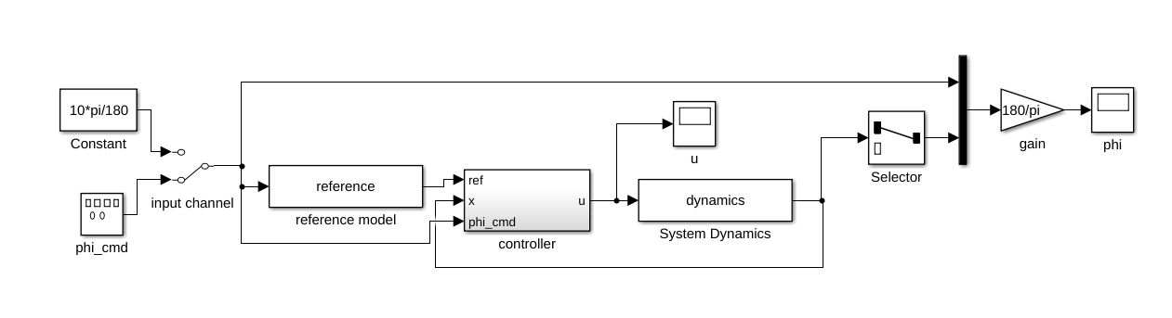

Result
