ECEn 774
HW 11
Jae Lee

param.m
clear; close all; clc;
% initial conditions
P.phi0 = 10*pi/180;
P.p0 = 0;

% sample rate for controller
P.Ts = 0.01;

% baseline controller
P.A = [0 1 0; 0 0 1; 0 -0.018 0.015];
P.B = [0; 0; 1];
P.B_ref = [-1; 0; 0];
lqr_Q = eye(3);
lqr_R = eye(1);

[K,S,E] = lqr(P.A, P.B, lqr_Q, lqr_R);
P.K = K;

% adaptive controller
value = 100;
P.gamma_theta = [value 0 0; 0 value 0; 0 0 value];

P.a_ref = P.A - P.B*P.K;

P.Q_ref = diag([100; 100; 100]);
P.P_ref = lyap(P.a_ref', P.Q_ref);

ctrl.m
function out = ctrl(in,P)
e_i = in(1);
phi_ref = in(2);
p_ref = in(3);
phi = in(4);
p = in(5);
phi_cmd = in(6);
t = in(7);

persistent theta_hat;
if t==0
theta_hat = [0; 0; 0];
else
e = [e_i; phi; p] - [e_i; phi_ref; p_ref];
theta_hat = theta_hat + P.Ts * (P.gamma_theta * [abs(phi)*p abs(p)*p phi^3]' * e' * P.P_ref * P.B);
end
x = [e_i; phi; p];
u_bl = -P.K*x;
u_ad = -theta_hat'*[abs(phi)*p abs(p)*p phi^3]';
u = u_bl + u_ad;
out = [u_bl; u_ad; u];
end

reference.m
function sys=mdlDerivatives(t,x,u,P)
e_i = x(1);
phi_ref = x(2);
p_ref = x(3);
phi_cmd = u(1);

x_dot = (P.A-P.B*P.K)*x + P.B_ref*phi_cmd;

sys = x_dot;

result
Input
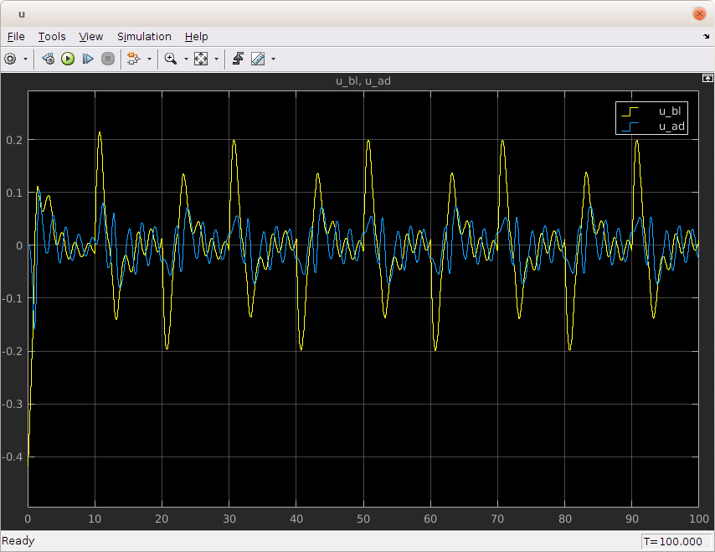

Response

