ECEn 774
Final
Jae Lee

1. PD controller
No parameters change
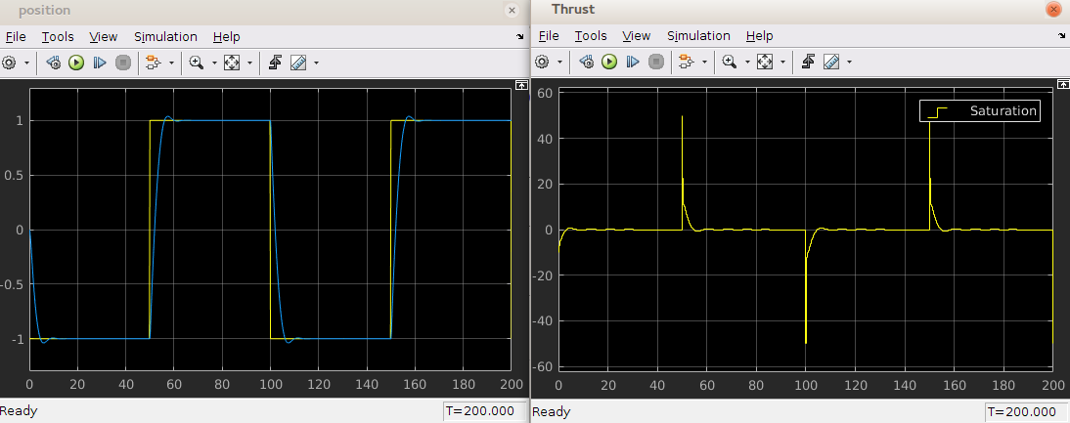
Possible 100% change in parameters
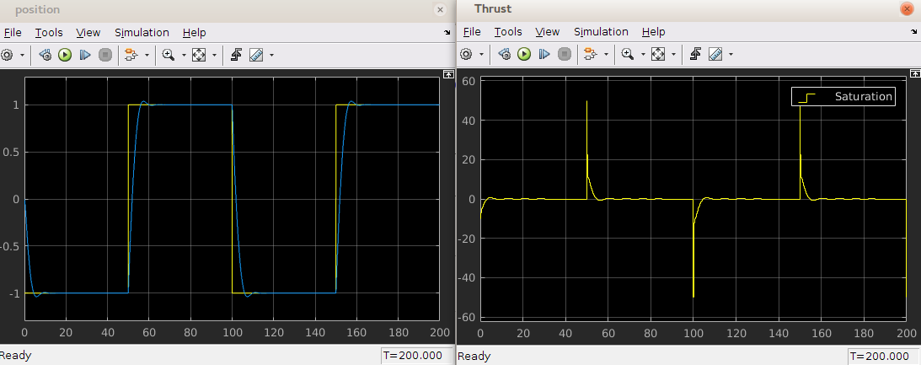
PD controller seems to be very robust in parameter changes. As shown above, parameter changes didn't make any noticeable difference on performance of the controller.

2. Backstepping
No parameters change
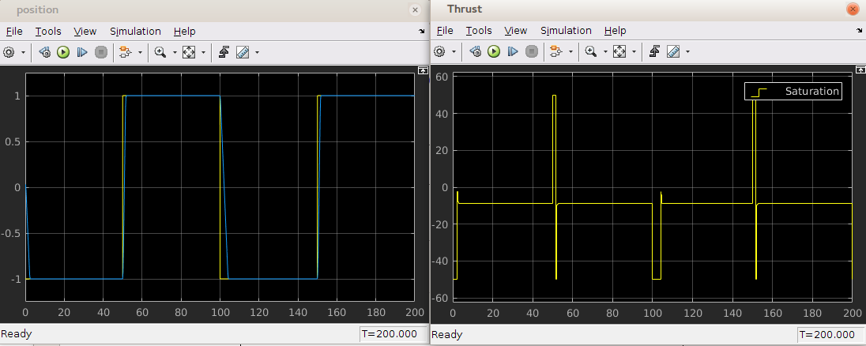
Possible 50% change in parameters
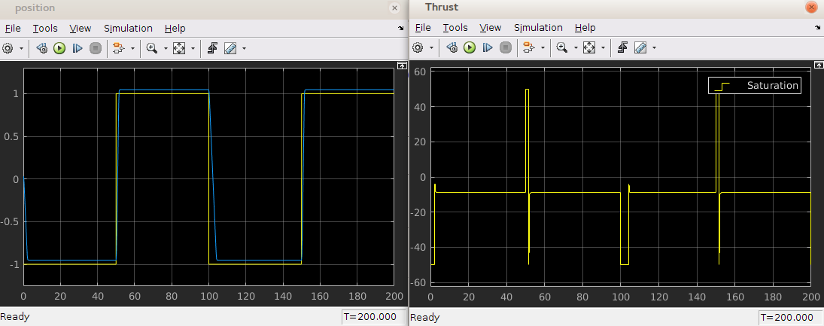
Backstepping can't handle the uncertain parameters very well. The higher uncertainty is, the more steady-state error generated.

3. Feedback linearizing controller
No parameters change
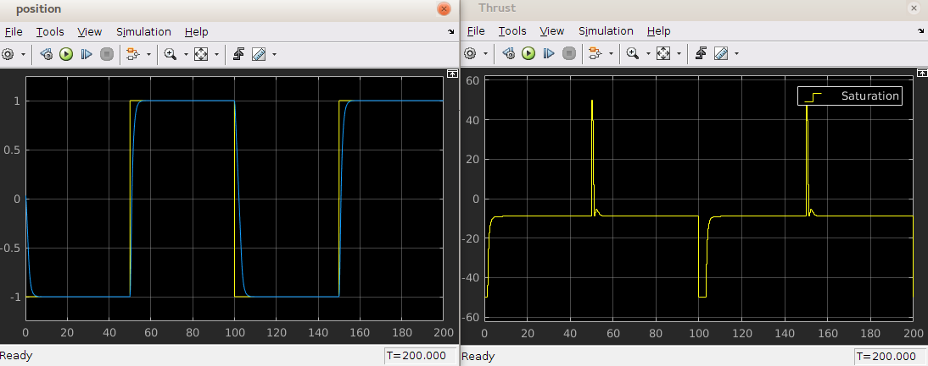
Possible 50% change in parameters
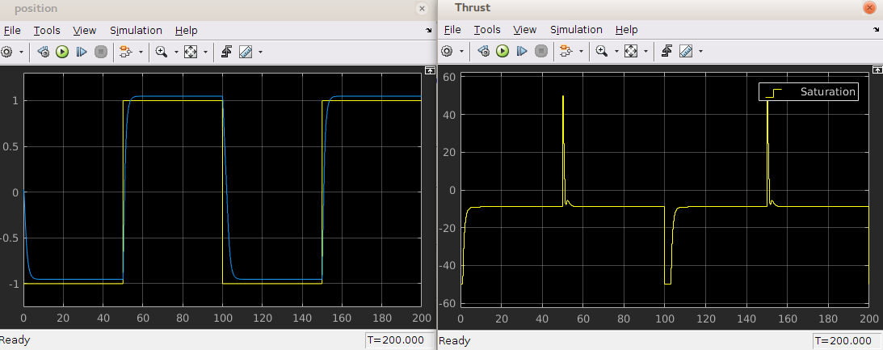
Feedback linearizing controller can't handle the uncertain parameters very well. The higher uncertainty is, the more steady-state error generated. It is behaving similar to backstepping.

4. Sliding mode
No parameters change

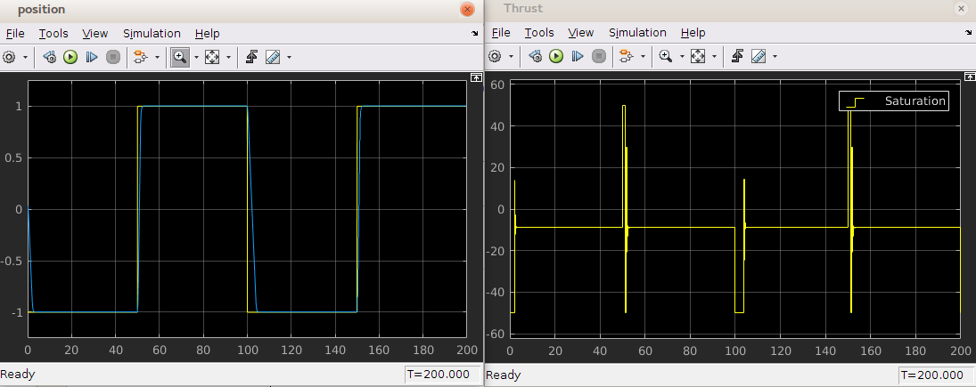
Possible 50% change in parameters

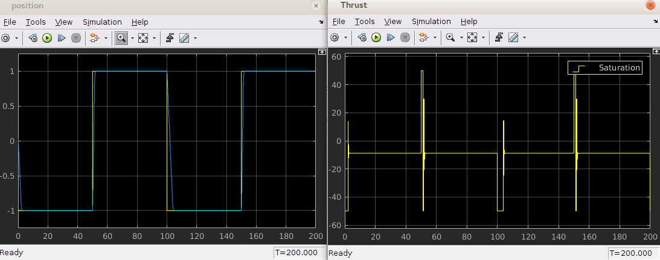
Sliding mode is quite robust in uncertainty because the controller is usually designed based on the maximum or minimum values that the uncertain parameters can possibly be. It did a lot better in dealing with not precisely known parameters than backstepping or feedback linearizing controller.

5. Baseline + adaptive controller
Only baseline controller
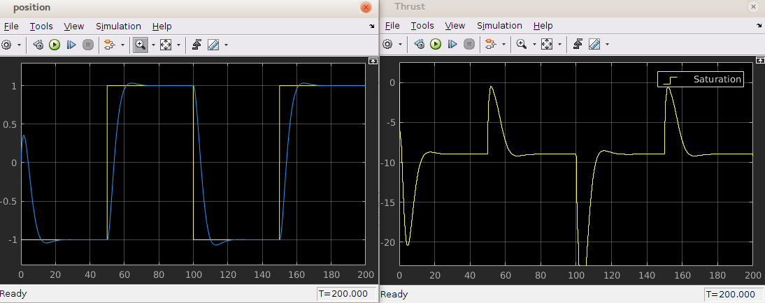
Baseline + adaptive
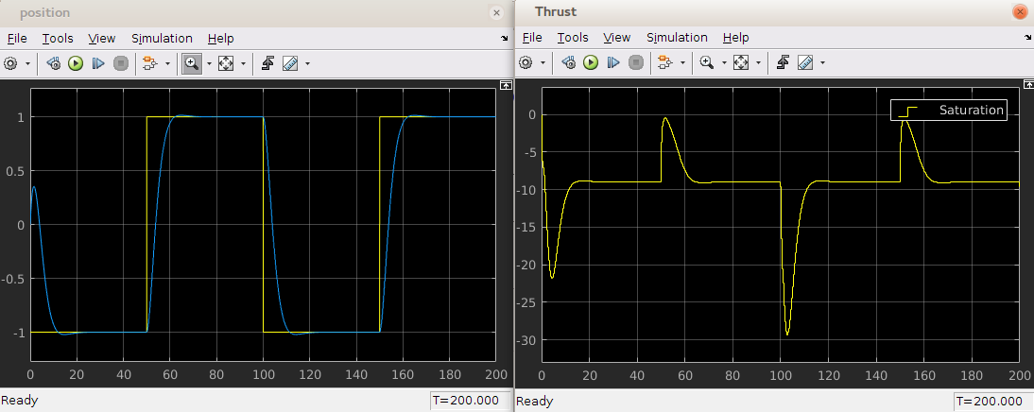
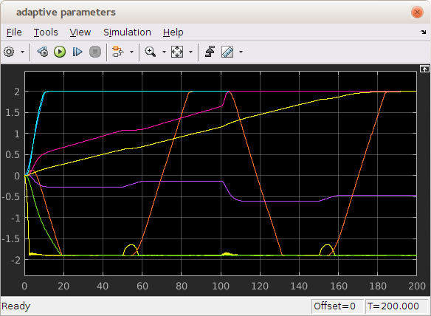

Possible 50% change in parameters
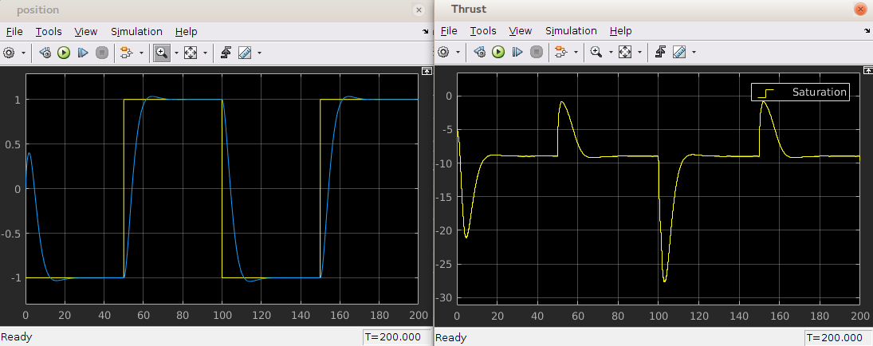
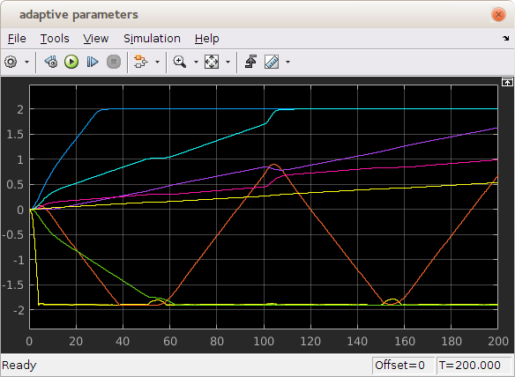

Adaptive controller is very robust to uncertainties in parameters. The baseline controller itself is quite robust, but the baseline+adaptive is even better.

