Problem 4

param.m
clear;
% inverted Pendulum parameter file

% actual system parameters used in simulation model
% randomly select a
P.a = 4*rand-2;

% initial conditions
P.y0 = 0;
P.ydot0 = 0;
P.z0 = 0;

% sample rate for controller
P.Ts = 0.01;
% dirty derivative gain
P.tau = 0.5;

ctrl.m
function u=ctrl(in,P)
yr = in(1);
y = in(2);
ydot = in(3);
z = in(4);
t = in(5);

mode = 2; % a is known
% a is unknown
% persistent xi3_derivative;
% persistent xi3_d1;
% if t==0
% xi3_derivative = 0;
% xi3_d1 = 0;
% end

if mode == 1
beta0 = 0.3;
beta1 = 1;
beta2 = 1;

x1 = y-yr;
x2 = ydot;
x3 = z;

x1_dot = x2;
x2_dot = -P.a*x2*abs(x2) + x3;

xi2 = -beta0 * sat(x1);
xi2_dot = 0;
xi2_ddot = 0;
xi3 = -x1 + P.a*x2*abs(x2) + xi2_dot - beta1*sat(x2 - xi2);
if x2 >= 0
xi3_dot = -x1_dot + 2*P.a*x2*x2_dot + xi2_ddot - beta1*x2_dot;
else
xi3_dot = -x1_dot - 2*P.a*x2*x2_dot + xi2_ddot - beta1*x2_dot;
end

u = -x2 + xi2 + x3 + xi3_dot - beta2*sat(x3 - xi3);

elseif mode==2
beta0 = 0.1;
beta1 = 1;
beta2 = 1;

x1 = y-yr;
x2 = ydot;
x3 = z;

x1_dot = x2;
x2_dot = -P.a*x2*abs(x2) + x3;

xi2 = -beta0 * sat(x1);
xi2_dot = 0;
xi2_ddot = 0;
if x2-xi2~=0
xi3 = -x1 + xi2_dot - beta1*sat(x2 - xi2) - 2*abs((x2-xi2)*x2)*abs(x2)/(x2-xi2);
else
xi3 = -x1 + xi2_dot - beta1*sat(x2 - xi2) - 2*abs((x2-xi2)*x2)*abs(x2)/(x2-xi2+1);
end
% error = xi3 - xi3_d1;
% xi3_derivative = (2*P.tau-P.Ts)/(2*P.tau+P.Ts)*xi3_derivative...
% + 2 / (2*P.tau+P.Ts) * (error);
% xi3_d1 = xi3;

% u = -x2 + xi2 + x3 + xi3_derivative - beta2*sat(x3 - xi3);
u = -x2 + xi2 + x3 - beta2*sat(x3 - xi3);

end

end

function out = sat(in)
if in>1, out=1;
elseif in<-1, out=-1;
else out=in;
end
end

Result of the controller(a - known)
y_r – yellow
y - blue

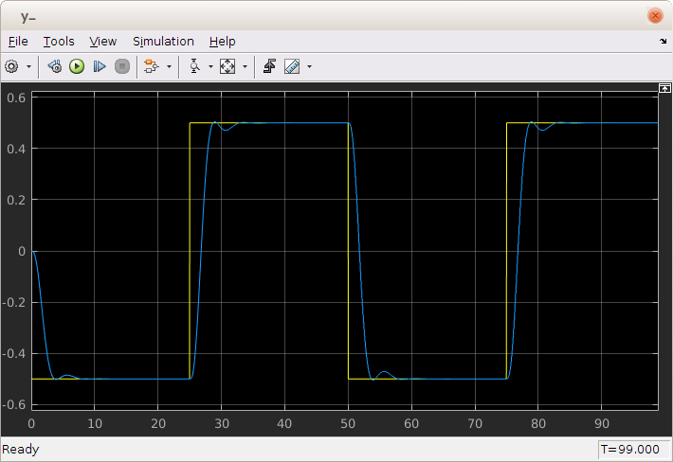

Control input
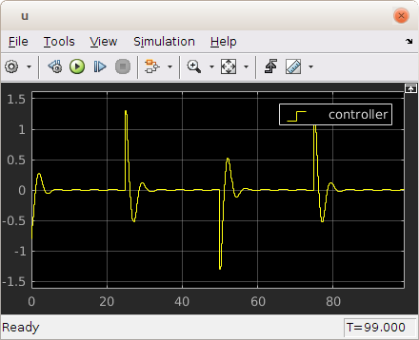

Result of the controller(a – unknown)
y_r – yellow
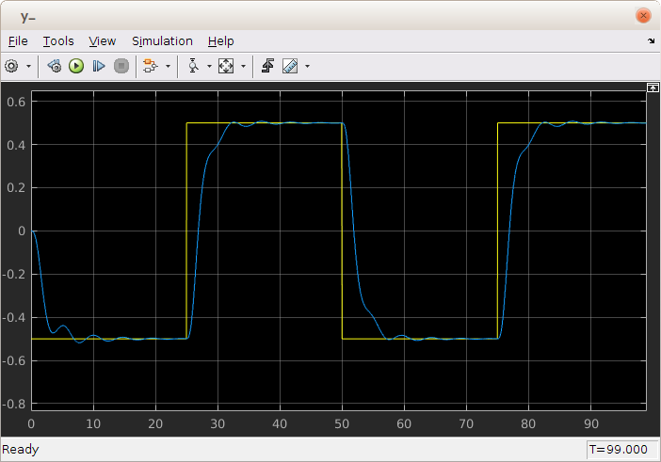
y - blue

control input

