ECEn 631
Assignment 3 – Stereo Calibration and Rectification
Jae Lee

Task 1
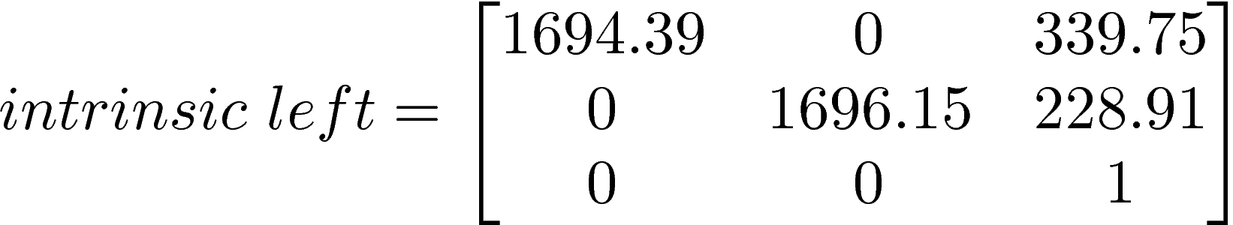

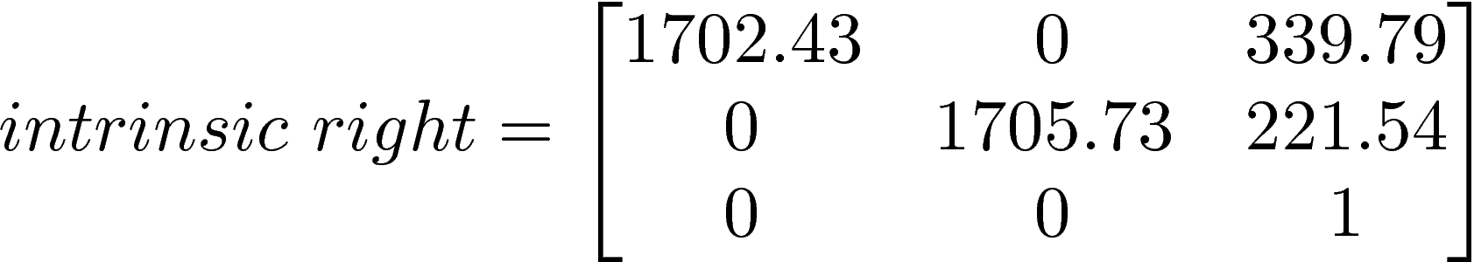

Intrinsic parameters seem reasonable since both cameras are identical. I originally got a huge number for the last number on distortion coefficient of the right camera, but as I adjusted the number of images used for calibration, -27.82696 was the lowest number I could get with images I had available.

Task 2
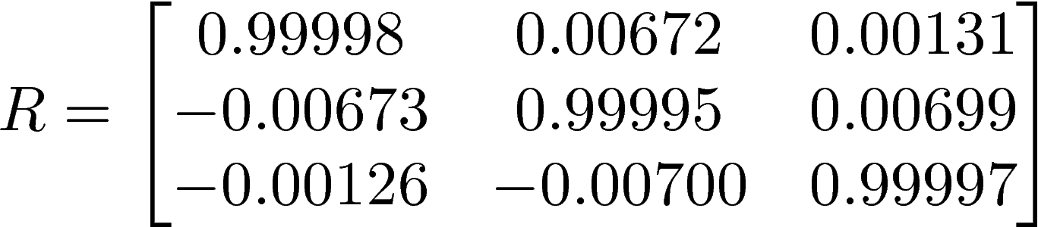

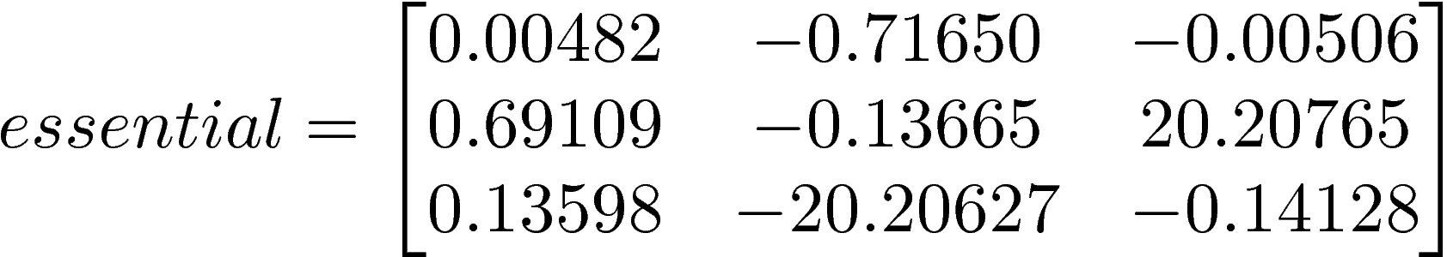

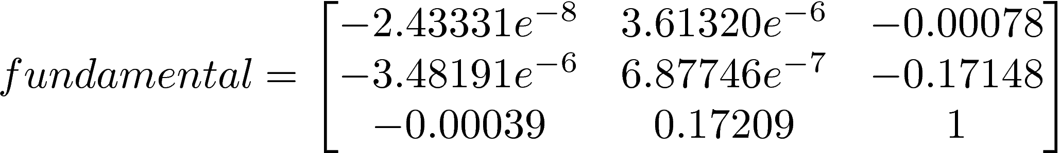

The translation matrix(T) looks good after several failures. It tells that there is displacement only along X axis. The fundamental matrix contained very small numbers.

Task 3
Epipolar line left and right
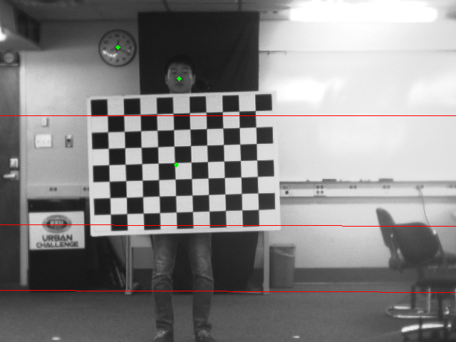
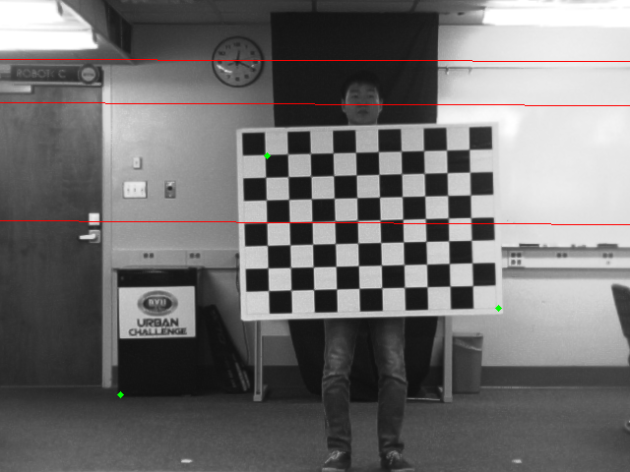

As shown above, several epipolar lines are drawn corresponding to the points on the other images.

Task 4
Original images

Rectified images
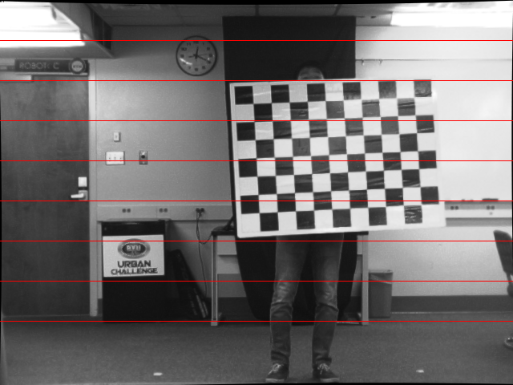
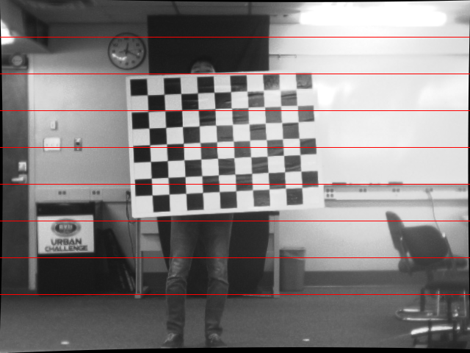

Difference images

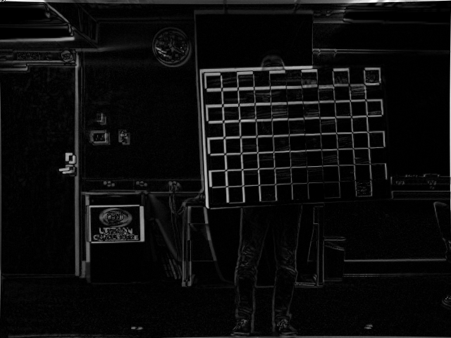
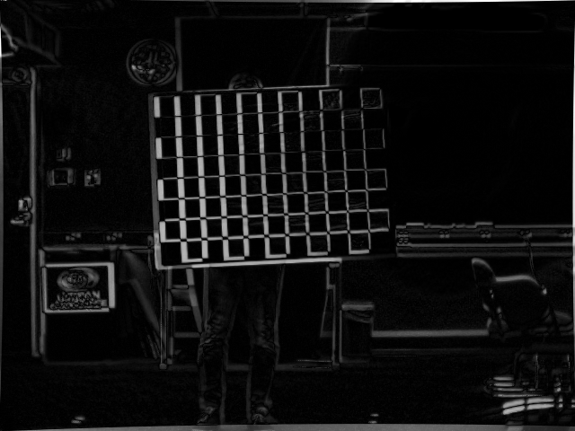

As expected, after image rectification, images from left camera and right camera are aligned horizontally.

