ECEn 631
HW 7 – Time to Impact
Jae Lee

Task 1
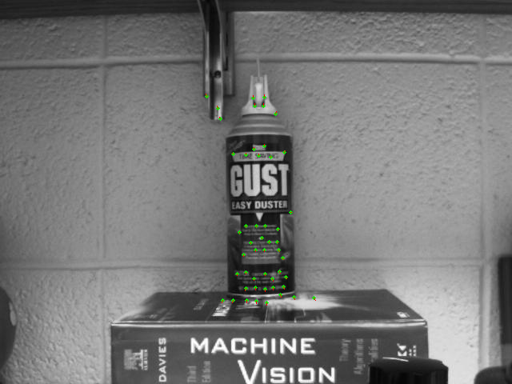
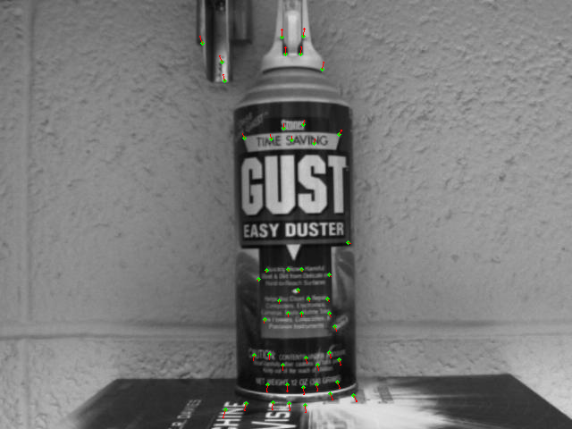

The left image is the first image of the image sequence with features found around the can. I intentionally didn’t include features nearby the principal point because their optical flow is too small to make good results. Also, I used optical flow in y-direction because there was more movement in y-direction. The equations from the slide 25, page 3-4 are used to find ‘a’ and ‘tau’. After finding all possible ‘tau’ for every feature points, I picked the median of those possible taus to be my time to impact to safely reject outliers.

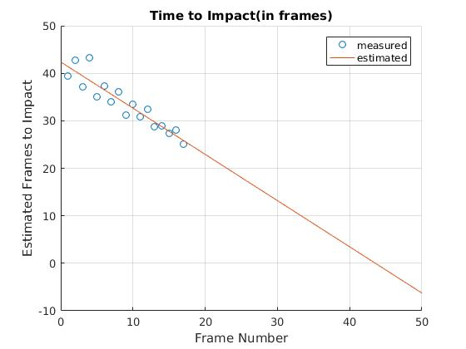

Based on the result and plot above, it is estimated that in frame number 43-44, the camera will hit the can.

Task 2
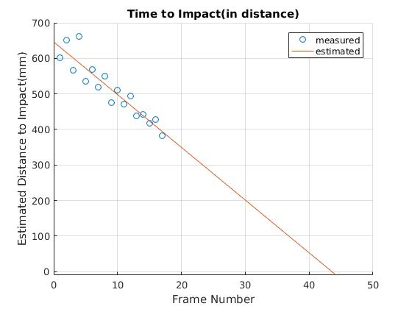

Since how much camera moved per frame(camera velocity) is known, the distance to impact in mm can be computed by multiplying the distance to impact in frames by the camera velocity. Basically, this is the same plot as Task 1, but scaled up to the actual distance in mm.

Task 3
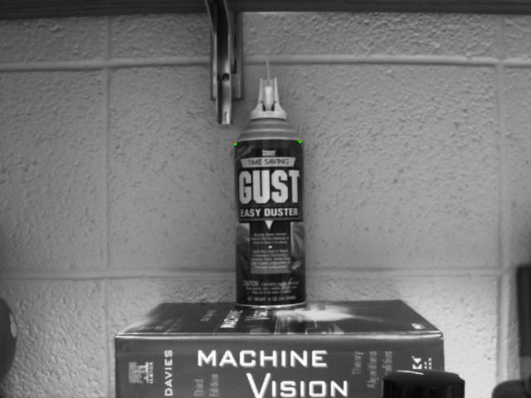

I assigned the region of interest to goodFeaturesToTrack function so that only two corners shown above are selected to be the features to be tracked. Then, calcOpticalFlowPyrLK allows these features to be tracked throughout the image sequence. By calculating the difference between these two corners in pixel in x-direction, the distance to the object can be computed by using the pinhole camera model. Since camera focal length, actual width of the object, and projected width of the object on image are known, the actual distance to the object is (actual width*focal length)/(projected width on image).
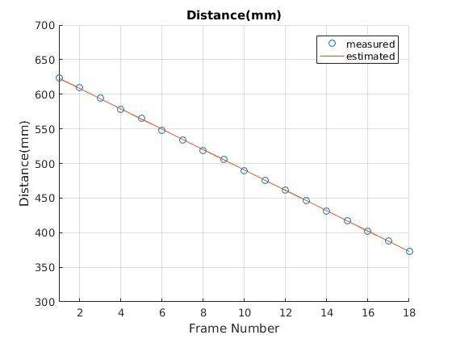
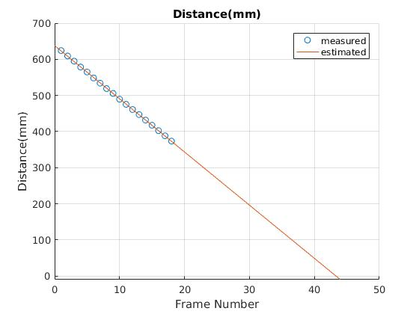

As shown in the plot, when the actual size of the object and focal length of the camera are known, estimating the distance to the object from the camera is much more accurate than knowing just the object velocity and having to guess the distance to the object using optical flow.

