ECEn 631
Assignment 2 - Camera Calibration & Distortion Correction
Jae Lee

Task 1
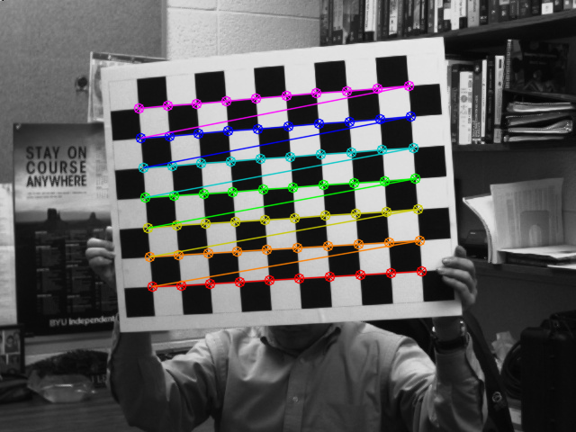

Corners are found with subpixel accuracy.

Task 2
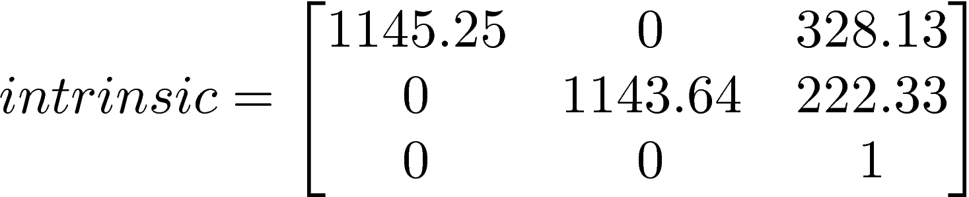

This makes sense because focal length x, y are close enough and center is almost at the center of 640x480 image.
Task 3
Close Difference
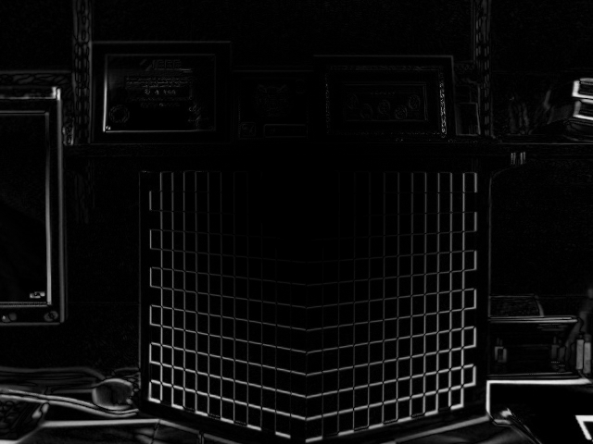

Far Difference
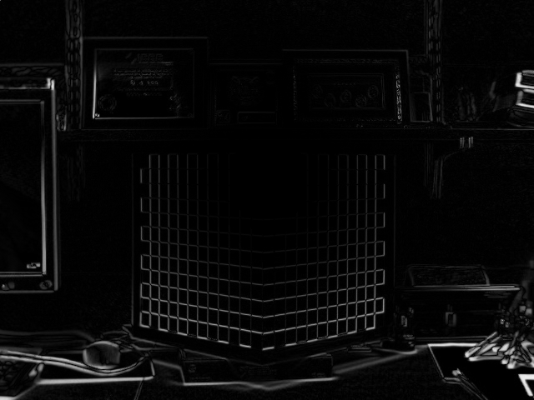

Turned Difference
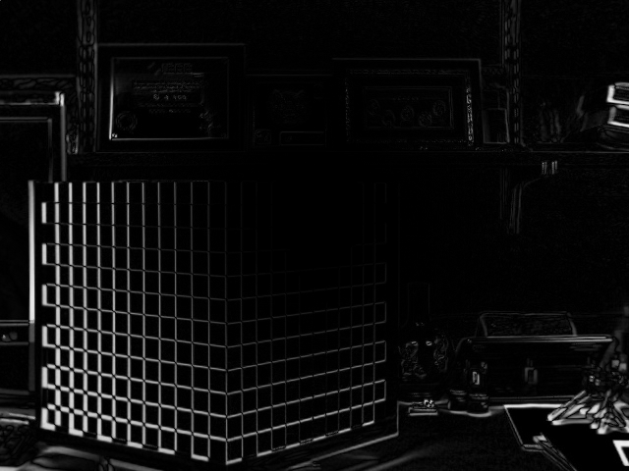

Difference images are taken between original image and distortion corrected image using distortion coefficients from task 2. As shown, there is more distortion to the corners than the center of the image.

Task 4
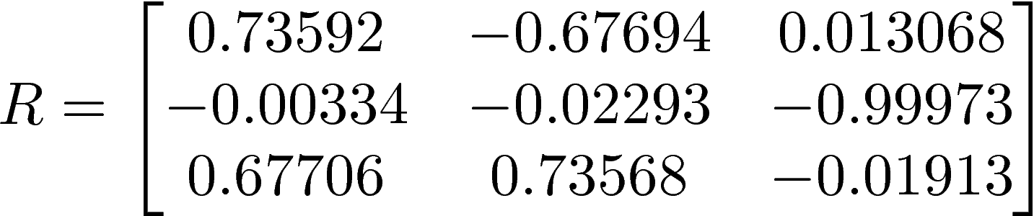

Object pose is estimated in camera frame using solvePnP() function. R is how the object is oriented and T is how the object is translated from the origin of the camera frame.

Task 5
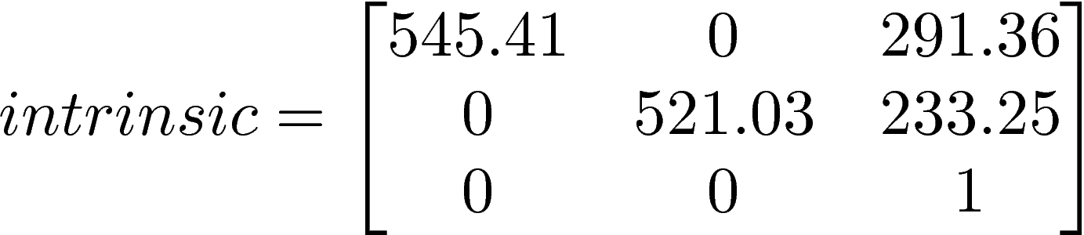

I found the intrinsic parameters and distortion coefficient of my webcam. Focal length are close enough and principal point is also close enough to the center of 640x480 image.

Task 6
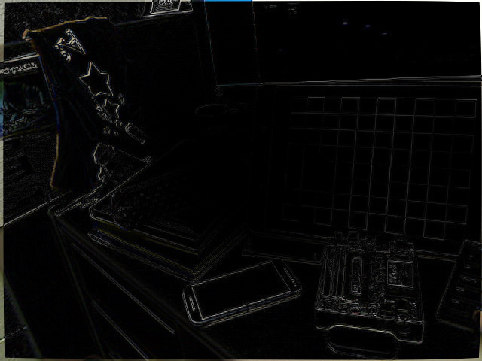

Using the distortion coefficient from task 5, difference image between the original image and distortion corrected image. As shown, more distortion to the corners than to the center of the image.

