ECEn 631
HW 6
Jae Lee

Task 1
Parallel cube
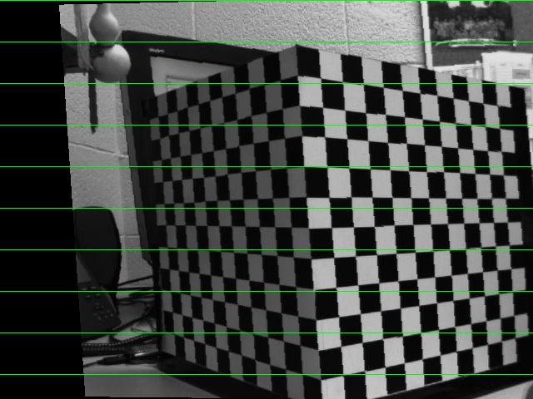
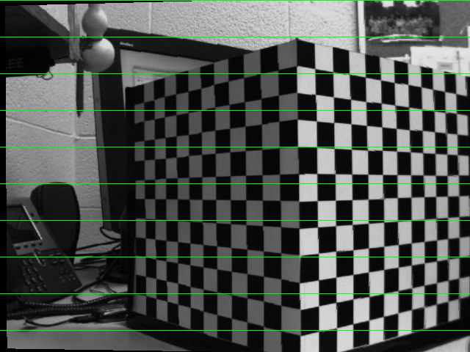

Parallel real
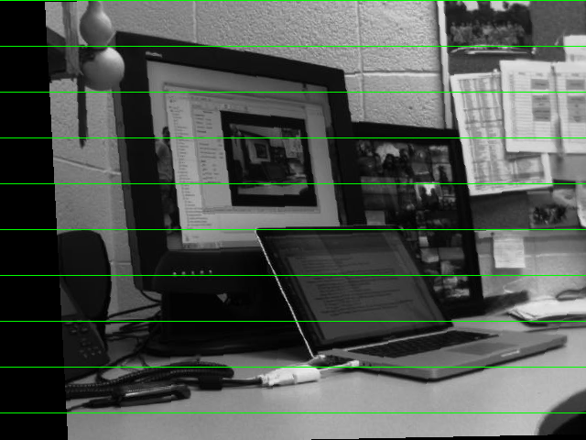
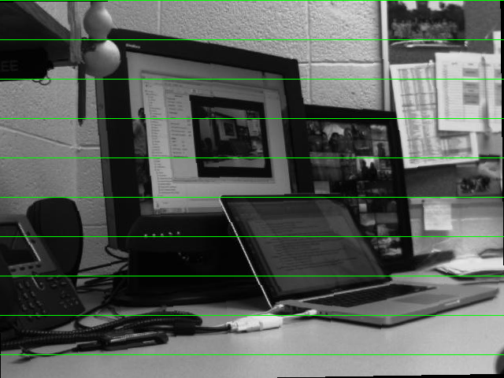

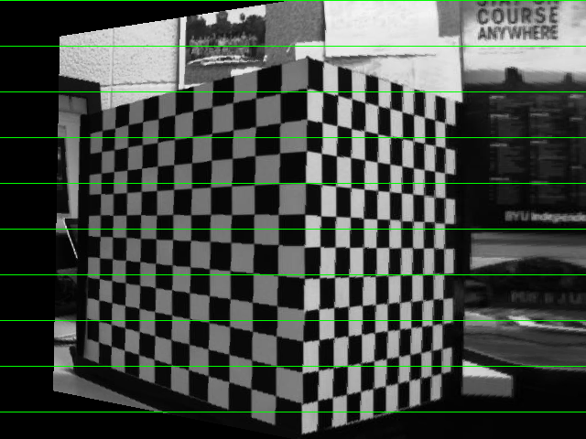
Turned cube
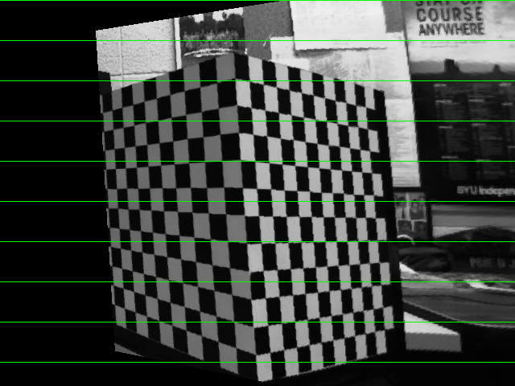

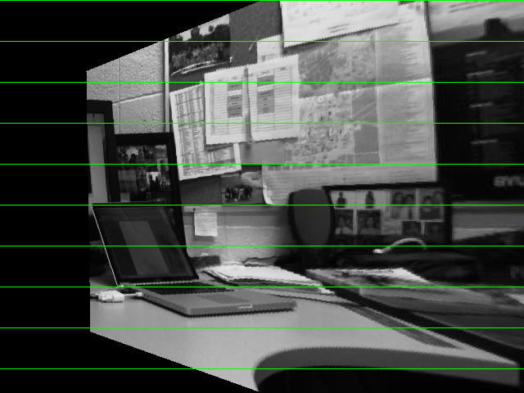
Turned real
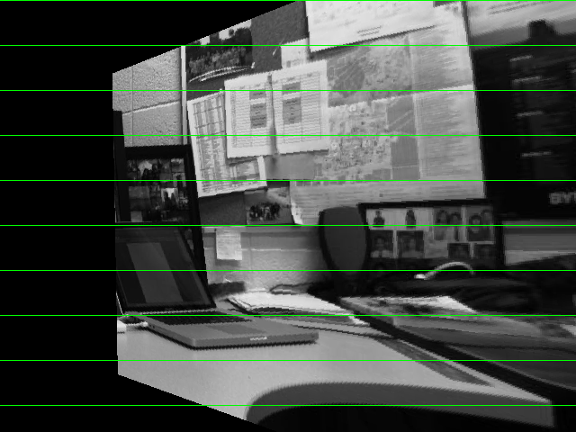

As I guessed my camera intrinsic parameters and distortion coefficients, it is difficult to reconstruct good 3D structure and we don’t know the projective transformation of the environment. However, as I observed the result, even without camera intrinsic parameters, it was able to distinguish between just parallel motion and turned motion.

Task 2
Parallel cube
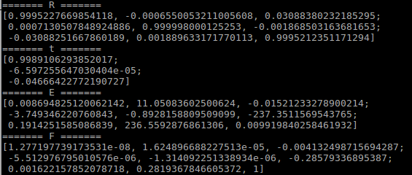

Parallel real
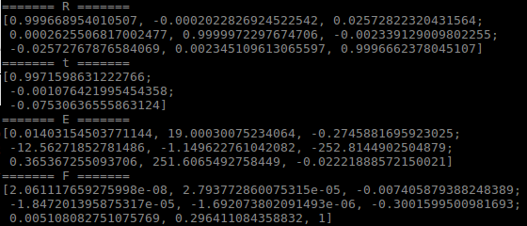

By observing R, t, I am convinced that these results are correct. Rotation is almost identity matrix and translation vector tells there is camera movement in only X direction.

Turned cube
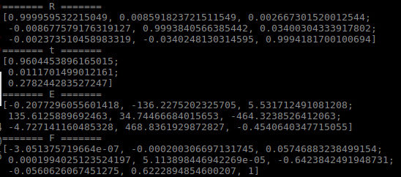

Turned real
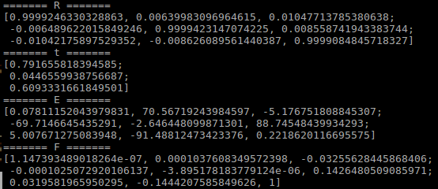

When the first image was taken, camera was turned already. Thus, there is no rotation movement between the first and last frame and my rotation matrices are identity matrix. There are some translations in X and Z directions which makes sense because camera moved into the optical axis little bit and X axis of the camera frame.

