ECEn 631
Jae Lee
HW 4

Task1
From Left camera
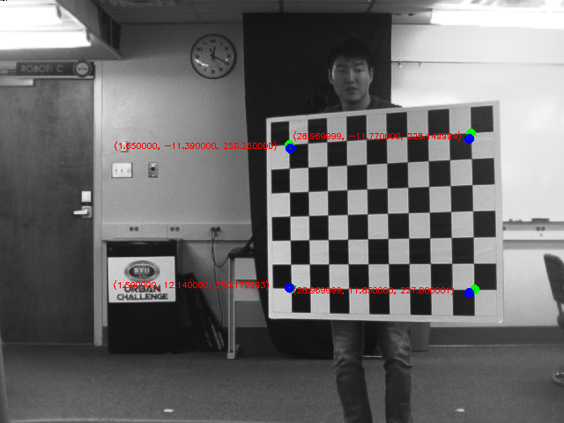

From Right camera
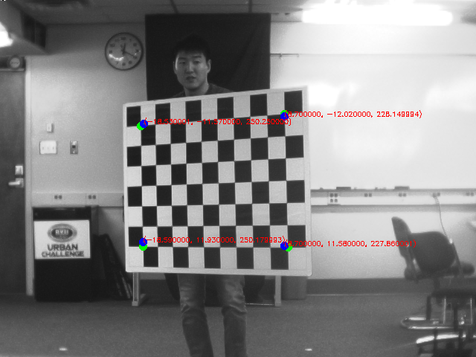
The result seems convincing for couple reasons. First, the X coordinates of the four points from left camera and right camera are about 20 inches apart. This is almost identical to the distance between left camera and right camera. Second, the Z coordinates shown above are close to the actual distance between camera and me standing with chessboard. I was about 20 feet away from the camera which is about 240 inches and the Z coordinates are close to this value. Also, the left two corners of chessboard have higher values than the right two corners which is also intuitively correct.

Task 2
Left camera 1st, 5th, 10th, 15th, 20th images
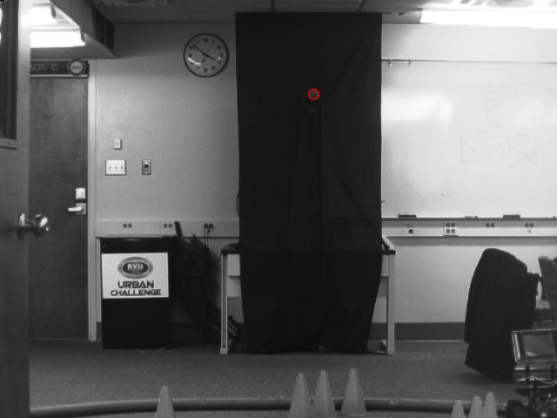
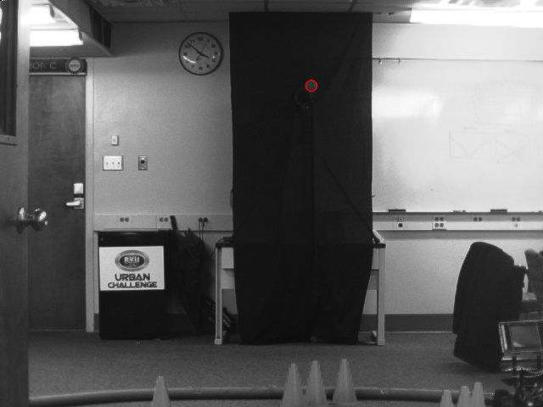

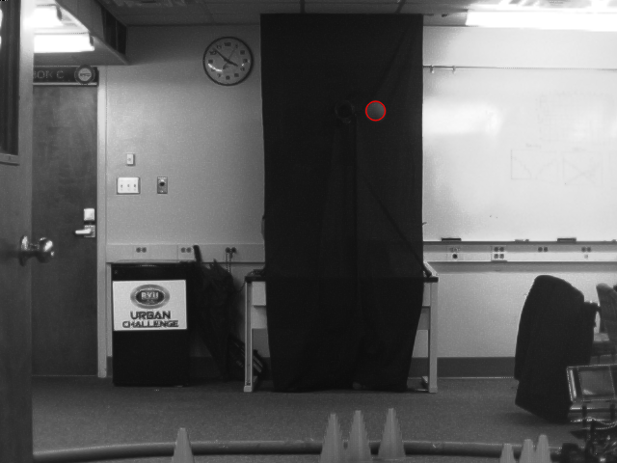
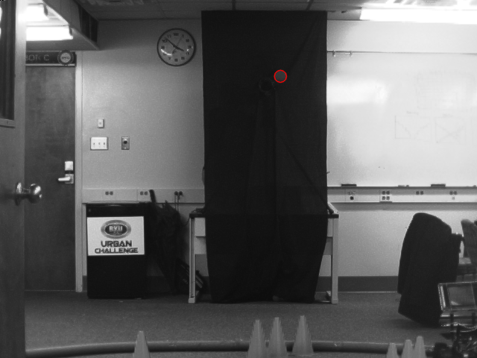

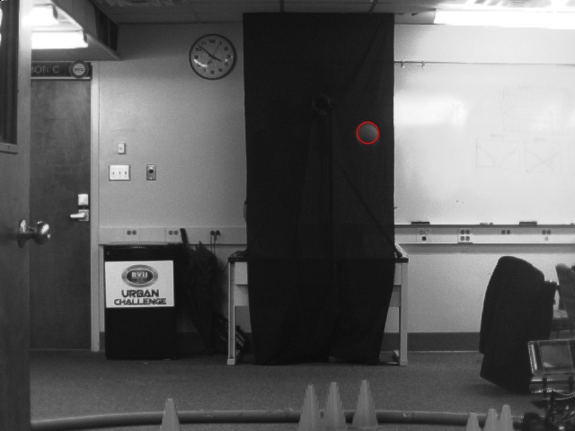

Right camera 1st, 5th, 10th, 15th, 20th images
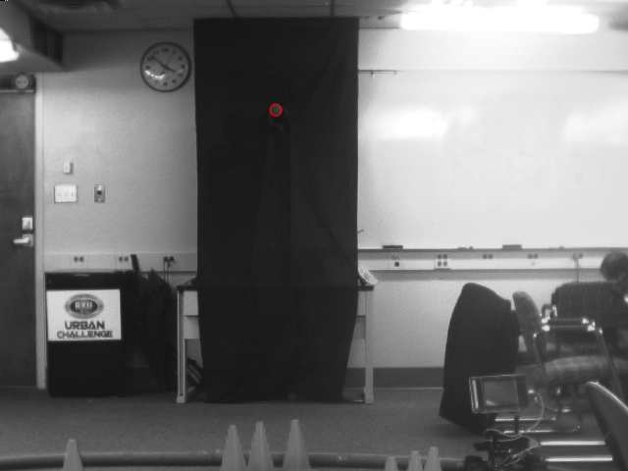
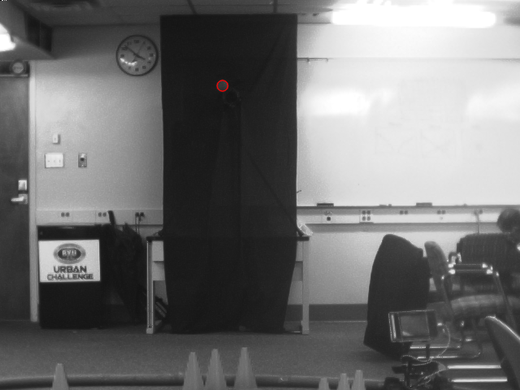

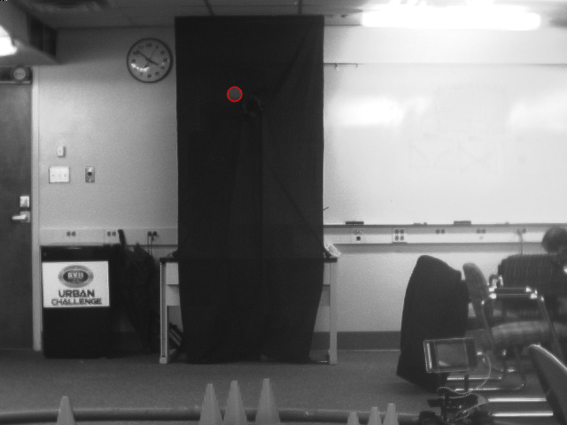
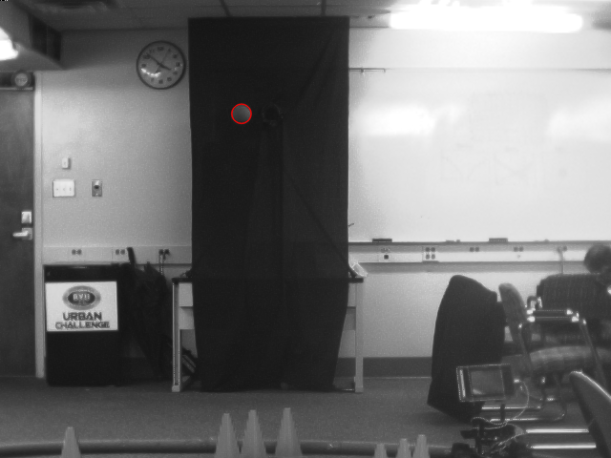

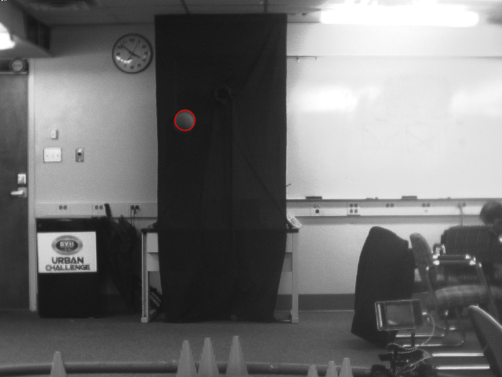

Task 3
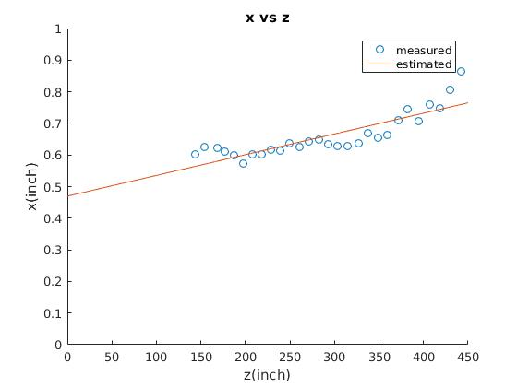
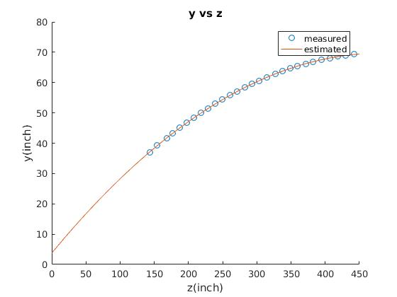
I estimate trajectory by using least-square curve fitting. Since X is known to be linear, the fitting curve has the degree of 1 which is linear curve. However, it is reasonable to assume that Y is quadratic because of gravity. Thus, the fitting curve is a quadratic function.

