Personal Portfolio Website Plan

Your Name: Johnathan McMahon

Ideas for your website
Determine how you will use your personal portfolio website to showcase your skills.
Idea 1: Since this assignment seems pretty like the lab, I will format it by somewhat imitating how that looks. I am choosing the first option, Aka the personal portfolio giving information about my skills and experience. I’m not exactly sure what the purpose of the site is other than listing that info about myself and myself, so I will keep it simple. I will have a homepage listing general information about myself, where I’m from, what I’m good at, and my experience. I will add links leading to specific skillsets and how I have used them. To through out a few ideas, I am proficient at cooking at a professional level, I have lots of experience in the fitness world (I have been training for several, play multiple sports, and have run a marathon.), I love to play and compose songs on the piano, and I have experience with leadership, teamwork, and problem solving though my years in the scouts and other activities that I have done. This website can be helpful for networking and having a more put together resume.

Idea 2:

Idea 3:

Idea 4:

Idea 5:

Website Plan
Topic | Questions | Answers
Purpose of Website | What is the purpose and goal of the website? | To build my resume and help with my network by having a consolidated website listing my skills and experience.
Target Audience | Describe the target audience (age, gender, demographics) | Potential employers or coworkers; people my age either working or going to college.
Graphics | What graphics will you use on the website? | The graphic will be pretty basic and reliant on what I have learned so far. I will include the main header, followed by the main element with the bulk of the info, and last will be a footer.
Color | What colors will you use within the site to enhance the purpose and brand? | I’m think a light blue and grey color scheme to keep it clean and professional.
Accessibility | How will the website accommodate people with disabilities? | Provide bold images and easy to navigate descriptions
Project Timeline | Identify the project timeline | I think each of the sections will take a day or 2 to complete so I just have to leave myself with enough time to do them all

Wireframe
Sketch the wireframe for your home page below.

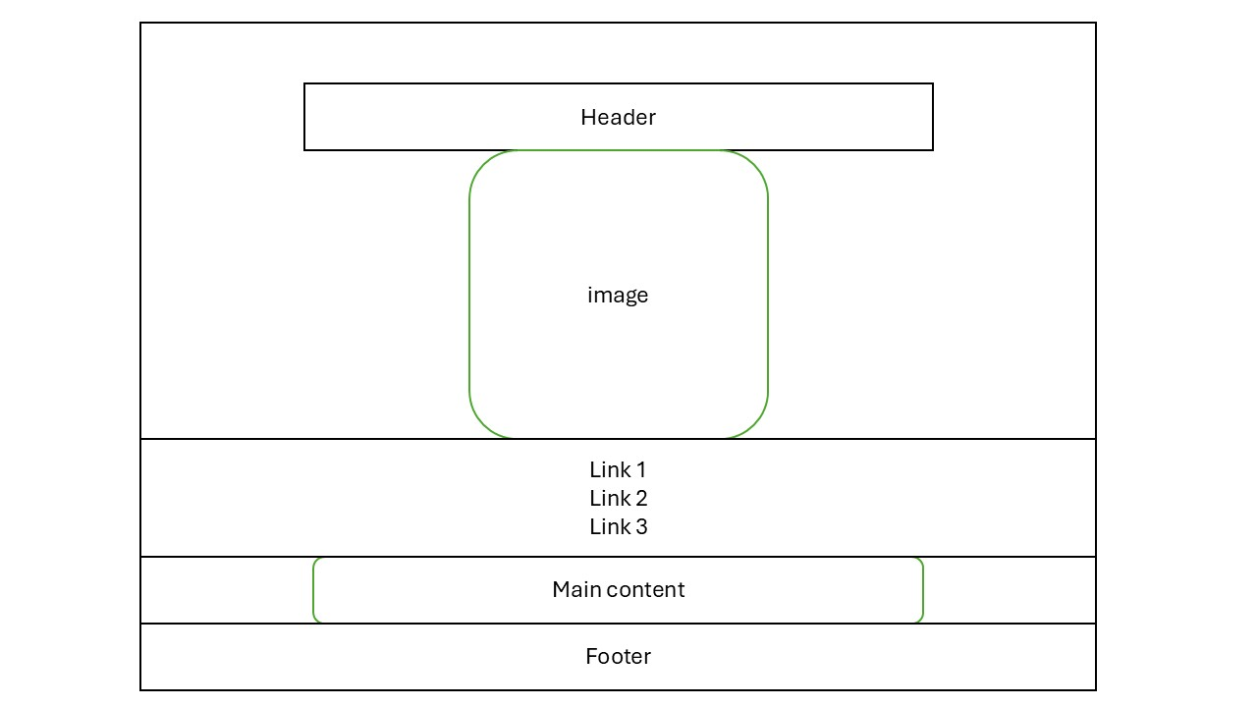

Site map
Create a site map for the website below.
