Technical specifications for the development of an information system for the sale of audio sessions

Introduction
This specification describes a possible implementation of the information system and the interaction of its components. Practical implementation may differ from this description and is carried out at the discretion of the development team during the testing and development phase, in consultation with the Customer.
The functional and non-functional requirements provided in this document are target requirements, but may differ from those implemented in practice during subsequent stages of the project if the development team justifies the need for deviations from the specification and such deviations are approved by the Customer.
The design of interface elements is developed by specialists from the development team, depending on the applicability of specific elements. Various design options are developed, including those using corporate colors and fonts provided by the Customer. The final design is approved after discussion with and approval by the Customer.
The decision regarding the practical implementation of any components and functions described in this specification is made directly by the project development team, in consultation with the Customer.
The text of messages, buttons, category names, and other elements is preliminary and must be refined during subsequent stages of development.
Practical implementation may vary depending on:
- current infrastructure conditions;
- feasibility of implementation;
- changes in business processes.

Terms and definitions
Term | Definition
Technical specifications, TS | A technical document (specification) that describes all the necessary project data required by the developer.
System, web system (web system), project, platform, Internet platform, IS | The final product obtained during the Contractor's work on this project. It is a collection of web pages, database information, and mechanisms for managing this information, processing it, and presenting it to the user as web pages.
DB (database) | An information model that allows for the organized storage of data about a group of objects with the same set of properties. Software designed to work with databases is called a database management system (DBMS).
Chapter | A structural unit, a collection of a set of system pages. System interface pages are linked to sections and subsections. The entire set of sections, subsections, and associated pages forms the system's structural tree (system structure).
Essence | An object type in the system is defined by a set of attributes with a specified value type for each. For example, a news item might have a title (a text string), a date (date/time), and the full text of the news item (HTML text). An entity object is defined by a set of values ​​for the specified attributes (system fields and properties). A specific news item from December 20, 2012, with a specific title and full text, is an element/object of the "News" entity.  With respect to the database, the list of entities defines the database structure, and the set of elements defines its content.  All entities are defined in this specification and are not subject to change during system operation.  Entity elements/objects, on the other hand, can be created by the Customer independently using the website management system within the scope of the element creation and management capabilities described in the specification.
Button | A control that, when clicked, starts an action (procedure or function).

General information about the project
Project Title
Information system and mobile app for selling and listening to audio sessions.
Project Goal
To create a user-friendly, secure, and scalable information system, including a mobile app and web administration panel, that will:
- give users access to free and paid audio sessions;
- ensure a fast and secure way to purchase digital content;
- implement a flexible content and user management mechanism for administrators;
- expand the customer base by integrating promo codes and personalized features;
- maintain statistics and analytics on sales and user activity.
Scope of Application
The system is designed for:
- individuals wishing to listen to wellness, relaxation, educational, and other audio sessions;
- professionals offering audio content via a digital channel;
- administrators managing content, users, and analytics.

Information system architecture
The IT solution must be built on a proprietary service architecture using industrial technologies and programming languages. The IT solution's application software platform must meet fault-tolerance requirements. The hosting system must meet the IT solution's requirements and the anticipated workload. The IT solution must support the secure https data transfer protocol and have a localized interface.

Technology stack
Suggested web application technology stack for implementation:
Frontend:
Language/Framework:
HTML5 + CSS3 + JavaScript (base)
React.js / Vue.js / Angular (SPA frameworks)
Build:
Webpack / Vite (code packaging)
npm / yarn (package manager)
Backend:
Server:
Node.js (Express.js / NestJS)
Python (Django / Flask)
PHP (Laravel)
Database:
PostgreSQL / MySQL (relational)
MongoDB (NoSQL)
API:
REST or GraphQL (Apollo Server)

Suggested mobile app technology stack for implementation
Cross-platform development (React Native / Flutter):
React Native:
JavaScript/TypeScript + React
Expo (for rapid prototyping)
Flutter:
Dart + Flutter SDK
Ready-to-use widgets for iOS/Android
Native apps:
Android:
Kotlin / Java + Android Studio
iOS:
Swift / Objective-C + Xcode
Backend (shared with web):
Same technologies as for the web (Node.js/Django + PostgreSQL/MongoDB).

IS Scalability
Horizontal scaling is suitable for the system being developed. It allows for the use of standard, low-cost hardware, provides sufficient resources for workloads, and does not require infrastructure migration. Horizontal scaling also avoids downtime, as software instances run on multiple IT infrastructure nodes, and if one node fails, the other nodes take over.

Security When Using External APIs
Security when using external APIs includes various methods and technologies for maintaining data confidentiality, integrity, and protection against unauthorized access, data leaks, and other risks. This ensures that personal data remains safe when used in a cyber environment.
To ensure API security, the following practices are recommended:
- Role-based access control (RBAC).
- API gateways with WAF (web application firewall) integration.
- JSON web tokens (JWT) for authentication and authorization.
- Regular penetration testing to identify vulnerabilities.
- Proactive risk management to identify and address security gaps.
- Comprehensive monitoring and analysis of API activity to promptly identify threats and anomalies.
The frequency of data synchronization depends on the project's needs and data currency requirements. Synchronization typically occurs regularly, for example, every few hours or days.

Monitoring and Logging
Monitoring information systems is the process of tracking the system's status and performance, including checking system availability, response time, functionality, and other important parameters. Monitoring helps identify problems early and ensure stable system operation. Popular monitoring systems are listed below:
- Pingdom.
- UptimeRobot.
- New Relic.
- StatusCake.
- Site24x7.
- Datadog.
- Zabbix.
Logging information systems is the process of recording user and program activity in special files (logs) containing system information about server or program operation. Logs are useful for debugging various application components, collecting and analyzing system information, identifying errors, and monitoring application performance. Popular monitoring systems are listed below:
- LOGalyse.
- Logstash.
- LogPacker.
- Logwatch.
- Fluentd.
- Graylog.
- Sentry.
- ELK (ElasticSearch, Logstash, Kibana).

Data Storage
Data Caching Requirements:
- Understanding Caching: Understanding the principles of caching and its layers (client and server).
- Benefits of Caching: Assessing performance improvements, reducing server load, and improving user experience.
- Determining the Need for Caching: Assessing the dynamism of data and the frequency of requests.
- Selecting a Cache Type: Determining the appropriate cache type based on the characteristics of the application and data.
- Cache Invalidation Strategy: Developing a mechanism for updating stale data in the cache.
- Cache Lifetime Configuration: Determining the optimal time to retain data in the cache.
- Cache Monitoring and Optimization: Setting up a monitoring system and periodically profiling the cache to optimize its performance.
Data storage optimization requirements:
- Fault tolerance: Data storage systems must be reliable and resilient to failures.
- Flexibility: The ability to scale and adapt to changes in the volume of stored data.
- Scalability: The ability of a system to expand and contract based on the organization's needs.
- Compliance with information security standards: Data protection from unauthorized access, leakage, and loss.
- Compression: The use of compression algorithms to reduce the volume of stored data without loss of quality.
- Distribution: Evenly distribute information across different cluster segments to ensure consistent performance.
- Volume consolidation: Logical partitions are combined using specialized software to improve fault tolerance and performance.

IT Solution
The architecture is structured as follows:
- The service provides information to the web and mobile applications;
- The service collects information from the web and mobile applications;
- The primary information storage is the database;
- The service writes information to the database and makes changes to existing entities in it;
- The system can operate on any compatible hosting infrastructure, as agreed upon between the Client and the Contractor.

Information System Development Implementation Framework
The information system is recommended to provide a set of environments for developing and testing applications and integration interfaces, as well as pre-production and production environments.
Среда | Description
Writing code | the stage of directly writing the program code for all components of the IT solution.
Preparation for publication/testing | The preparatory stage of development, which includes the following steps:  1. Assembly;  2. Functional tests;  3. Integration tests.
Assembly | the process of translating program code into a computer-readable language (the compilation process).
Production environment | provides direct interaction with users and clients

The development process should be structured as follows:
- Program code is written;
- The written code is compiled;
- It is recommended that testing be performed automatically using specially written methods (the contractor's internal testing processes);
- After internal testing for build quality and the refinement of all necessary methods, testing is performed in a realistic environment with demo data (pre-production environment); the customer participates in this testing;
- Once all testing is complete (the functionality is deemed functional and requires no further development or adjustments), the finished product is transferred to the public internet, accessible to all users with access to the system.
This type of work minimizes errors in the code due to the iterative approach and, as a result, allows for saving time required for the development of the entire information system.

Role Models
The system provides several roles for using web and mobile applications:
Role | Functions
User | - Login  - Viewing and purchasing audio content  - Editing your information
Administrator | - Content management (creation, deletion, editing)  - View user information with the ability to block them  - View statistics

Main business processes of the system

Mobile app for selling audio sessions
Registration and authorization
- Access to the app is only possible after authorization.
- Registration:
- Required field: phone number
- Additional fields: Full name, date of birth, gender, email
- Authorization:
- Enter phone number → receive SMS code → enter code → log in
Onboarding (welcome screen)
Displayed once after the first login.
Contains information about the mobile app.
Can be skipped.
After completion, you'll be redirected to the catalog.
Audio Session Catalog
Contains:
- Search bar
- Category filter
- Audio session cards:
- Title
- Cover
- Category
- Detailed Description
- Duration
- Price
- Play Button:
- Free/Purchased → Player opens
- Unpaid → Message: "Purchase required to play"
- "Add to Cart" button. Clicking this button adds the audio session or audio session package to your cart. The "Add to Cart" button changes to "Remove from Cart." Tapping this button removes the audio recording from your cart.
- "Add to Favorites" button. Tapping this button adds the audio session to the "My Audio Sessions" section in the "Favorites" tab. The "Add to Favorites" button changes to "Remove from Favorites." Tapping this button removes the audio recording from your favorites.
- Audio Session Packages section (clicking this button opens a screen with a list of the audio session cards included in the package)
Using Promo Codes
- When placing an order, a field for entering a promo code is added to the "Cart" section.
- The user can enter the promo code before confirming payment.
- After entering the promo code, a verification process is performed:
- Validity (by duration, activity)
- Applicability (e.g., to specific audio sessions or packages)
- Restrictions (once per user, etc.)
- If verification is successful:
- The discount amount is displayed (in rubles or percentages)
- The final amount is recalculated
- If the code is invalid, an error message will be displayed.
- A promo code can:
- Reduce the price by a fixed amount
- Reduce the price by a percentage
- Apply only to certain sessions or categories
- Have an expiration date
- Be single-use or reusable
User Profile
- Editing options:
- Phone number (only via confirmation)
- Full name, date of birth, gender, email
- "Delete Profile" button. Tapping it opens a confirmation window. After confirmation, the profile is deleted, and the user is redirected to the registration screen.
- "Purchase History" tab. Contains a screen with the user's purchase history.
"My Audio Sessions" section
- Two categories:
- Purchased
- Favorites
- Ability to play purchased audio and view/delete favorites
Cart
- List of added audio sessions
- Promo code entry field and confirmation button
- Total amount
- "Buy" button
- Transition to the payment screen (via GETPAY)
About Us Section
The About Us section contains the following information about the company and its contact information (with links to social media):
Navigation menu (bottom of screen)
- Catalog
- My Audio Sessions
- Profile
- Cart
- About Us

Payment system integration
- Payment system: GETPAY (or other, upon agreement)
- Bank card and mobile payment methods supported
- Payment interface: within the app
- The order is confirmed only after successful payment
- Upon successful payment:
- The audio session becomes available for listening
- Recorded in purchase history
- Secure protocol support (3-D Secure, HTTPS, tokens)

Web Administration Panel
Authorization
- Access by login/password only
- Role: Administrator
- Password recovery via email
Audio Session Management
Audio Session Creation/Edit Form:
- Title
- Cover (Image)
- Category
- Detailed Description
- Duration (in minutes/seconds)
- Price (0 = free)
- Activity Status (visible/not visible)
- Ability to group into a package
- A package contains multiple audio sessions
- Separate price per package (with discount)
Generating and Managing Promo Codes
Promo Code List:
- Table with the following fields:
- Promo Code Name
- Discount Type (₽ / %)
- Discount Amount / Percentage
- Applicable Audio Sessions / Categories
- Expiration Date (Start Date - End Date)
- Usage Limit (e.g., "1 time per user")
- Total Number of Activations
- Status: Active / Inactive
- Buttons: Edit / Delete
Promo Code Creation Form:
- Name (Unique Code)
- Discount Type:
- Fixed Amount
- Percentage of Cost
- Discount Amount / Percentage
- Restrictions:
- Applicable Audio Sessions or Categories
- Number of Uses in the System
- Number of Uses per User
- Expiration Date:
- Start Date
- Expiration Date
- Activity (On/Off)
Statistics Section (Dashboard)
- Date Filter
- Displayed Metrics:
- Number of Users
- Number of Purchases
- Purchase Amount
- Top 5 Audio Sessions by Sales
- Revenue Share for Each Top Session (in %)
User Information
- List of users with details:
- Phone number
- Full name
- Date of birth
- Gender
- Email
- Ability:
- Edit user information
- Block user (access to the app is limited)

Functional requirements
- User registration and authorization by phone number.
- Audio session catalog with filtering, search, and cards with detailed information.
- Support for both free and paid audio sessions.
- Payment system integration (preliminary: GETPAY).
- Option to purchase a single audio session or a package.
- View purchased and favorite audio sessions.
- Cart management and order processing.
- User profile with editing and deletion options.
- First-time onboarding.
- Web-based administration panel: manage content, users, and analytics.

Non-functional requirements
- Platform support: iOS and Android.
- Performance: Response time no more than 1 second under standard load.
- Security: Personal data protection (encryption, HTTPS, token authentication).
- Scalability: Expandable functionality and load.
- Reliability: Purchase security, failure tolerance.

Main screen forms of the IS

Figure 1 - Authorization screen
Зарегистрироваться — Register
Авторизация — Login
Введите ваш номер — Enter your number
Войти — Log in button
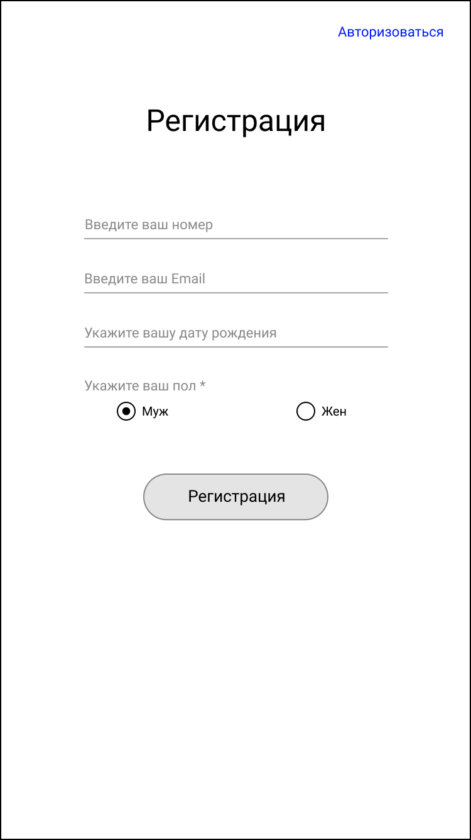
Figure 2 - Registration screen
Авторизоваться — Log in
Регистрация — Registration
Введите ваш номер — Enter your number
Введите ваш Email — Enter your email
Укажите вашу дату рождения — Enter your date of birth
Укажите ваш пол * — Select your gender *
Муж — Male
Жен — Female
Регистрация — Register button
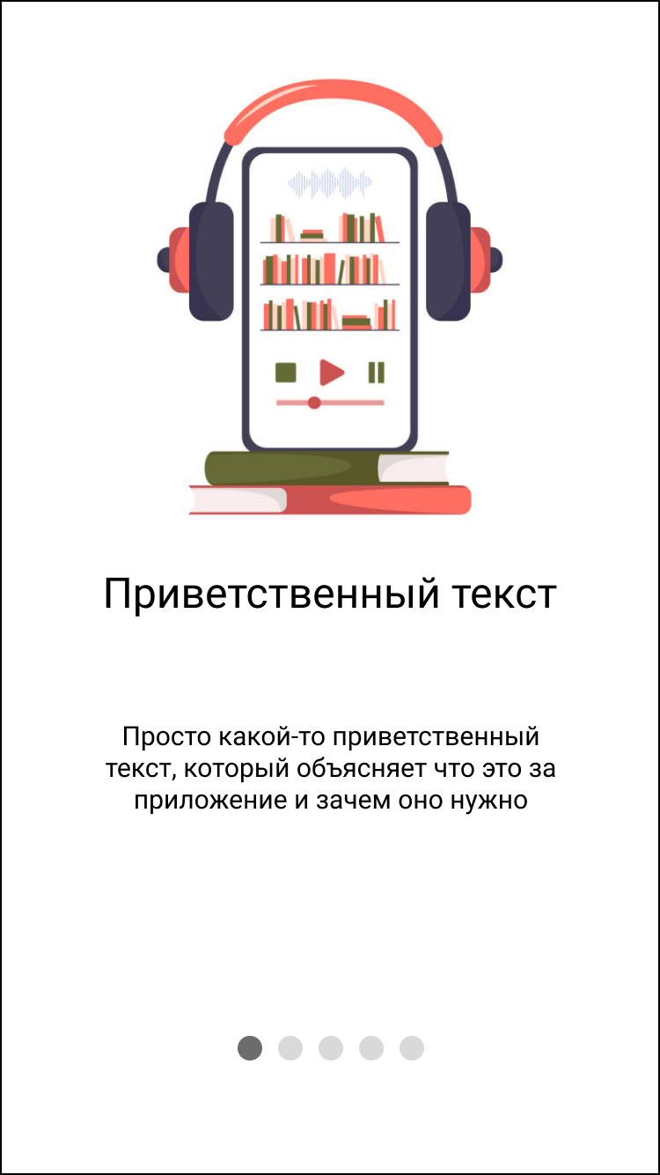
Figure 3 - Start screen for new users (onboarding)
Приветственный текст — Welcome text
Просто какой-то приветственный текст, который объясняет что это за приложение и зачем оно нужно — Just a welcome message that explains what this app is and why it's needed

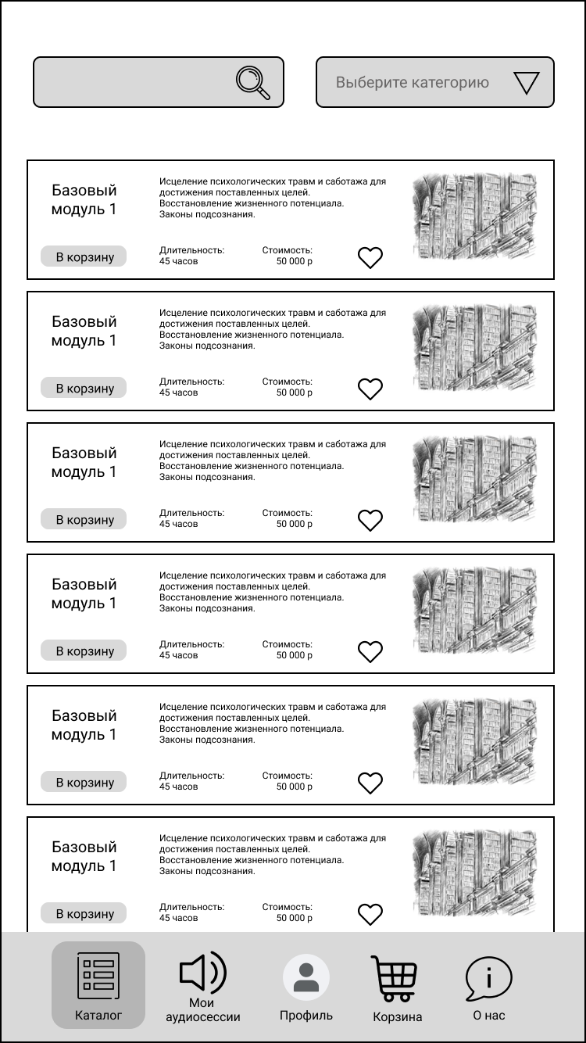
Figure 4 - Catalog screen
Базовый модуль 1 — Basic Module 1
Исцеление психологических травм и саботажа для достижения поставленных целей — Healing psychological traumas and sabotage to achieve set goals
Восстановление жизненного потенциала — Restoration of life potential
Законы подсознания — Laws of the subconscious
В корзину — Add to cart
Длительность: 45 часов — Duration: 45 hours
Стоимость: 50 000 р — Cost: 50,000 rubles

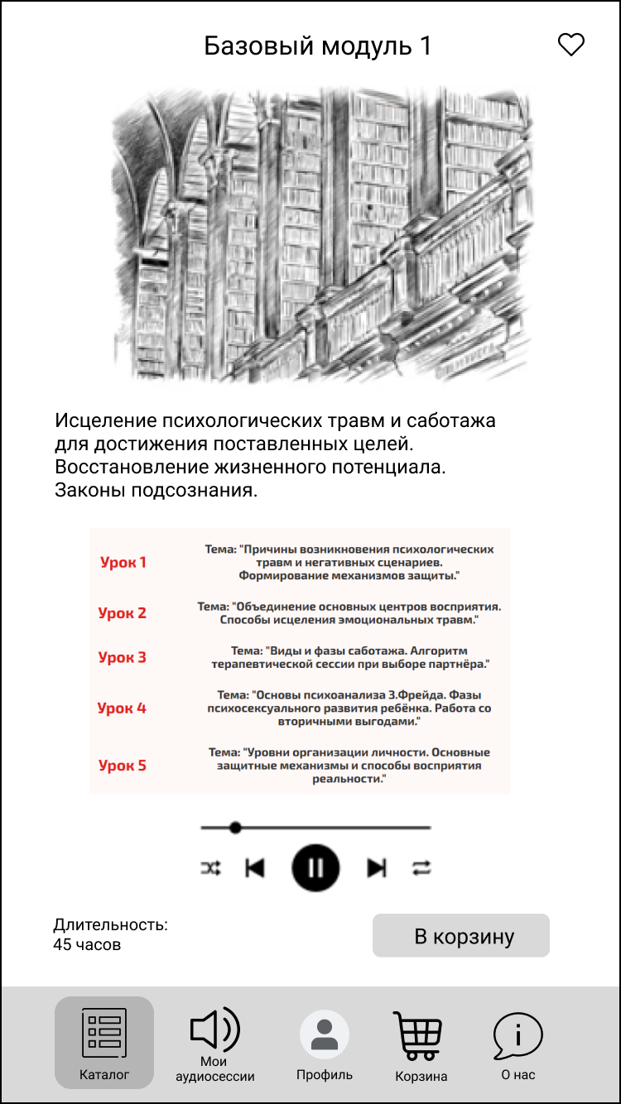
Figure 5 - Catalog screen. Detailed information about an audio session (audio session package)
Базовый модуль 1 — Basic Module 1
Исцеление психологических травм и саботажа для достижения поставленных целей — Healing psychological trauma and sabotage to achieve set goals
Восстановление жизненного потенциала — Restoration of life potential
Законы подсознания — Laws of the subconscious

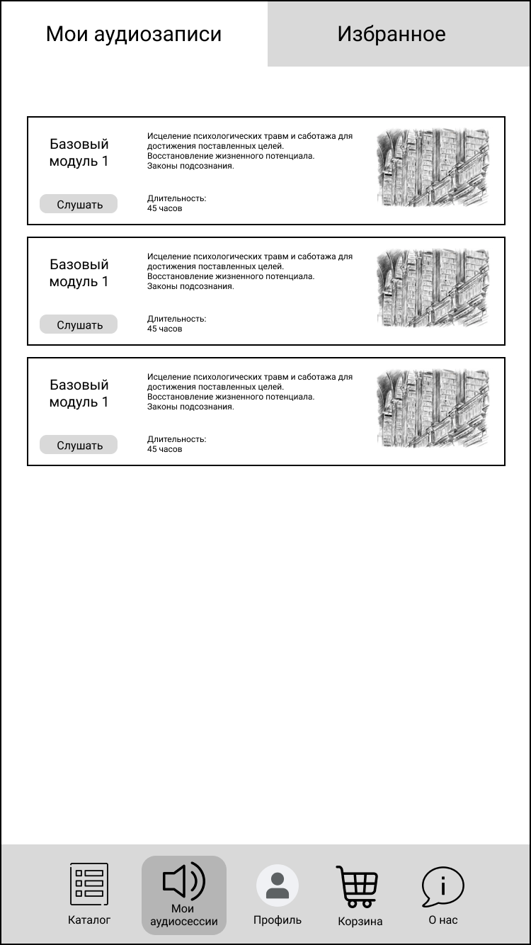
Figure 6 - Purchased Audio Sessions Screen
Мои аудиозаписи — My audio recordings
Избранное — Favorites
Базовый модуль 1 — Basic Module 1
Исцеление психологических травм и саботажа для достижения поставленных целей — Healing psychological trauma and sabotage to achieve set goals
Восстановление жизненного потенциала — Restoration of life potential
Законы подсознания — Laws of the subconscious
Слушать — Listen
Длительность: 45 часов — Duration: 45 hours

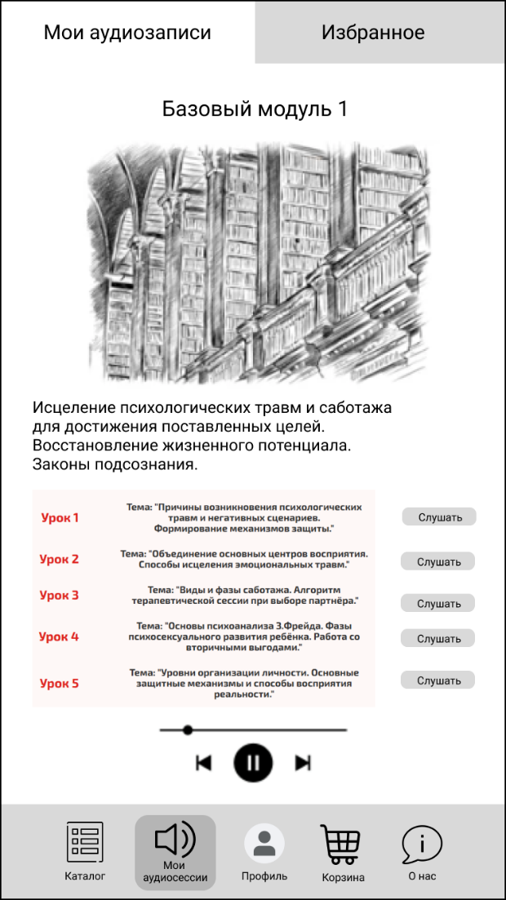
Figure 7 - Purchased Audio Sessions Screen. Detailed Information
Мои аудиозаписи — My audio recordings
Избранное — Favorites
Базовый модуль 1 — Basic Module 1
Исцеление психологических травм и саботажа для достижения поставленных целей — Healing psychological trauma and sabotage to achieve set goals
Восстановление жизненного потенциала — Restoration of life potential
Законы подсознания — Laws of the subconscious

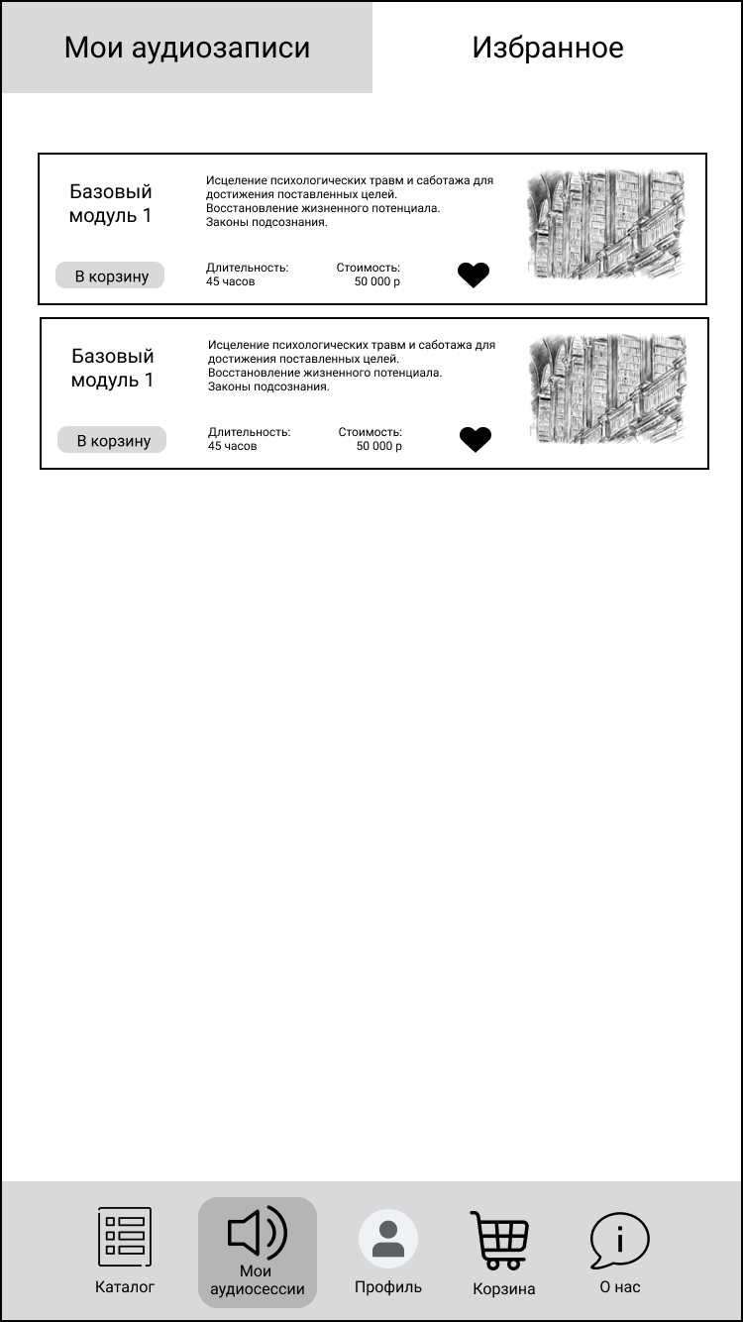
Figure 8 - Favorite Audio Sessions Screen
Мои аудиозаписи — My audio recordings
Избранное — Favorites
Базовый модуль 1 — Basic Module 1
Исцеление психологических травм и саботажа для достижения поставленных целей — Healing psychological trauma and sabotage to achieve set goals
Восстановление жизненного потенциала — Restoration of life potential
Законы подсознания — Laws of the subconscious
В корзину — Add to cart
Длительность: 45 часов — Duration: 45 hours
Стоимость: 50 000 р — Cost: 50,000 rubles

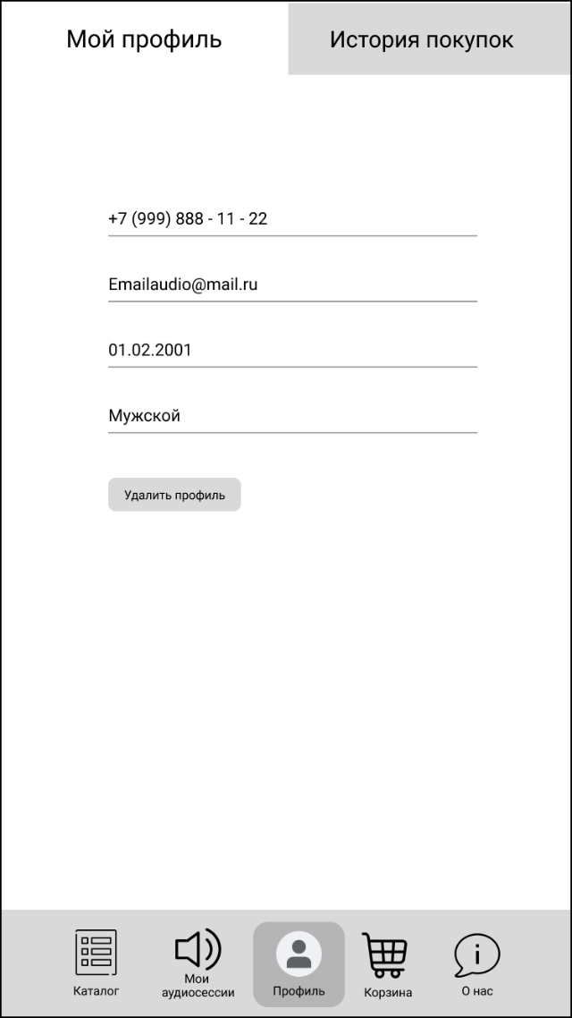
Figure 9 - Profile Screen
Мой профиль — My Profile
История покупок — Purchase History
Номер телефона: +7 (999) 888 - 11 - 22 — Phone number: +7 (999) 888 - 11 - 22
Email: Emailaudio@mail.ru — Email: Emailaudio@mail.ru
Дата рождения: 01.02.2001 — Date of birth: 01.02.2001
Пол: Мужской — Gender: Male
Удалить профиль — Delete Profile

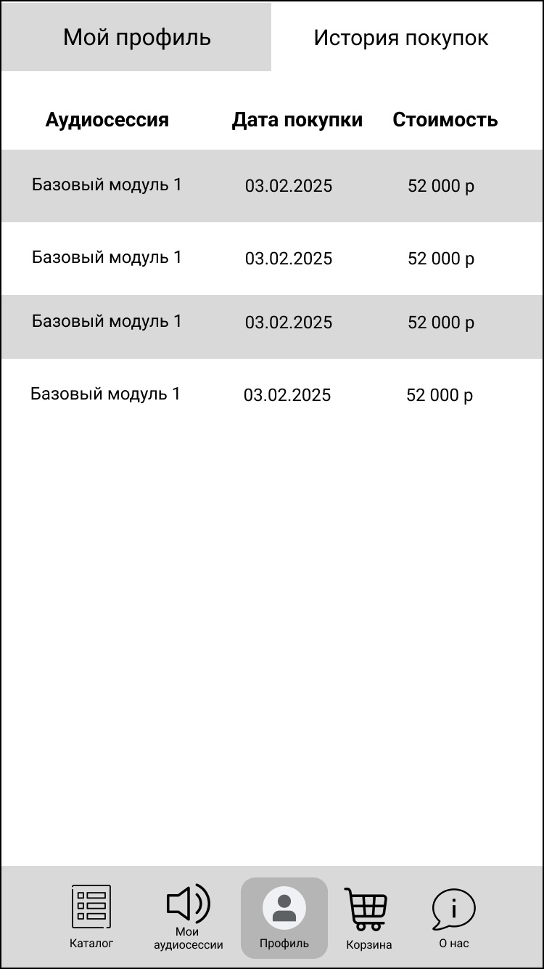
Figure 10 - Purchase history screen
Мой профиль — My Profile
История покупок — Purchase History
Аудиосессия — Audio session
Дата покупки — Purchase date
Стоимость — Cost
Базовый модуль 1 — Basic Module 1
03.02.2025 — 03 February 2025
52 000 р — 52,000 rubles

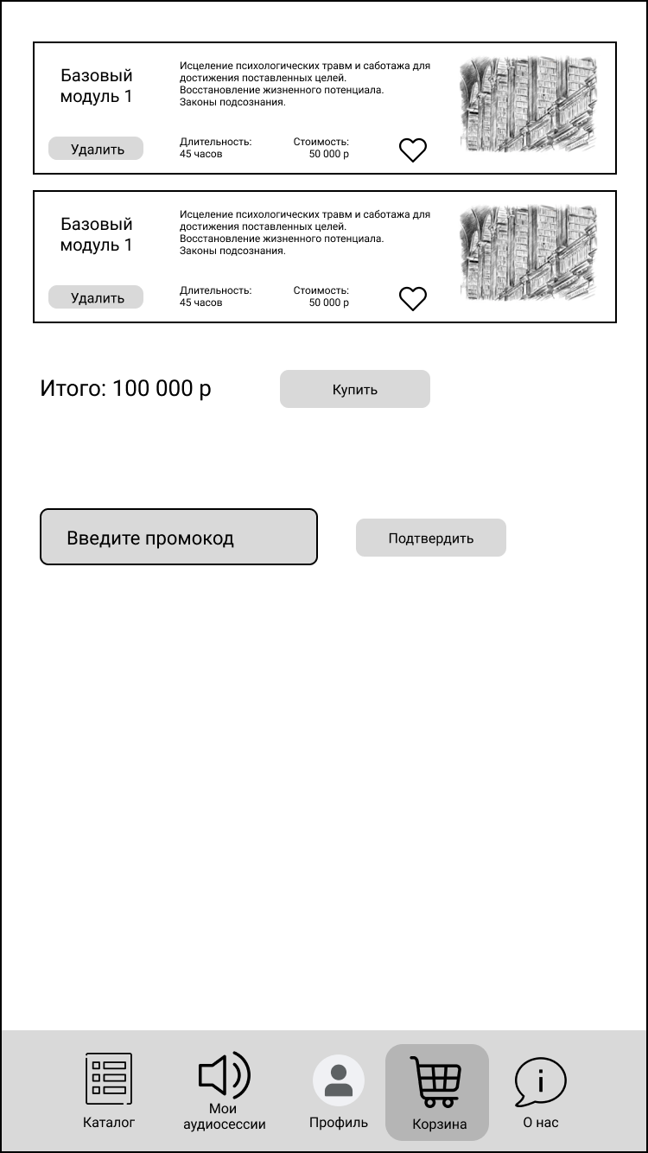
Рисунок 11 - Экран корзины
Базовый модуль 1 — Basic Module 1
Исцеление психологических травм и саботажа для достижения поставленных целей — Healing psychological trauma and sabotage to achieve set goals
Восстановление жизненного потенциала — Restoration of life potential
Законы подсознания — Laws of the subconscious
Удалить — Delete
Длительность: 45 часов — Duration: 45 hours
Стоимость: 50 000 р — Cost: 50,000 rubles
Итого: 100 000 р — Total: 100,000 rubles
Купить — Buy
Введите промокод — Enter promo code
Подтвердить — Confirm

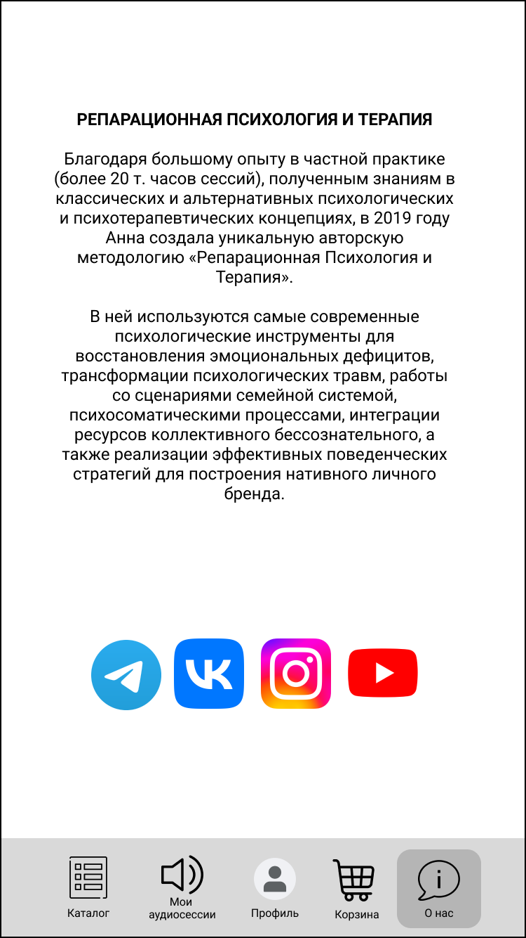
Figure 12 - About Us Screen
РЕПАРАЦИОННАЯ ПСИХОЛОГИЯ И ТЕРАПИЯ — Reparative Psychology and Therapy
Благодаря большому опыту частной практики (более 20 000 часов сессий)... — Thanks to extensive experience in private practice (over 20,000 hours of sessions)...
...и знаниям в области классических и альтернативных психологических и психотерапевтических концепций... — ...and knowledge in classical and alternative psychological and psychotherapeutic concepts...
...в 2019 году Анна создала уникальную авторскую методику «Репарационная психология и терапия» — ...in 2019 Anna created a unique author's methodology called "Reparative Psychology and Therapy"
Методика использует современные психологические инструменты... — The methodology uses modern psychological tools...
...для восстановления эмоциональных дефицитов — ...to restore emotional deficits
...трансформации психологических травм — ...transform psychological traumas
...работы с семейными сценариями — ...work with family system scenarios
...психосоматическими процессами — ...psychosomatic processes
...интеграции ресурсов коллективного бессознательного — ...integration of collective unconscious resources
...и реализации эффективных поведенческих стратегий — ...and implementation of effective behavioral strategies
///lkz gjcnhjtybz frnbdyjuj kbxyjuj ,htylf — ///for building an active personal brand

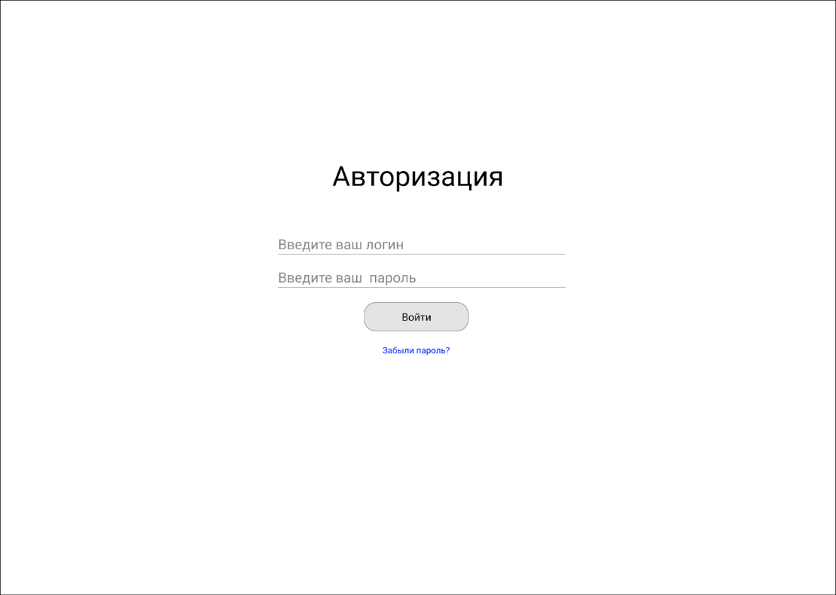
Figure 13 - Administration panel. Authorization
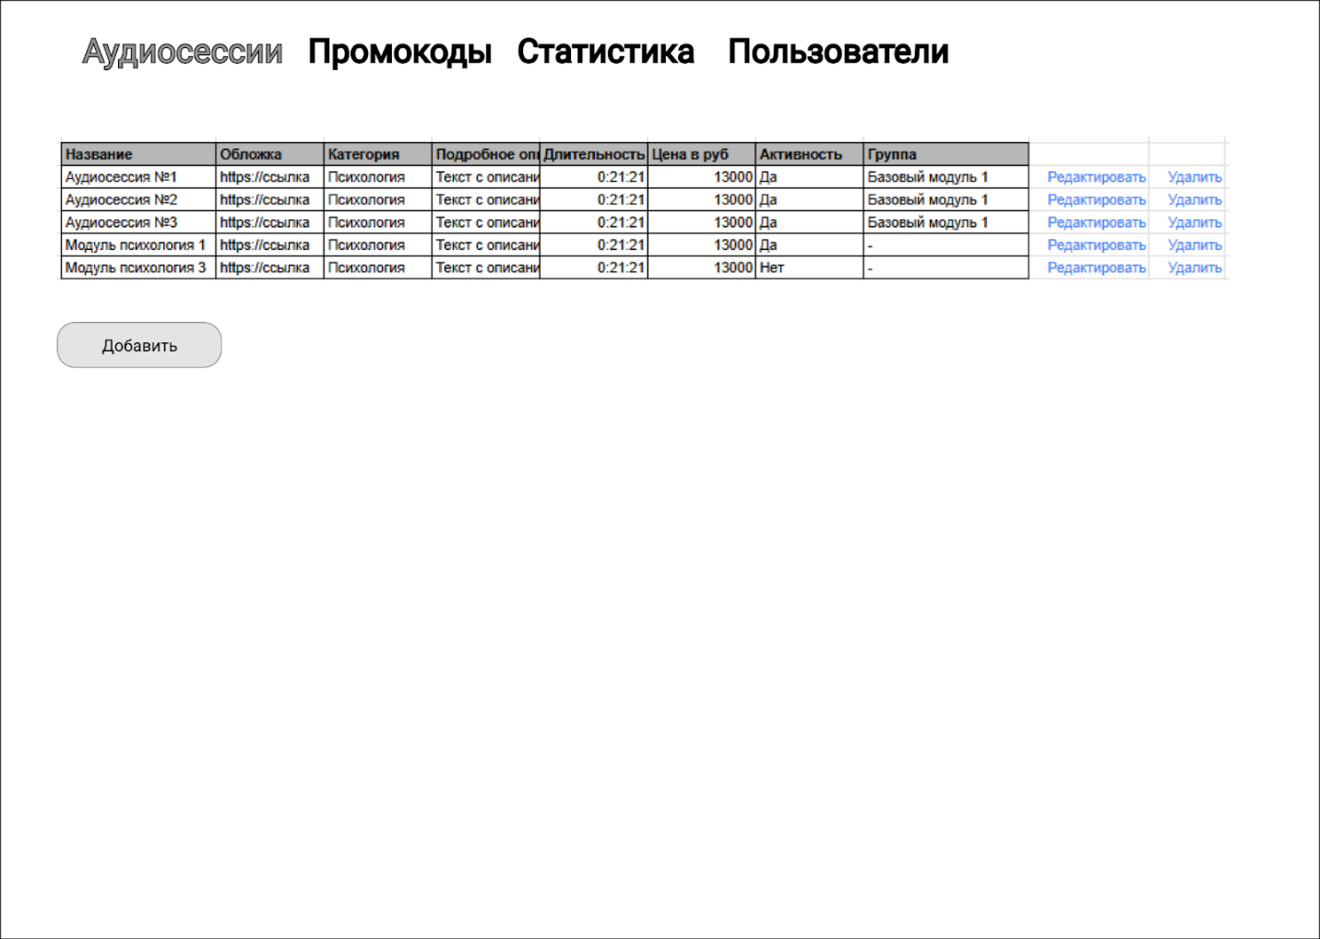
Figure 14 - Administration panel. List of audio sessions
Аудиосессии — Audio Sessions
Промокоды — Promo Codes
Статистика — Statistics
Пользователи — Users
Название — Title
Обложка — Cover
Категория — Category
Подробное описание — Detailed Description
Длительность — Duration
Цена в руб — Price in rubles
Активность — Active
Группа — Group
Аудиосессия №1 — Audio Session No. 1
Аудиосессия №2 — Audio Session No. 2
Аудиосессия №3 — Audio Session No. 3
Модуль психология 1 — Psychology Module 1
Модуль психология 3 — Psychology Module 3
Да — Yes
Нет — No
Редактировать — Edit
Удалить — Delete
Добавить — Add

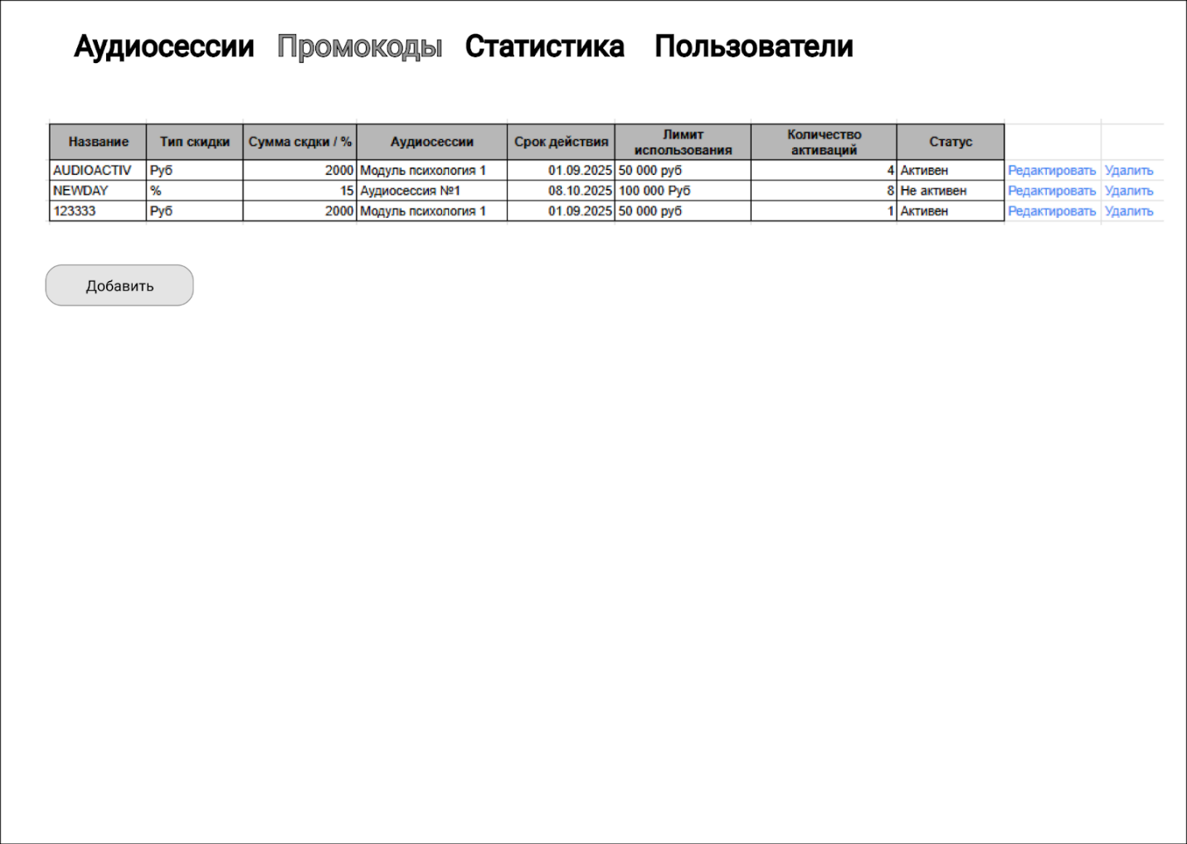
Figure 15 - Administration panel. Promo codes
Промокоды — Promo Codes
Название — Name
Тип скидки — Type of Discount
Сумма скидки / % — Discount Amount / %
Аудиосессии — Audio Sessions
Срок действия — Expiration Date
Лимит использования — Usage Limit
Количество активаций — Number of Activations
Статус — Status
AUDIOACTIV — AUDIOACTIV
Руб — Rubles
Модуль психология 1 — Psychology Module 1
01.09.2025 — 01 September 2025
50 000 руб — 50,000 rubles
Активен — Active
Аудиосессия №1 — Audio Session No. 1
08.10.2025 — 08 October 2025
100 000 руб — 100,000 rubles
Не активен — Inactive
Руб — Rubles
Модуль психология 1 — Psychology Module 1
01.09.2025 — 01 September 2025
50 000 руб — 50,000 rubles
Активен — Active
Редактировать — Edit
Удалить — Delete
Добавить — Add

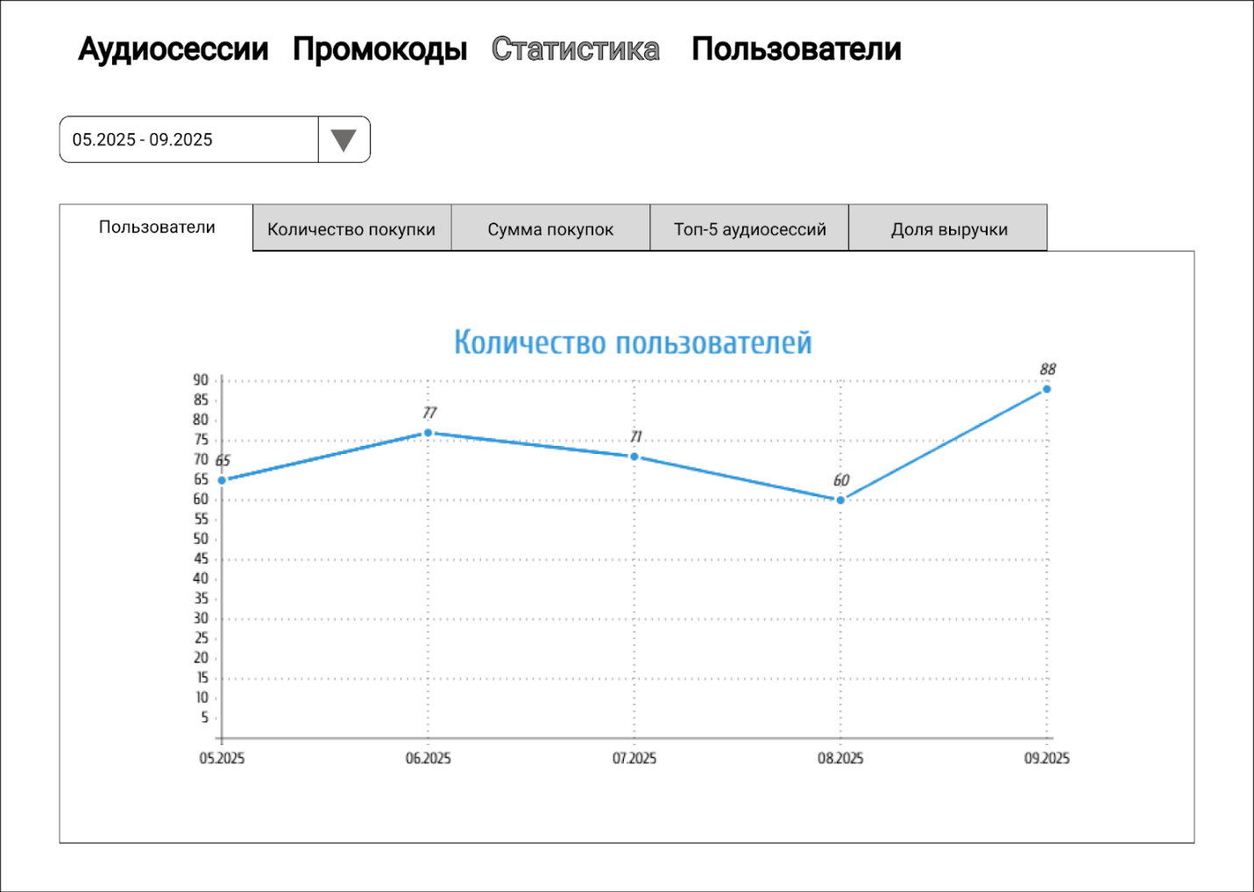
Figure 16 - Administration Panel. Statistics (Users)
Пользователи — Users
Количество покупки — Number of purchases
Сумма покупок — Total purchase amount
Топ-5 аудиосессий — Top-5 audio sessions
Доля выручки — Revenue share

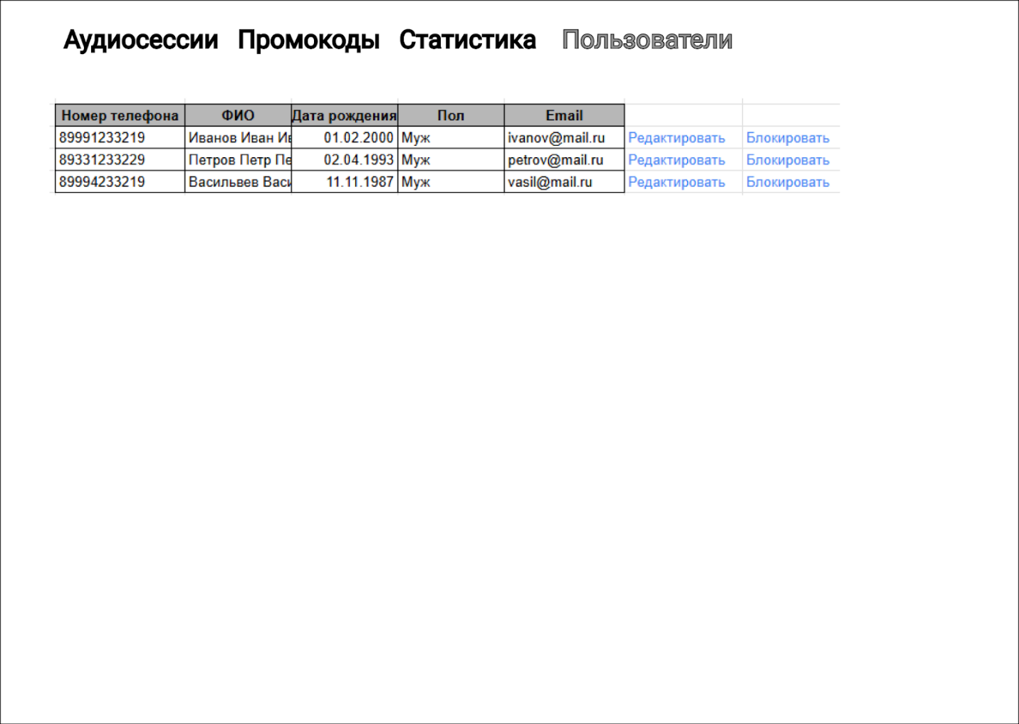
Figure 17 - Administration Panel. Users

