SIM University
School of Science and Technology



Portfolio website for a modelling agency

Project proposal

Student : Liu hao wen (PI no.w0901963)
SUPERVISOR : KOH CHUNG HAUR
Project Code : JAN2012/ICT499/YYYY

Contents
PART 1 PROJECT DEFINATION 3
Project Objectives: 3
Overall Objectives: 3
Proposed approach and method to be employed 4
Requirements 5
Design 5
Implementation 5
Verification 6
Maintenance 6
Others 6
Skills review 6
PART2 INVESTIGATION OF PROJECT BACKGROUND 7
Background summary 7
CMS Introduction 7
Problems faced 7
Current practice in industry 7
PART3 PROJECT PLAN 8
WBS and Gantt chart 8
Risk Assessment 10
Additional resources 12
PART4 APPENDIX 12
A. Reference 12
B. Development and Test Environment 13
Hardware 13
Software 13

PART 1 PROJECT DEFINATION

Project Objectives:

The main objective is to design and build up a showcase website for a modelling agency to demonstrate and show its portfolio. In general, it is a CMS (Content Management System) that build with PHP, MySQL and Apache Http Server.

In general, once the website is online, the website contents are able to be maintained by administrator of the Modelling Agency. CUD (Create Update and Delete) functions are provided to the webmaster to control the portfolios and announcement contents.

In details:
- The CMS will have a portal to allow webmasters to log in.
- Once webmasters logged in, the CMS allow webmasters to change the password for security reason.
- The CMS allows webmasters to create new users to maintain the system. (However the reverse can only be done by database administrators.)
- The CMS allows webmasters to create new portfolio pages under each category.
- The CMS allows webmasters to amendment existing portfolio pages under each category.
- The CMS allows webmasters to delete existing portfolio pages under each category.

Overall Objectives:

From business point of view:
This project requires designing and building up a web platform for business purpose. This is a real life project and it’s required by a modelling agency in Singapore. It reflects what and how the real market demand and requirements.

Nowadays, most of companies, no matter small or big, selling intangible products or nontangible services, have their own websites. Those websites are like windows and showcases to consumers, they are showing companies’ strength, and helps consumers to know the company. In this case, websites are considered as advertisement campaign, and it is on the pre-sale stage of the business. It is also a way to build up strong reputation, and make the company well known.

Furthermore, as this project required to build up a CMS system. It allows less trained users to maintain the contents. There is no need to hire professional staff to keep the website up-to-date. This helps company to save both manpower and financial resources.

This is absolutely a great opportunity to gain more working experiences and understand the market. It is definitely a challenging project.

From technical point of view:
The project is challenging because it requires responsible personnel to understand both side of the structure of the modern website, both back-end and front-end.

This project required to use Apache, MySQL and PHP. There are three very famous components of 'XAMP' platform. (X stands for Operation Systems. LAMP is acronym for Linux, Apache, MySQL and PHP. WAMP is for Windows Apache MySQL and PHP). Over 80 percent of web pages are using these technologies, especially small to medium company who has online business due to the implementation fee is lower. (Linux, Apache, MySQL and PHP are free of charge.).

Besides design and achieve the functional requirements in the back-end (Most likely programming, code jam). The project also requires skills to build up the front-end as well, which includes layout design (HTML and CSS) and visual effects (Graphic design, drawing, and JavaScript etc.)

Unfortunately, nowadays, most academies are teaching their IT students .net and Java as programming languages, and MSSQL and even Microsoft Accesses as database and DBMS. So basically they don't have chance to learn PHP and MySQL unless they are working on that field, and learn PHP and MySQL by themselves. To those who good at front-end design, like students graduated from IT multimedia. Learning and using a new programming language and DBMS is definitely a nightmare.

For the front-end, drawing with Adobe Fireworks, Adobe Photoshop is another “pain in the neck” to most students who graduated from IT software engineering. Those software tools are easy enough to use, but still require some skills to play well with them.

It is known that, in real life, front-end and back-end are usually separate. But as an individual project, it offers a chance to challenge skills on both front-end and back-end.

Overall, this is a challenging project and a good opportunity to learn more about both real life business and improve skills.

Proposed approach and method to be employed

According to the nature of the project, the project is going to be applied modified waterfall methodology as the System Development Life-cycle (SDLC) or as known as software development process.

Requirements
Design
Implementation
Verification
Maintenance
Comparing with pure waterfall methodology, modified waterfall has all advantages of pure waterfall methodology, but with much more flexibilities. It is able to reverse back to the previous process and fix the error and reduce the risk of the project (Ref 1and2. “Risk reduction spirals can be added to the top of the waterfall to reduce risks prior to the waterfall phases.”). It is suitable for project, if the requirements is frequently changed, in other words, it is flexible. However, milestones of the project may be more ambiguous than the pure waterfall methodology.

Requirements
Brain Storm stage after project initialization.

During this phase, developer will require necessary information from supervisor via email and face to face sessions and proposal both functional and non-functional requirements to supervisor. Once proposal has been approved, then move to the next phase, design.

Design

Design the whole project based on requirements from scratch.

On this stage, it is going to design the UI of the webpages’ templates by using storyboard and Photoshop. Database structure also will be design by using methodology such as ER model and Boyce–Codd Normal Form (BCNF approach). Test plan will also be produced on this stage.

Overall, all design activities will follow the standards (non-functional requirements) determined on last phase.

Implementation

Programming and installation stage of the project.

During implementation phase, github will also be applied into this project as version controller of all source code such as PSD files, HTML code, JavaScript code, PHP Code, SQL Execution Script etc. After coding process, the prototype of the project shall be produced. The prototype will be configured and implemented on the test environment and wait for the next phase, verification.

Verification

All function will be tested in this phase, and test plane will be used here as guidance.

Maintenance

Bug fixing and review stage. Any problems exposed on verification stage would be fixed, and advises and suggestion from supervisor would be implemented into the project.

Others

Other standards, principals and external libraries will be applied would be W3C standards (Ref 3), HTML5 (Ref4), Camel Case name spacing, 920 Grid System, white box test and JQuery.

Software tools and system environment will be covered in part4 appendix B environment.

Skills review

First of all, the project should be fully functional and can be finished on time. To achieve this, WBS and Gant Chart will help to trace the progress, several online project management tools will be also introduced into this project, such as github etc. Those tools would keep the developer in the right track and easy to check the progress of the project. It is also a perfect way to implement quality control to ensure the project quality is meet the requirement.

To ensure the overall goals and targets mentioned above, skills needed are listed below:
- Proficient in PHP programming.
- Proficient in using HTML and CSS to create basic web pages.
- Good programming skills and logic design.
- Proficient in database design.
- Good at graphic design.
- Interpersonal skills. Interact and communicate with supervisor, establish good and health relationship, gather enough necessary information and comprehend the requirements.
- Project management skills (such as time management, resources management, planning etc.)
Based on self-evaluation, strengths are programming skills, thus the first priority is to improve the interpersonal skills.

PART2 INVESTIGATION OF PROJECT BACKGROUND

Background summary

A modelling agency requires a web platform to introduce its services and display its models and make announcements to public as part of agency advertisement campaign, most importantly, this web platform will become a modern tool to propagandize its business, and hope it can help to promote its business, and take it to the next level.

The customer requires a CMS (Content Management System) that allows them to manage the website contents by themselves. For example, the webmaster of the website should be able to add, delete pages of the website, and has privileges to add, delete and modify content in each page as well.

In conclusion, this system should provide website authoring, collaboration, and administration tools to allow users with little knowledge of professional skills to create and manage website.

CMS Introduction

CMS may also as known as WCMS (Web Content Management System) is a “software system that provides website authoring, collaboration, and administration tools designed to allow users with little knowledge of web programming languages or markup languages to create and manage website content with relative ease.” (Ref 5)

Most of CMS are written in PHP and use MySQL as database (Repository system). Some well-known CMS such as WordPress, Joomla and Drupal are wildly used nowadays. (Ref 6)

Problems faced

As mentioned above in the background summary section, this project has been developed for several years by a few students. However it has not been finished yet. During the initialize stage of the project, it is decided that this project would be start from scratch. All previous materials and documents would be discarded.

Considering that the webmaster would be an internal employee of the modelling agency. The webmaster is lack of web programming language and web mark-up language knowledge. The usability should be high and extreme user friendly. Another issue would be trouble-shooting and maintenance, the running status of the system should be stable or offering a quick solution once encountered a fatal error. Thus the system must be easy and robust.

Current practice in industry

Currently, Most of Singapore modelling agencies have their own websites, but according to the result done by investigation and research phase. The fact is that some websites are not up-to-date. It might means that those websites were designed as one time usage only, which are wrong examples. However, some websites are using CMS or CMS concept to manage website, although they are applying different technologies inside and their qualities are jaggy.

According to the technologies be used, It could be classified into 5 categories as shown below.

Category Number | Category Type
1 | Pure HTML
2 | Adobe Flash
3 | PHP
4 | Microsoft Asp.net
5 | Oracle Java Jsp

(This table shows the main technologies used in modelling agency websites, although most of them are using multiple technologies at the same time)

The advantages of using Flash is obviously, it offers pleasant brilliant visual and animation effects, compatibility is very good, it only requires devices with adobe flash plugin. Ironically, adobe stops developing flash plugin for mobile devices. As time goes on, more and more mobile devices (smart phones and tablet PCs) will be used to visit web pages. Without adobe flash plugin, those mobile devices won’t be able to visit those pages at all.

Asp.net and Jsp are robust. They are usually used to develop enterprise systems, but it may be too excessive and expensive to a modelling agency, for example, running asp.net programs requires windows servers, which is costly.

PHP is open source, cross platform, lightweight, all requests are done by the server side, so that don’t have to concern about compatibility. With JavaScript (include third party libraries such as JQuery) and CSS, It is able to produce a modern and robust showcase website and suitable for both PC and mobile devices.

PART3 PROJECT PLAN

WBS and Gantt chart

All working packages are listed in the Gantt chart.
The project starts from 4th Feb 2012 and will end on 1 Dec 2012

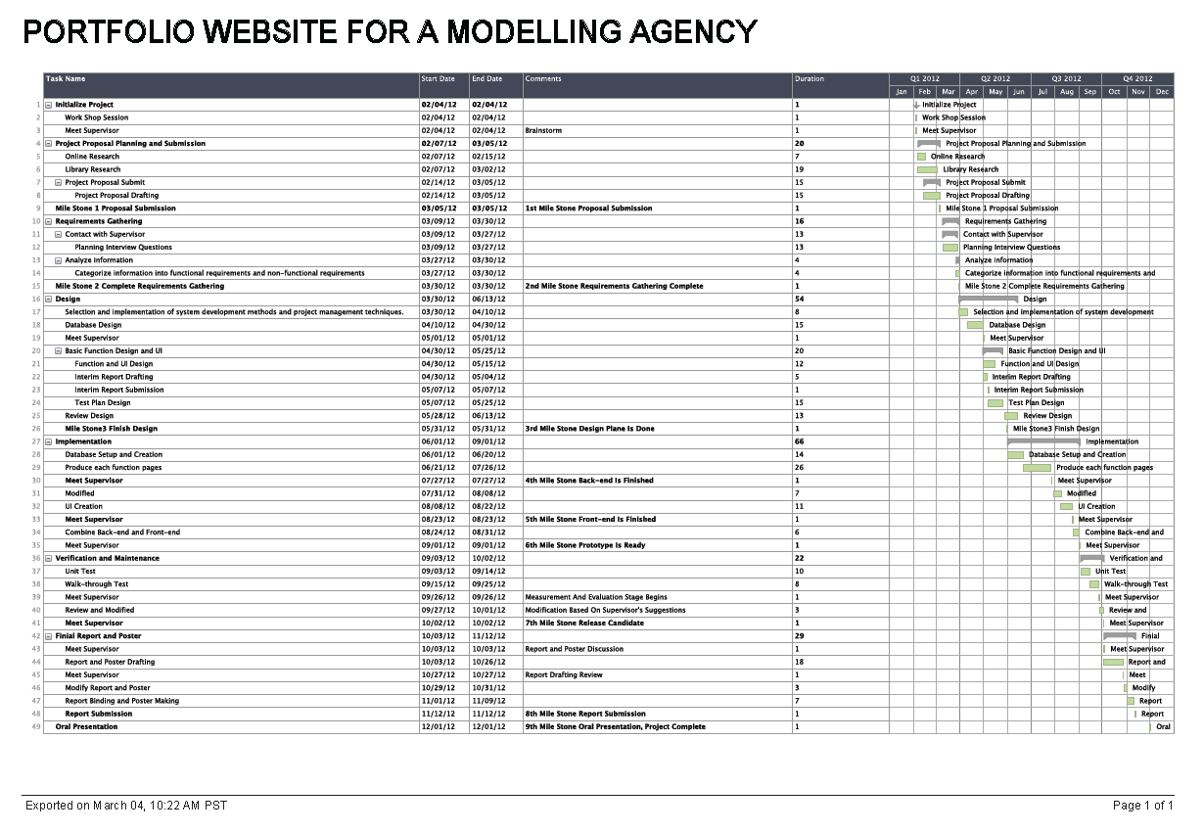

The total duration is 208 man-days.

Risk Assessment

To ensure the project would be done successfully. Some risks possible happen during the project are listed down below in the risk assessment form.

The matrix form would be used as a guidance to eliminate or reduce risks damage. There will be three parts in the matrix form.

- Hazard Identification, is used to identify the risk, explain why the risk would happen.
- Risk Evaluation, is used to describe the level of the risk.
- Risk Control, is used to introduce the mitigation steps to be taken to ensure a successful project.

1.Hazard Identification |  |  |  | 2.Risk Evaluation |  |  |  | 3.Risk Control
1a | 1b | 1c | 1d | 2a | 2b | 2c | 2d | 3a | 3b
No. | Task | Hazard | Possible consequences | Existing Risk Control (If any) | Severity | Like Hood | Risk Level | Additional Risk Control | Action officer designation
1 | Online Research | Internet offline | Unable to connect to internet Online Research fail | Switch to library research | Minor | Remote | Low | NA | NA
2a | Proposal Submission | Internet offline | Cannot submit proposal | Switch network | Minor | Remote | Low | Contact Supervisor | NA
2b | Proposal Submission | Can’t finish proposal on time | Withdraw capstone course | NA | Major | Occasional | High | Contact Supervisor | NA
3a | Requirements gathering | Can’t gathering enough information due to bad interview question | Wrong requirements before planning | Review Interview questions | Major | Occasional | High | Confirm with supervisor | NA
3b | Requirements gathering | Understand the requirements wrongly | Wrong requirements before planning | NA | Major | Occasional | High | Confirm requirement with supervisor | NA
4a | System Design | Omit requirements | System Missing functions | Checking requirement list and review plan | Major | Remote | Medium | Review design with supervisor before implementation | NA
4b | System Design | Lack of time due to other reasons | Project progress delay | Time overlapping | Moderate | Occasional | Medium | Put in more efforts and increase man-days | NA
4c | System Design | Requirements changed | Need to redesign | NA | Moderate | Remote | Low | Accept risk and redesign | NA
5a | Implementation | Omit plan procedure | System Missing functions | Checking List of plan | Major | Remote | Medium | Review plan before implementation | NA
5b | Implementation | Lack of time due to other reasons | Project progress delay | Time overlapping | Moderate | Occasional | Medium | Put in more efforts and increase man-days | NA
6a | Interim report submission and drafting | Lack of time due to other reasons | Project progress delay | Time overlapping | Moderate | Occasional | Medium | Put in more efforts and increase man-days | NA
6b | Interim report submission and drafting | Internet offline | Cannot submit interim report | Switch network  and contact unisim technic support | Major | Remote | Medium | Contact Supervisor | NA
7 | Testing fail | Some bugs are not tested out | Possible have bugs in system | Review test plan | Major | Occasional | High | Accept risks or review test plan with supervisor | NA
8 | Poster design | Lack of time due to other reasons | Project progress delay | Time overlapping | Moderate | Occasional | Medium | Put in more efforts and increase man-days | NA
9a | Final report drafting and submission | Lack of time due to other reasons | Project progress delay | Time overlapping | Moderate | Occasional | Medium | Put in more efforts and increase man-days | NA
9b | Final report drafting and submission | Internet offline | Cannot submit final report | Switch network  and contact unisim technic support | Major | Remote | Medium | Contact Supervisor | NA
9c | Final report drafting and submission | Hardcopy delivery | Cannot submit hard copy of final report | Confirmation of reception is required | Major | Remote | Medium | Contact Supervisor | NA
10 | Source code and documentation control | Lost source code and documentation of project | The project cannot be continued | Process backup and recovery mechanism | Major | Remote | Medium | Three different back up location and one version control system will be involved into recovery process. (Please refer to additional resources section) | NA

Additional resources

Three locations and methods will be introduced into this project as back up process.

After each operation and modification, all source code and documents will be copied into
- The working folder of the project on development PC 1TB HD. (please refer to appendix B)
- The backup external 1TB HD.(Please refer to appendix B)
- Github.(A project with the same name will be created under developer’s account)

One external online tool will be introduced into this project as version controller.

Before each modification process, the latest copies of source code or documents will be checked out from github. All modification would be done on those latest copies.

After each modification, all source code and documents will be uploaded into github. There would be a project folder with the same name under developer’s account.

PART4 APPENDIX

Reference

- DeGrace, Peter, and Stahl, Leslie Hulet, 1990, Wicked Problems, Righteous Solutions: A Catalogue of Modern Software Engineering Paradigms, Prentice-Hall, 244 pages. ISBN: 0-13-590126-X
- Boehm, Barry W., 1988, "A Spiral Model of Software Development and Enhancement". Computer, May: p. 61-72.
- The Web Standards Project http://www.webstandards.org/ &W3C XHTML standards http://www.w3.org/MarkUp/#xhtml1
- HTML 5 Reference Guide http://www.w3schools.com/html5/html5_reference.asp
- Web Content Management System http://en.wikipedia.org/wiki/Web_content_management_system
- WordPress http://wordpress.com/ Joomla! http://www.joomla.org/ Drupal http://drupal.org/

Development and Test Environment

Hardware

  - PC Platform X86-64
  - Intel Q9550
  - 8GB RAM
  - 1TB wroking HD
  - 1TB Backup HD

Software
  - Windows 7 64bit Enterprise Edition
  - Apache Http Server version 2.2.21
  - PHP version 5.3.10
  - MySQL 5.5.1 64bit
  - Photoshop CS5
  - Dreamweaver CS5
  - Notpad++
  - GitHub

