Heart Disease Risk Prediction
An End-to-End MLOps Pipeline: Model Development, CI/CD, and Production Deployment
MLOps (AIMLCZG523) — Assignment 01
BITS Pilani
[Your Name] | [Your BITS ID] | [Date]
Repository: [insert your GitHub repository URL here]

1. Project Overview
This project implements a complete, production-style MLOps pipeline that predicts the risk of heart disease from patient health data, using the UCI Heart Disease (Cleveland) dataset. The pipeline covers the full lifecycle: data acquisition, cleaning and exploratory analysis, feature engineering, model training with hyperparameter tuning, experiment tracking with MLflow, model packaging, automated testing, CI/CD via GitHub Actions, Docker containerization, Kubernetes deployment, and API monitoring/logging.
Problem statement: build a binary classifier that predicts presence/absence of heart disease, and deploy it as a cloud-ready, monitored REST API.

1.1 Tool Stack
Category | Tool / Technology
Programming Language | Python 3.11
Data Processing | Pandas, NumPy
Visualization | Matplotlib, Seaborn
ML Framework | Scikit-learn
Experiment Tracking | MLflow (SQLite backend)
API Framework | FastAPI + Uvicorn
Testing | Pytest
Containerization | Docker
CI/CD | GitHub Actions
Orchestration | Kubernetes (Minikube / EKS / GKE / AKS)
Monitoring | Prometheus + Grafana (via prometheus-fastapi-instrumentator)
Version Control | Git / GitHub

1.2 Architecture
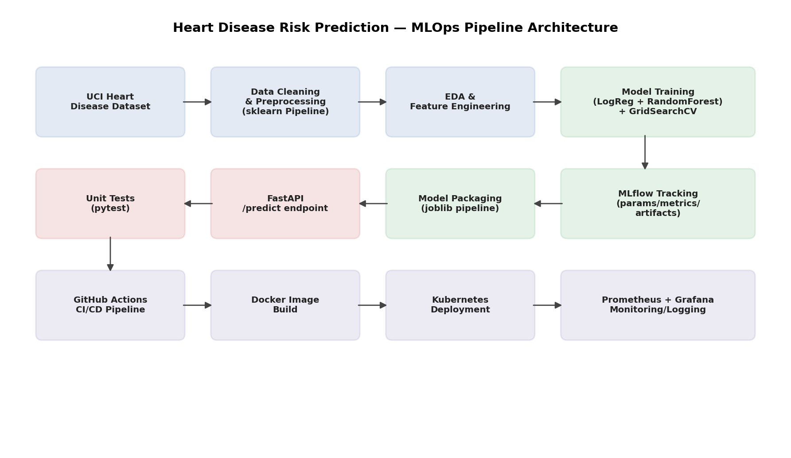
Figure 1. End-to-end pipeline architecture, from data ingestion through monitored deployment.

2. Dataset and Exploratory Data Analysis
The dataset is the UCI Heart Disease (Cleveland) dataset: 303 patient records with 13 clinical features (age, sex, chest pain type, resting blood pressure, cholesterol, fasting blood sugar, resting ECG results, max heart rate, exercise-induced angina, ST depression, slope, number of major vessels, and thalassemia) plus a multi-class diagnosis label. The diagnosis label (0-4) was binarized to 0 (no disease) / 1 (disease present) as required. Six records had missing values (4 in 'ca', 2 in 'thal'), encoded as '?' in the source file, handled via median/most-frequent imputation.
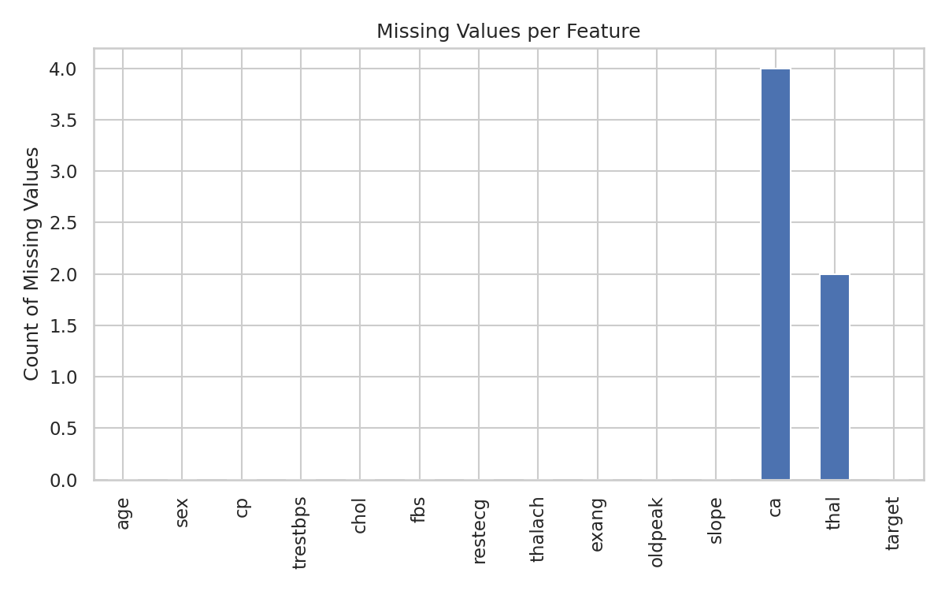
Figure 2. Missing values by feature (post numeric coercion).
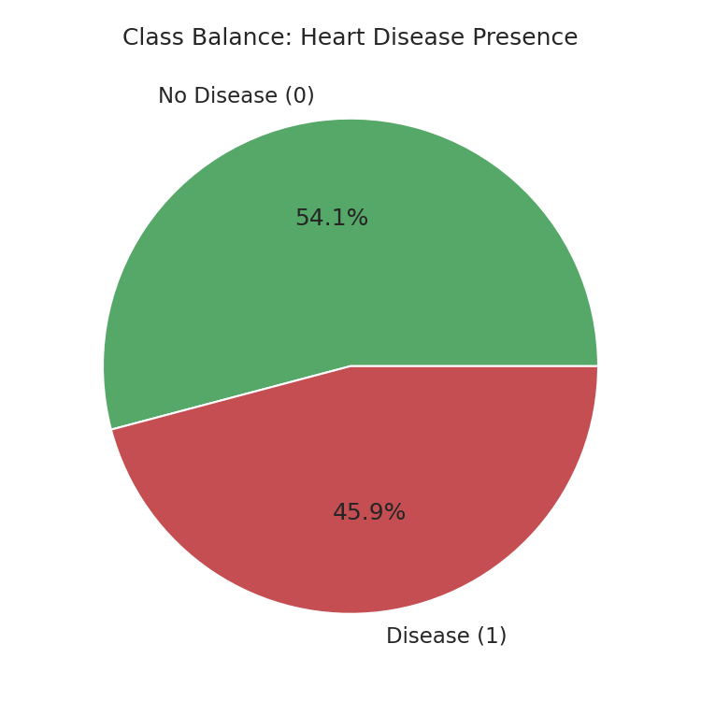
Figure 3. Class balance — approximately 54% no disease vs. 46% disease present.
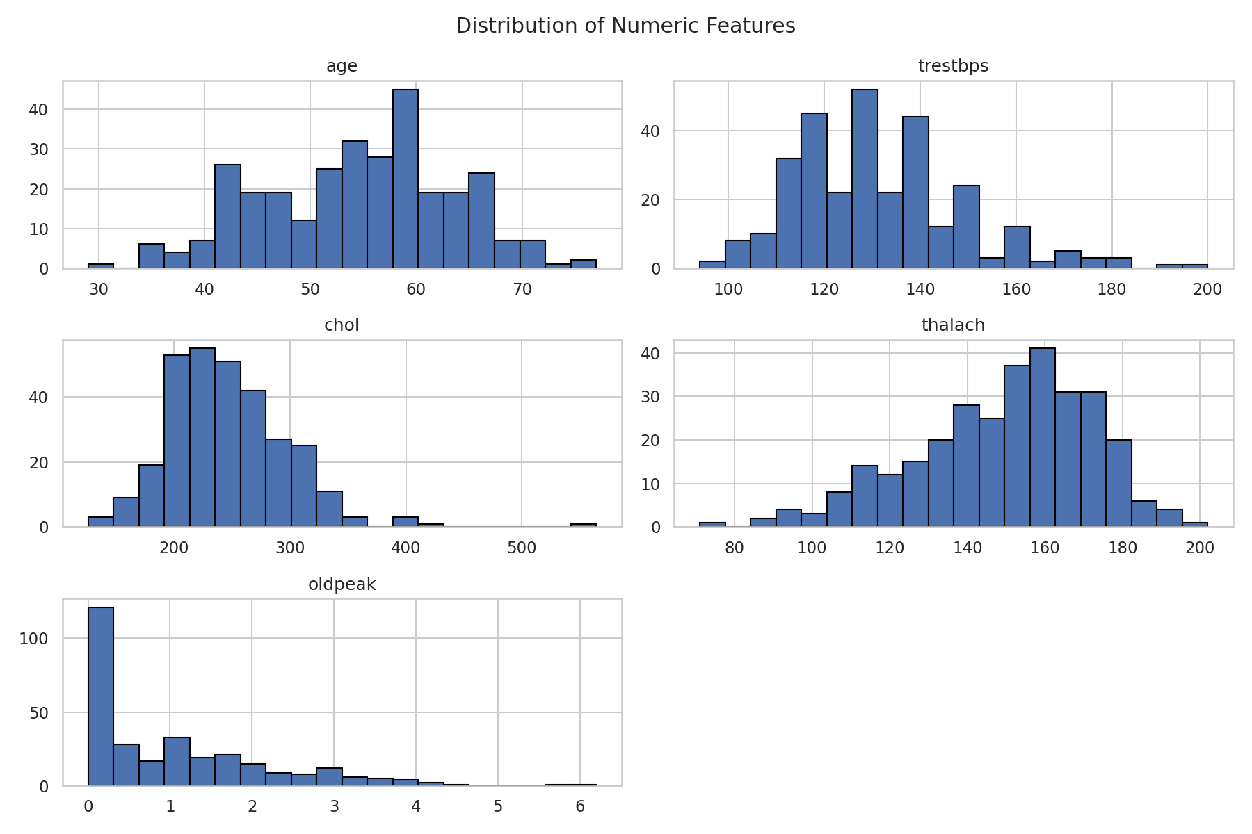
Figure 4. Distribution of numeric features.
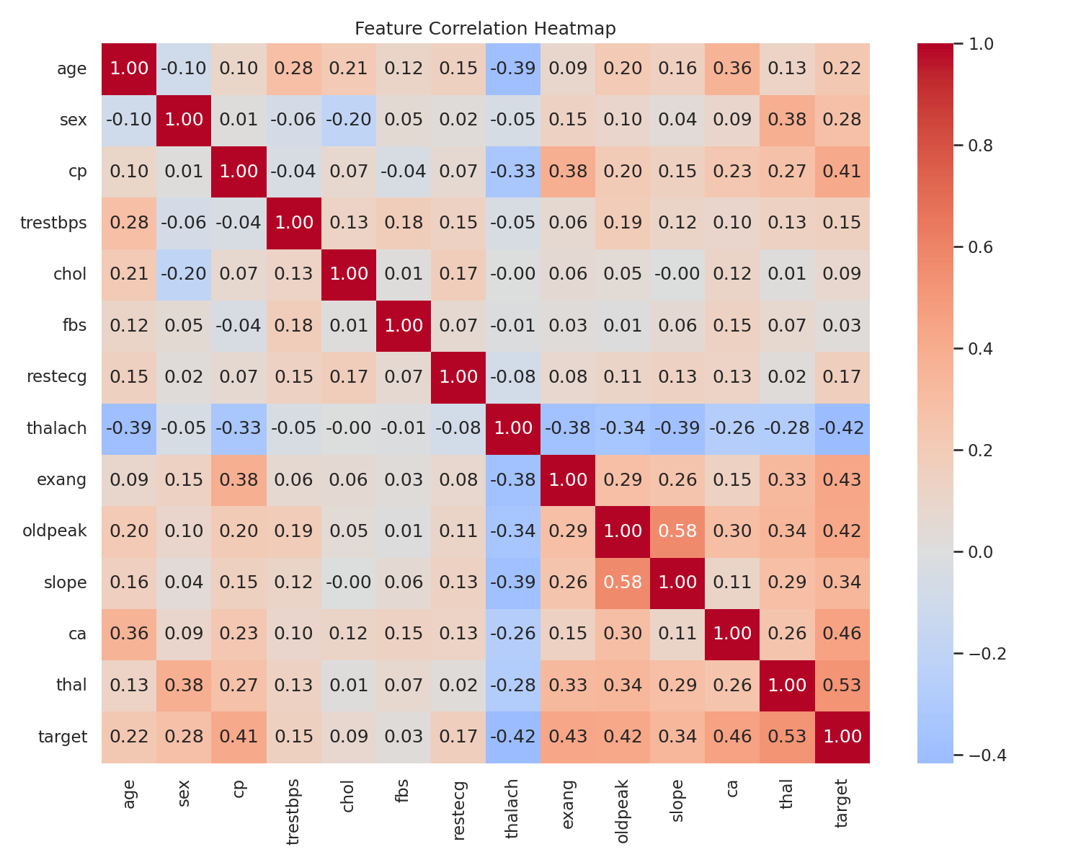
Figure 5. Feature correlation heatmap. thal, ca, oldpeak, cp, and exang correlate most strongly with the target.
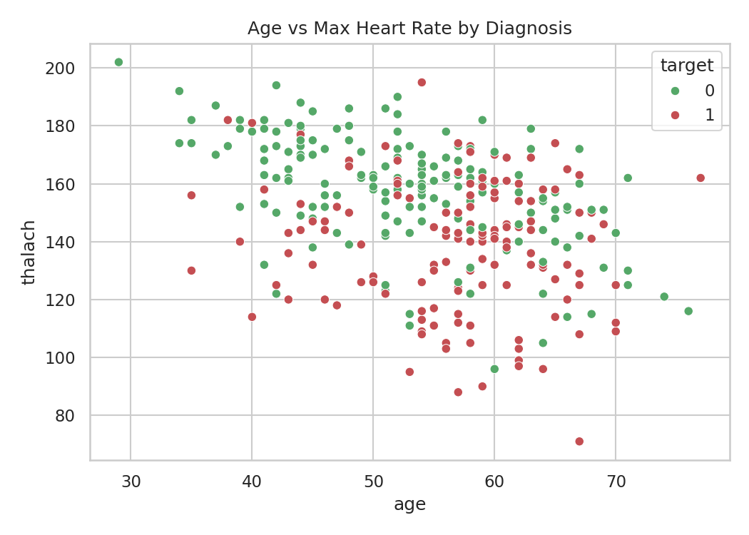
Figure 6. Age vs. maximum heart rate, colored by diagnosis — patients with disease cluster at lower max heart rates.
Key EDA findings: the dataset is moderately balanced, so accuracy is meaningful but precision/recall/ROC-AUC were still prioritized given the clinical cost asymmetry of false negatives. The strongest univariate predictors of disease were thal, ca, oldpeak, cp, and exang, consistent with established clinical risk factors.

3. Feature Engineering and Model Development
Numeric features (age, trestbps, chol, thalach, oldpeak) were median-imputed and standardized. Categorical features (sex, cp, fbs, restecg, exang, slope, ca, thal) were most-frequent-imputed and one-hot encoded. Both steps are encapsulated in a single scikit-learn ColumnTransformer, wrapped in a Pipeline together with the classifier — guaranteeing identical preprocessing at training and inference time.
Two classifiers were trained and tuned with 5-fold stratified cross-validation and GridSearchCV, optimizing for ROC-AUC: Logistic Regression (C, solver) and Random Forest (n_estimators, max_depth, min_samples_split). An 80/20 stratified train/test split was used for final evaluation.

3.1 Model Comparison (held-out test set)
Model | Accuracy | Precision | Recall | F1-Score | ROC-AUC
Logistic Regression (tuned) | 0.885 | 0.839 | 0.929 | 0.881 | 0.966
Random Forest (tuned) | 0.869 | 0.833 | 0.893 | 0.862 | 0.947

Logistic Regression was selected as the final model, achieving the highest ROC-AUC (0.966) with best hyperparameters C=1, solver='lbfgs'.
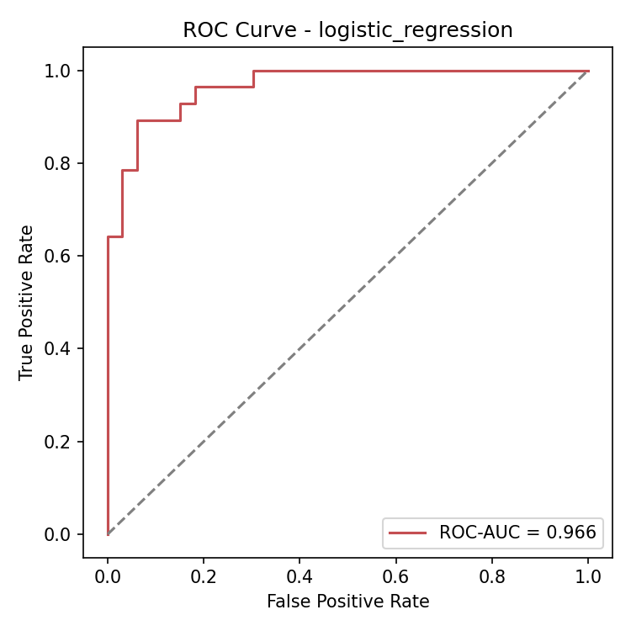
Figure 7. ROC curve — Logistic Regression (selected model).
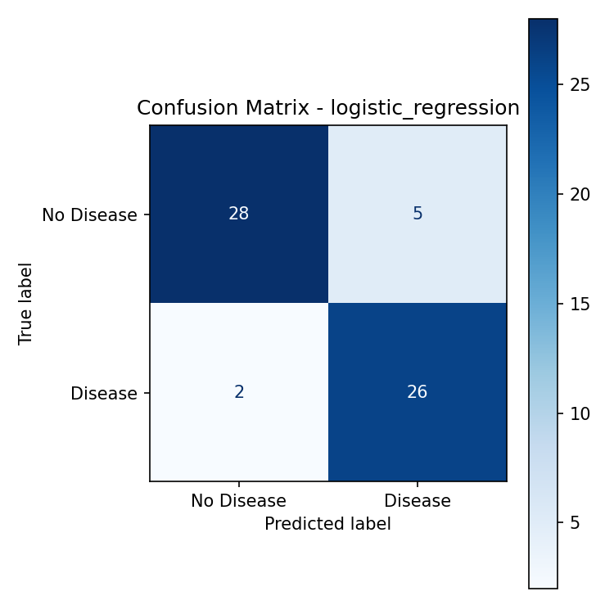
Figure 8. Confusion matrix — Logistic Regression on the test set.

4. Experiment Tracking (MLflow)
MLflow (SQLite-backed tracking store) was integrated to log, for every run: model type, hyperparameters (including the GridSearchCV best_params_), cross-validated and test-set metrics (accuracy, precision, recall, F1, ROC-AUC), confusion matrix and ROC curve plots as artifacts, and the fitted pipeline itself as a versioned model artifact. Runs are organized under the 'heart-disease-classification' experiment and are browsable via `mlflow ui`.
[Insert screenshot of the MLflow UI here: experiment run list, and a run detail page showing logged params/metrics/artifacts.]

5. Model Packaging and Reproducibility
- The full pipeline (preprocessing + classifier) is serialized with joblib as models/best_model.joblib.
- Model metadata (chosen model name, feature column order) is saved alongside as models/model_metadata.joblib.
- requirements.txt pins major dependency version ranges for a reproducible environment.
- Random seeds are fixed throughout (random_state=42) for reproducible data splits and training.
- The same preprocessing pipeline used in training is loaded directly by the serving API — no logic duplication.

6. CI/CD Pipeline
A GitHub Actions workflow (.github/workflows/ci-cd.yaml) automates four stages on every push/PR: (1) Lint — flake8 and black formatting checks; (2) Unit Tests — installs dependencies, downloads the dataset, trains the model, and runs the pytest suite, uploading the trained model and MLflow tracking database as workflow artifacts; (3) Build Docker Image — builds the container image and smoke-tests the /health endpoint; (4) Deploy — a placeholder stage (main branch only) for wiring in real kubectl/cloud deployment credentials. The pipeline fails fast and reports clear logs if linting, tests, or the Docker build fail.
[Insert screenshot of a green GitHub Actions run here, showing all four jobs (lint, unit-tests, build-docker, deploy) passing.]

7. Model Containerization
The FastAPI serving application is packaged into a Docker image (python:3.11-slim base) containing the API code, trained model artifacts, and all dependencies. The container runs as a non-root user and exposes port 8000 with a built-in HEALTHCHECK against GET /health. The /predict endpoint accepts JSON patient records and returns a prediction, human-readable label, and confidence score.
[Insert screenshots here: `docker build` success output, `docker run` output, and a successful curl/Postman call to /predict against the running container.]

8. Production Deployment (Kubernetes)
Kubernetes manifests (k8s/) define a Deployment (2 replicas, readiness/liveness probes against /health, resource requests/limits), a Service (type LoadBalancer, port 80 -> 8000), a ConfigMap for environment configuration, and an optional Ingress. The manifests are portable across Minikube, Docker Desktop Kubernetes, and managed cloud Kubernetes (GKE/EKS/AKS).
[Insert screenshots here: `kubectl get pods` (all Running), `kubectl get svc`, and a successful request against the exposed service endpoint/LoadBalancer IP.]

9. Monitoring and Logging
API request logging is implemented via Python's logging module (console + api_requests.log file), capturing method, path, status code, and latency for every request, plus structured logs of each prediction's input and output. GET /metrics exposes Prometheus-format metrics (request counts, latency histograms, status code breakdown) via prometheus-fastapi-instrumentator; GET /stats exposes simple JSON counters. docker/docker-compose.yml wires up Prometheus (scraping /metrics) and Grafana for dashboarding, enabling detection of model/API failures, latency regressions, and traffic anomalies in production.
[Insert screenshot here: Grafana dashboard or Prometheus target/graph page showing live metrics from the API.]

10. Conclusion
This project demonstrates a complete, reproducible MLOps workflow: from raw clinical data to a monitored, containerized, Kubernetes-deployable prediction API. The selected Logistic Regression model achieves strong discriminative performance (ROC-AUC 0.966) while remaining simple and interpretable — an appropriate trade-off for a clinical decision-support context. Future improvements could include model registry promotion workflows in MLflow, automated data drift detection, canary/blue-green deployment strategies, and a richer Grafana dashboard with alerting rules.

Repository
GitHub repository: [insert your repository URL here]
Deployed API URL / access instructions: [insert public URL, or local access instructions, here]

