Assignment/exercise 2: PHP/DB System

Michał Pawlicki

[Cph-mp394@cphbusiness.dk](mailto:Cph-mp394@cphbusiness.dk)

Solution: <http://projects.michaeldesign.pl/flashcardsreborn/>

Source on GitHub: <https://github.com/magicmychal/flashcardsreborn>

# Project description

## Using CRUD

CRUD – create, read, update, delete. Those were 4 main features that had to be implemented in this project. The idea behind the webpage was to make the web version of existing mobile application – Flashcards. The functionality includes managing categories and flashcards.

Let’s start with the entrance - login and registering a new user.

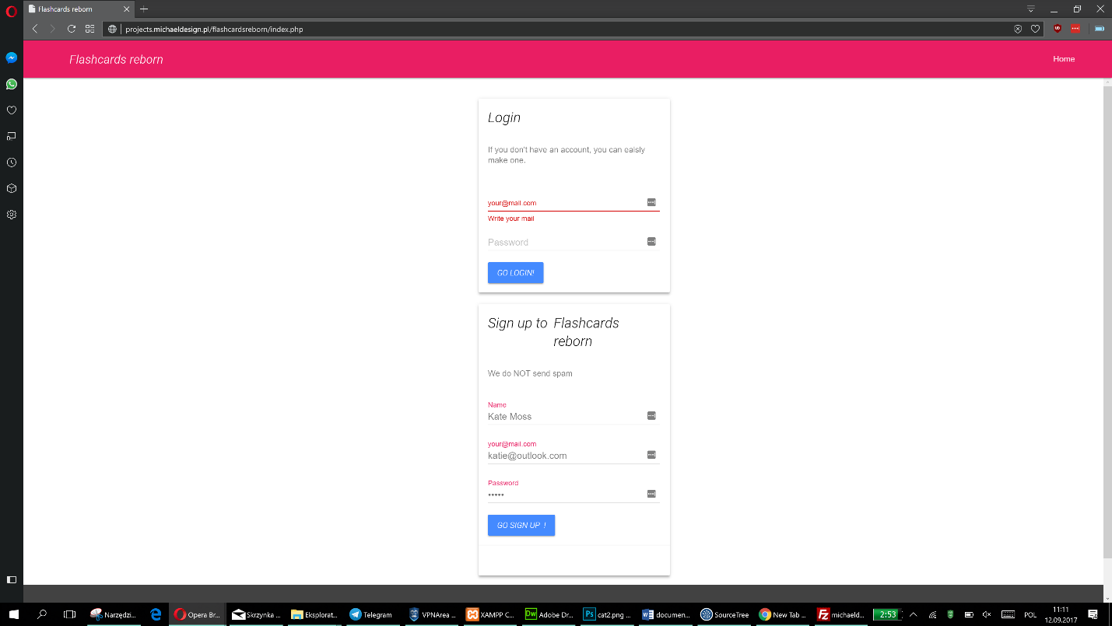

- the main screen

That’s the first example of ‘CR’ – create and read. What’s interesting here is that both login and signing up are wrapped in a function and are stored in the separate file (login.php) and also that allows to call a function in the places where the alert text (for eg. ‘incorrect login’) should appear.

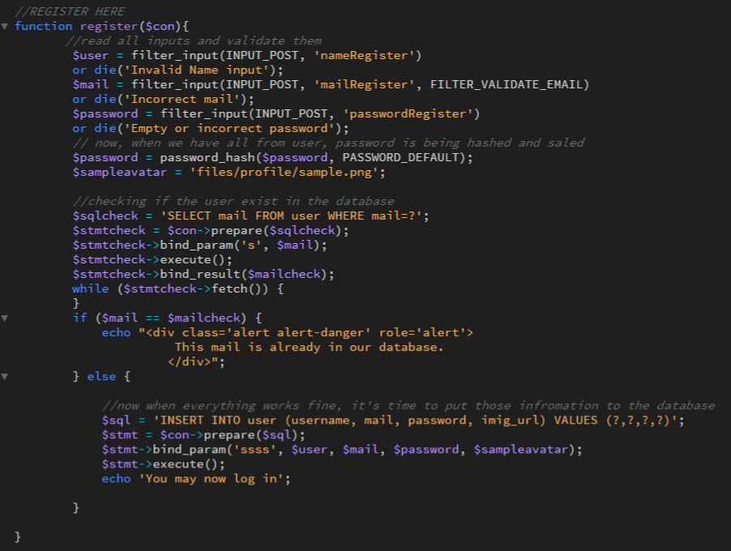

2 - singing up function; available in login.php

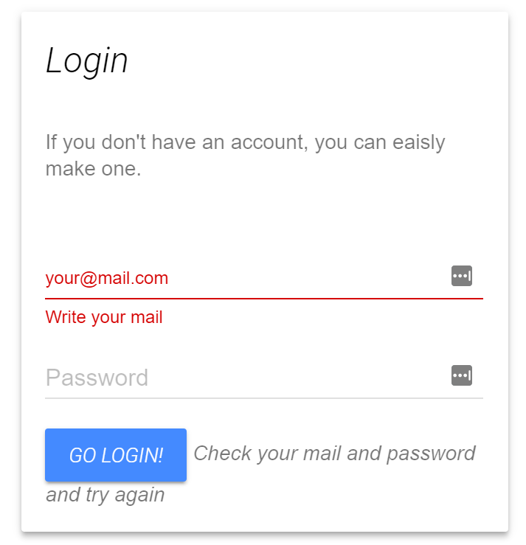

3 - 'Check your email and password and try again' alert after incorrect login

When the user creates a new account, it is automatically associate with a sample profile picture, so after login user is able to see a background image on the left side

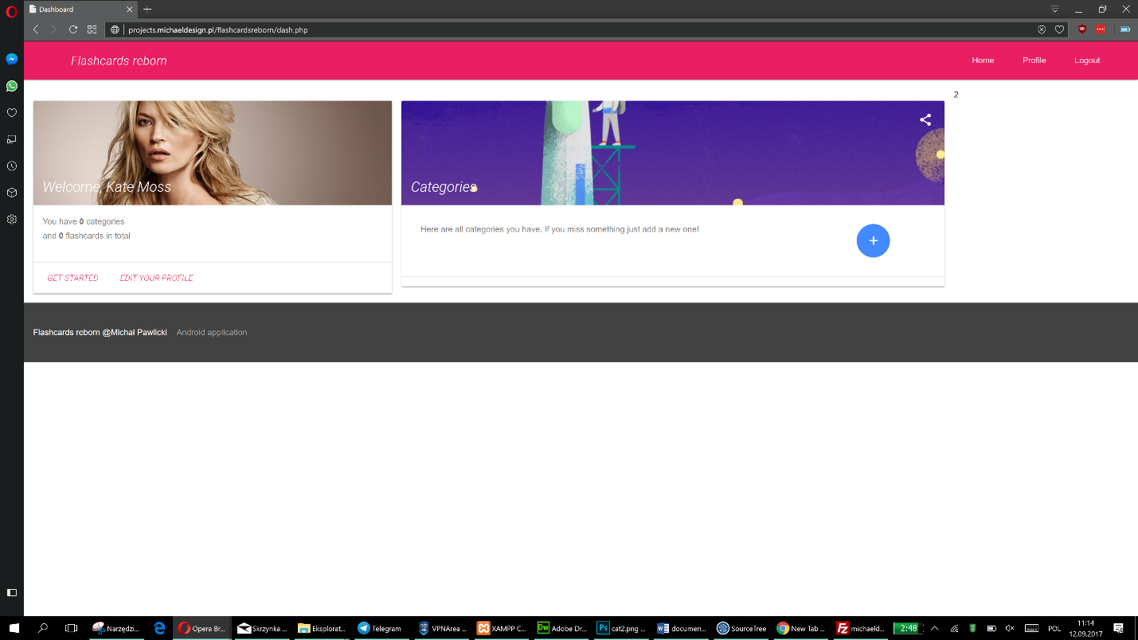

- custom profile picture on the left

As it can be seen on the screenshot above, there are two cards, on the left, there’s a one with profile information and it also display ‘statistics’ for the user.

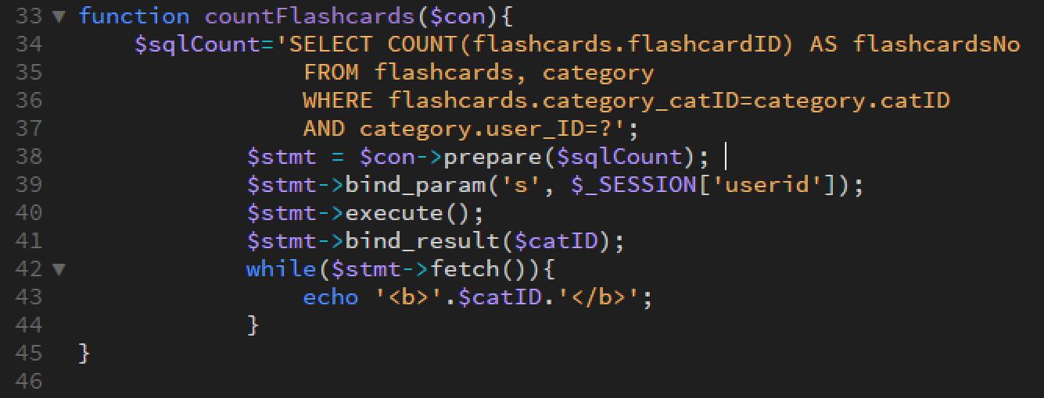

From that point, there’s a possibility to go to the page where the profile can be managed or display/add a new category.

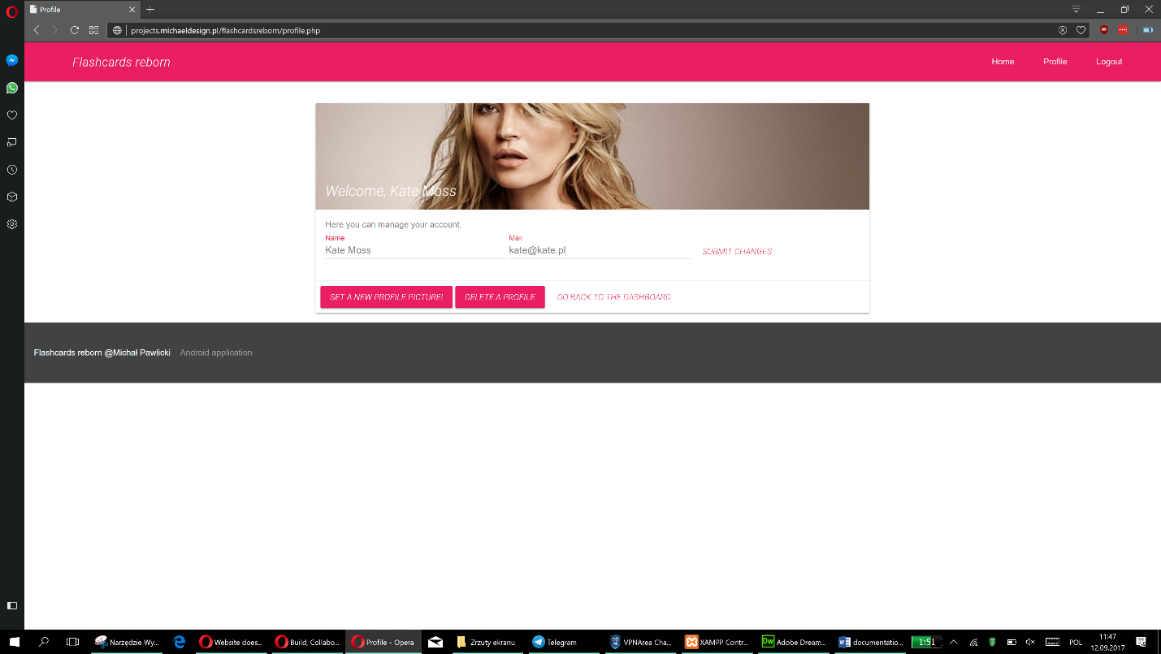

5 - managing profile

Focusing for a bit on managing an account. This is an example of ‘U’ – update. The user can change their name and mail whereas new mail is also going through checking if it’s in the database since that’s an ID that user uses to login. From that point, it is also to upload a new picture. The old one is going to stay on the server. Multiple users can upload the same file.

That page is also an example of ‘D’ – delete. The user can delete their account at that point, but before that there’s a confirmation alert.

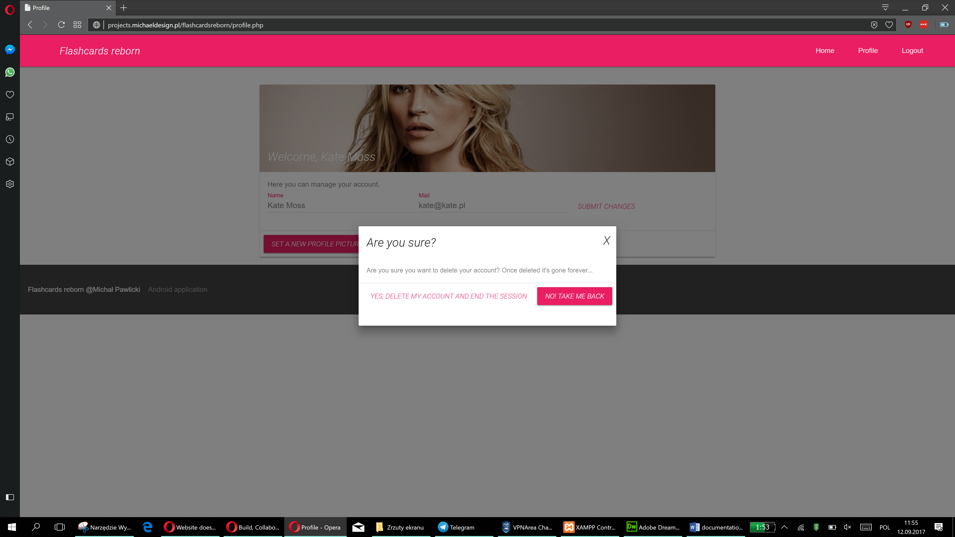

6 - confirmation before deleting an account

After deleting an account, the session is also ended, so there’s no way to make any operation on the deleted account. Unfortunately, profile picture stays on the server.

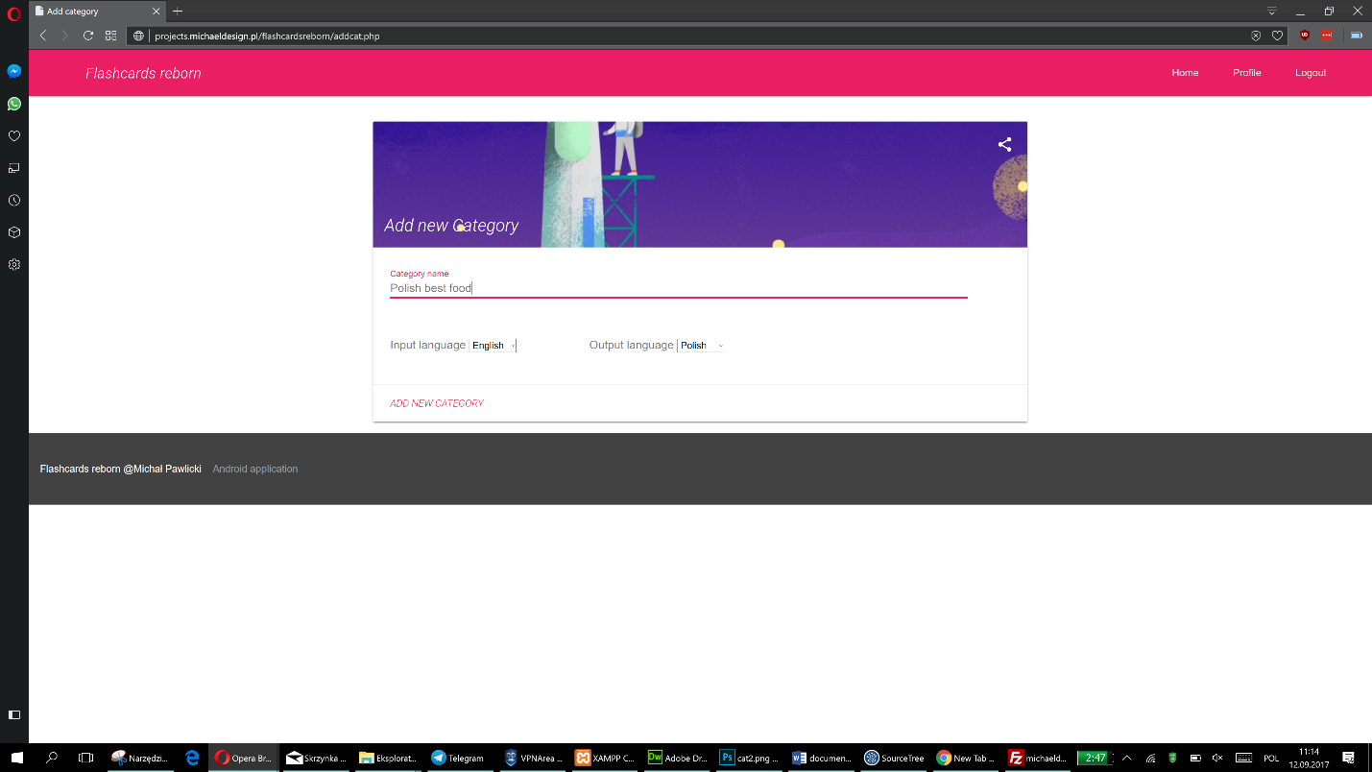

7 - screen of adding a new category

Going back to the main screen, there’s an option to add a new category. Here There’s also a select statement to draw the list of languages available in the database

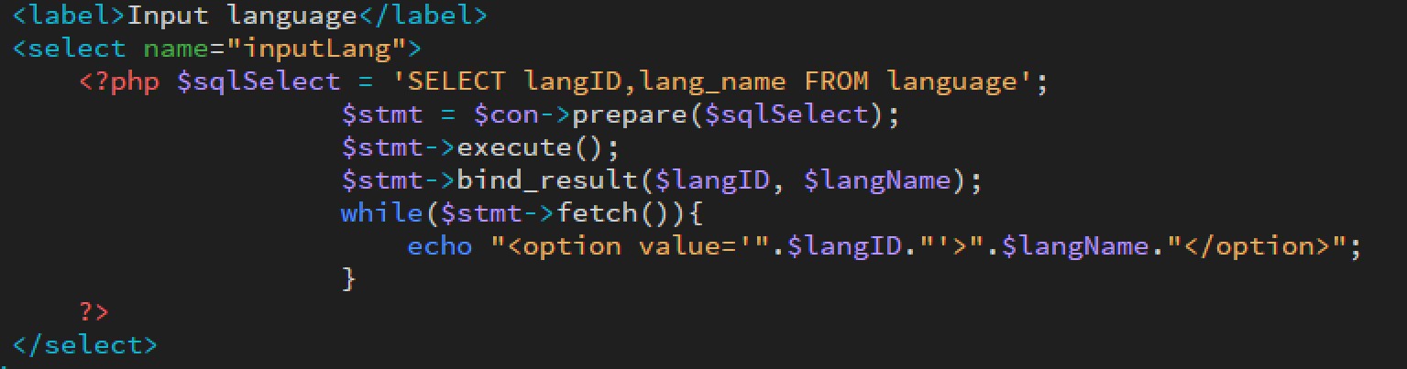

Being inside category, there’s an option to add a new flashcard.

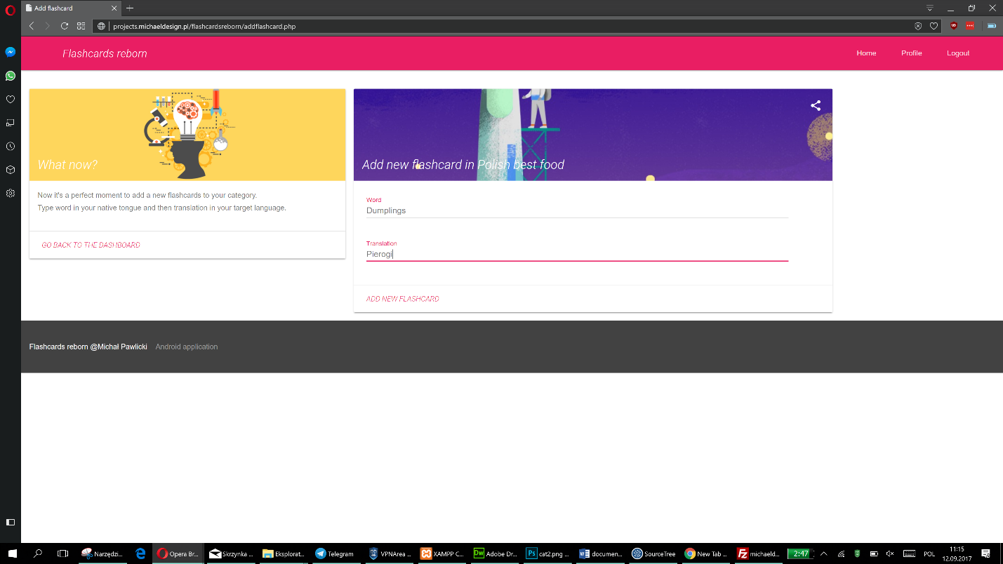

8 - tips for users on the left, adding a new flashcard on the right

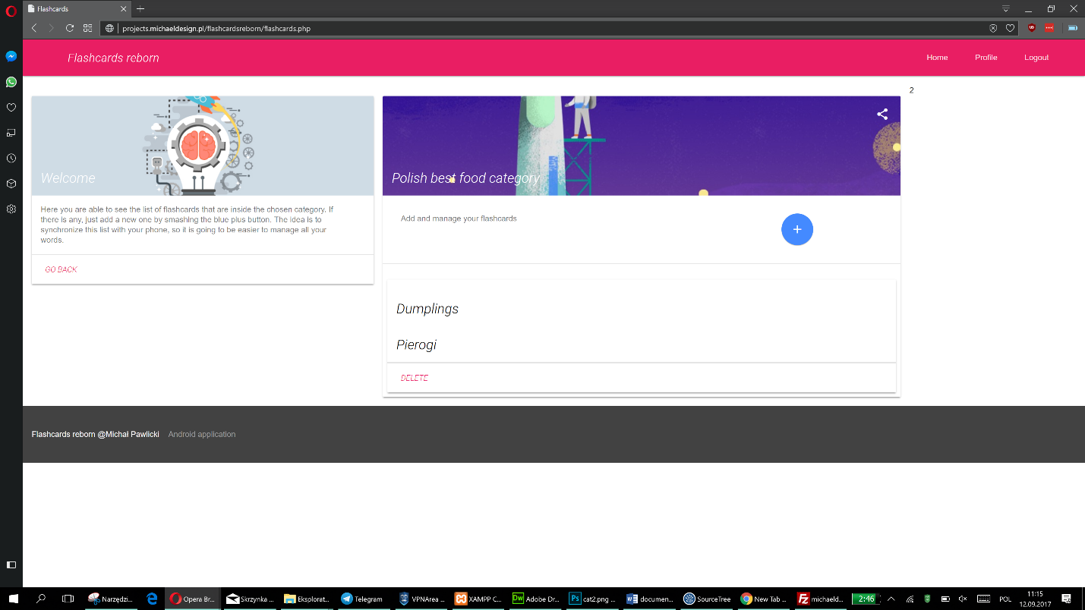

9 - sample list of flashcards inside category and possibility to delete them

Delete is also used when managing the flashcard, the user is able to delete the specific flashcard. The upside is that it has to be done by double-clicking because the webpage has to be refreshed and it cannot be by using ‘header’ due to the fact that on every single page there’s already at the very beginning implemented header to check if the user is logged in.

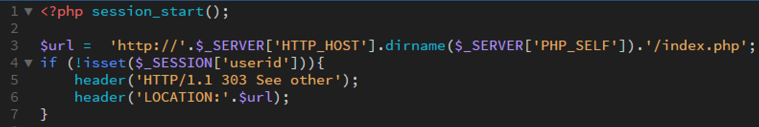

10 - session starts at the very beginning and checks if someone is logged in

## Using session

The session starts whenever user access one of the pages. When they log in 4 sessions variables are created, as listed down below.

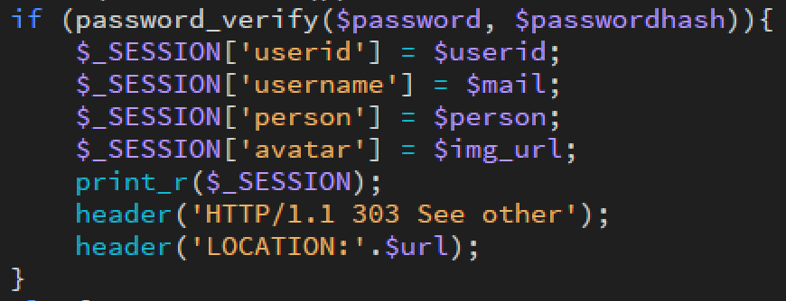

11 - after passwords are veryfied, session variables are created

‘person’ is a name, that’s displayed in the dashboard as ‘Welcome, person’. ‘avatar’ is the background of the same card as the name is displayed. ‘userid’ is used in multiple subpages to select correct information.

## Technical issues

During this project, I met several problems in the process of making. Most of them were caused by my misunderstanding how the PHP code works. Thankfully now I’m aware of what I’m doing and that will help in future projects.

Other problems were mostly connected to the framework that was used in this project, which is MDL (Material Design Light). For instance – sometimes placeholders of inputs don’t hide automatically when the user tries to type (issue #7).

The project underwent a testing phase right and it has some open issues that are visible on my GitHub account.

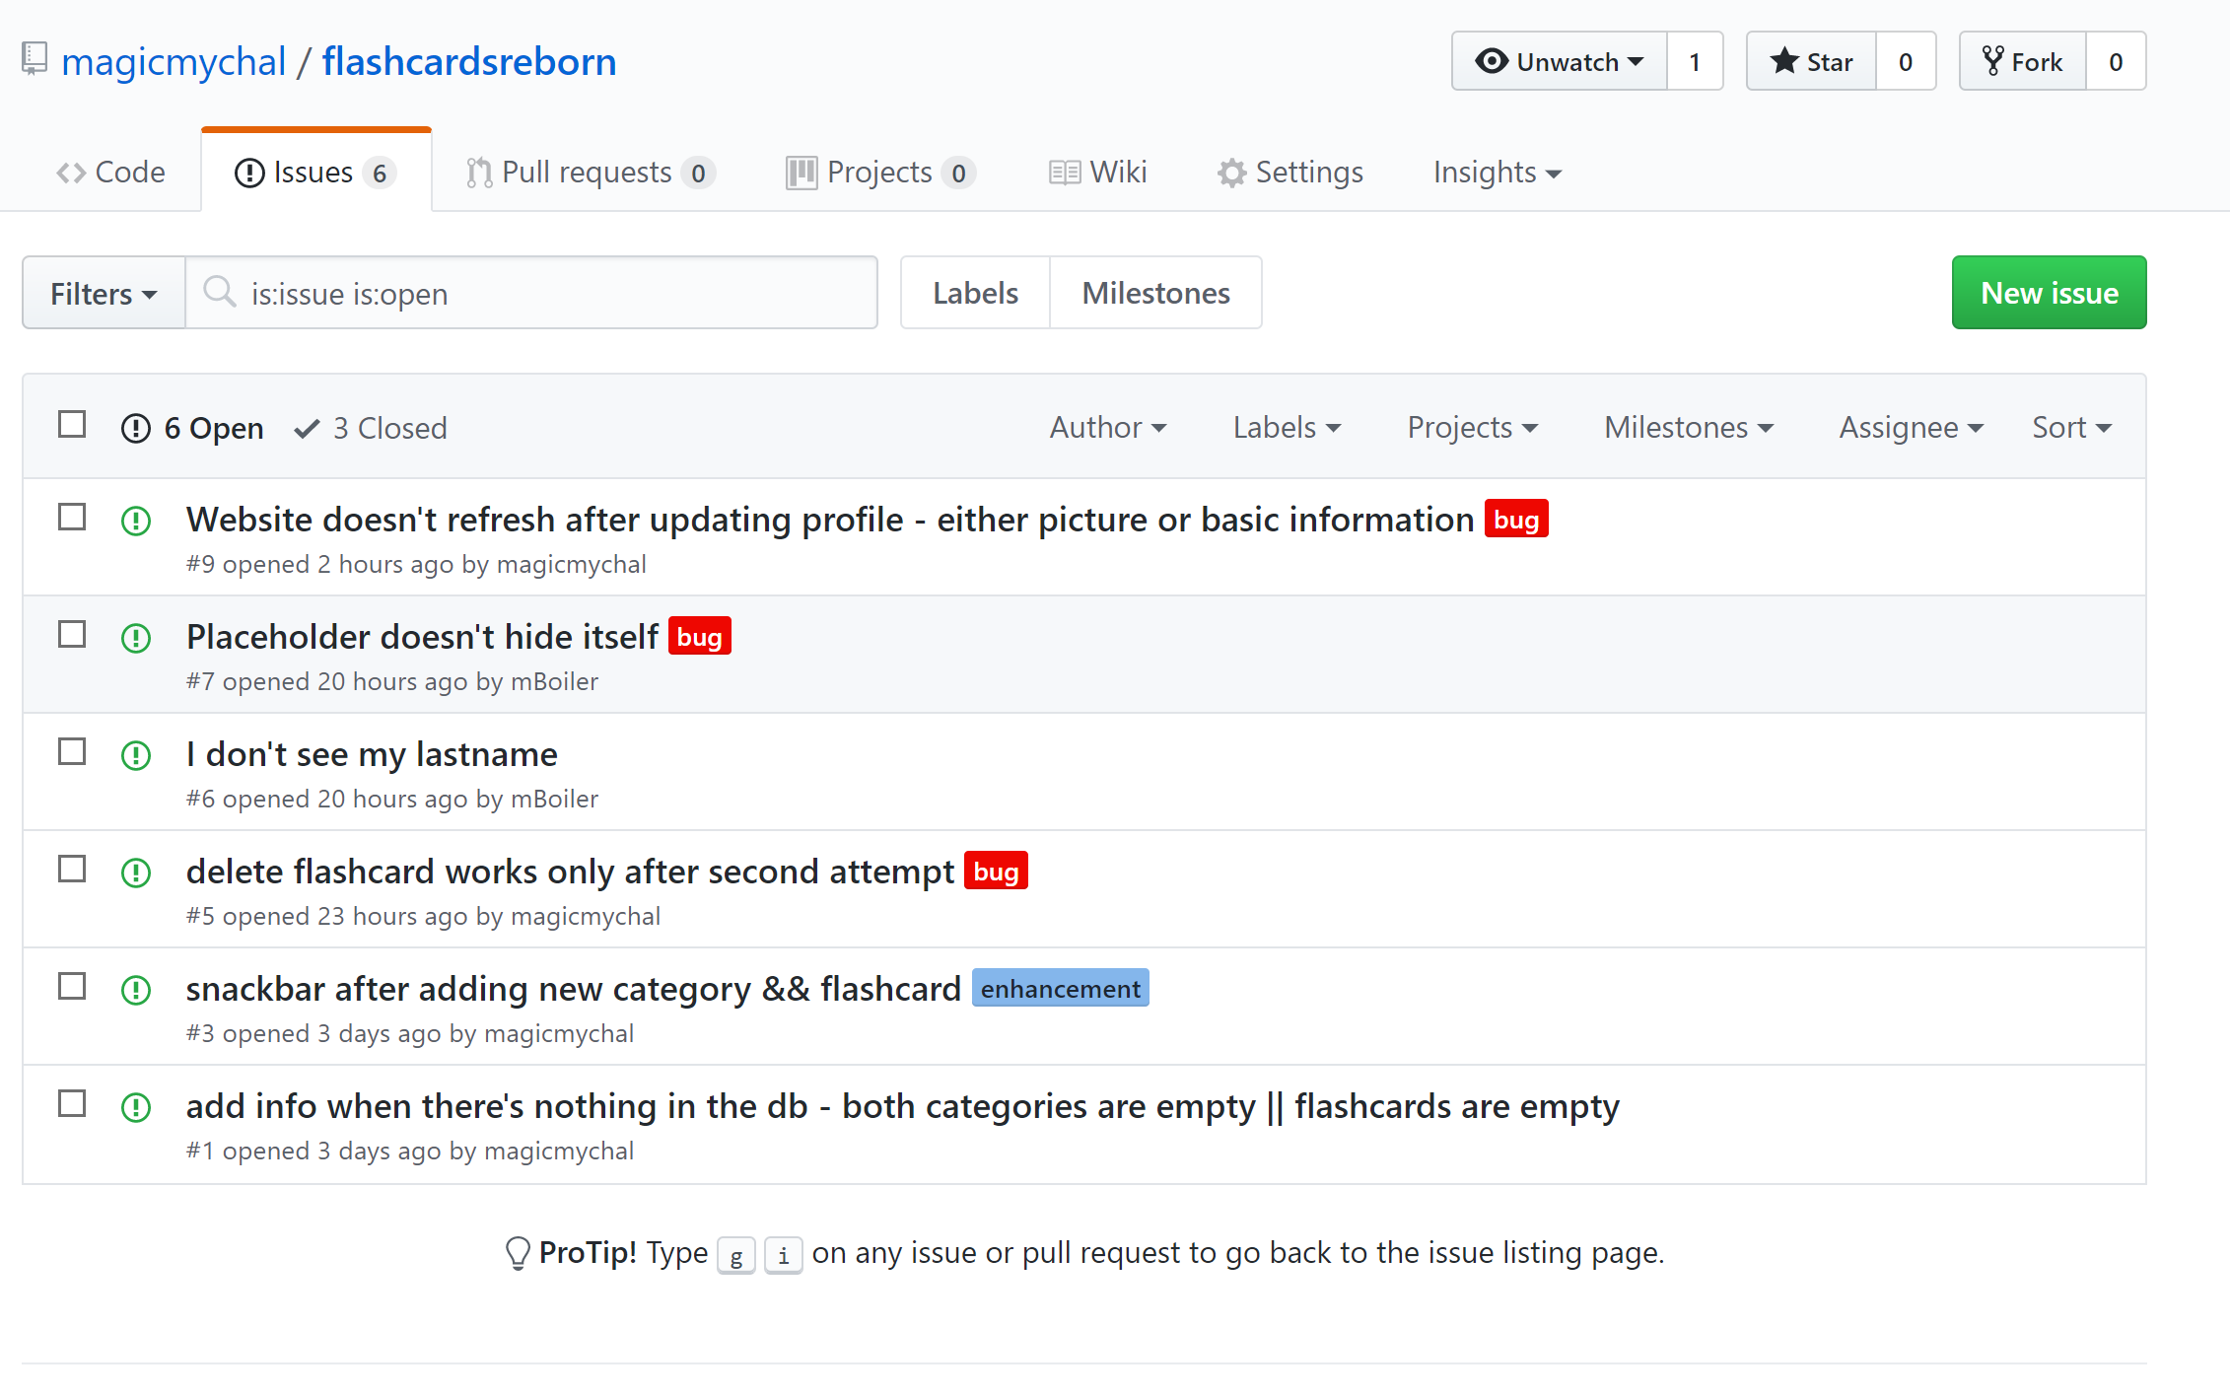

12 - open issues on GitHub