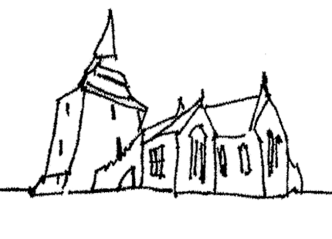

st mary’s church, kington
Registered charity number 1185453

St. Mary's P.C.C. Meeting held in the Parish Hall on Tuesday November 3rd. 2026

Present: Sally Welch, Christine Robinson, Ann Edwards, , Margaret Pengelley, Julia Reid, Penny Halcrow, Margaret Cooke, Nick Cooke, Philip Sell, Debbie Sell, Greg Wright, and Rob McCurrach
Sally welcomed the members of the PCC and opened the meeting with a prayer.
Apologies: Bev Fensome, Eileen Thomas, Stephen Lacey, Elizabeth Banks and Phillipa Wright

- Minutes of Last Meeting: | The minutes of the last meeting were taken as read and signed | Action
- Matters Arising: | The microphone for the parish Hall – It is felt that this is no longer needed
- Notification of matters to be raised under any other business | Eileen and Priscilla (PH)  Christmas Trees (MC)  Charity Shop (DS
- Safeguarding Report:  - Vicar’s Report  - Curates Report  - (PW)  - Churchwarden’s Report MC and GW  - Finance Report GW  - Other Reports | Safeguarding is currently up to date, but some items will be due to be updated in the next few months.  Safeguarding training is mandatory for all PCC member and members cannot stand again for the PCC if they have not completed their training.  It was agreed there should be in person training and Christine will approach the diocese for this.  - The Dove has had a soft launch with the meeting of the music group today. Sally has completed her food hygiene and allergies training and there is a need for others to do this. Please contact Sally or Christine if you are prepared to do this.  - It is proposed to have a permissive footpath along the south side of the church. This will include an alteration to the signposting for the Offa’s Dyke footpath. In order to keep it permissive the path will need to be shut for one day of the year. It was proposed that this should be on Christmas Eve, but there will still be access to the church. Proposed by P Sell. Seconded by D Sell. All present were in favour. SW will respond to the footpath’s officer Kevin Robinson  - Handrail in the church to assist people going up to the altar. In order for a handrail to be installed a faculty will be necessary. Margaret Pengelly offered to pay for the handrail. The members of the PCC offered they’re thanks to Margaret. NC offered to start the faculty process  The report had been circulated.  - The tiles in the church should be cleaned later this month.  - The cherry picker should come in November to examine the damaged part of the ceiling.  - Th Bonus Ball will not be going ahead for the time being.  - £1000 from the proceeds of the Huntingdon Chase has ben donated to St Mary’s and will go towards the expenses of Dove. Greg has sent a message of thanks to the organisers of the Chase.  - Music Report (P.S) see report.  - Parish Hall report (P.H.) see report.  - Children’s activities S.L. no report  - Social Committee M.C. nothing to report.  - Events Committee (CR) see music report. The events committee is meeting next week.  - Health and Safety and First Aid (J.R.) The health and Safety policy has been completed and will be made available to PCC members and placed on the website | CR  CR/SW  SW  NC  CR and GW
A.O.B.: | Eileen  a) Eileen There will be discussions with Eilleen’s family as to how Eileen’s years of service can be recognised. This will depend on what Eileen’s future plans are. (SW)  Priscilla  b) After many years Priscilla Scott has given up flower arranging. PH will arrange for a thank you card to be signed.  Christmas Trees  c)Elizabeth was kindly going to check with Richard Jones about the provision of a tree for the memory service and other trees. MC will follow up the offer of a free tree from Edward Maygothling  Charity shop  d} Charity Shop (D.S.) Phillip will provide a sign-up sheet for the forthcoming St Mary’s week at the Community Shop. Debbie and Philip are asking for additional help this year as they will be away.  The Vision Day  d) The Vision Day will be held at the Parish Hall on Saturday 14th November from 10am. CR will recirculate d the preparatory material as some members had not received it | SW  PH  EB  MC  P.S  CR
Meeting ended at: 8.0pm with the Grace
Date of next PCC meeting: Tuesday 1st December 7.00-9.00pm (latest)
At The Parish Hall at St Mary’s, Kington.

