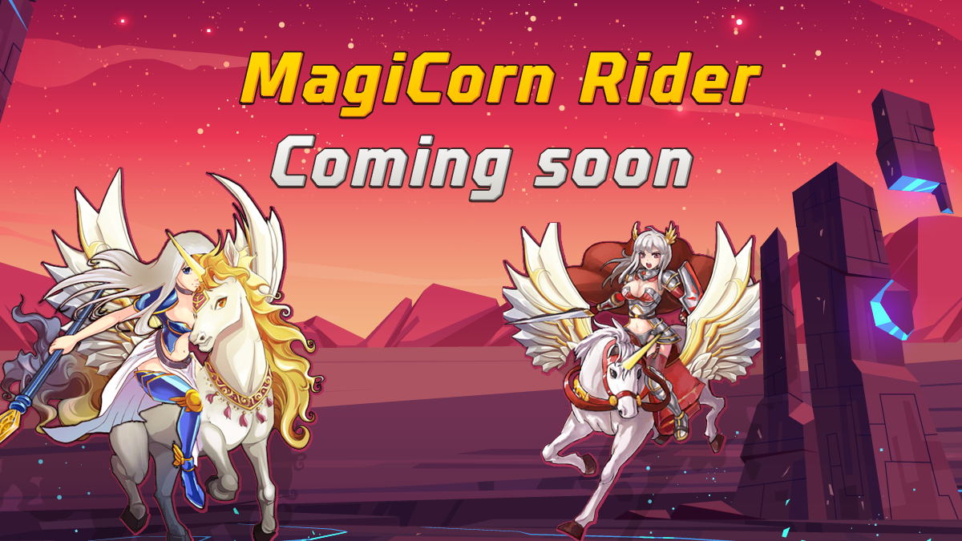

Magicorn Raider
P2E Game For Everyone Everywhere
Game: In game player traveling various places like, space, an old castle, a barren field, a haunted house with our Magicorn. There will be initially 3-4 level in Magicorn Raider

Advantages: Users can play on PC using VR accessories. Near future, we have plan to publish it on Meta Store & PlayStation Store also. Magicorn Raiders has much opportunities to add as many characters as we can as well as many environment, like underwater, desert, mountain etc. We made it for continuous development segment basis.
[ Below some characters models ]



Gamefication: Before make travel, an user need to buy RIDER, ARMS & Extra power or energy. And those buying will be done using #MANU token. At the time of traveling users collect COINS/POINTS through its journey. By using those COINS/POINTS, users can upgrade/buy more elements from in-game shop. Every transactions needs users wallet sign.
After collecting those COINS/POINTS, users can convert those to #MANU or any STABLE Coin or can keep in-game wallet.

[ Mountain nvironment -1 ]


[ Mountain environment -2 ]

Portability: It can be played/installed directly from linux PPA, MacOS AppStore & Windows App Store.

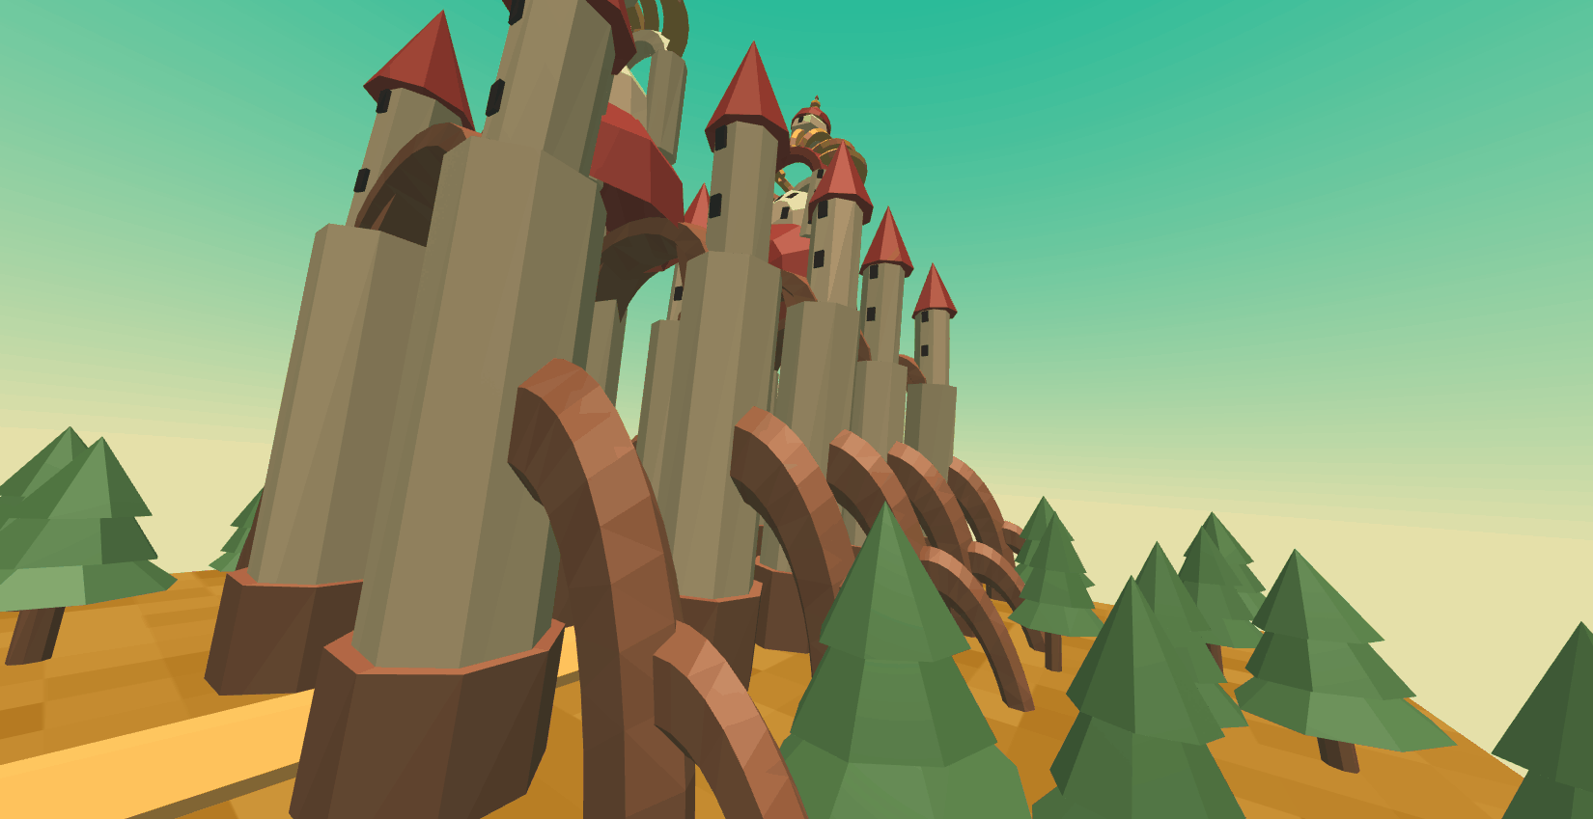
[ Old castle environment ]

Framework: For game we are using Unity SDK and for VR usability, using WebVR engine. Unity SDK helps to bring Magicorn Rider ship/publish any platform. For web version we are using ReactJS and desktop version we are using Electron. Future we will use QT. [ Qt is cross-platform software for creating graphical user interfaces as well as cross-platform applications that run on various software and hardware platforms such as Linux, Windows, macOS, Android, iOS and many others. ]

Security: Magicorn Rider is an open source game which using MAGIC Protocol [ Fork of "web3-unity-sdk" ] for any internal or external transaction execution. MP [ Magic Protocol ] using EVM based blockchains, like Ethereum, Binance Smart Chain, Polygon, Avalanche. All the blockchains are global community proven highly secure. So we can assure our community, by using MP, Magicorn Rider will be one of the best secure game for P2E.

Development: We have already developed core framework like, environments, motion objects, reward algorithm and many others utility stuff.

Publish: First Beta version will be released 20th October, 2022


Right Reserved By MAGICORN.IO | 2021-2022

