Resource Management System

Software Requirements Specification
Version 1.0

Danang, Jan 2015

TABLE OF CONTENTS
TABLE OF CONTENTS 2
1. DOCUMENT HISTORY 4
2. REFERENCE DOCUMENTS 4
3. DISTRIBUTION LIST AND APPROVALS 5
4. GLOSSARY OF TERMS 5
5. INTRODUCTION 5
5.1 Purpose 5
5.2 In Scope 5
5.3 Assumptions 6
6. OVERVIEW 7
6.1 Actors 7
6.2 System Use Case Diagram 7
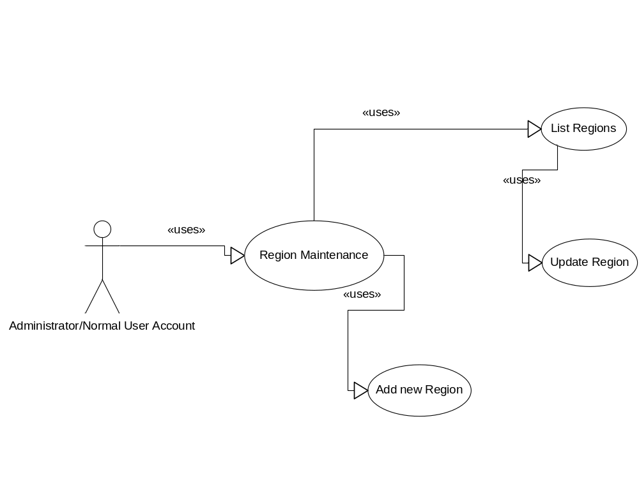 12
6.3 System Pages Flow 15
7. Functional Description 16
7.1 Login: 16
User Account ID and Password must be active directory authenticated. 16
When executing login, the system needs to validate user account to check if it is existing in the JAVA01Resource Management System or not (user account is stored in User Account Maintenance and assigned role). If yes, then the application will lead user to default screen of JAVA01Resource Management System: View Active Project/Contract Schedule. 16
7.2 Airlines Information Maintenance 16
7.3 Vendor Resources Maintenance 22

8. NON-FUNCTIONAL REQUIREMENTS AND OTHERS 123
Performance 123
Scalability 123
Security 123
Infrastructure 123
Browser 123
Reliability 123
Purchased Components 123
Interfaces 123
Extensibility 124
Assumptions 124
9. APPENDIX 124
JAVA01JAVA01

DOCUMENT HISTORY
Date | Summary of Changes | Version

REFERENCE DOCUMENTS
Document Name | Description

DISTRIBUTION LIST AND APPROVALS
This document is distributed to the following stakeholders to get their valuable comments and corrections.
Name | Title

INTRODUCTION

Purpose
- Giới thiệu mục đích của hệ thống...

In Scope
- Phạm vi công việc của dự án...

OVERVIEW

Actors
The below diagram describes all actors of the JAVA01Resource Management System. An actor represents a User Role; currently we have Administrator and Normal User Account. Each user has his own actions when accessing into the system, base on his rights. Administrator and Normal User Account have the rights to add new, update and delete records in all features; except User Accounts Maintenance and Housekeeping Modules, only Administrator can access.
Actor | Description
Administrator | Has the right to View, Add new, Update and Delete data in all modules.
Normal User Account | Has the right to View, Add new, Update and Delete data in all modules, except User Accounts Maintenance and Housekeeping Modules.

System Use Case Diagram
The following diagram provides an overall picture of the functionality groups, Actors of the JAVA01Resource Management System. JAVA01Resource Management System’s functionalities are divided into these use cases:
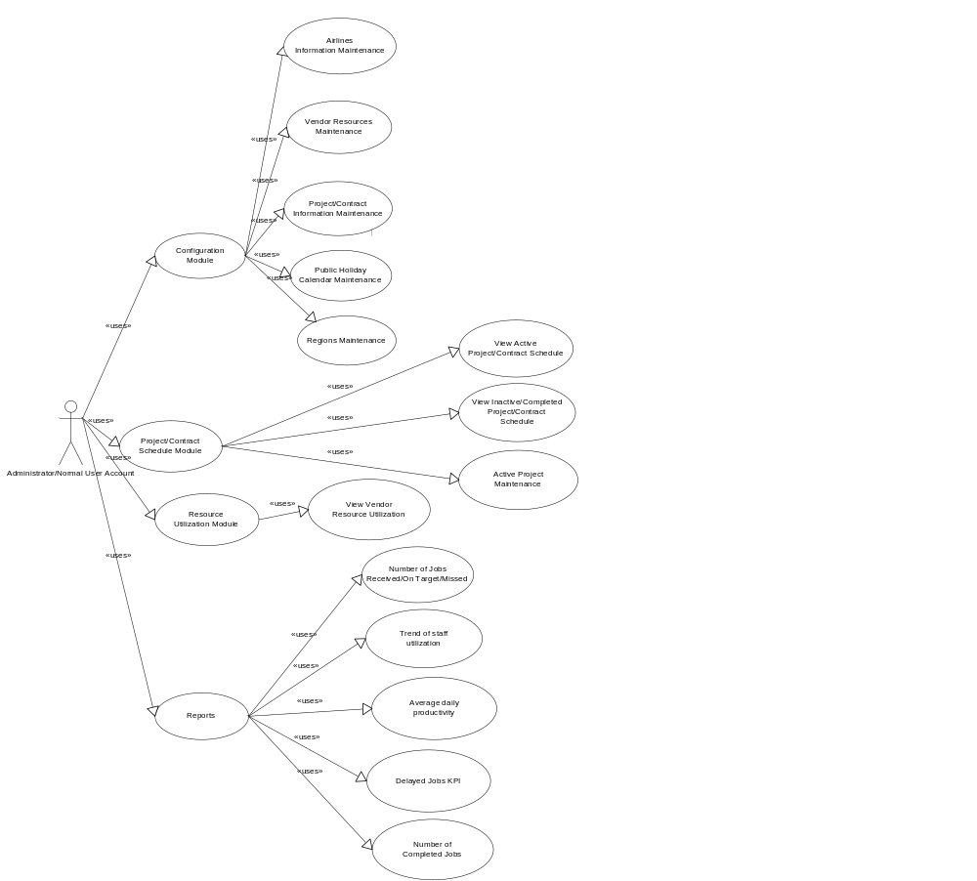

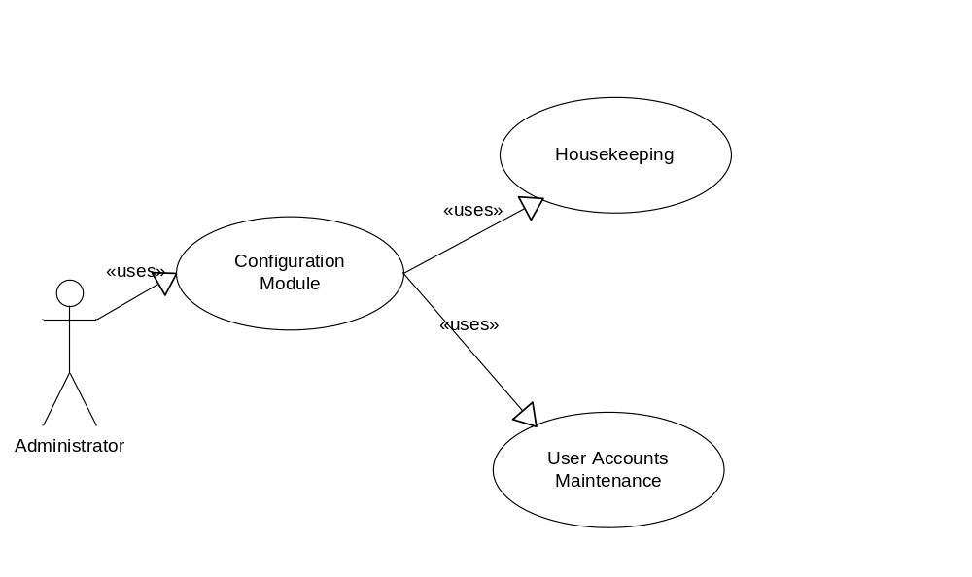

Airlines Information Maintenance - Use Case Diagram
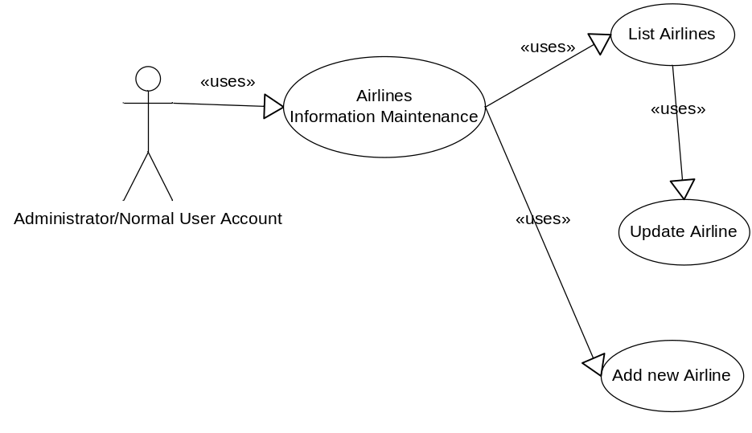

Vendor Resources Maintenance - Use Case Diagram

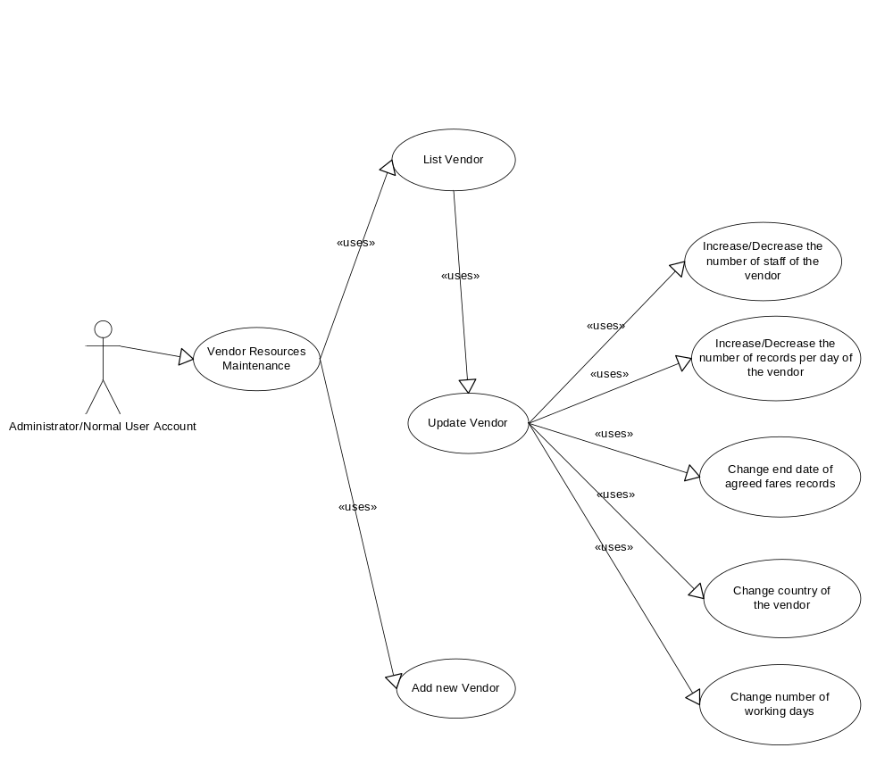

System Pages Flow
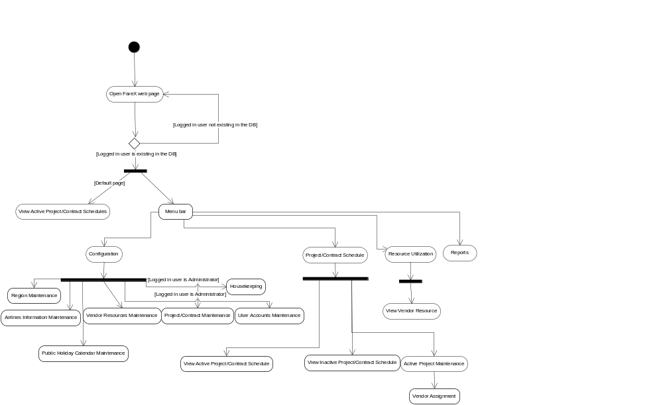

Functional Description

Login:
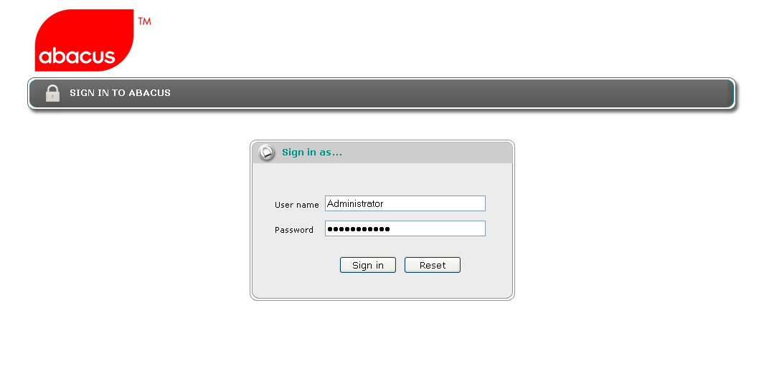

User Account ID and Password must be active directory authenticated.
The system needs to provide a login page for user to enter user id and password. System needs to validate the user id and password against Customer active directory server. Two active directory servers host name will be provided; one is primary server and the other, secondary server. The system needs to authenticate using the primary server first. If it fails due to primary server unavailability, the system will authenticate using the secondary server.
If the account can’t be found in any server, then the system throws an error message:
“Invalid user name. Please re-enter.Customer”

When executing login, the system needs to validate user account to check if it is existing in the JAVA01Resource Management System or not (user account is stored in User Account Maintenance and assigned role). If yes, then the application will lead user to default screen of JAVA01Resource Management System: View Active Project/Contract Schedule.
If not, then the application throws an error message:
“You are not authorised to use this application. Please contact the application administrator.”

Airlines Information Maintenance
Use Case Name | Airlines Information Maintenance
Use Case ID | JAVA01002
High Level Requirement Ref | All general airlines information is queried from the DB and displayed on the screen. All Administrators and Normal User Accounts can view list of airlines, add new airlines information and update existing records.
Actor | Administrator, Normal User Account.
Description | This use case allows users to view/add new/edit airline.
Trigger | NA
Pre-condition | User has already successfully logged onto the system.
Post-processing

Screen Design

Airlines Information Maintenance - Filter
Screen | Airlines Information Maintenance – Filter
Description |  | Display query screen to filter displayed results. “All” value is set by default; the system displays all airlines information from the DB, on the screen. Then users can choose to display any airline information, by choosing value in dropdown lists of Airline Name.
Screen Access |  | Users click on menu Configuration -> Airlines Information Maintenance
Screen Content
Item |  | Type | Data | Description
Airline Name |  | Dropdown list - Alpha numeric (5) | Default: All  Lookup from AIRLINE.NAME - AIRLINE.CODE, ordered by AIRLINE.NAME | - Display both name and code but name first, value is code.  - User can type for searching, for example: user can type ‘S’ in the dropdown list and the system will show all airlines that started by ‘S’.
Screen Actions
Action Name |  | Description |  | Success | Failure
Filter |  | List of all airlines will be ordered by AIRLINE.NAME.  When users choose any value in the above dropdown list and click Filter button then the system returns data of that airline. |  | Display general data of inputted Airline code (data is selected from table AIRLINE). | Displays message “No data found.” in the Message Area.

Airlines Information Maintenance - List

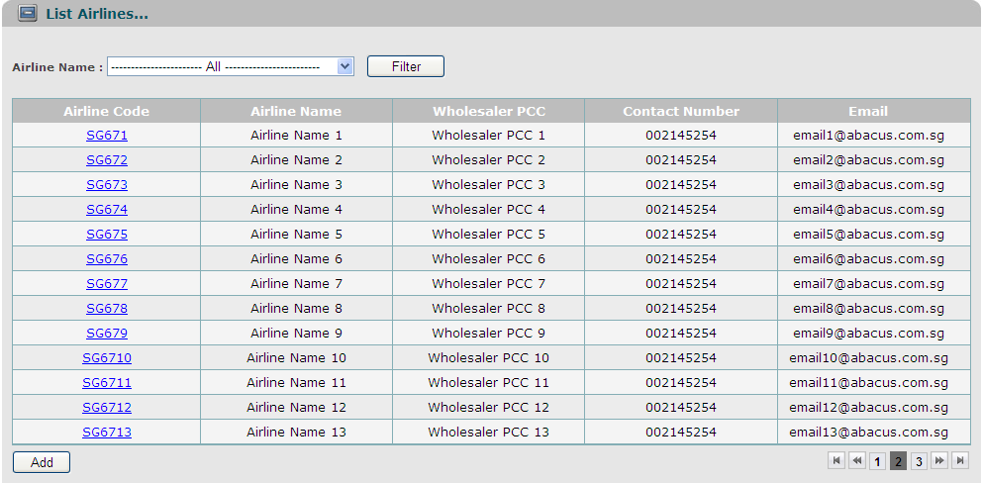
Screen | Airlines Information Maintenance – List
Description |  | Display all airlines information, base on Airline Code.
Screen Access |  | Users click on menu Configuration -> Airlines Information Maintenance
Screen Content
Item |  | Type | Data |  | Description
Airline Code |  | Link - Alpha numeric (5) | Lookup from AIRLINE.CODE |  | For users that are Administrators or Normal User Accounts, then airline code will be displayed as links, allow users to click on them, and go to “Update” screen.
Airline Name |  | Label - String (45) | Lookup from AIRLINE.NAME
Wholesaler PCC |  | Label - Alpha numeric (5) | Lookup from AIRLINE.AGENT_CODE
Contact Number |  | Label - Number (15) | Lookup from AIRLINE.CONTACT_NUMBER |  | Phone number of the airline.
Email |  | Label - String (50) | Lookup from AIRLINE.EMAIL |  | Email of the airline.
Add |  | Button |  |  | For users that are Administrators or Normal User Account, then this button will be displayed, allow users to click on, and go to “Add” screen.
Screen Actions
Action Name |  | Description |  | Success |  | Failure
Update |  | - If the user logged in is Administrator or Normal User Account, then airline codes are displayed as links.  - The user clicks on the link, then the system leads the user to “Update” screen. |  | “Update” screen is displayed.
Add |  | - This button is only displayed if logged in user is Administrator or Normal User Account. |  | “Add” screen is opened.

Airlines Information Maintenance – Update
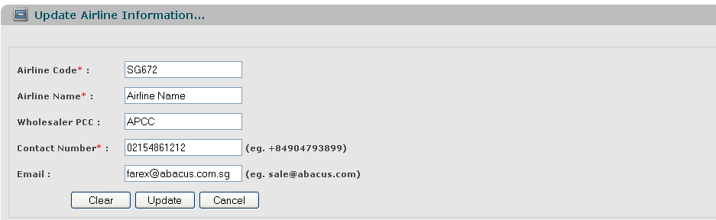
Screen | Airlines Information Maintenance – Update.
Description |  | Allow Administrator and Normal User Account to update existing records.
Screen Access |  | Users click on the links of Airline Code.
Screen Content
Item |  | Type | Data |  | Description
Airline Code |  | Text field - Alpha numeric (5) | Default data is looked up from previous screen.  After changed, will be updated into AIRLINE.CODE |  | This field is mandatory.  A sequence number that auto generated by database will be used as foreign key to join primary table and reference table.  So that, when we update value of any item in the main table, then that value can be referenced by other tables using foreign key.
Airline Name |  | Text field -String (45) | Default data is looked up from previous screen.  After changed, will be updated into AIRLINE.NAME |  | This field is mandatory.
Wholesaler PCC |  | Text field - Alpha numeric (5) | Default data is looked up from previous screen.  After changed, will be updated into AIRLINE.AGENT_CODE
Contact Number (Eg. +84904793899) |  | Text field - Number (15) | Default data is looked up from previous screen.  After changed, will be updated into AIRLINE.CONTACT_NUMBER |  | This field is mandatory.
Email (Eg. chittp@fsoft.com.vn) |  | Text field - String (50) | Default data is looked up from previous screen.  After changed, will be updated into AIRLINE.EMAIL
Clear |  | Button |  |  | Clear all inputted data.
Update |  | Button |  |  | Submit data.
Cancel |  | Button |  |  | Cancel update.
Screen Actions
Action Name |  | Description |  | Success | Failure
Update |  | Updated data will be saved into the DB. |  | Back to the “List” screen with updated record on the list.  If the user chooses to update an airline from the list of all airlines, then when go back to the list from update, the updated record will be focused on. | Display message “The selected record has been removed by someone.”  Display message “The selected record has been changed by another user! Please refresh to get the latest data for your update.”  Display message: “Database connection error.”  Display message:  “Airline Code must be entered.”  Display message:  “Airline Code must be in the format of alpha numeric”.  Display message “The airline code exists in the system. Please enter a new airline code.”  Display message:  “Airline Name must be entered.”  Display message:  “Wholesaler PCC must be in the format of alpha numeric”.  Display message:  “Contact Number must be entered.”  Display message:  “Contact Number must be a number and in the format of: +650123456.”  Display message:  “Email must be in the format of abc@def.com.”
Clear |  | Clear inputted data and reset to the previous data. |  | Display “Update” screen with the previous data.
Cancel |  | Close “Update” screen and return to the list. |  | Return to the “List” screen (previous list before going to “Update” screen).

Airlines Information Maintenance – Add

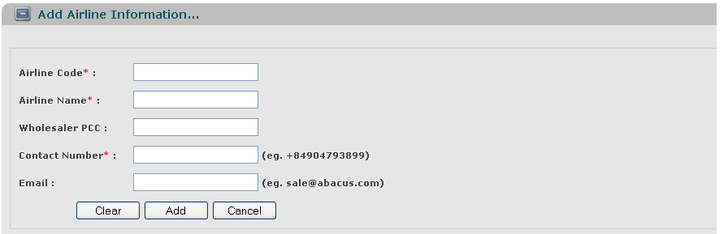
Screen | Airlines Information Maintenance – Add
Description |  | Allow Administrator and Normal User Account to add new airlines.
Screen Access |  | Users click on the button Add.
Screen Content
Item |  | Type | Data |  | Description
Airline Code |  | Text field – Alpha numeric (5) | Inserted into AIRLINE.CODE |  | This field is mandatory.
Airline Name |  | Text field – String (45) | Inserted into AIRLINE.NAME |  | This field is mandatory.
Wholesaler PCC |  | Text field – Alpha numeric (5) | After being inputted, inserted into AIRLINE.AGENT_CODE
Contact Number (Eg. +84904793899) |  | Text field – Number (15) | Inserted into AIRLINE.CONTACT_NUMBER |  | This field is mandatory.
Email (Eg. chittp@fsoft.com.vn) |  | Text field – String (50) | Inserted into AIRLINE.EMAIL
Clear |  | Button |  |  | Clear all inputted data.
Add |  | Button
Cancel |  | Button |  |  | Cancel to add new and back to “List” screen.
Screen Actions
Action Name |  | Description |  | Success | Failure
Submit |  | Inputted data will be saved into the DB. |  | Back to the “List” screen with new record on the List (default list with all data).  When go back to the list from “Add” screen, the new record will be focused on. | Display message: “Database connection error.”  Display message “The airline code exists in the system. Please enter a new airline code.”  Display message:  “Airline Code must be entered.”  Display message:  “Airline Code must be in the format of alpha numeric”.  Display message:  “Airline Name must be entered.”  Display message:  “Wholesaler PCC must be in the format of alpha numeric”.  Display message:  “Contact Number must be entered.”  Display message:  “Contact Number must be a number and in the format of: +650123456.”  Display message:  “Email must be in the format of abc@def.com.”
Clear |  | Clear inputted data. |  | Display “Add” screen with blank data.
Cancel |  | Close “Add” screen. |  | Return to the “List” screen (default list with all data).

Vendor Resources Maintenance
Use Case Name | Vendor Resources Maintenance
Use Case ID | JAVA01003
High Level Requirement Ref | Customer manages many vendors all over the world. Each country can have many vendors. All Administrators and Normal User Accounts can view, add new records and update existing records.
Actor | Administrator, Normal User Account
Description | This use case allows users to view/add new/edit vendor resources information.
Trigger | NA
Pre-condition | User has already successfully logged onto the system
Post-processing

Screen Design

Vendor Resources Maintenance – Filter
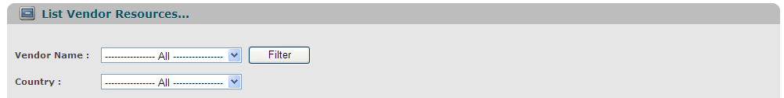
Screen | Vendor Resources Maintenance – Filter
Description |  | Display query screen to filter displayed results. “All” value is set by default; the system displays all vendors of all countries from the DB, on the screen. Then users can choose to display any vendor information, by choosing value in dropdown lists of Vendor Name/Country.
Screen Access |  | Users click on menu Configuration -> Vendor Resources Maintenance
Screen Content
Item |  | Type | Data | Description
Vendor Name |  | Dropdown list – String (50) | Default: All  Lookup from VENDOR.NAME, ordered by VENDOR.NAME | Display Vendor Name but value stored is Vendor Code.  User can type free text to search for Vendor Name.
Country |  | Dropdown list – String (50) | Default: All  Lookup from COUNTRY.NAME, ordered by COUNTRY. NAME | Refers to the country of origin of the vendor.  Display Country Name but value stored is Country Code.  User can type free text to search for Country Name.
Screen Actions
Action Name |  | Description |  | Success | Failure
Filter |  | List of all vendors will be ordered by Vendor Name.  When users choose any value in the above two dropdown lists and click Filter button, then the system returns data of that Vendor/Country. |  | Display general data of inputted Vendor Name/Country (data is selected from table VENDOR, linked with table COUNTRY). | Display message “No data found.” In the Message Area.

Vendor Resources Maintenance – List
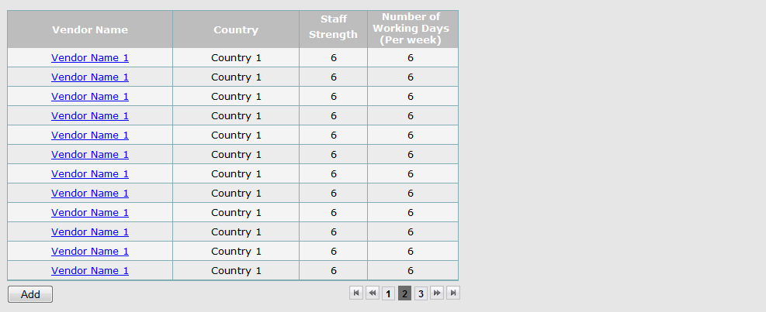
Screen | Vendor Resources Maintenance – List
Description |  | Display all vendors information, base on Vendor Name/Country
Screen Access |  | Users click on menu Configuration -> Vendor Resources Maintenance
Screen Content
Item |  | Type | Data |  | Description
Vendor Name |  | Link – String (50) | Lookup from VENDOR.NAME |  | For users that are Administrator or Normal Users Account, then vendor name will be displayed as links, allow users to click on them, and go to “Update” screen.
Country |  | Label – String (50) | Lookup from COUNTRY.NAME
Staff Strength |  | Label – Number (10) | Lookup from COUNTRY.STAFF_STRENGTH |  | Number of staff of a particular vendor. Staff strength may change from time to time. The change will only affect new task.
Number of Working Days (Per week) |  | Label – Number (1) | Lookup from VENDOR.WORKING_DAYS
Add |  | Button |  |  | For users that are Administrators or Normal User Account, then this button will be displayed, allow users to click on, and go to “Add” screen.
Screen Actions
Action Name |  | Description |  | Success |  | Failure
Update |  | - If the user logged in is Administrative or Normal User Account, then Vendor Names are displayed as links.  - The user clicks on the link, then the system leads the user to “Update” screen. |  | “Update” screen is displayed.
Add |  | - This button is displayed if logged in user is Administrator or Normal User Account. |  | “Add” screen is opened.

Vendor Resources Maintenance – Update
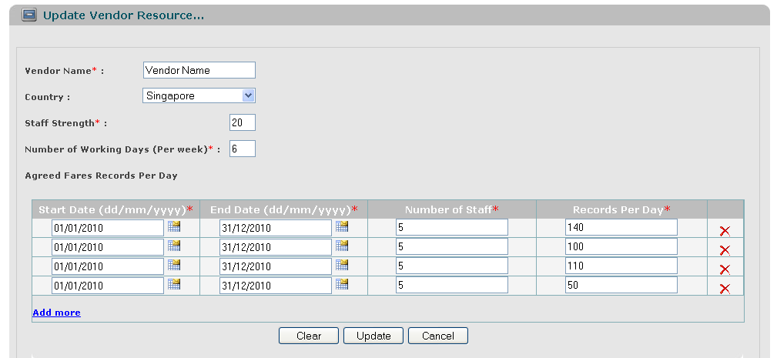
Screen |  | Vendor Resources Maintenance – Update
Description |  |  | Allow Administrator and Normal User Account to update existing records.
Screen Access |  |  | Users click on the links of Vendor Name.
Screen Content
Item |  |  | Type | Data |  | Description
Vendor Name |  |  | Text field – String (50) | Default data is looked up from previous action (getting data from the DB and displaying on the list)  After changed, will be  updated into VENDOR.NAME |  | This field is mandatory.
Country |  |  | Dropdown list – String (50) | Lookup from COUNTRY.NAME and displayed in dropdown list (ordered by COUNTRY.NAME), default value is the value of selected record.  After changed, will be  updated into VENDOR.COUNTRY_CODE |  | This field is displayed as a dropdown list if the selected vendor hasn’t been assigned to any contract before (vendor is not existing in the table CONTRACT)  If not, this field will be displayed as a label.
Staff Strength |  |  | Text field – Number (10) | Default data is looked up from previous action (getting data from the DB and displaying on the list)  After changed, will be  updated into VENDOR.STAFF_STRENGTH |  | This field is mandatory.
Number of Working Days (Per week) |  |  | Text field – Number (1) | Default data is looked up from previous action (getting data from the DB and displaying on the list)  After changed, will be  updated into VENDOR.WORKING_DAYS |  | This field is mandatory.
Agreed Fares Records Per Day |  |  | Label | Each vendor can have more than one group of “Agreed Fares Records Per Day” |  | This field is mandatory.
Number of Staff |  |  | Text field – Number (4) | Default data is looked up from previous action (getting data from the DB and displaying on the list)  After changed, will be  updated into VENDOR.STAFF_PER_DAY |  | This field is mandatory.
Start Date (dd/mm/yyyy) |  |  | Text field – Date (Date Picker) | Default data is looked up from previous action (getting data from the DB and displaying on the list)  After changed, will be  updated into VENDOR.START_DATE |  | This field is mandatory.
End Date (dd/mm/yyyy) |  |  | Text field – Date (Date Picker) | Default data is looked up from previous action (getting data from the DB and displaying on the list)  After changed, will be  updated into VENDOR.END_DATE |  | This field is mandatory.
Records Per Day |  |  | Text field – Number (4) | Default data is looked up from previous action (getting data from the DB and displaying on the list)  After changed, will be  updated into VENDOR.RECORDS_PER_DAY |  | This field is mandatory.
Add more |  |  | Link button | Add more group of four above text fields, each time user clicks to Add more, then only one group will be added. |  | This field is mandatory.
Delete icon |  |  | Image button | Remove current record of productivity.
Clear |  |  | Button |  |  | Clear all inputted data.
Update |  |  | Button |  |  | Submit data.
Cancel |  |  | Button |  |  | Cancel update.
Screen Actions
Action Name | Description |  |  |  | Success | Failure
Update | - User increases the number of staff of the vendor.  Ex: a. From 1st Feb to 15th Feb, all vendor resources are assigned.  b. On 10th Feb, user increases the number of staff of the vendor.  - No changes to any of scheduled contracts, only new contracts are applied.  - User decreases the number of staff of the vendor.  Ex: a. From 1st Feb to 15th Feb, all vendor resources are assigned.  b. On 10th Feb, user decreases the number of staff of the vendor.  - No changes to on-going contracts.  - System collects and displays on the screen all contracts that have start date later than 10th Feb.  - System removes the schedules of all contracts that have start date later than 10th Feb and moves the resources back to the pool.  - System proposes new schedules of all contracts that are removed in above step on the screen.  - User increases the number of records per day of the vendor.  Ex: a. From 1st Feb to 15th Feb, all vendor resources are assigned.  b. On 10th Feb, user increases the number of records per day of the vendor.  - No changes to on-going contracts.  - System collects and displays on the screen all contracts that have start date later than 10th Feb.  - System proposes new schedules for the contracts that start after 10th Feb based on increased productivity and update schedule with new expected end date.  - User decreases the number of records per day of the vendor.  Ex: a. From 1st Feb to 15th Feb, all vendor resources are assigned.  b. On 10th Feb, user decreases the number of records per day of the vendor.  Start2  - No changes to on-going contracts.  - System collects and displays on the screen all contracts that have start date later than 10th Feb.  - System removes schedules of the contracts that start after 10th Feb and moves the resources back to the pool.  - System proposes new schedules for the contracts that start after 10th Feb based on decreased productivity and update schedule with new expected end date.  - User changes end date of agreed fares records per day of the vendor.  Ex: a. From 1st Feb to 15th Feb, all vendor resources are assigned.  b. On 10th Feb, user changes the end date of agreed fares per day of vendor from 28th Feb to 15th Feb.  Original  No of Staff: 2  Records Per Day: 50  start date: 1st Jan 2010  end date: 28th Feb  New Value:  No of Staff: 2  Records Per Day: 50  start date: 1st Jan 2010  end date: 15th Feb  No of Staff: 2  Records Per Day: 70  start date: 16th Feb  end date: 28th Feb  - No changes to on-going contracts.  - System collects and displays on the screen all contracts that have start date later than 15th Feb.  - System removes the schedules of the contracts that start after 15th Feb and moves the resources back to the pool.  - System proposes new schedules for the contracts that start after 15th Feb based on new start date, end date of agreed fares.  - User changes country of the vendor.  - User can change country if the selected vendor hasn’t been assigned to any contract (vendor is not existing in the table CONTRACT).  - User changes number of working days.  a. From 1st Jan to 30th Jul, all vendor resources are assigned with number of working days is 5  b. On 01st Jul, user changes number of working days to 4 (or 6).  - No changes to on-going contracts.  - System collects and displays on the screen all contracts that have start date later than 01st Jul.  - System removes the schedules of the contracts that start after 01st Jul and moves the resources back to the pool.  - System proposes new schedules for the contracts that start after 01st Jul based on new number of working days and update schedule with new expected end date.  - User changes start date, end date of agreed fares records per day of the vendor.  Ex: The first case  Old Start Date: 03-Jan-10; Old End Date: 30-Jan-10  New Start Date: 01-Jan-10; New End Date: 31-Jan-10  - The system will check if the new [Start Date; End Date] conflict with other existing Start Date, End Date then inform user if have any error.  - If have no conflict, then update new [Start Date; End Date] into the DB.  The second case:  Old Start Date: 03-Jan-10;  Old End Date: 30-Jan-10  New Start Date: 05-Jan-10;  New End Date: 25-Jan-10  - The system will check if the new [Start Date; End Date] conflict with other existing Start Date, End Date then inform user if have any error.  - No changes to on-going contracts.  - System collects and displays on the screen all future contracts that have expected start date on or later than 03-Jan and/or expected end date between [26-Jan; 30-Jan].  - System removes the schedules of the above contracts and moves the resources back to the pool.  - System proposes new  schedules for the  above contracts based  on new [Start Date;  End Date]. |  |  |  | Back to the List screen with updated record on the list.  If the user chooses to update a vendor from the list of all vendors, then when go back to the list from update, the updated record will be focused on. | Display message “The selected record has been removed by someone.”  Display message “The selected record has been changed by another user! Please refresh to get the latest data for your update.”  Display message: “Database connection error.”  Display message:  “Vendor Name must be entered.”  Display message “The vendor name exists in the system. Please enter a new vendor name.”  (To dev: Need to check if the inputted name is the same as the old name of selected vendor, then it’s ok. But it can’t be the same as other existing name in the system)  Display message:  “Staff strength must be entered.”  Display message:  “Staff strength must be a number and > 0.”  Display message:  “Number of Working Days must be entered.”  Display message:  “Number of Working Days must be a number >0 and <= 7 ”  Display message:  “Number of Staff must be entered.”  Display message:  “Number of Staff must be a number and > 0”  Display message:  “Start Date must be entered.”  Display message:  “Start Date must be a Date type.”  Display message:  “End Date must be entered.”  Display message:  “End Date must be a Date type.”  Display message:  “Records Per Day must be entered.”  Display message:  “Records Per Day must be a number and > 0.”  Display message:  “Start Date must be earlier than or equals to End Date.”  Validation for Start Date/End Date each set of agreed fares.  a.  Start2  End2  Start1  End1  If number of staff of [Start2, End2] < staff strength, then display message: “Staff productivity is not fully defined. Please check.”  If number of staff of [Start2, End2] > staff strength, then display message: “Staff productivity defined is more than staff strength of vendor. Please check.”  b.  Start2  End2  Start1  End1  Display message:  “Can’t locate resource! Please extract to other groups, such as: [Start2, Start1]; [Start1, End2].”  c.  Start2  End2  Start1  End1  Display message:  “Staff productivity defined does not tally with staff strength of vendor. Please check.”  d.  Start2  End2  Start1  End1  Display message:  “Can’t locate resource! Please extract to other groups, such as: [Start2, End1]; [End1, End2].”  e.  End2  Start1  End1  Start2  If number of staff of [Start2, End2] < staff strength, then display message: “Staff productivity is not fully defined. Please check.”  If number of staff of [Start2, End2] > staff strength, then display message: “Staff productivity defined is more than staff strength of vendor. Please check.”
Clear | Clear inputted data and reset to the previous data. |  |  |  | Display “Update” screen with the previous data.
Cancel | Close “Update” screen. |  |  |  | Return to the “List” screen (previous list).
Add more | Add more group of “Agreed Fares Records Per Day”. |  |  |  | Each time user clicks to Add more, then only one group will be added.

Vendor Resources Maintenance – Delete on screen “Update”
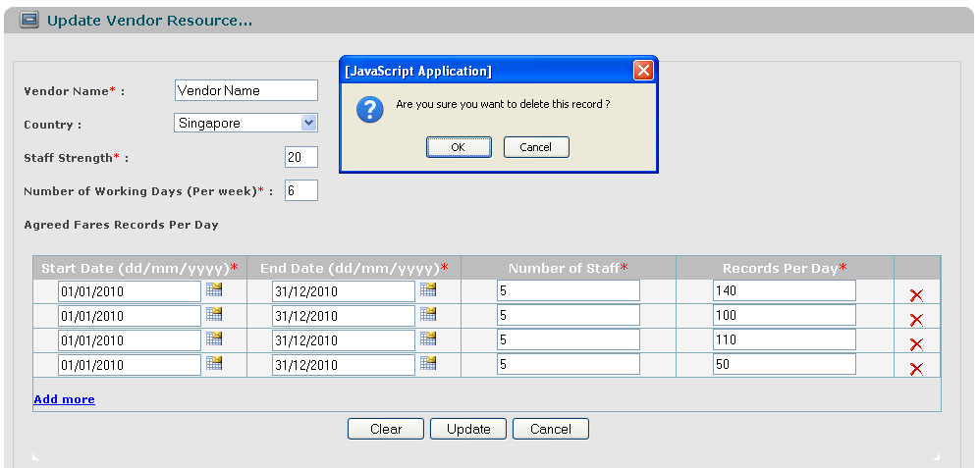
Screen | Vendor Resources Maintenance – Delete on screen “Update”
Description |  | Allow Administrator and Normal User Account to remove productivity on the screen “Update”.
Screen Access |  | User clicks on the Delete icon, besides each row of productivity.
Screen Content
Item |  | Type | Data |  | Description
OK |  | Button |  |  | After clicking on the delete icon, the system will display a dialog screen that allows user getting confirmation before delete.
Cancel |  | Button |  |  | Cancel Deletion and stay on “Update” screen.
Screen Actions
Action Name |  | Description |  | Success | Failure
Confirmed |  | Agree to remove productivity. |  | - Selected record is removed on the screen and from the DB.  - Keep “Update” screen opened. | Display message “The selected record has been removed by someone.”  Display message: “Database connection error.”  Display message “Some contracts have been executing or scheduling in this period of time, record can’t be removed.”  After displaying error message, the system stays on the “Update” screen.
Cancel |  | Close dialog screen. |  | Stay on the same screen.

Vendor Resources Maintenance – Add

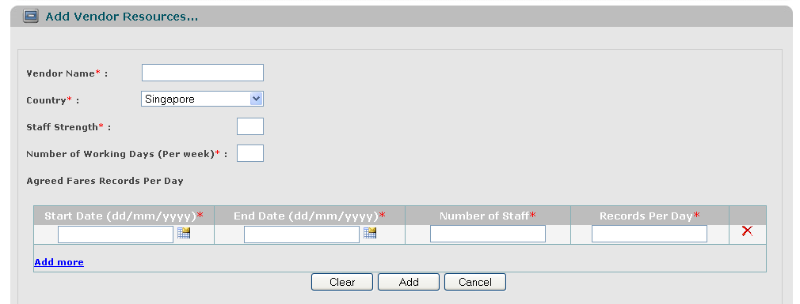
Screen | Vendor Resources Maintenance – Add
Description |  | Allow Administrator and Normal User Account to add vendor resources.
Screen Access |  | Users click on the button Add.
Screen Content
Item |  | Type | Data |  | Description
Vendor Name |  | Text field - String (50) | Inserted into VENDOR.NAME |  | This field is mandatory.
Country |  | Dropdown list - String (50) | Lookup from COUNTRY.NAME and displayed in dropdown list, default value is the first value (ordered by COUNTRY.NAME). After being chosen, inserted into VENDOR.COUNTRY_CODE |  | This field is mandatory.
Staff Strength |  | Text field - Number (10) | Inserted into VENDOR.STAFF_STRENGTH |  | This field is mandatory.
Number of Working Days (Per week) |  | Text field - Number (1) | Inserted into VENDOR.WORKING_DAYS |  | This field is mandatory.
Agreed Fares Records Per Day |  |  |  |  | This field is mandatory.
Number of Staff |  | Text field - Number (4) | Inserted into VENDOR.STAFF_PER_DAY |  | This field is mandatory.
Start Date (dd/mm/yyyy) |  | Text field – Date (Date Picker) | Inserted into VENDOR.START_DATE |  | This field is mandatory.
End Date (dd/mm/yyyy) |  | Text field – Date (Date Picker) | Inserted into VENDOR.END_DATE |  | This field is mandatory.
Records Per Day |  | Text field - Number (4) | Inserted into VENDOR.RECORDS_PER_DAY |  | This field is mandatory.
Add more |  | Link button | Add more group of four above text fields, each time user clicks to Add more, then only one group will be added. |  | This field is mandatory.
Delete icon |  | Image button | Remove current record of productivity.
Clear |  | Button |  |  | Clear all inputted data.
Add |  | Button
Cancel |  | Button |  |  | Cancel to add new and back to “List” screen.
Screen Actions
Action Name |  | Description |  | Success | Failure
Submit |  | At least one Agreed Fares Records Per Day must be inputted.  Inputted data will be saved into the DB. |  | Back to the “List” screen with new record on the List (default list with all data).  When go back to the list from “Add” screen, the new record will be focused on. | Display message: “Database connection error.”  Display message “The vendor name of this country exists in the system. Please enter a new Vendor Name.”  Display message:  “Vendor Name must be entered.”  Display message:  “Staff strength must be entered.”  Display message:  “Staff strength must be a number and > 0.”  Display message:  “Number of Working Days must be entered.”  Display message:  “Number of Working Days must be a number and > 0 and <= 7.”  Display message:  “Number of Staff must be entered.”  Display message:  “Number of Staff must be a number and > 0.”  Display message:  “Start Date must be entered.”  Display message:  “Start Date must be a Date type.”  Display message:  “End Date must be entered.”  Display message:  “End Date must be a Date type.”  Display message:  “Records Per Day must be entered.”  Display message:  “Records Per Day must be a number and > 0.”  Display message:  “Start Date must be earlier than or equals to End Date.”  Validation of Start Date/End Date is the same as “Update” section.
Clear |  | Clear inputted data. |  | Display “Add” screen with blank data, except dropdown list is displayed with default data.
Cancel |  | Close “Add” screen and return to the list. |  | Return to the “List” screen (default list with all data).

NON-FUNCTIONAL REQUIREMENTS AND OTHERS

Performance
No. | Requirement
1. | Allow at least 5 users to access into the system at the same time.

Scalability
No.
1.
2.

Security
No. | Requirement
1. | Web Server => Redhat 4, running apache 2.2  Appl Server => Solaris 10, running weblogic 10 MP1
2.

Infrastructure
No. | Requirement
1.

Browser
No. | Requirement
1. | IE6 and above (IE8 is not recommended).  FireFox is not mandatory.

Reliability
No. | Requirement
1.

Purchased Components
No. | Requirement
1.
2.

Interfaces
No. | Requirement
1. | Font style is the same with http://www.customer.com.sg/default.aspx

Extensibility
No. | Requirement
1.

Assumptions
No. | Requirement
1.

APPENDIX

