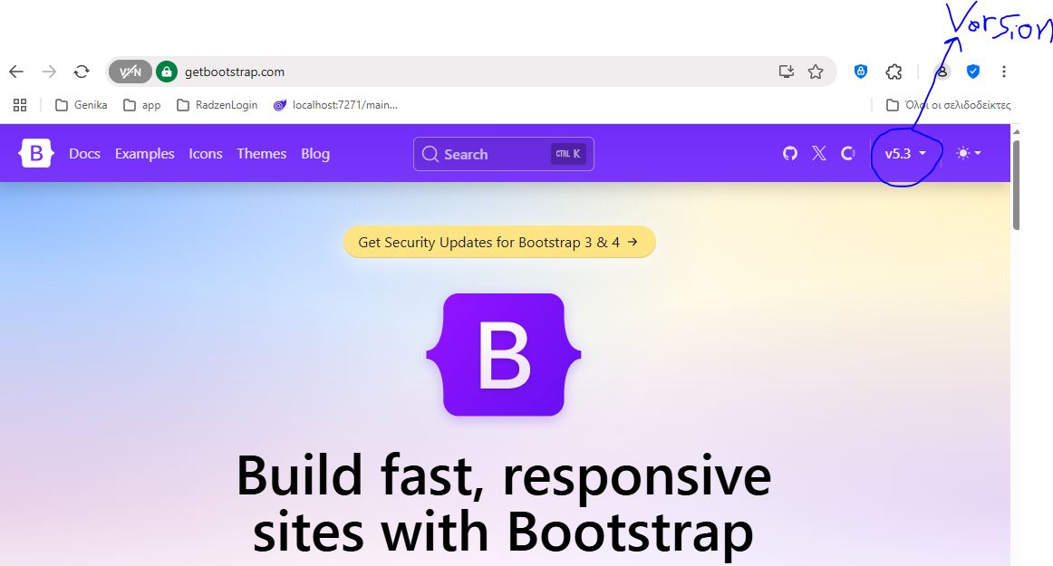

Copy the upper right (1st) CDN Link for js and bottom right for CSS and add them to **App.razor**

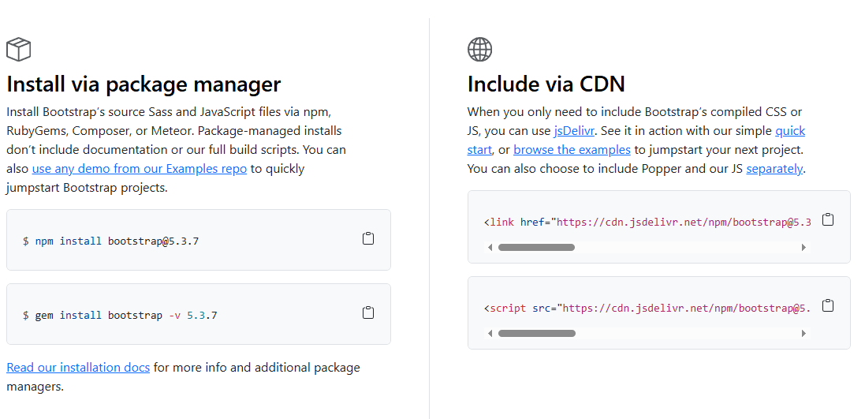

Select the icons link

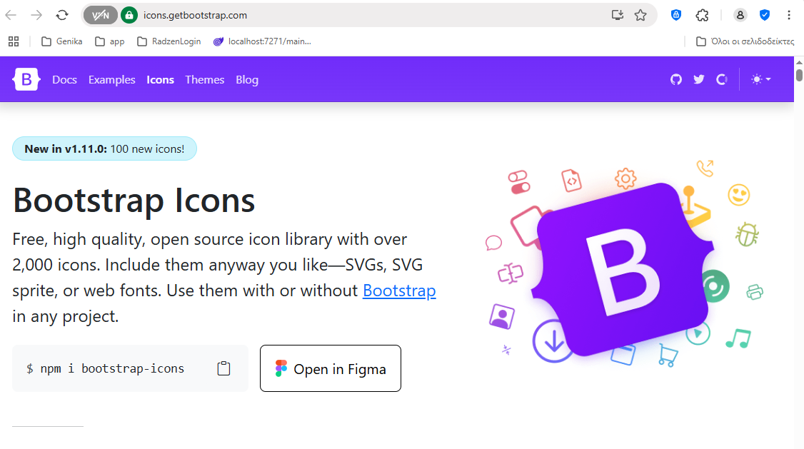

Copy the CDN link at the bottom (Αν πατήσεις το Link Install σε πάει)

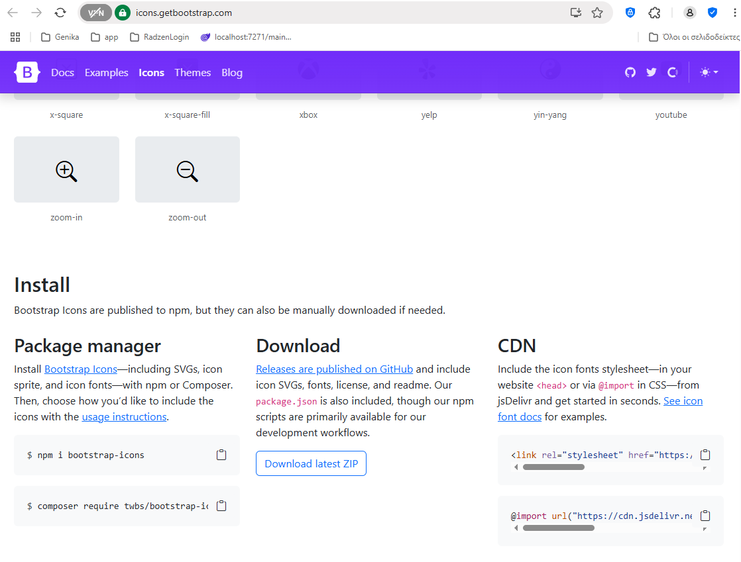

Παίρνω τα **Toastr Notifications** από το Minified πλαίσιο (*Γράφει ότι το JQuery είναι required*).

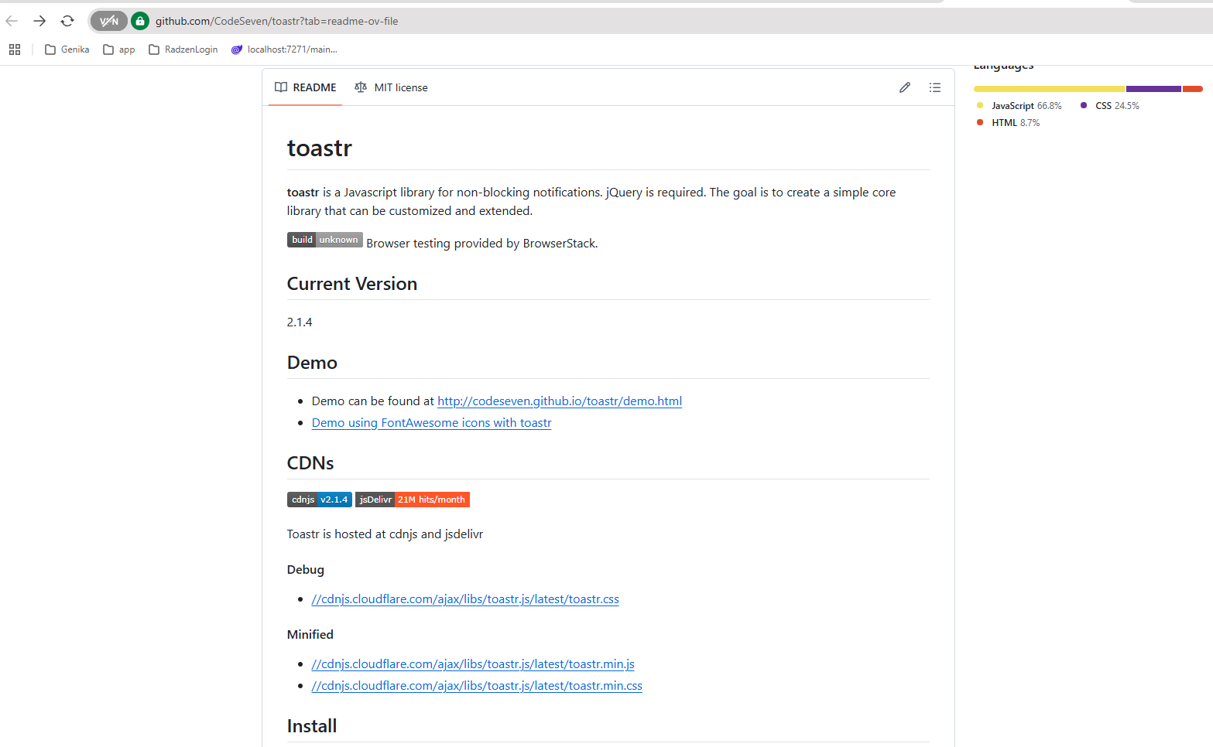

Βάζω και το **JQuery CDN**

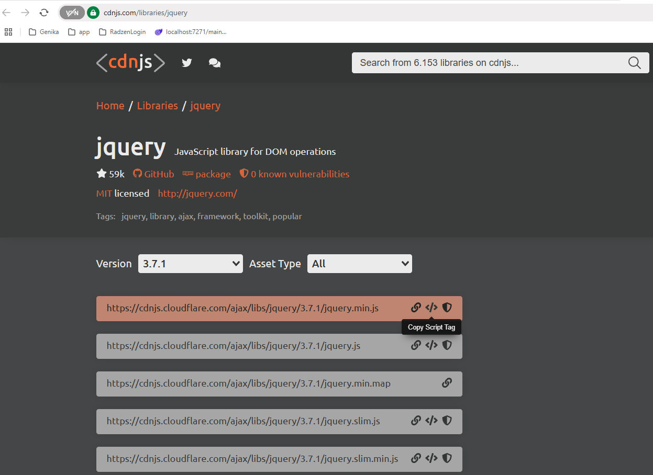

Μπορείς να ψάξεις για **icon**

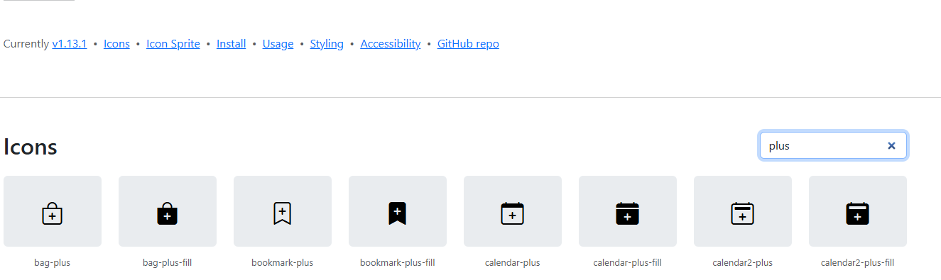

To επιλέγω και κάνω **copy**

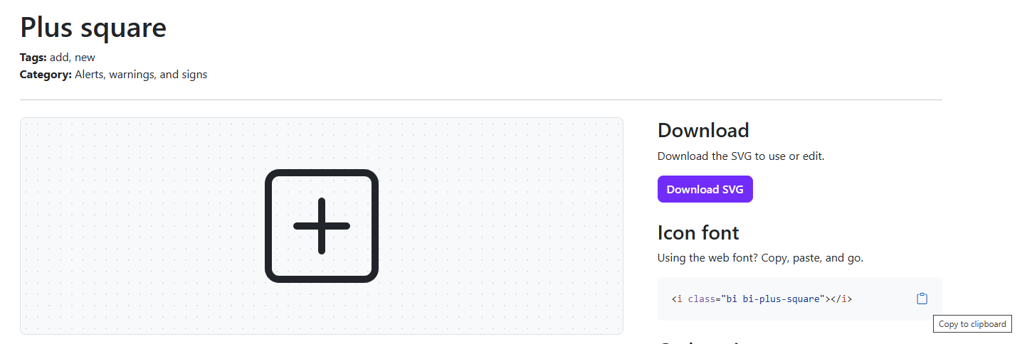

**Modals**

1. Search for ‘Bootstrap Modal’  
   <https://getbootstrap.com/docs/5.3/components/modal/>  
   or  
   from search box in bootstrap portal, type ‘Modal’  
   <https://getbootstrap.com/docs/5.3/components/modal/#how-it-works>
2. Copy Sample code
3. Run and press F12. In console write  
   *bootstrap.Modal.getOrCreateInstance(document.getElementById('exampleModal')).show();*

*If modal is shown the above will working*

*Instead use the following*

1. *bootstrap.Modal.getOrCreateInstance(document.getElementById('exampleModal ')).hide();*

*to paste the above line of code, in* ***browser console*** *write ‘allow pasting’ press enter and then paste.*