**Image Processing:**

**Tutorial 6: Multi-resolution Splines**

Today we will be looking at blending images using multi-resolution splines. We will first start off by building a Gaussian pyramid, followed by a Laplacian Pyramid. We will then look at how to combine two Laplacian Pyramids to blend two images together to replicate the classic orange and apple image shown further down.

**Task 1: Gaussian Pyramid**

To build a Gaussian Pyramid we will first need to create a method that will apply a Kernel to our image. We can do this using fft2, and ifft.

FFT2

Image

Filtered Image

ifft

.*

H

FFT2

Our filter H can be computed with the following formula:

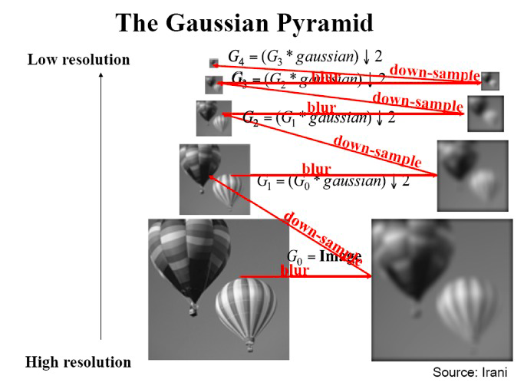A Gaussian pyramid can be built by blurring and down sampling, giving us a sequence of low-pass filtered images *G0* , *G1 ,G2 , …Gn*:

**Task 2: Laplacian Pyramid**

Next it’s time to build a (band-pass) Laplacian pyramid. This can be built using your Gaussian pyramid each level will be computed by taking the difference from one level to the next, therefore:

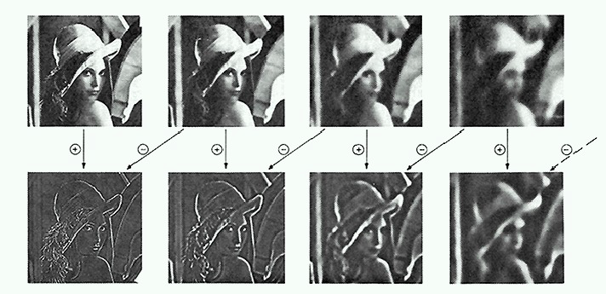*Li = Gi – EXPAND(Gi +1)*

Resulting in *L0* , *L1 ,L2 , …Ln.* Where *EXPAND* upscales the image.

**Task 3: Multi-resolution Spline**

Once we have the methods that will create our Gaussian and Laplacian pyramids we can use these to blend our images together using the following algorithm:

1. First compute the laplacian pyramids LA and LB for images A and B
2. We then need to create a mask that will be used to blend our images, (remember we could use roiploy)
3. Once we have a mask we want to create a Guassian pyramid of the mask, GR.
4. We now need to compute the Laplacian pyramid LS that is a combination of LA and LB, computed by:

LSi  = GRi(i,j)LAi(i,j) + (1 – GRi(i,j))LBi(i,j)

1. The pyramid LS now needs to be EXPANDED, this is done by simply upscaling and adding each level.

Results:

