Anthony Urbina

CSET 4250

Grading Application

Opening Screen

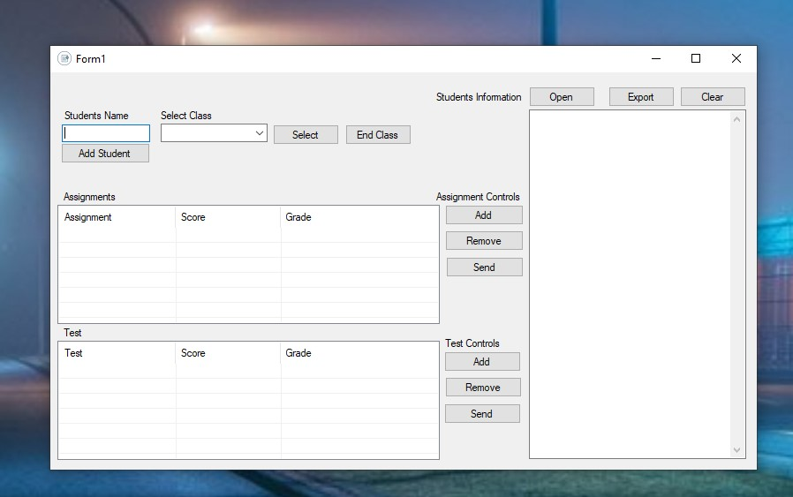

**Instructions**

**Add a student**

Type a student’s name into the student’s name box. Once you’re done click the Add Student Button and the student will be added.

**Select Class**

Click on the arrow underneath Select Class to open the drop-down menu to select class.

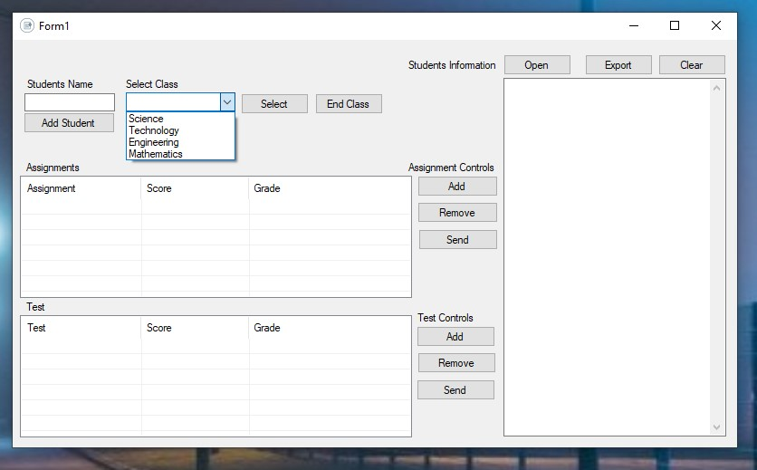

Next click on the Select Button to add it to the textbox.

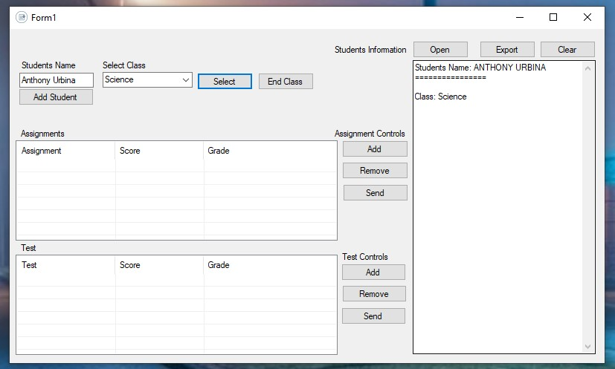

**Add/Remove/Send Assignments and Test**

To add an assignment, click on the Add Button and it will bring up an input box.

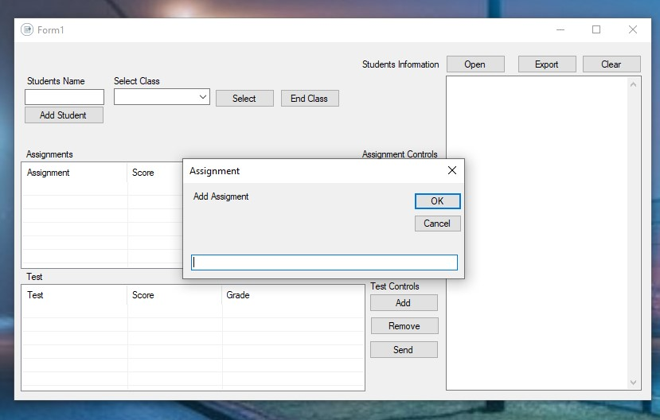

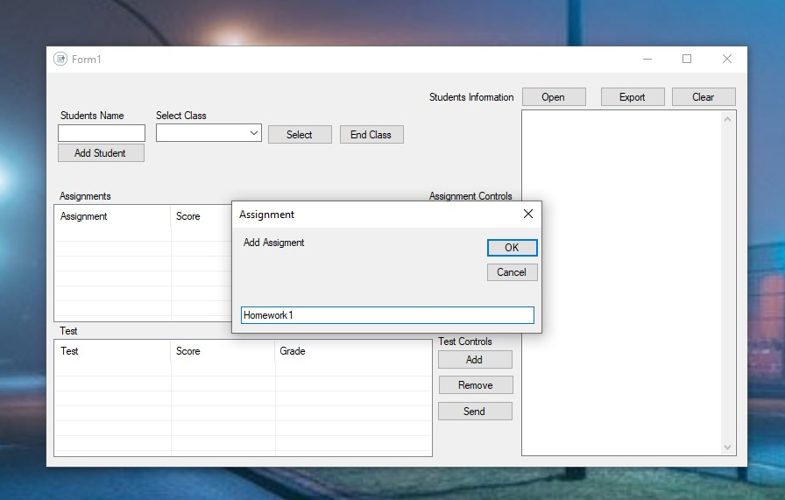

Enter the assignments name in the empty textbox. You can either hit the enter button or click on the OK button to continue. Next it will ask you for the assignment score. Once the score is entered it will calculate the letter grade. Once again, you can either press the Enter button to proceed or click on the OK button to continue.

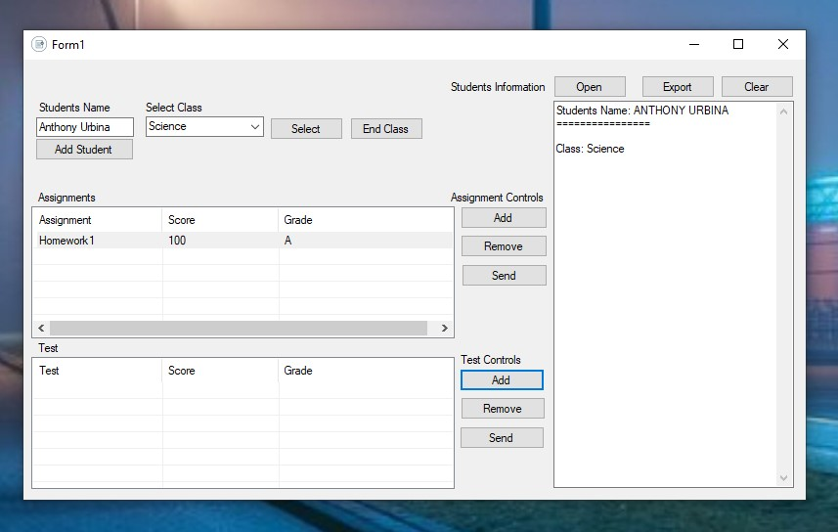

If the following the steps were completed successfully your program should look the like the following image above. Once you have completed the following steps proceed to the Test Controls. Then click on the Add button. The Add button would then bring up another dialog box asking for the test name or number. Please Enter Test following number or name with no spaces in-between. As following:

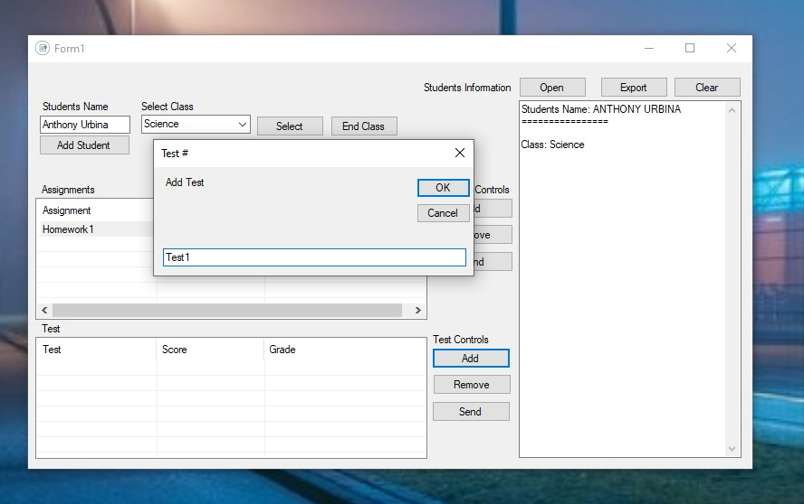

Press Enter or click on the OK button to continue. Next it will ask you for the assignment score. Once the score is entered it will calculate the letter grade. If everything was done correctly it should look like the following:

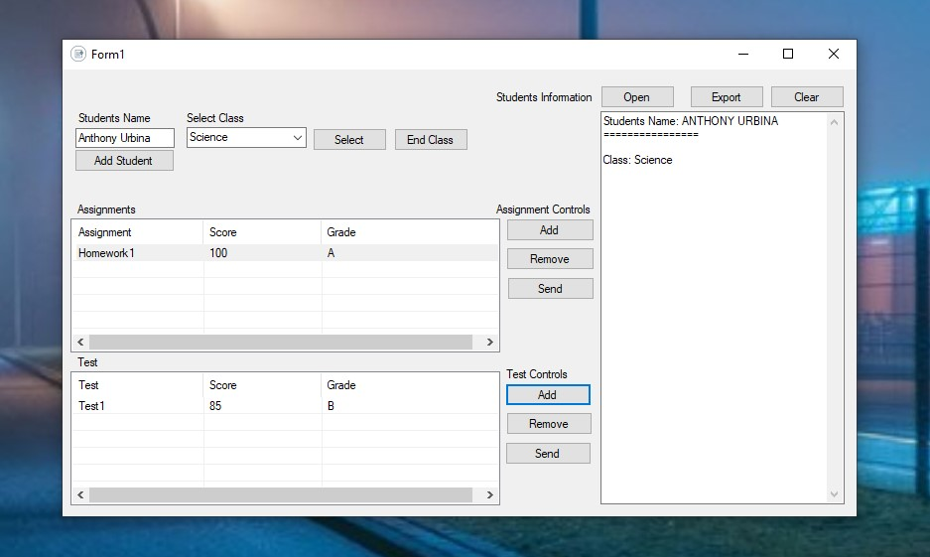

You can enter as many Assignments or Test as you want. There is no limit cap to the number of test or assignments you can add.

You can also remove Assignments and Test by clicking on assignment or test you want to remove. When clicked on it will become highlighted as shown:

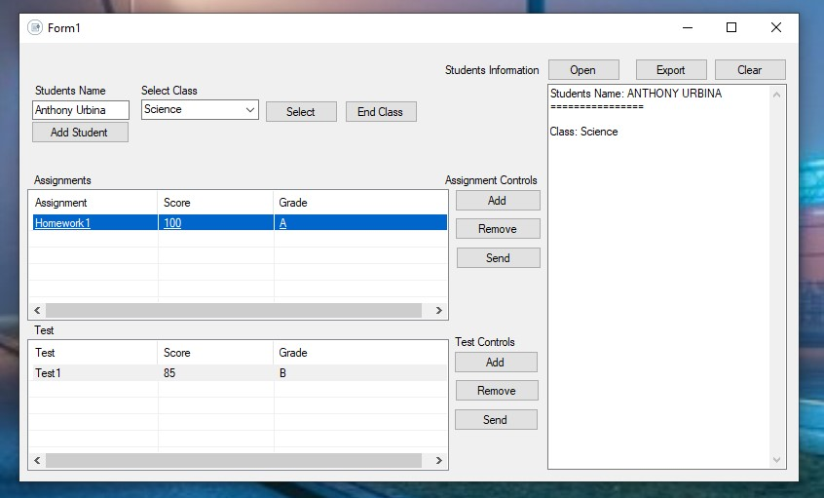

Once highlighted you can click on remove button to remove the item. Then the item would be removed from the list.

Once you’re finished, you can click on the item you want to add to the student’s information. If you want to add multiple items at one time you hold the ctrl button down click on the item you want to add. Then click the Send button to add it to the Student information list or also known as Student Information textbox. If done properly the result should look like this:

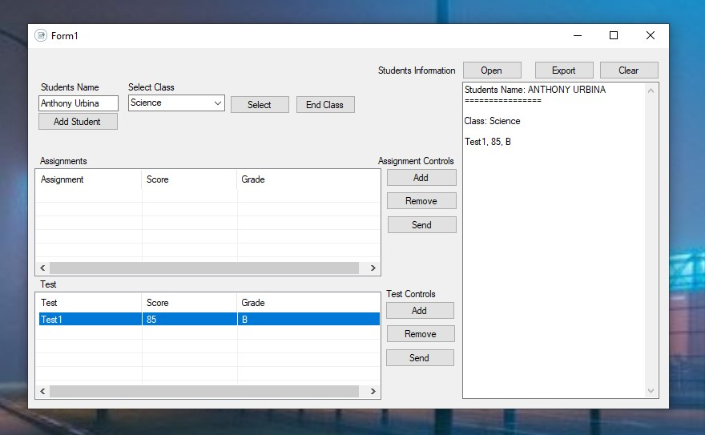

After your done adding assignments and test you can click on the End Class button. The button would then add a line separating the class from other classes. It should look like the following:

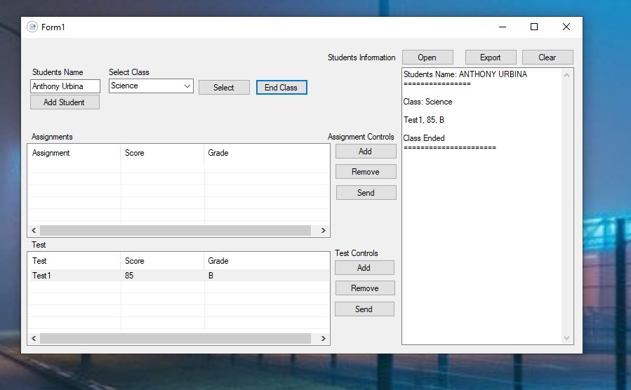

If you want to add another class, you can repeat the previous steps. If not, you can continue with the next steps.

**Export/Save File**

To save the Textbox you can click on the Export button. The button would then bring a dialog box letting you choose where you want to save your file. As shown below:

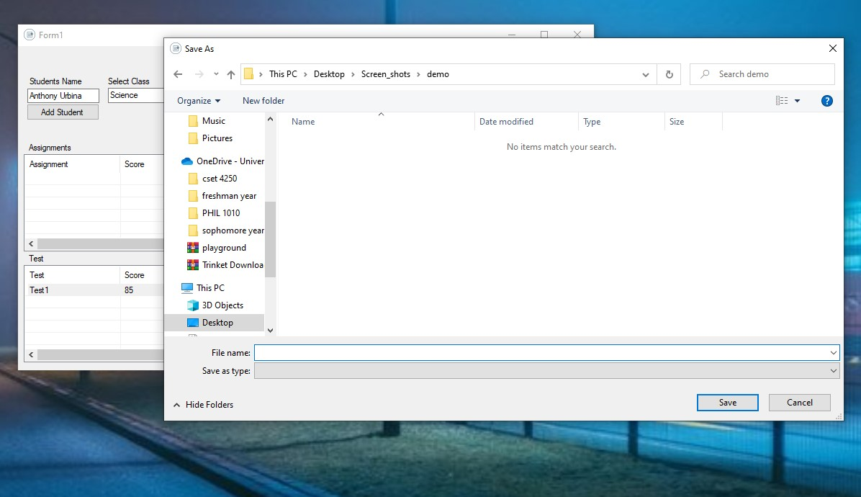

Then save your file as shown below:

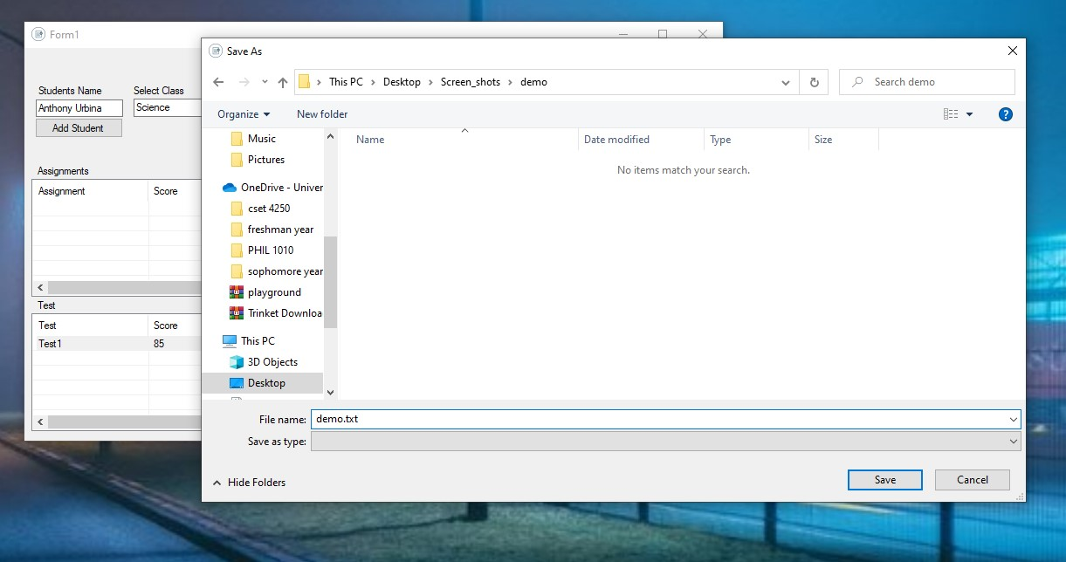

Then click save. The file would then be saved to the directory of your choice.

**OPEN/EDIT FILE**

If you want to open a file and edit it, you can click on the Open button. The button would then bring up a dialog box as shown below:

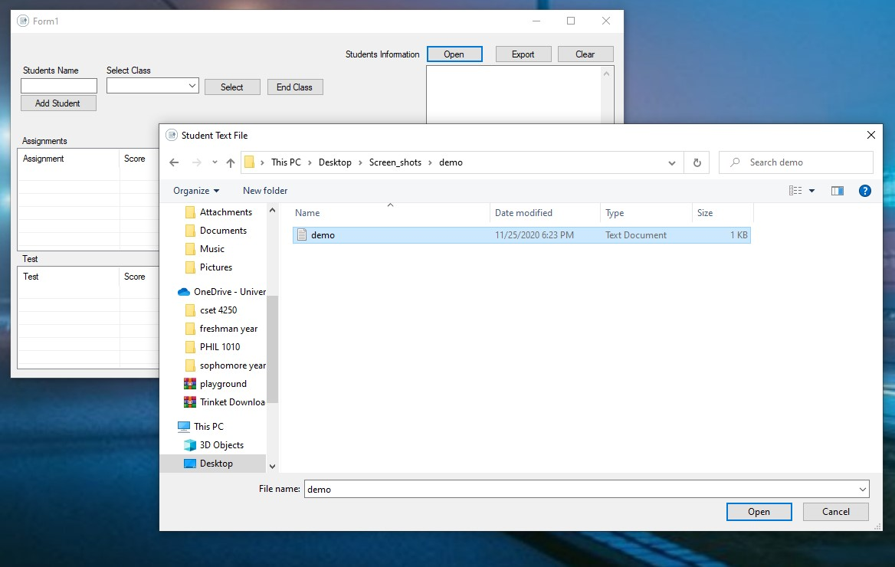

Then the textbox should be filled with text and allow you to edit it.

