KANK3333R :

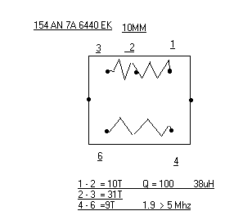
between pins 1 and 2 14 turns
between pins 2 and 3 41 turns
between pins 1 and 3 55 turns
between pins 4 and 6 14 turns, pin 5 is not connected !
Inductance 45 µH, Q = 60 probably measured between pins 1 and 3.

