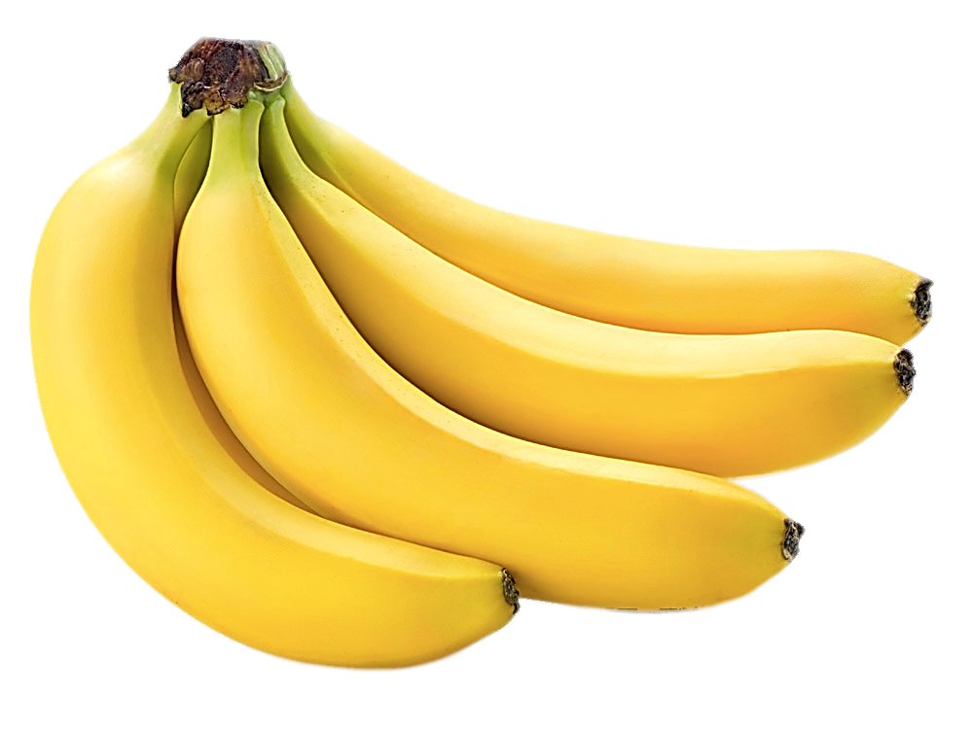

**A banana is an elongated, edible fruit – botanically a berry – produced by several kinds of large herbaceous flowering plants in the genus Musa.**

**One serving, or one medium ripe banana, provides about 110 calories, 0-gram fat, 1 gram protein, 28 grams carbohydrate, 15 grams sugar (naturally occurring), 3 grams fiber, and 450 mg potassium.**

**BANANA**