CHAPTER 1
INTRODUCTION

Content based image retrieval system deals with finding images in large databases using query image given by the user and providing the output image. Here we combine relevance feedback, evolutionary computation concepts and distance-based learning in order to reduce the gap between the high level semantic content of the images and the information provided by their low-level descriptors. Using Genetic algorithm, various crossover strategies and mutation rates is evaluated and their results are compared with various other algorithms, obtaining best possible results.

When relevance feedback is used, the user is considered an active part of an iterative process. At each step, the user selects the best matches from a series of pictures which are displayed on a graphical user interface (GUI). Then, the selection is processed and a new set of images are presented again on the GUI, repeating the process until a satisfactory group of pictures is retrieved. The sys- tem is then able to progressively retrieve better images according to the available information about what the user is looking for and how he/she judges its relevance.

Evolutionary algorithms have been used to solve a wide diversity of problems in the machine learning area. An evolutionary algorithm attempts to solve a problem applying Darwin’s basic principles of evolution on a population of trial solutions to a problem, called individuals. Genetic algorithms (GAs) are a class of evolutionary algorithms, which place a special emphasis on the application of genetic operators, such as mutation and crossover. GAs use an encoding method to represent potential solutions to the problem, and a fitness measure that allows a quantitative evaluation of each candidate according to how close it is to an ideal optimal solution. Starting from an initial population, each candidate is evaluated using the fitness function and the most promising individuals are allowed to reproduce and determine the next generation of individuals. The population evolves according to a series of pre-established rules and the process is repeated until a convenient solution is found or some convergence criteria are met.

The proposed work combines interactive evolutionary computation concepts with distance-based strategies to produce an efficient relevance feedback algorithm for image retrieval. In particular, an adapted extension of a previously introduced nearest neighbor (NN) approach including feature weighting and local search is plugged into a real-coded IGA in order to produce meaningful relevance scores without requiring a large number of feedback iterations as if a pure genetic approach was used.

1.1 Applications
CBIR is used in Military, Medical Diagnosis, Crime prevention, Intellectual property, Architectural and engineering design, Geographical information and remote sensing systems, etc. Few are explained as follows.

1.1.1 Medical Applications
The use of CBIR can result in powerful services that can benefit biomedical information systems. Three large domains can instantly take advantage of CBIR techniques: teaching, research, and diagnostics. From the teaching perspective, searching tools can be used to find important cases to present to students. Research also can be enhanced by using services combining image content information with different kinds of data. For example, scientists can use mining tools to discover unusual patterns among textual (e.g., treatments reports, and patient records) and image content information. Similarity queries based on image content descriptors can also help the diagnostic process. Clinicians usually use similar cases for case-based reasoning in their clinical decision-making process.

1.1.2 Biodiversity Information Systems
Biologists gather many kinds of data for biodiversity studies, including spatial data,
and images of living beings. Ideally, Biodiversity Information Systems (BIS) should help researchers to enhance or complete their knowledge and understanding about species and their habitats by combining textual, image content-based, and geographical queries. An example of such a query might start by providing an image as input (e.g., a photo of a fish) and then asking the system to “Retrieve all database images containing fish whose fins are shaped like those of the fish in this photo”. A combination of this query with textual and spatial predicates would consist of “Show the drainages where the fish species with ‘large eyes’ coexists with fish whose fins are shaped like those of the fish in the photo”.

1.1.3 Digital Libraries
There are several digital libraries that support services based on image content. One example is the digital museum of butterflies, aimed at building a digital collection of Taiwanese butterflies. This digital library includes a module responsible for content-based image retrieval based on color, texture, and patterns. In a different image context, is presented a content-based image retrieval digital library that supports geographical image retrieval. The system manages air photos which can be retrieved through texture descriptors. Place names associated with retrieved images can be displayed by cross referencing with a Geographical Name Information System (GNIS) gazetter. In this same domain, Bergman et al. describe architecture for storage and retrieval of satellite images and video data from a collection of heterogeneous archives. Other initiatives cover different concepts of the CBIR area. For example, while research presented in concentrates on new searching strategies for improving the effectiveness of CBIR systems, another popular focus is on proposing image descriptors.

CHAPTER 2
LITERATURE REVIEW

Knowledge about Feature extraction, genetic algorithm with interactive relevance feedback is required to perform hybrid CBIR. Integrating the individual methods into one hybrid method without affecting the retrieval time is one of the primary tasks.

2.1 Feature Extraction:
Raw images cannot be processed by the computer as such. Each image has to be processed and its pixel values are to be obtained in order to classify and compare. Therefore feature vectors which are numbers are derived from the image. The feature extractor computes a set of descriptors which facilitate in associating the images with numbers that represent its features. These are used subsequently in the generation of a summary or description of the scene. The feature vectors of an image are color histogram, texture, grayscale intensity, edge detection ,etc,
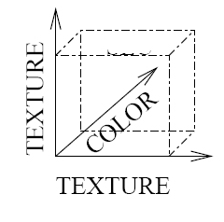
Fig 2.1 Feature vectors of an image

- Edge detection is a fundamental tool in image processing and computer vision, particularly in the areas of feature detection and feature extraction, which aim at identifying points in a digital image at which the image brightness changes sharply or, more formally, has discontinuities. The edges are detected based on the sudden local maximas or minimas in an image pixel matrix.
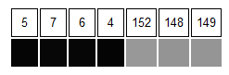
Fig 2.2 Edge detection process(Representation of pixel values)

Here there is a drastic change in the pixel value of pixel 4 and 5 . Thus it denotes the occurrence of an edge.

- Color histogram is a representation of the distribution of colors in an image. For digital images, a color histogram represents the number of pixels that have colors in each of a fixed list of color ranges, that span the image's color space, the set of all possible colors. For monochromatic images, the term intensity histogram may be used instead as it denotes only the grayscale intensity.
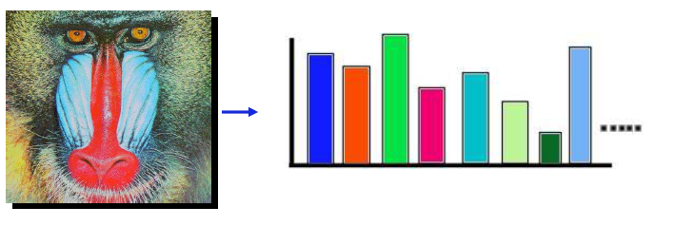
Fig 2.3 The histogram of a grayscale image

- Image texture is a set of metrics calculated in image processing designed to quantify the perceived texture of an image. Image Texture gives us information about the spatial arrangement of color or intensities in an image or selected region of an image.

2.2 Image Transformation:
Images are represented by the pixel values. To store and manipulate large pixel values, the space complexity as well as the time complexity increases. In order to represent the images with a fewer set of numbers , but at the same time preserve the features of the image we use image transformation.

Wavelet transformation
Fourier theory states that a signal can be expressed as the sum of a, possibly infinite, series of sines and cosines. This sum is also referred to as a Fourier expansion. The disadvantage of a Fourier expansion is that it has only frequency resolution and no time resolution. This means that although we might be able to determine all the frequencies present in a signal, we do not know when they are present. So a signal cannot be simply represented as a point in the time-frequency space called ‘Heisenberg’s uncertainty principle’.
The wavelet transform or wavelet analysis is probably the most recent solution to overcome the shortcomings of the Fourier transform. In wavelet analysis the use of a fully scalable modulated window solves the signal-cutting problem. The window is shifted along the signal and for every position the spectrum is calculated. Then this process is repeated many times with a slightly shorter (or longer) window for every new cycle. In the end the result will be a collection of time-frequency representations of the signal, all with different resolutions. Because of this collection of representations we can speak of a multiresolution analysis. Multi resolution analysis is defined as seeing functions at different scales (picture, person, face)
Wavelet transformation has the features of
- Space frequency localization
- Multiresolution analysis.
The wavelets are generated from a single basic wavelet (t), the so-called mother wavelet, by scaling and translation:
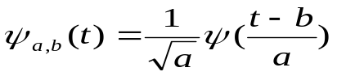
where a and b denote the scaling and translation parameters respectively.

Discrete Wavelet Transformation
Discrete wavelets are not time-discrete, only the translation- and the scale step are discrete, which is implemented by choosing appropriate filter banks. Thus DWT decomposes an image to sub images having low and high frequency components. Low frequency components represent the global description and high frequency components represent fine details. Multi resolution analysis of an image is produced by subjecting the image on different levels (scales) and by repeating the filtering and decimation process on low pass outputs.
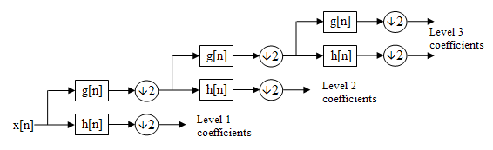
Fig 2.4 Multiresolution approach for image decomposition

where g[n] is low pass filter and h[n] is high pass filter.

Algorithm for 1D Haar Wavelet Transformation
procedure transform (array of pixel )
Transformed array as Wavelet pixel
For i= pixel length till 1
Begin
Sum= pixel [2i] + pixel [2i+1]
Difference= pixel [2i]- pixel [2i+1]
Wavelet pixel [i] =Sum;
Wavelet pixel [i+1] =Difference;
i= pixel length>>1
end
end procedure

Each step in the forward Haar transform calculates a set of wavelet coefficients and a set of averages. If a data set s₀, s₁ ... s_{N-1} contains N elements, there will be N/2 averages and N/2 coefficient values. The averages are stored in the lower half of the N element array and the coefficients are stored in the upper half. The averages become the input for the next step in the wavelet calculation, where for iteration i+1, N_{i+1} = N_{i}/2. The recursive iterations continue until a single average and a single coefficient are calculated. This replaces the original data set of N elements with an average, followed by a set of coefficients whose size is an increasing power of two (e.g., 2⁰, 2¹, 2² ... N/2).
Scaling function coefficients
h₀ = 0.5 , h₁ = 0.5
Wavelet function coefficients
g₀ = 0.5, g₁ = -0.5 , h_{0,} h_{1,} g_{0,} g₁ are filter coefficients

Computation of 2D Discrete Wavelet transformation

Procedure 2dWaveletTransform(image as 2 dimensional array of pixel)
Wavelet image = image;
k = 0;
for level = 1 and level < 5
begin
for i = 0 and i less than length of Wavelet image
begin
transform(Wavelet image);
transpose(Wavelet image);
end
for i = 0 and i less than length of Wavelet image
begin
transform(Wavelet image);
transpose(Wavelet image);
end
end
end procedure

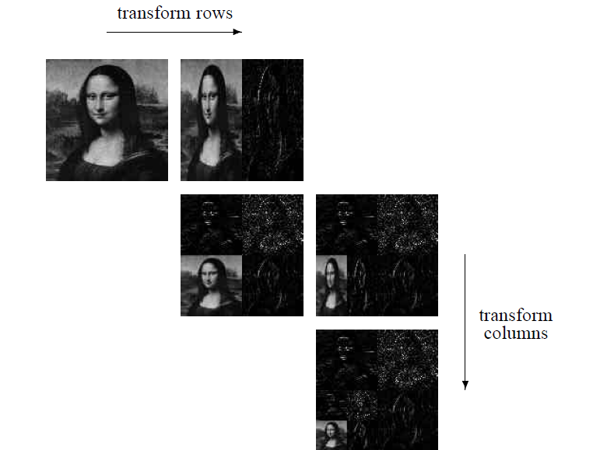

Fig 2.5 Two level wavelet decomposition of images

Advantages
- Computationally efficient (because of its smaller dimension at higher level)
- Provides multiresolution analysis of an image.

2.3 Genetic algorithm:
The genetic algorthim (GA) is a model of machine learning derived from the procedure of evolution in nature. This works by creating a population of individuals that are represented by chromosomes. A chromosome is a string that can be thought of as the human gene. The individuals in the population go through the evolutionary procedure in which different individuals compete for resources in the environment. Some of the better individuals are more likely to survive, and propagate their genetic material to offsprings.
The algorithm starts with an initial population, the individuals of which are randomly generated. In the beginning, the fitness value of each individual is evaluated to determine how appropriate it is for the given problem. Two individuals of relatively high fitness value are selected from the population, and they are regarded as the “parents.” New individuals called “children” are created by recombining the chromosomes of parents. Here, crossover and mutation operators are used to induce variations in the population.
Thus usage of GA will result in better offsprings and thus image retrieval will be more efficient.

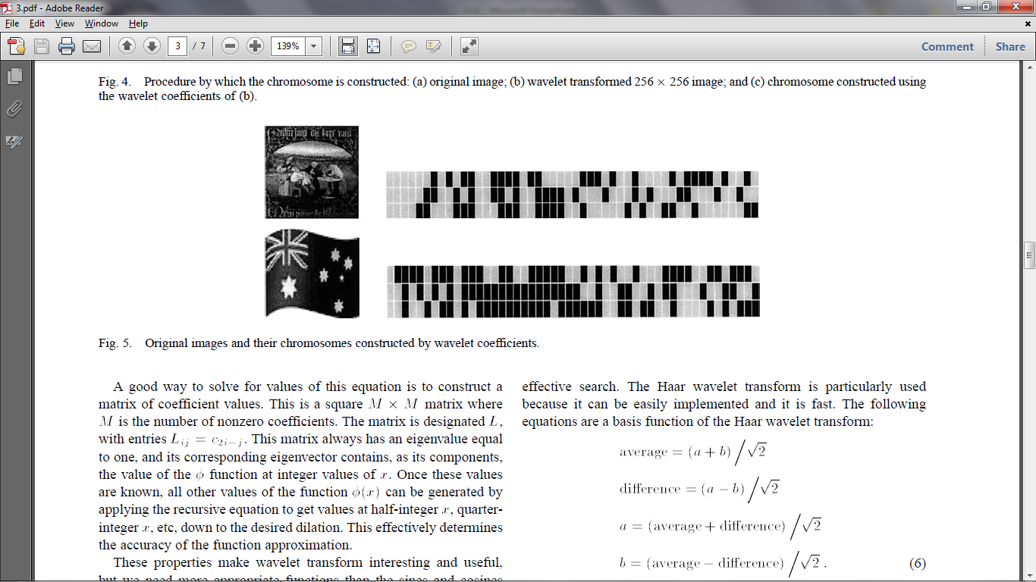
Fig 2.6 Image and its genotype
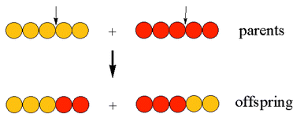
Fig 2.7 Genetic operation on genes(crossover )

2.4 Relevance Feedback
This allows developing a system operated on human intuition or emotion. High retrieval precision in content-based image retrieval can be attained by adopting relevance feedback mechanisms. These mechanisms require that the user judges the quality of the results of the query by marking all the retrieved images as being either relevant or not. Then, the search engine exploits this information to adapt the search to better meet user’s needs. At present, the vast majority of proposed relevance feedback mechanisms are formulated in terms of search model that has to be optimized. Such an optimization involves the modification of some search parameters so that the nearest neighbor of the query vector contains the largest number of relevant images.

2.5 Nearest Neighbour
In pattern recognition, the k-nearest neighbours algorithm (k-NN) is a method for classifying objects based on closest training examples in the feature space. The k-nearest neighbor algorithm is amongst the simplest of all machine learning algorithms: an object is selected by a majority vote of its neighbors, with the object being assigned relevant to the most similar one amongst its k nearest neighbors (k is a positive integer, typically small). If k = 1, then the object is simply returned to the class of its nearest neighbor. Usually Euclidean distance is used as the distance metric. The Euclidean distance between points p and q is the length of the line segment connecting them (pq).In Cartesian coordinates, if p = (p₁, p₂,..., p_{n}) and q = (q₁, q₂,..., q_{n}) are two points in Euclidean n-space, then the distance from p to q, or from q to p is given by:

CHAPTER 3
SYSTEM DESIGN

Algorithm
X: database of images.
Q+, Q−: relevant and non-relevant images, respectively.
S: images shown to the user at each iteration, |S| = p.
Initially, S contains p arbitrary images from X.
Repeat:
1.Show the images in S to the user.
2. Update Q+ and Q− according to user selection.
3. Evolve: obtain a set of p off springs O from Q+ using genetic operators.
4. Mapping: produce a new set of p images S ⊂ X (one from each off spring in O).

The general idea of the proposed approach consists of considering a population of p individuals (images) which will be obtained from Q+ by applying genetic operators. Instead of evolving a set of query points and devise a ranking strategy to obtain scores, the same population resulting from genetic operators will be shown to the user after an appropriate genotype–phenotype mapping. On the one hand, this will lead to a dramatic speed-up with regard to a pure genetic approach. On the other hand, it will give rise to the beneﬁt of distance-based scoring.

The proposed approach can be summarized graphically as in Fig. 3.2. The user makes a judgment about the images being shown at a particular iteration and the sets of positive (relevant) and negative (non-relevant) selections are updated. Then, genetic operators are applied to distinct pairs of genotypes chosen randomly from the set Q+ of positive ones in order to obtain a set of p potentially relevant feature vectors (genotypes). Finally, each of these feature vectors is mapped to an image in the database (X) and shown to the user again.

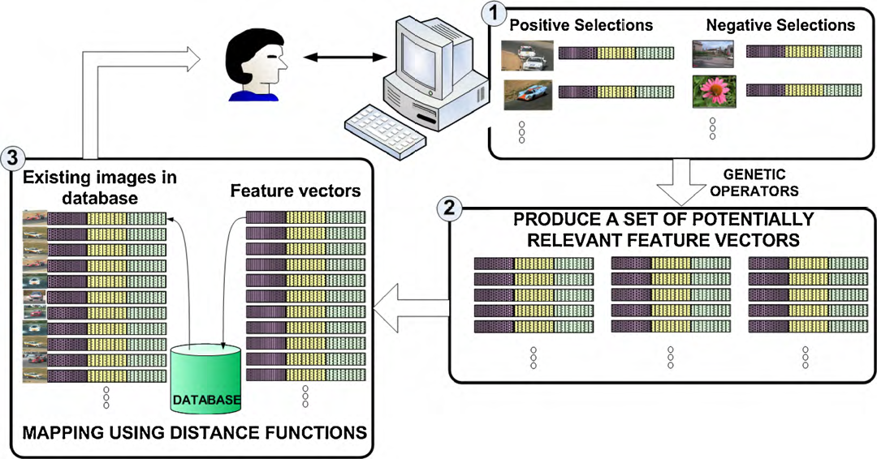
Fig 3.1 System Architecture
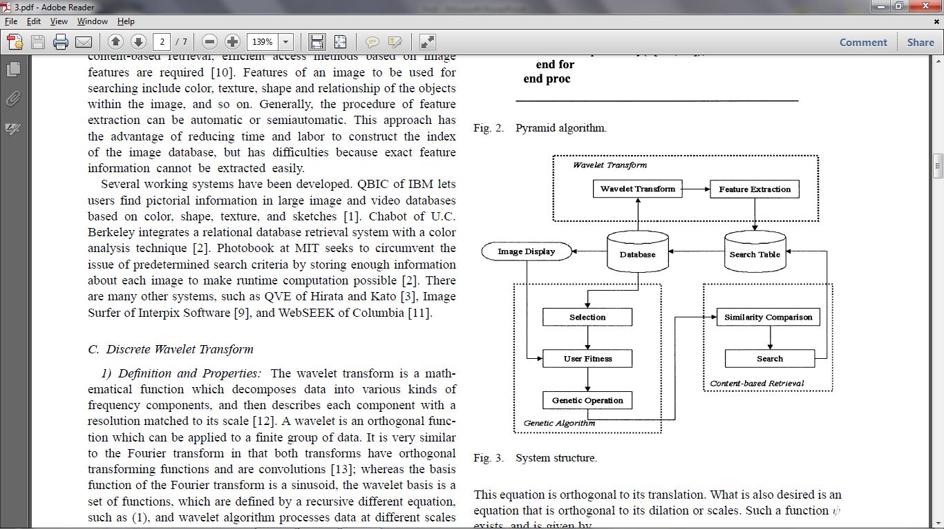

Fig 3.2 Flow diagram of Proposed Architecture

CHAPTER 4
REQUIREMENT ANALYSIS

4.1 HARDWARE REQUIREMENTS

- Processor of Pentium IV or above
- 512MB of RAM.

4.2 SOFTWARE REQUIREMENTS:
- OS - Windows XP or above.
- Language - Java
- IDE - NetBeans IDE
4.2.1 NetBeans IDE
NetBeans refers to an integrated development environment (IDE) for developing with Java, JavaScript, PHP, Python, Ruby, Groovy, C, C++, Scala, Clojure, and others.
The NetBeans IDE is written in Java and can run anywhere a JVM is installed, including Windows, Mac OS, Linux, and Solaris. A JDK is required for Java development functionality, but is not required for development in other programming languages.
The NetBeans Platform allows applications to be developed from a set of modular software components called modules. Applications based on the NetBeans platform (including the NetBeans IDE) can be extended by third party developers. Users can extend its capabilities by installing plug-ins written for the NetBeans software framework, such as development toolkits for other programming languages, and can write and contribute their own plug-in modules. Released under the terms of the Public License, is free and open source software.
NetBeans IDE and NetBeans Platform are based on software from netbeans.org, which has been dual licensed under the Common Development and Distribution License (CDDL) and the GNU General Public License version 2 with Classpath exception.

4.2.2 Image Processing packages in JAVA

4.2.2.1. ImageIcon
javax.swing.ImageIcon :

An implementation of the Icon interface that paints Icons from Images. Images that are created from a URL or filename are preloaded using MediaTracker to monitor the loaded state of the image.
Eg:- ImageIcon(Image image)
Creates an ImageIcon from an image object.

Use:- To read images from files and to display result.

4.2.2.2 BufferedImage
java.io.image.BufferedImage :

The BufferedImage subclass describes an Image with an accessible buffer of image data. A BufferedImage is comprised of a ColorModel and a Raster of image data.

Eg:- BufferedImage(int width, int height, int imageType)
Constructs a BufferedImage of one of the predefined image types.
Use:- To store image and convert to grayscale by changing image type.

The imageType may be one of these
TYPE_BYTE_GRAY- Represents a unsigned byte grayscale image, non-indexed.
TYPE_4BYTE_ABGR - Represents an image with 8-bit RGBA color components with the colors Blue, Green, and Red stored in 3 bytes and 1 byte of alpha

4.2.2.3. Raster
java.awt.image.Raster :

A class representing a rectangular array of pixels. A Raster encapsulates a DataBuffer that stores the sample values.

Eg:- DataBuffer databuffer = image.getRaster.getDataBuffer();
Use:- Retrieves databuffer of raster from image.

4.2.2.4. Input/Output
java.io.*:
This package contains a lot of input, output classes used for graphical as well as textual output. We can also store the output in a file and also read from a file/directory.Here we use the class File to read and process all the images in the directory.
Eg: File directory = new File(dir);
String filename[] = directory.list();
Directory is the object of class File and we specify the path of the directory as a parameter while calling the constructor. List() is an inbuilt function to retrieve all the filenames from the directory. This list() returns an array of filenames that can be stored in a string array for later use.

4.2.2.5. Serializable
import java.io.Serializable

The ability to store and retrieve Java objects is essential to building all but the most transient applications. The key to storing and retrieving objects in a serialized form is representing the state of objects sufficient to reconstruct the object(s). Objects to be saved in the stream may support either the Serializable or the Externalizable interface. For Java objects, the serialized form must be able to identify and verify the Java class from which the contents of the object were saved and to restore the contents to a new instance. For serializable objects, the stream includes sufficient information to restore the fields in the stream to a compatible version of the class. For Externalizable objects, the class is solely responsible for the external format of its contents. Objects to be stored and retrieved frequently refer to other objects. Those other objects must be stored and retrieved at the same time to maintain the relationships between the objects. When an object is stored, all of the objects that are reachable from that object are stored as well.
The goals for serializing Java objects are to:
• Have a simple yet extensible mechanism.
• Maintain the Java object type and safety properties in the serialized form.
• Be extensible to support marshaling and unmarshaling as needed for remote objects.
• Be extensible to support simple persistence of Java objects.
• Require per class implementation only for customization.
• Allow the object to define its external format.

4.3 DATASET
4.3.1 COREL dataset:The Corel Dataset contains around 10000 images in JPG format There are images of animals, sceneries, people, nature, etc,. The set of images used in the proposed system consist of 1000 images.

CHAPTER 5
MODULES DESCRIPTION

Hybrid content based CBIR involves five modules

- Feature Extraction
- Image Transformation
- Similarity Comparison
- Genetic Algorithm Implementation with Relevance Feedback
- Nearest Neighbour Approach

5.1 FEATURE EXTRACTION
There has been tremendous work on different approaches to the detection of various kinds of features in images. These features can be classified as follows:
- General features: Features in this category are all application independent, e.g. color, texture, and shape. According to abstraction level, they can be further divided into:
  - Pixel-level features: Can be calculated at each pixel, e.g. color, location, and the first and second derivatives of gray-scale values at each pixel.
  - Local features: Can be calculated over the results of image segmentation and edge detection algorithms, that is, they are all based on a part of an image with some special properties. Object shape is an example of such feature.
  - Global features: Should be calculated over the entire image or just regular sub-area of an image. Usually, they are in fact the statistical properties of an image, e.g. histogram, mean, variance, and moment.
- Domain-specific features: Features in this category are all application dependent, e.g. human faces, fingerprints, and conceptual features, which are synthesis of low-level features for a specific domain aim.

On the other hand, all features can be coarsely classified into low-level features and high-level features. Low-level features can be extracted directed from the original images, whereas high-level feature extraction must be based on low-level features.

For accurate image segmentation, edge detection always plays a very important role. The output of edge detection should be an edge image or edge map, in which the value of each pixel reflects how strong the corresponding pixel in the original image meets the requirements of being an edge pixel. Edges are paid much attention due to its computational cheapness, because differences in pixel values between regions are relatively easy to calculate by considering gradients.

5.1.1 Scaling Images
Images in the dataset are scaled to 128x128 resolution in order to reduce the processing time. The scaling is done on the images to reduce the number of pixels. The scaled images are saved in the database directory itself and are overwritten. Scaling is done as a separate process before feature extraction. Hence it does not affect the performance of the feature extraction scheme. The image scaling also allows for uniformity in processing the images and having images with similar dimensions are easily comparable.

5.1.2 Pixel Extraction
Pixels are extracted using the in-built Java method Pixelgrabber(). Pixels are extracted and stored in a array. The array contains the RGB components of each pixel. Each pixel in the image is then processed to identify the feature vectors of the image. We use edges as our only feature vector.

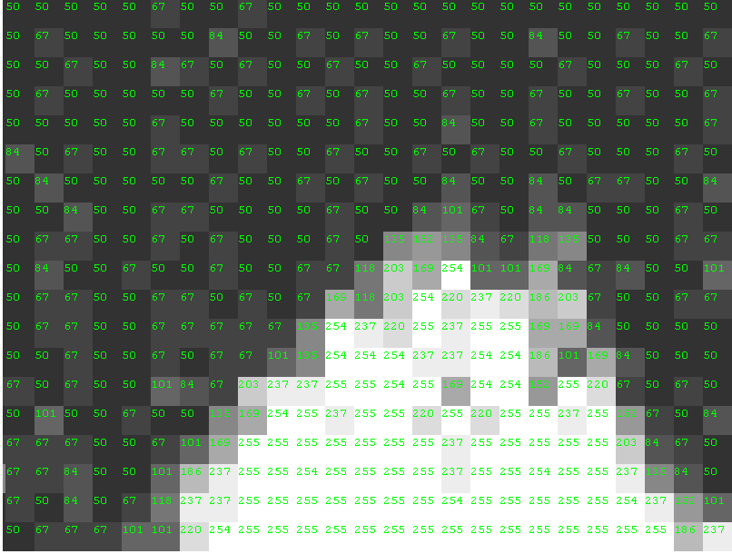
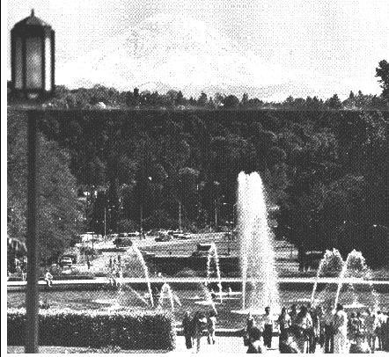

Fig 5.1 Digital Representation of an image

5.1.3 Sobel Edge Detection Technique
The Sobel operator performs a 2-D spatial gradient measurement on an image and so emphasizes regions of high spatial frequency that correspond to edges. Typically it is used to find the approximate absolute gradient magnitude at each point in an input grayscale image. In theory at least, the operator consists of a pair of 3×3 convolution kernels as shown in Figure 1. One kernel is simply the other rotated by 90°(Transpose multiplied by -1).
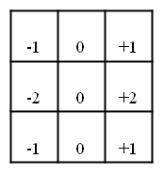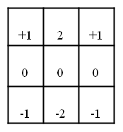
G_{x} G_{y}
Fig 5.2 Sobel convolution kernels
These kernels are designed to respond maximally to edges running vertically and horizontally relative to the pixel grid, one kernel for each of the two perpendicular orientations. The kernels can be applied separately to the input image, to produce separate measurements of the gradient component in each orientation (call these Gx and Gy). These can then be combined together to find the absolute magnitude of the gradient at each point and the orientation of that gradient. The gradient magnitude is given by:
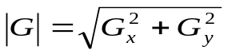

Typically, an approximate magnitude is computed using:

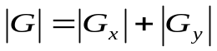
The angle of orientation of the edge (relative to the pixel grid) giving rise to the spatial gradient is given by:
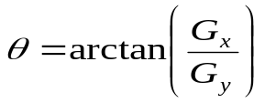

In this case, orientation 0 is taken to mean that the direction of maximum contrast from black to white runs from left to right on the image, and other angles are measured anti-clockwise from this.
Often, this absolute magnitude is the only output the user sees the two components of the gradient are conveniently computed and added in a single pass over the input image using the pseudo-convolution operator shown in Figure 2.

P₁ | P₂ | P₃
P₄ | P₅ | P₆
P₇ | P₈ | P₉

Fig 5.3 Pseudo-convolution kernels
It is used to quickly compute approximate gradient magnitude.
Using this kernel the approximate magnitude is given by:

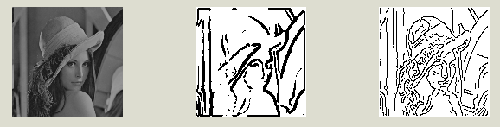
Fig 5.4 Images on performing Sobel Edge Detection

Thresholding (Hysteresis)
An upper and lower edge value limits are set. If a value lies above the upper threshold limit it is immediately accepted. If the value lies below the low threshold it is immediately rejected. Points which lie between the two limits are accepted if they are connected to pixels which exhibit strong response.

5.1.4 Grayscale Conversion Process
After the feature vectors are found the image is converted to grayscale. We convert the edges to grayscale as it eliminates the RGB components of each pixel and contains only a single value for each pixel. The grayscale luminance range varies from 0-255. The converted edges are stored as a 128x128 pixel matrix.

5.2 IMAGE TRANSFORMATION
The image transformation technique used here is discrete wavelet transform.
Wavelets are mathematical functions that satisfy certain criteria, like a zero mean, and are used for analyzing and representing signals or other functions.
In Discrete Wavelet Transform (DWT) the scale and translate parameters are chosen such that the resulting wavelet set forms an orthogonal set, i.e. the inner product of the individual wavelets is equal to zero.
Wavelet Transform have several advantages. Here we list a number of these in regard to image compression and processing.
- One of the main features of Wavelet Transform, which is important for data compression and image processing applications, is its good decorrelating behavior.
- Wavelets are localized in both the space (time) and scale (frequency) domains. Hence they can easily detect local features in a signal.
- Wavelets are based on multi-resolution analysis. A wavelet decomposition allows to analyze a signal at different resolution levels (scales), which results in superior objective and subjective performance
- Wavelets are smooth, which can be characterized by their number of vanishing moments.
- Fast and stable algorithms are available to calculate the Discrete Wavelet Transform and its inverse.

5.2.1 Discrete Wavelet Transformation
The two-dimensional wavelets transform alternates between operations on rows and columns. First, we perform one step of horizontal pair wise averaging and differencing on the pixel values in each row of the image. Next, we apply vertical pair wise averaging and differencing to each column of the result. To complete the transformation, we repeat this process recursively only on the quadrant containing averages in both directions.

DWT Algorithm:
- Step 1: replace each row with its 1-D DWT
- Step 2: Replace each column with its 1-D DWT
- Step 3: Repeat steps 1 & 2 on the lowest subband for the next scale
- Step 4: Repeat step 3 until as many scales as desired

Original image
L
H
LH
HH
HL
LL
LH
HH
HL
One scale
Two scales

Key: L=low H-high
Fig 5.5 DWT

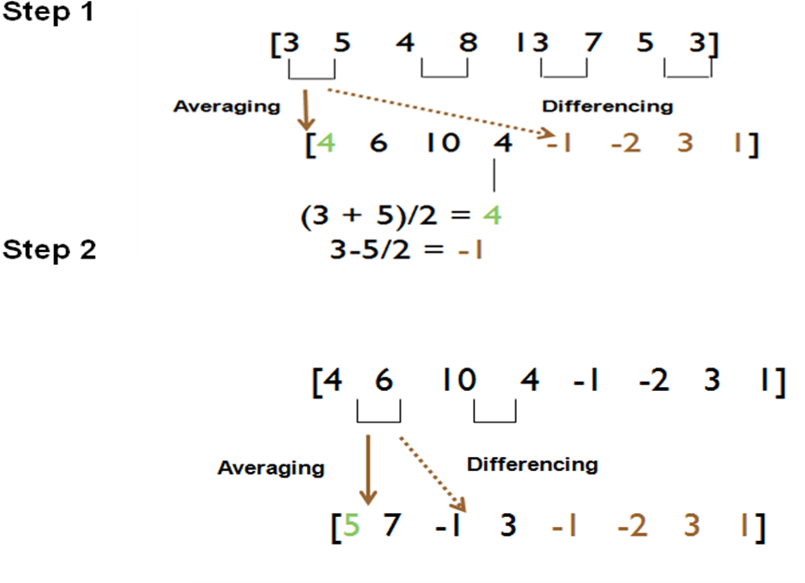
Fig 5.6 Array representation of two level wavelet decomposition of images
5.2.2 Advantages
- Computationally efficient (because of its smaller dimension at higher level)
- Provides multiresolution analysis of an image.

5.3 SIMILARITY COMPARISON
A very widely used class of image similarity metrics involve performing some operation on the differences between corresponding pixels in two images, then summing over these modified differences. These are referred to collectively as the LP family of similarity metrics, or the Minkowski metric. The most commonly used members of this family are the L1 and L2 norms. The L1 metric is also called the Manhattan distance or the Mean Absolute Error (MAE), and the L2 metric is also called the Euclidean distance or Mean Square Error (MSE). The L2 metric has the advantage of being continuously differentiable.
The Minkowski distance of order p between two points

is defined as:
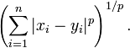
Minkowski distance is typically used with p being 1 or 2. The latter is Euclidean distance(L2 norm), while the former is sometimes known as the Manhattan distance(L1 norm).
5.3.1 Comparison of pixel values
Upon Discrete Wavelet transformation a 32x32 resultant image matrix is obtained. This contains the most efficient pixel data which is used to compare the images. The user selected image is processed and the standard deviation of the pixel values for each row and column are calculated. These steps are repeated for every image in the dataset. Finally the standard deviations of the discrete wavelet transformed pixel matrices are compared to obtain the nearest neighbors.

5.3.2 Finding nearest neighbor
The standard deviations of each image matrix’s row and column are stored in a lookup structure. The nearest neighbor is merely calculated as the difference of the Euclidian distance between the standard deviations found. In other words, the Euclidian distance between the standard deviations of each row and column of image are calculated and this resulting distance value is used to find the nearest neighbors.

5.3.3 Displaying most relevant images
The differences between the distances are used to find the 10 most relevant images from the dataset. These images are retrieved from the dataset and displayed in the Graphical User Interface (GUI).

5.4 GENETIC ALGORITHM IMPLEMENTAION WITH RELEVANCE
FEEDBACK
A Genetic Algorithm is an AI technique which uses adaptive procedures to solve problems of searches that satisfy certain requirements, and is inspired in the mechanisms of biological evolution, based on the principle of natural selection and on species’ genetic codes. The input to a GA is a population of individuals called chromosomes. These represent the possible solutions to the problem. The chromosomes may be randomly generated, or, if one already has some knowledge of the optimal distribution, one may use that information to create part of the initial set of potential solutions. These individuals evolve in successive iterations called generations, by processes of selection, crossover, and mutation. These iterations stop when the system ceases to improve or when a set of maximum number of generations is reached. The output of the GA is the best individual of the final population or a combination of the best chromosomes of that population. Relevance feedback is done instead of finding a fitness function.

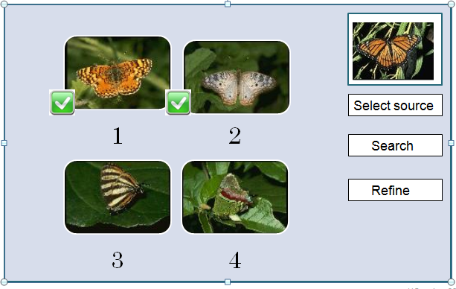
Fig 5.7 GUI of IGARF implementaion

5.4.1 Relevance Feedback Technique
Relevance Feedback is used to display to the user, the 10 most relevant images in the database. In the refine stage, relevance feedback is used to get the input from user, whether the images are relevant or not. A checkbox is provided to select relevant images. These images are processed using genetic algorithms and the dataset is refined to produce a refined set of results to the user. Thus feedback is taken to refine the dataset.
Here the user does the positive selection thereby eliminating the irrelevant images and selecting only the relevant images. This ensures better results in the further iterations and the images are retrieved in accordance to the users expectance.

5.4.2 Selection of Parents
User selection is essential in performing genetic algorithm, as among the many user selected choices, only two are selected as parents. The two images are selected at random and they are chosen as the parents, for which an offspring is generated. Essentially they are the phenotypes, which generate the genotype.
Discard the images which were not selected as irrelevant (Negative selection).

5.4.3 Genetic Operations (Crossover)
Two user selected images are taken as the parents for genetic algorithms. The genetic operation performed here is crossover. Wherein the two parent images are chosen and one half of the image matrix is overlapped with the other half to form a resultant matrix. This matrix is termed the offspring of the genetic operation. The offspring is then compared with the dataset to refine the database, and produce a new set of relevant images.

Procedure by which chromosome is constructed in Genetic Algorithm:

begin
t=0;
Initialize P(t);
Evaluate P(t);
While (not termination-condition) do
begin
t=t+1;
Select P(t) from P(t-1);
After (crossover) P(t);
Evaluate P(t);
end
end

The iterative procedure can be summarized as follows: during iteration (generation) ‘t’ the GA has a population P(t) of potential solutions (the chromosomes or vectors). Each chromosome is evaluated by means of the fitness function to give a measure of its suitability. The most suitable individuals are selected to form part of the reproduction population.
Some of the members of this intermediate reproduction population undergo alterations (recombination) due to the action of genetic operators (crossover) to form new solutions which make up a new population P(t+1), and which in turn will be the initial population of the following generation. The process is iterated until the termination condition is reached.

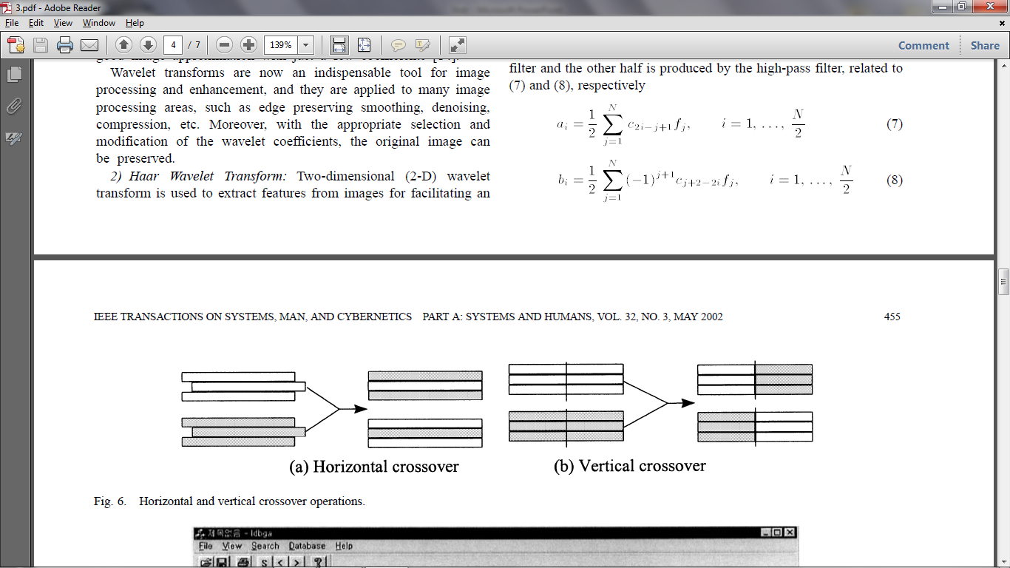
Fig 5.8 Crossover in Genetic Algorithm

5.5 NEAREST NEIGHBOUR APPROACH
In nearest neighbour approach we calculate the Euclidian distance between the standard deviation values of the image pixel matrices. This distance is used to find the 10 nearest images to the query image and display them to the user through the GUI.
The k value in the k-nearest neighbour algorithm is fixed to be 10 in this case.
The nearest neighbour is found to be the image with the least distance in the dataset and the image is classified accordingly. The same process is used during refine stage, when an offspring is classified.

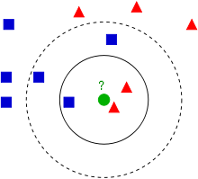

Key

- Genotype of input image in the feature space
- Genotypes that belong to a class
- Genotypes that belong to another separate class

Fig 5.9 Example of k-NN classification.

The test sample (center circle) should be classified either to the first class of squares or to the second class of triangles. If k = 3 it is assigned to the second class because there are 2 triangles and only 1 square inside the inner circle. If k = 5 it is assigned to the first class (3 squares vs. 2 triangles inside the outer circle).

Here the nearest images are obtained by calculating the L2 norm (distance from the input query image/offspring ). The k images with least L2 norm value is obtained as they are the most similar ones (nearest neighbour) in the feature vector space.

CHAPTER 6
IMPLEMENTATION RESULTS

SCREENSHOTS

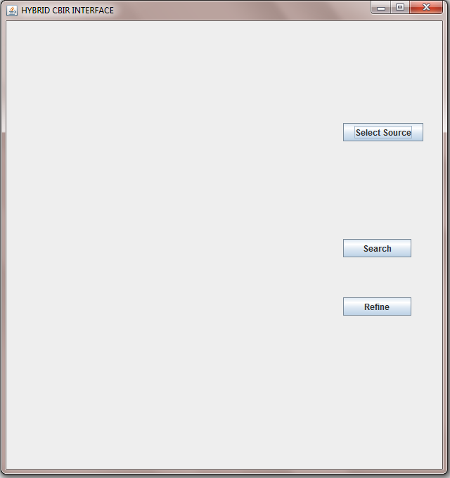

Fig 6.1 GUI before selecting input query image

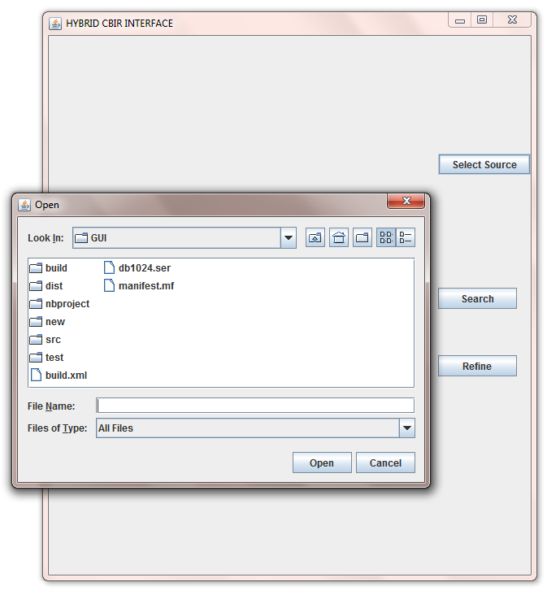

Fig 6.2 Interface to select input query image

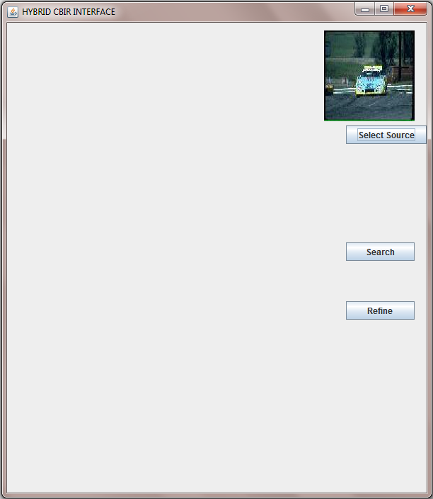

Fig 6.3 GUI after selecting query image

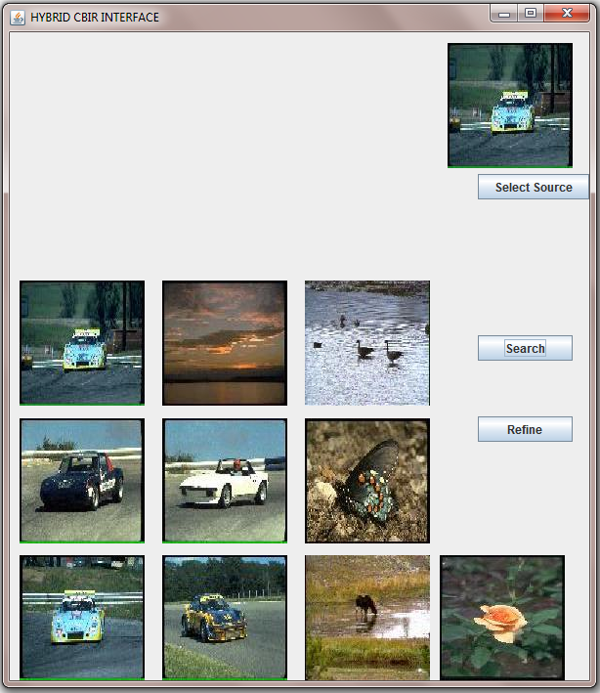

Fig 6.4 Initial search result
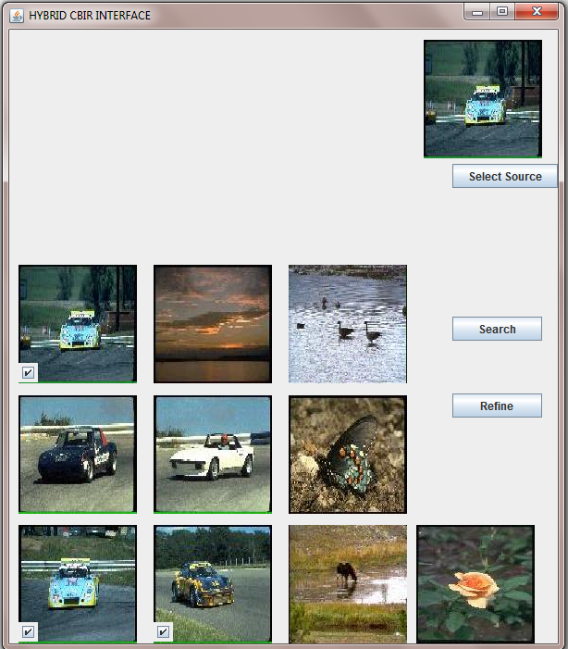

Fig 6.5 Selection of Relevant images by the user
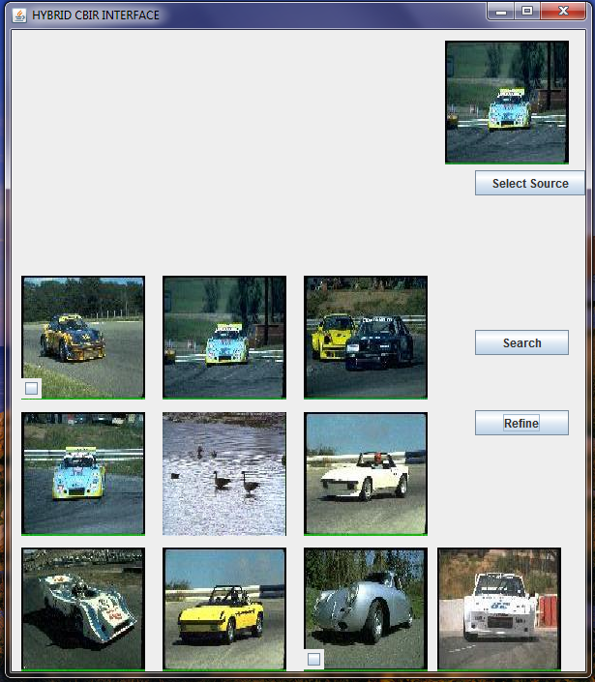

Fig 6.6 Search Result after refining using IGARF
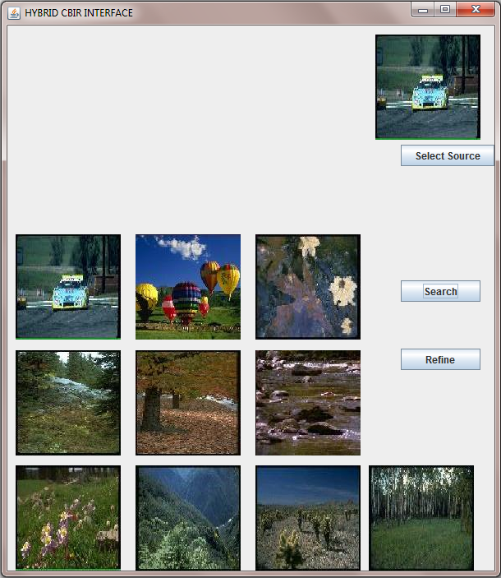

Fig 6.7 Search result using color histogram as feature vector

Comparison Table

Method | Color Histogram | Sobel  Edge detection | Hybrid CBIR
Avg no. of images retrieved | 2 | 3 | 6
Retrieval  accuracy % | 20% | 30% | 60%

Table 6.1 Comparison of Retrieval rate

CHAPTER 7
CONCLUSION AND FUTURE WORK
CONCLUSION
The project attempts to present a hybrid technique for content based image retrieval, which uses the combination of Feature extraction (edge detection) with Interactive Genetic Algorithm with Relevance Feedback yields an better image retrieval accuracy. Usage of genetic algorithm yields fitter individuals to make the search more efficient and thereby increase the retrieval rate. Interactive relevance feedback helps in retrieval of desired image as the user selects the relevant images for the next iteration, thus the retrieved images will be in accordance to the users expectation. Thus the combined approach incorporates the advantages of each individual method to result in a better retrieval method.

FUTURE WORK
The present work can be extended by improving the recognition rate by increasing the feature vectors and using a combined approach to retrieve similar images. The present implementation has an application in lot of fields such as military, medicine, crime detection, etc,. An embedding of number plate recognition program with this method will help to identify vehicles automatically, which will help in finding stolen vehicles. Given a image database of vehicles(images capture by the surveillance camera), the program can retrieve similar images of cars from database in accordance to input image. The viewer can refine the database for more accurate results. The use of relevance feedback is essential in refining the search. Further more using number plate recognition program the user can search for number plates by giving the number as query, and retrieve information about the vehicle. A hardware device for capturing pictures in a highway can be used to update the database with images of number plates in a certain locality. The user can then find the time of theft from the database and similarity comparison provides accurate results about the number plate.

REFERENCES

[1] MiguelArevalillo-Herráez,FrancescJ.Ferri,SalvadorMoreno-Picot,(2011) ‘Distance-based relevance feedback using a hybrid interactive genetic algorithm for image retrieval ‘, Applied Soft Computing, vol.11, issue 2, pp 1782-1791.

[2] S.-B. Cho, J.-Y. Lee, (2002) ‘A human-oriented image retrieval system using interactive genetic algorithms’, IEEE Transactions on Systems, Man, and Cybernetics. Part A: Systems and Humans vol.32, issue 3, pp452–458.

[3] Jack Sklansky, (1978) ‘Image Segmentation and Feature Extraction’, IEEE Transactions on systems, man, and cybernetics, vol.8, issue 4.

[4] http://www.pages.drexel.edu/~weg22/can_tut.html

[5] http://en.wikipedia.org/wiki/K-nearest_neighbor_algorithm

