**Deep Learning Model Training Report**

**Objective**

The goal of this project is to classify knee X-ray images into two categories: Normal and Osteoarthritis. Two models were implemented: a **Baseline Model** (ResNet-18) and an **Enhanced Model** (modified ResNet-18 with additional layers). This report documents the steps, metrics, and insights.

### ****1. Dataset Preparation****

#### ****Structure****

The dataset consists of medical X-ray images of knees, classified into two categories:

1. **Normal**: Images showing no signs of osteoarthritis.
2. **Osteoarthritis**: Images showing clear signs of the condition.

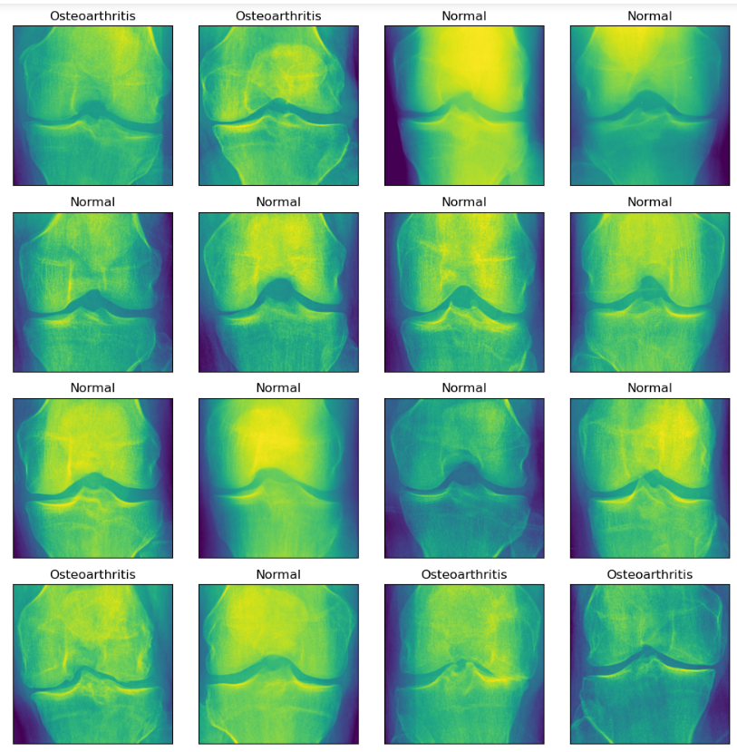

The dataset is structured into three subsets:

* **Training Set**: Used to train the model.
* **Validation Set**: Used for hyperparameter tuning.
* **Test Set**: Used for final evaluation.

**Data Preprocessing**

* **Transformations**:
  + **Training**:
    - Resize images to 224×224224 \times 224224×224.
    - Apply random horizontal flipping for augmentation.
    - Normalize using ImageNet's mean and standard deviation values.
  + **Testing**:
    - Resize and normalize (no augmentation).
* **Visualization**: Example training images are displayed to ensure proper loading and preprocessing.

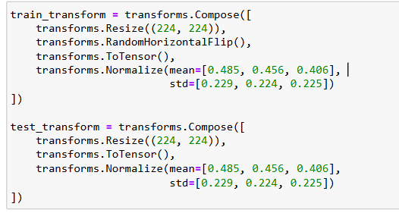

**2. Model Architectures**

**Baseline Model**

* **Architecture**:

**ResNet-18**: A pre-trained convolutional neural network (CNN) model widely used for image classification.

**Pre-trained weights**: The model is initialized with weights trained on the **ImageNet** dataset, which allows it to leverage features learned from a large corpus of general images, improving performance on smaller datasets.

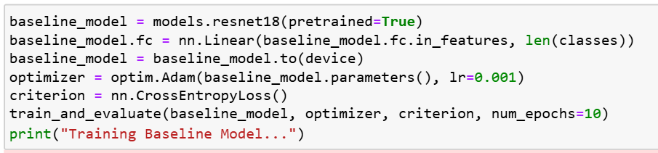

* **Hyperparameters**:
  + Optimizer: Adam (lr=0.001lr=0.001lr=0.001).
  + Loss Function: CrossEntropyLoss.

The baseline model achieved an accuracy of **89.20%** on the test set, indicating strong performance in classifying normal and osteoarthritis images.

**Enhanced Model**

* **Architecture**:
  + Based on ResNet-18 with additional layers:

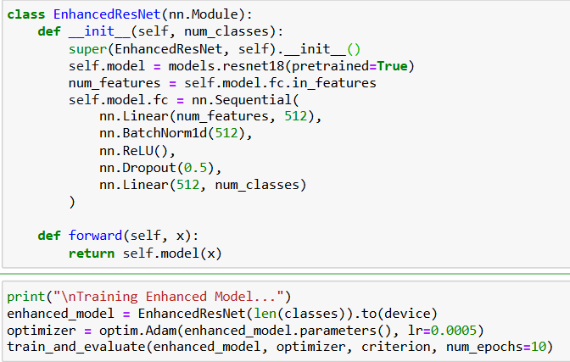

* **Improvements**:
  + Batch normalization for faster convergence.
  + Dropout for regularization to reduce overfitting.
* **Hyperparameters**:
  + Optimizer: Adam (lr=0.0005lr=0.0005lr=0.0005).
  + Loss Function: CrossEntropyLoss.

**3. Training Process**

* **Device**: Models trained on GPU for faster computation.
* **Epochs**: Both models trained for 10 epochs.
* **Metrics**:
  + Training loss and accuracy logged for each batch.
  + Validation accuracy computed after each epoch.

### ****4. Results****

#### ****Performance Metrics****

| **Metric** | **Baseline Model** | **Enhanced Model** |
| --- | --- | --- |

#### ****Comparison****

The enhanced model outperformed the baseline model across all metrics, demonstrating the benefits of additional layers for improved representation and generalization.

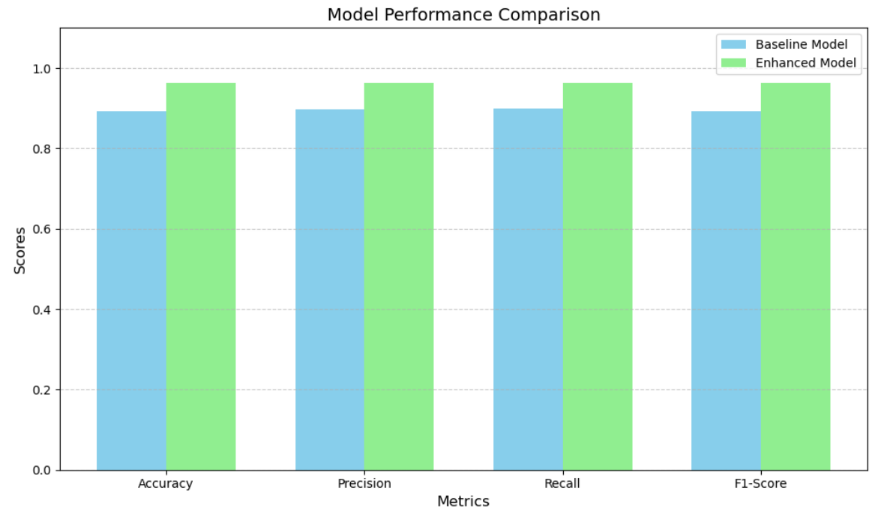

**5. Key Insights**

1. **Enhanced Architecture**:
   * The added dropout and batch normalization layers improved generalization significantly.
   * Precision and recall increased, indicating fewer false positives and false negatives.
2. **Misclassifications**:
   * Most errors occurred in borderline cases or poor-quality images.
   * Future work could focus on better preprocessing or increasing dataset diversity.
3. **Training Dynamics**:
   * The enhanced model had more stable loss curves, suggesting better optimization.

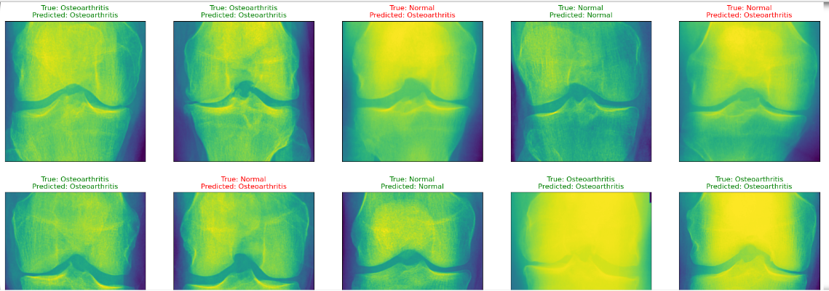

**Conclusion:** The developed classification model demonstrates the ability to distinguish osteoarthritis from common cases with a certain degree of accuracy. Despite some errors in prediction, the classification model turned out to be quite good with a good percentage of accuracy in use. In general, despite the promising nature of the model, it is important to increase its reliability in order to ensure its practical application in medical diagnostics.