# Supplementary Figures

Figure S1. Summary of the meta-analysis method.

Figure S2. Distribution of tau tissue specificity scores from the GTEx expression dataset.

Figure S3. Interaction networks showing the locations of the global analysis differentially expressed genes in the BioGRID and GeneFriends networks.

Figures S4-S7. Distributions of degree, betweenness and closeness centralities for overexpressed, underexpressed and unchanged genes in a genome-wide PPI network for the global, brain, heart and muscle analyses.

Figures S8-S10. Median degree, betweenness and closeness centralities for overexpressed, underexpressed and unchanged genes in a genome-wide PPI network for the global, brain, heart and muscle analyses, with statistical comparisons.

Figures S11-S14. Distributions of degree, betweenness and closeness centralities for overexpressed, underexpressed and unchanged genes in an unweighted co-expression network extracted from GeneFriends for the global, brain, heart and muscle analyses.

Figures S15-17. Median degree, betweenness and closeness centralities for overexpressed, underexpressed and unchanged genes in an unweighted co-expression network extracted from GeneFriends for the global, brain, heart and muscle analyses, with statistical comparisons.

Figures S18-S19. Distributions of human-mouse and human-rat dN/dS scores and comparisons between overexpressed, underexpressed and unchanged genes for the global analysis.

# Supplementary Tables (in accompanying excel files)

Table S1. List of datasets used in the meta-analysis.

Tables S2-S5. Genes overexpressed with age (*p*<0.05) in the global, brain, heart and muscle analyses.

Tables S6-S9. Genes underexpressed with age (*p*<0.05) in the global, brain, heart and muscle analyses.

Tables S10-S17. Enrichment anlaysis results for the global, brain, heart and muscle analyses.

Tables S18-S25. Enrichment anlaysis results for the global, brain, heart and muscle analyses.

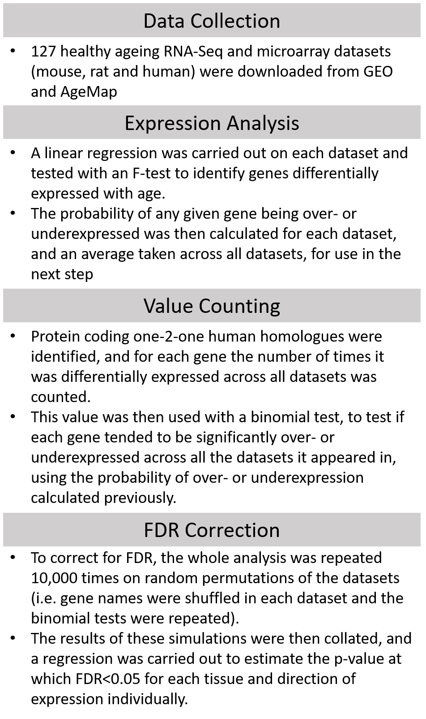

Figure S1. Summary of the meta-analysis method.

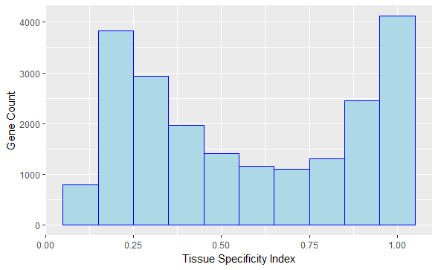

Figure S. Distribution of τ tissue specificity scores in the whole GTEx expression dataset. A τ specificity index of 0 indicates complete nonspecific expression while an index of 1 indicates completely specific expression.

Figure S3. Interaction networks showing the locations of the overexpressed (red) and underexpressed (blue) genes in the (A) BioGRID PPI network and the (B) GeneFriends coexpression network.

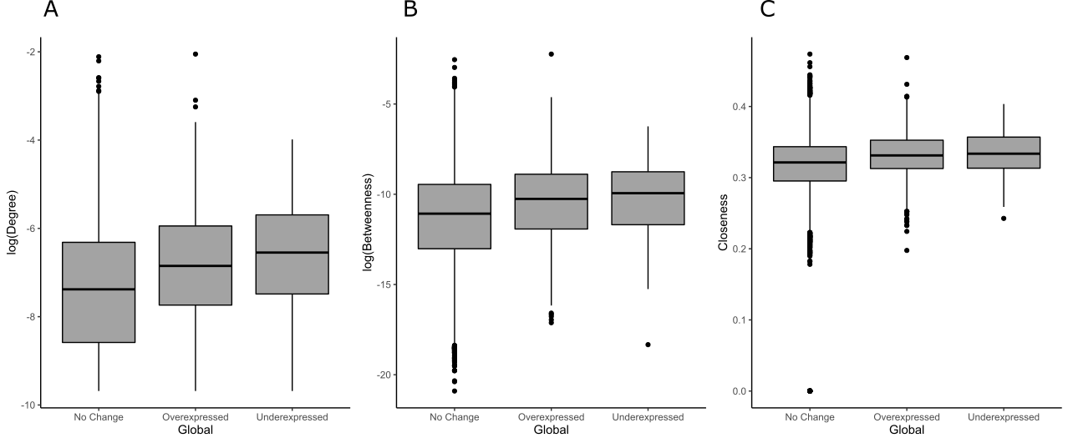

Figure S4. Distributions of degree (normalised by dividing by the maximum degree of a graph n-1, where n is the number of nodes in graph G) (A), betweenness (B) and closeness (C) centrality measures in a genome-wide PPI network for overexpressed, underexpressed and unchanged genes from the global analysis.

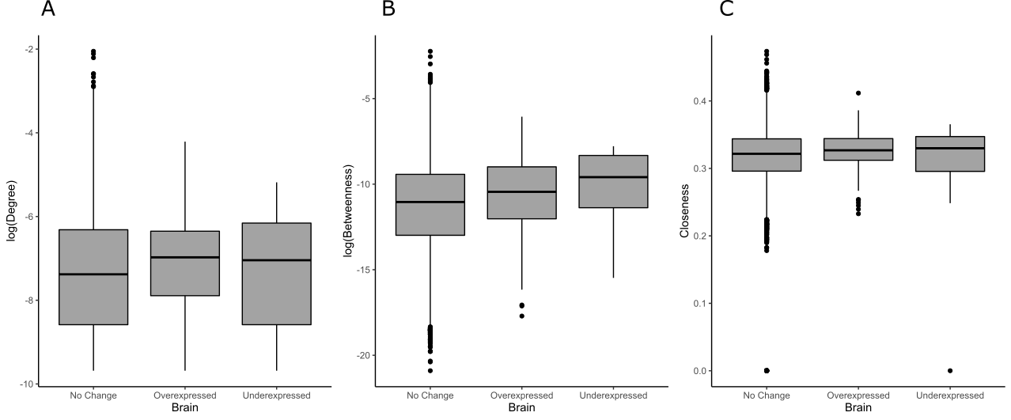

Figure S5. Distributions of degree (normalised by dividing by the maximum degree of a graph n-1, where n is the number of nodes in graph G) (A), betweenness (B) and closeness (C) centrality measures in a genome-wide PPI network for overexpressed, underexpressed and unchanged genes from the brain analysis.

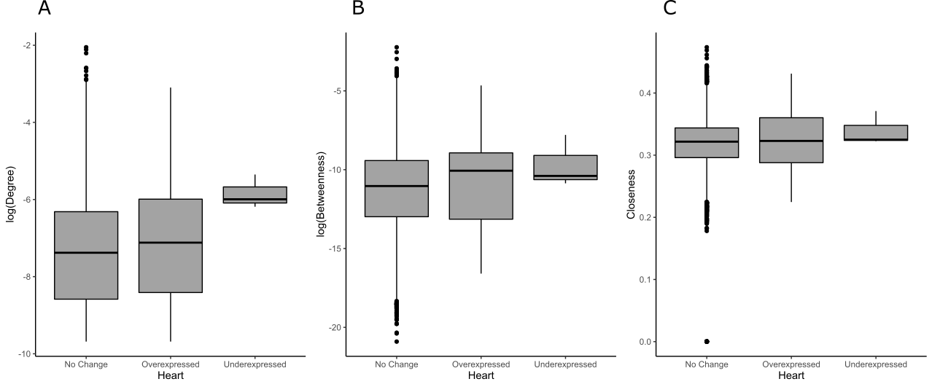

Figure S6. Distributions of degree (normalised by dividing by the maximum degree of a graph n-1, where n is the number of nodes in graph G) (A), betweenness (B) and closeness (C) centrality measures in a genome-wide PPI network for overexpressed, underexpressed and unchanged genes from the heart analysis.

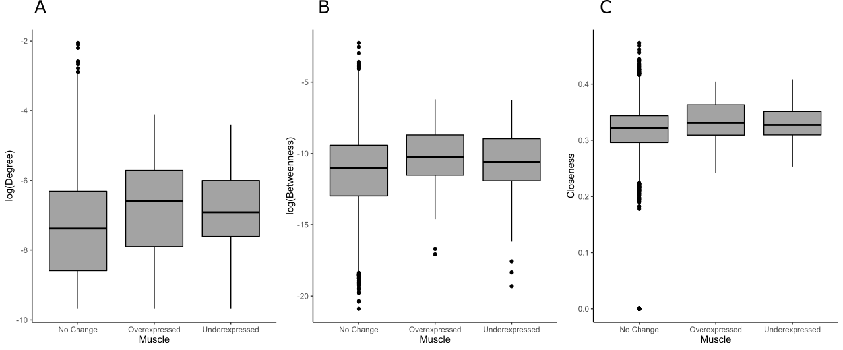

Figure S7. Distributions of degree (normalised by dividing by the maximum degree of a graph n-1, where n is the number of nodes in graph G) (A), betweenness (B) and closeness (C) centrality measures in a genome-wide PPI network for overexpressed, underexpressed and unchanged genes from the muscle analysis.

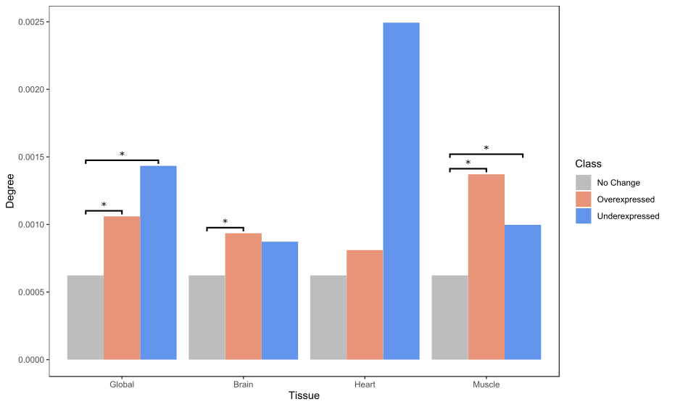

Figure S8. Median degree (normalised by dividing by the maximum degree of a graph n-1, where n is the number of nodes in graph G) values in a genome-wide PPI network for overexpressed, underexpressed and unchanged genes from each analysis. * indicates significance tested by a Mann-Whitney U test (Bonferroni corrected).

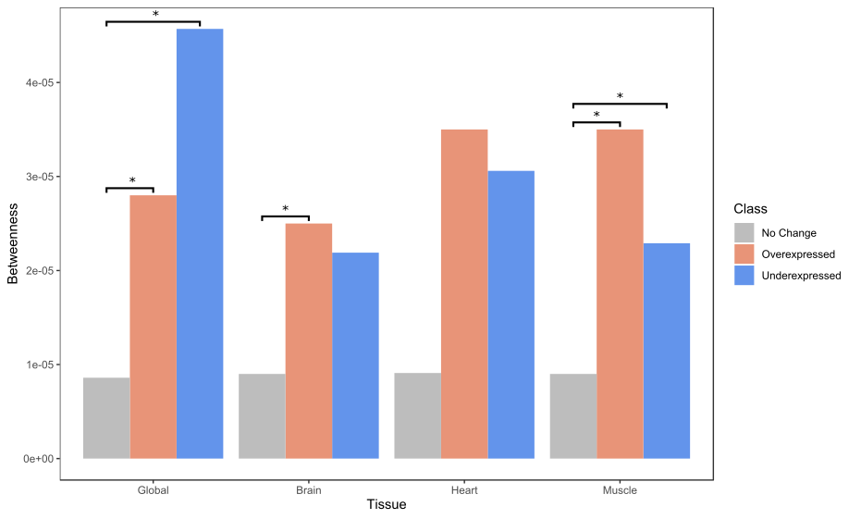

Figure S9. Median betweenness values in a genome-wide PPI network for overexpressed, underexpressed and unchanged genes from each analysis. * indicates significance tested by a Mann-Whitney U test (Bonferroni corrected).

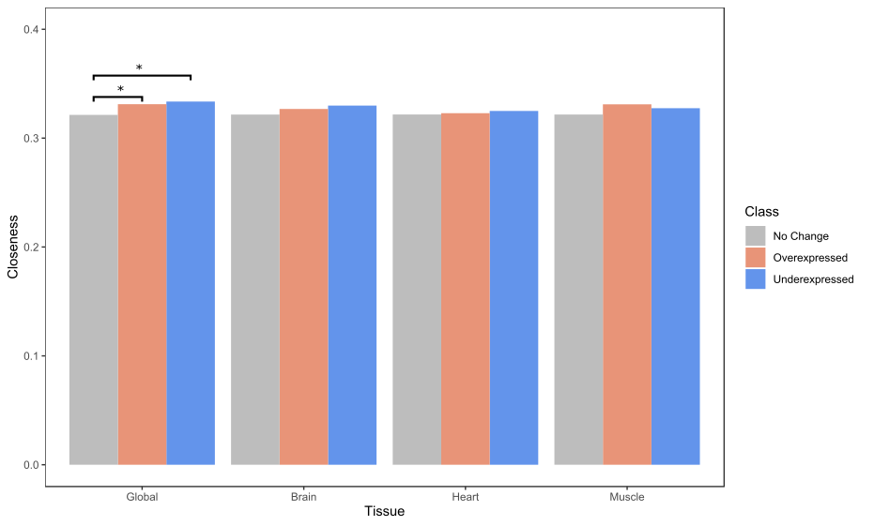

Figure S10. Median closeness values in a genome-wide PPI network for overexpressed, underexpressed and unchanged genes from each analysis. * indicates significance tested by a Mann-Whitney U test (Bonferroni corrected).

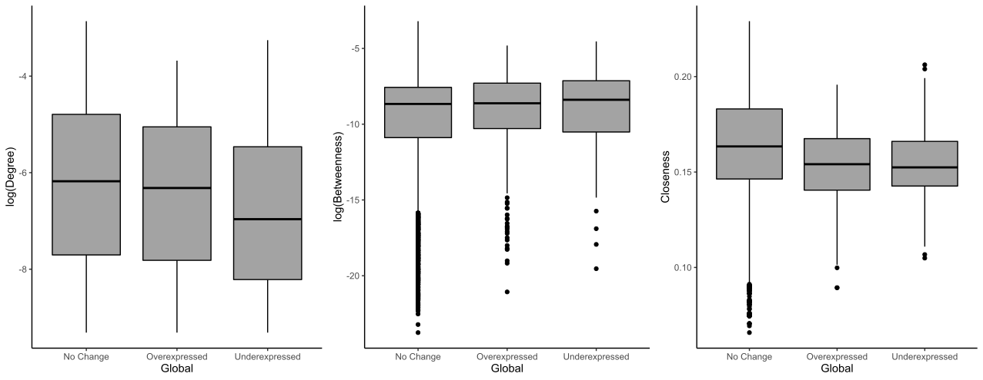

Figure S11. Distributions of degree (normalised by dividing by the maximum degree of a graph n-1, where n is the number of nodes in graph G) (A), betweenness (B) and closeness (C) centrality measures in an unweighted co-expression network extracted from GeneFriends for overexpressed, underexpressed and unchanged genes from the global analysis.

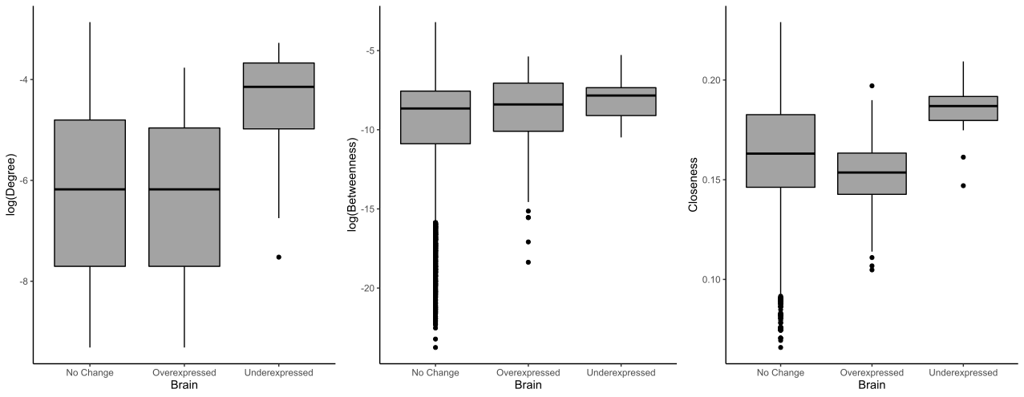

Figure S12. Distributions of degree (normalised by dividing by the maximum degree of a graph n-1, where n is the number of nodes in graph G) (A), betweenness (B) and closeness (C) centrality measures in an unweighted co-expression network extracted from GeneFriends for overexpressed, underexpressed and unchanged genes from the brain analysis.

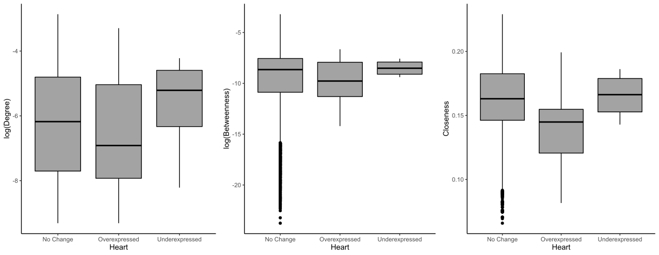

Figure S13. Distributions of degree (normalised by dividing by the maximum degree of a graph n-1, where n is the number of nodes in graph G) (A), betweenness (B) and closeness (C) centrality measures in an unweighted co-expression network extracted from GeneFriends for overexpressed, underexpressed and unchanged genes from the heart analysis.

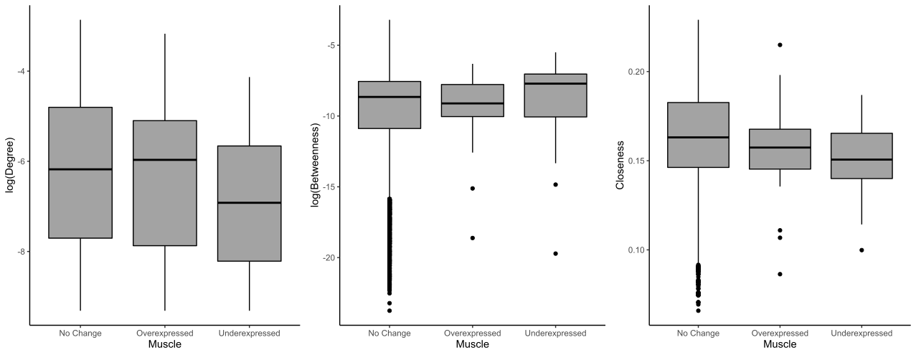

Figure S14. Distributions of degree (normalised by dividing by the maximum degree of a graph n-1, where n is the number of nodes in graph G) (A), betweenness (B) and closeness (C) centrality measures in an unweighted co-expression network extracted from GeneFriends for overexpressed, underexpressed and unchanged genes from the muscle analysis.

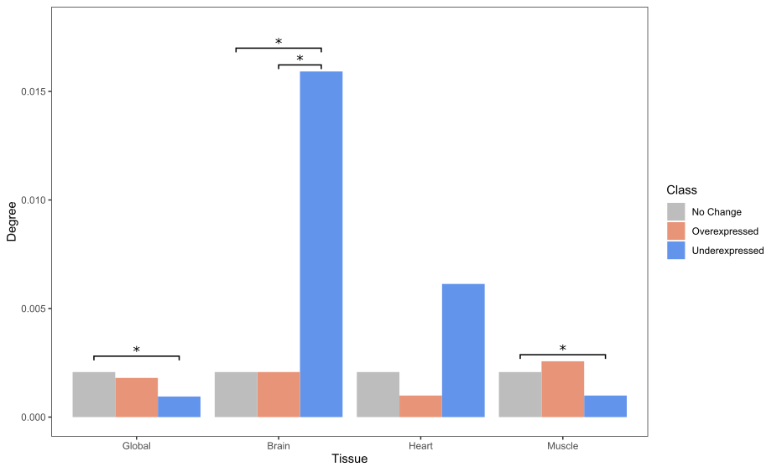

Figure S15. Median degree (normalised by dividing by the maximum degree of a graph n-1, where n is the number of nodes in graph G) values in an unweighted co-expression network extracted from GeneFriends for overexpressed, underexpressed and unchanged genes from each analysis. * indicates significance tested by a Mann-Whitney U test (Bonferroni corrected).

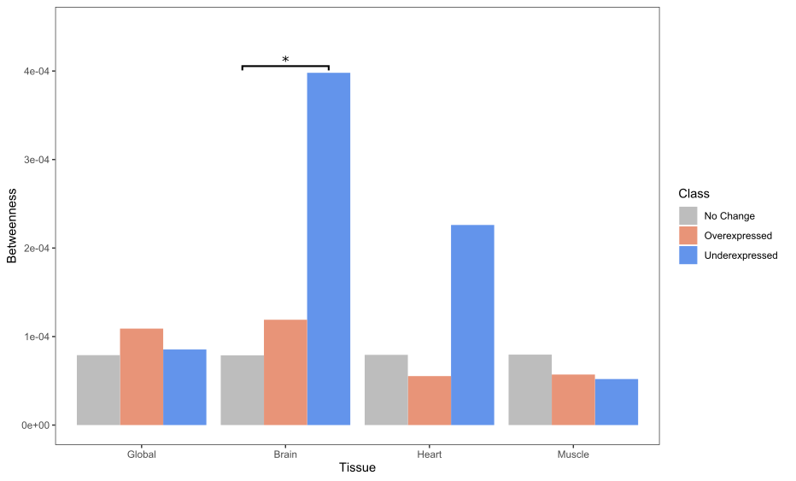

Figure S16. Median betweenness values in an unweighted co-expression network extracted from GeneFriends for overexpressed, underexpressed and unchanged genes from each analysis. * indicates significance tested by a Mann-Whitney U test (Bonferroni corrected).

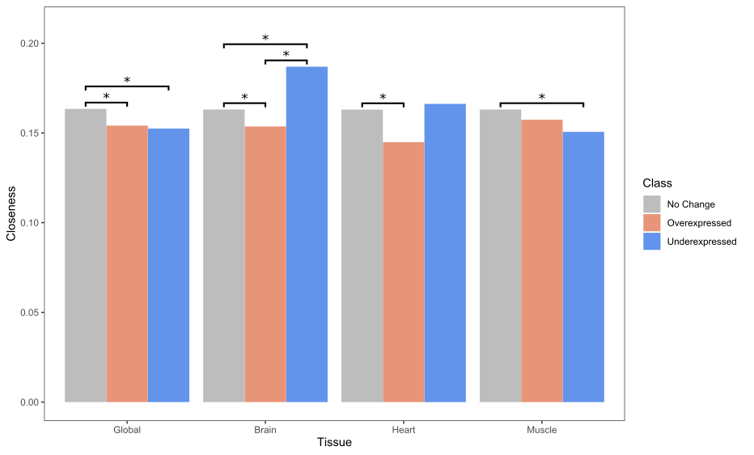

Figure S17. Median closeness values in an unweighted co-expression network extracted from GeneFriends for overexpressed, underexpressed and unchanged genes from each analysis. * indicates significance tested by a Mann-Whitney U test (Bonferroni corrected).

Figure S18. Distribution of human-mouse dNdS scores for the different gene classifications (not differentially expressed, overexpressed and underexpressed).

Figure S19. Distribution of human-rat dNdS scores for the different gene classifications (not differentially expressed, overexpressed and underexpressed).