SequenceTree 4.2.1 Released
April 3rd, 2009
I am very pleased to announce the release and immediate availability of a major new version of SequenceTree and related software. This new release includes the following new capabilities:
- Improved interfacing to the Siemens protocol and user interface, so that both standard and special parameters can be set and retrieved by the sequence.
- Improved interfacing to the Siemens online reconstruction system, enabling online reconstruction for SequenceTree sequences with simple 2D and 3D acquisition schemes.
- New tools for automatic parsing of raw data, for both SequenceTree and non-SequenceTree sequences.
- New tools for automatic real time parsing of raw data (during the scan), enabling efficient and automatic offline reconstruction.

In addition, SequenceTree 4.2.1 is now built on the very latest version of the Qt libraries (i.e. Qt 4.5.0). The installation procedure has changed slightly, so please visit the SequenceTree wiki for detailed instructions (http://www.thesouthpoles.com/sequencetree/wiki).

Online Reconstruction versus
Offline Reconstruction from Raw K-Space Data
A great dichotomy – whether to perform online reconstruction, and have the images pop up at the scanner console, or whether to gather the raw k-space data and perform offline reconstruction using MATLAB, ChainLink, C++, or other tools. In this section I will argue that there is no clear universal answer to this important question, but that the right choice depends on the application, and the goals and circumstances surrounding the research being conducted.
On the one hand, it is clear that in many cases it is very desirable, and even essential, to have images appear automatically at the scanner console when the scan has completed. For example this is an essential feature for localizer scans. Furthermore, for archiving purposes it is important for reconstructed images to enter into the image database associated with the patient. One could argue that the ultimate goal for any imaging technique is to eventually have a fully automated and fully integrated image reconstruction in place.
However, from the perspective of the researcher developing novel techniques, the convenience of online reconstruction must be weighed against the difficulty of implementation as well as the limitations inherent to the online reconstruction. For example, during technique development (or the prototyping phase), offline reconstruction based on raw k-space data is often the preferred technique since the changing reconstruction algorithm and data exploration can be most conveniently performed using offline tools such as MATLAB. But even after a novel technique has been developed, tested, and optimized, the image reconstruction algorithm may involve non-trivial and non-conventional steps that are again most easily and most effectively implemented in off-scanner environments. Indeed for some novel techniques, it may even be impossible to implement the appropriate image reconstruction algorithm within the Siemens ICE environment.
In summary, there tend to be two schools of thought regarding implementation of image reconstruction algorithms for novel MRI techniques on a clinical scanner. Some researchers refuse to ever look at the raw data, whereas other researchers will always save the raw k-space data, and perform all reconstruction offline. In general, the appropriate choice depends on the type of research being conducted. This new version of SequenceTree (and related tools) recognizes the need to support both online and offline efforts of image reconstruction, with new tools and capabilities addressing both strategies. See below for details.

Connecting ST Sequences to the
Siemens Protocol and Operator Interface
Beginning with version 4.2.1, SequenceTree has a new and improved method for interfacing to standard and special protocol parameters available on the Siemens operator interface. Recall that in previous versions of SequenceTree, this was accomplished using special syntax in the ‘Notes’ tab of the sequence. This method is now obsolete. Instead the interfacing is now done using C++ code in the Root node of the sequence.
‘Special’ parameters are user-defined parameters that appear on the WIP special card of the operator interface, whereas ‘standard’ parameters are parameters that are part of the standard Siemens protocol (e.g. TE, TR, flip angle). See Table 1 for a complete list of modifiable standard parameters.
Parameter Name | Description
numColumns | Number of readout points (for full acquisition)
numLines | Number of phase encode lines (for full acquisition)
numPartitions | Number of phase encode partitions (for full acquisition)
numSlices | Number of slices (or slabs for 3D imaging)
numAverages | Number of averages
numEchoes | Number of echoes
fovX | Field of view in the readout direction [mm]
fovY | Field of view in the phase encode direction [mm]
sliceThickness | Slice thickness (or partition thickness for 3D imaging) [mm]
sliceDistanceFactor | Factor for slice/slab spacing (fractional distance between slices/slabs)
flipAngle | Primary flip angle [degrees]
TE | Echo time [microsec]
TR | Repetition time [microsec]
Table 1. A list of standard parameters that can be accessed and set from within SequenceTree.
Here are the steps for connecting SequenceTree sequence parameters to the Siemens operator interface:
Step 1: Define the parameters you wish to interface as global parameters (this is not strictly necessary, but is the preferred approach in most cases). See the online user’s manual for instructions on creating global SequenceTree parameters.
Step 2: Go to the code for the Root node of your ST sequence and overload the following two functions:
void setup();
bool prepare();
Ensure that the above declarations appear in the ‘Header’ tab, and that the corresponding implementations appear in the ‘Source’ tab. For example, the implementations may look like this:
void STRoot::setup() {
//setup code goes here
}
bool STRoot::prepare() {
//prepare code goes here
return STSequence::prepare();
}
Step 3: Within the setup() function, set the default values and ranges for each special and standard parameter. For standard parameters, this is done in the following manner:
void STRoot::setup() {
//…
scanner()->setValue("TE",globalParameter("TE"));
scanner()->setRange("TE",1000,1000,40000);
//…
}
For special parameters, this is done in the following manner:
void STRoot::setup() {
//…
scanner()->setValue("RF_duration",globalParameter("RF_duration"));
scanner()->setRange("RF_duration",500,100,2000);
scanner()->addSpecialParameter("RF_duration","UIDOUBLE","RF duration","microsec");
//…
}
Step 4. If you would like to change your sequence functionality in response to the operator’s console choices, you must also set the values of your ST parameters in the prepare() function. For standard parameters this is done in the following manner:
bool STRoot::prepare() {
//…
setGlobalParameter("TE",scanner()->value("TE"));
//…
return STSequence::prepare();
}
For special parameters this is done in the following manner:
bool STRoot::prepare() {
//…
setGlobalParameter("RF_duration",scanner()->value("RF_duration"));
//…
return STSequence::prepare();
}

Online Reconstruction
for Basic 2D/3D Imaging Sequences
SequenceTree sequences can now be reconstructed by the default Siemens image reconstruction program. For now, only basic 2D and 3D Cartesian sampling schemes are supported. To implement online reconstruction, use the following steps:
Step 1: Interface your sequence to the standard protocol parameters (see previous section), especially numColumns, numLines, and numPartitions.
Step 2: Identify the readout nodes in your sequence that are used to acquire the raw data to be reconstructed and set the MDHOnline flag for each using the following syntax:
MainLoop->Block->Acquire->Readout->scannerCommand("setMDHOnline");
It is recommended that this be done in the prepare() function of the root node.
Step 3: Fill the Mdh header for each relevant readout object using the setCurrentLine() and setCurrentPartition() functions in the following manner:
Block->Acquire->Readout(setCurrentLine(PE1-PE1.minimum()));
Block->Acquire->Readout(setCurrentPartition(PE2-PE2.minimum()));
This should be done in the loopRun() function of the loop node. Note that the current line and current partition should be nonnegative integers.

RTST: Automatic Raw Data Parsing
including Real Time Offline Acquisition
SequenceTree contains a new component for parsing and processing of raw data. The program, named RTST, can be launched from the SequenceTree toolbar. This utility differs in the following significant ways from the older method that SequenceTree used for parsing raw data:
- RTST can be used to parse the raw data for both SequenceTree and non-SequenceTree pulse sequences.
- RTST uses the Mdh header information to parse the raw data, and therefore does not require the user to specify the pulse sequence or pulse sequence parameters.
- RTST can be used on a neighboring computer at the scanner to collect and parse the raw data in real time as it comes off the scanner.
- RTST provides an integrated environment for parsing, processing, and saving experiments.
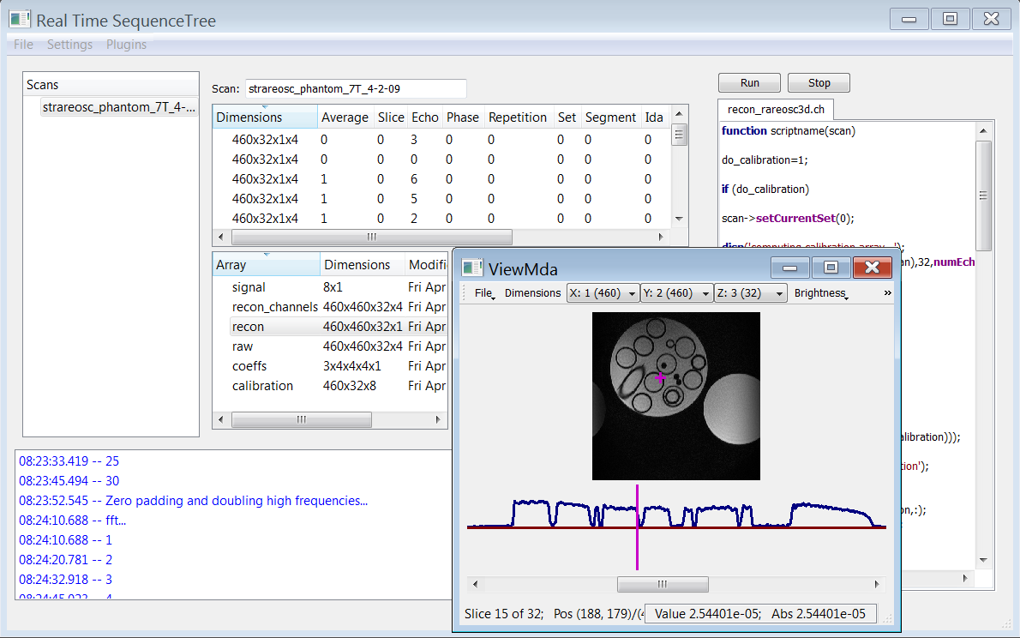
Figure 1. Screenshot of RTST utility (distributed with SequenceTree) for parsing and processing of raw data.
RTST uses the information stored in the Mdh header to assemble the raw data into a collection of four-dimensional arrays of size
.
The indices for these dimensions (found in the Mdh header) can be set from within the ST sequence using the functions setCurrentLine() and setCurrentPartition() as in the previous section. In addition, indices for seven other dimensions can also optionally be set from within the sequence using the following functions:
setCurrentAverage(int avg);
setCurrentSlice(int slice);
setCurrentEcho(int echo);
setCurrentPhase(int phase);
setCurrentRepetition(int rep);
setCurrentSet(int set);
setCurrentSegment(int seg);
RTST will create a separate (four-dimensional) array for each different value of the seven dimension indices above. For example, if a sequence features 8 echoes and 2 averages, then RTST will generate 16 four-dimensional arrays (one for each echo/average combination).
There are two different ways to load raw data into RTST. The first is simply open the raw data file using the menu option: “File->Open raw data…” The second method is to run RTST on a neighboring computer at the scanner and configure the program to collect the raw data in real time during scanning. The latter method only works using Siemens software version VB15.
To configure RTST to collect raw data in real time during the scan, you must first mount the scanner host computer as a network drive (e.g. k:) from the neighboring computer. Next, you must set the proper configuration directories using the menu command “Settings->Configure directories…” from within RTST. For example, you could use the settings in Fig. 2. In this case, you must create a directory (on the host computer) named “k:\temp\rtst”. This is where the raw data will temporarily be stored as it is generated by the scan before it is parsed (and then deleted) by RTST. You must also copy a file named ‘IceConfig_rtst.evp’ to the k:\MedCom\config\ice directory. Contact Jeremy for a copy of this configuration file (or instructions on creating the file).
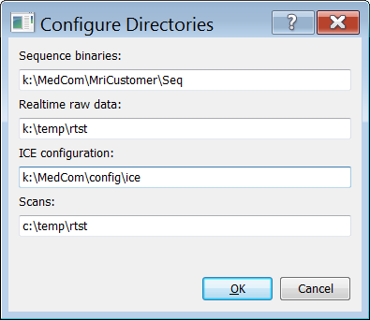
Figure 2. Sample configuration settings for RTST. Here, the host computer is mounted on drive k.
[More information coming soon…]

