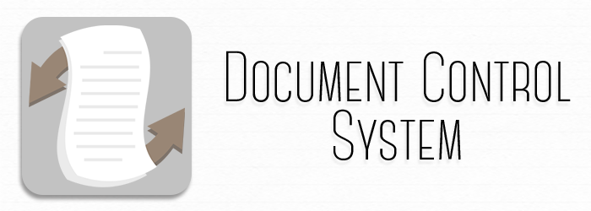

USER MANUAL

1. Purpose of this User Manual

This user manual provides information regarding the Document Control System which will be used by the Jollibee Foods Corporation. It shows how the user will use and navigate all of the capabilities and features needed to maneuver this system.

1. About the System

The Document Control System provides a number of module that are specifically made for the benefit of the client. It includes document submission, document tracking, as well as downloading. It aims to transform the manual processing and routing of documents into an automated one.

1. Employee’s Navigation

The following figures aims to guide the employee in navigating through the system.

Figure 1. Main page

This is the main/landing page of the system.

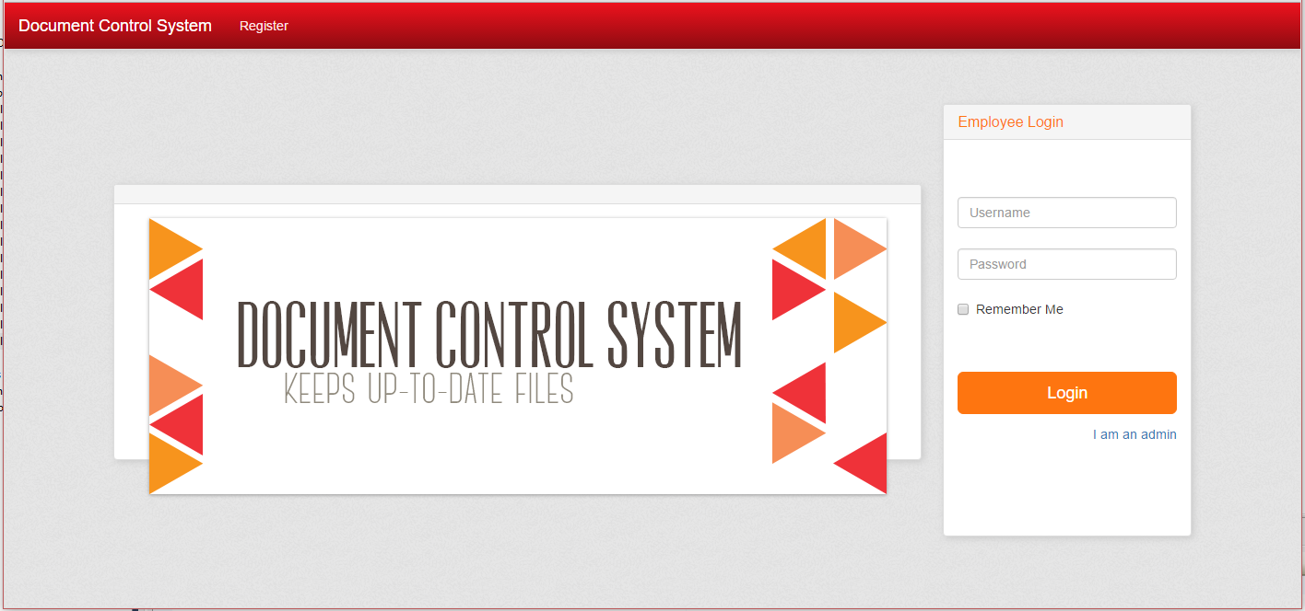

Figure 2. Admin button

To be able to login as a user, the admin needs to click a link below the login button.

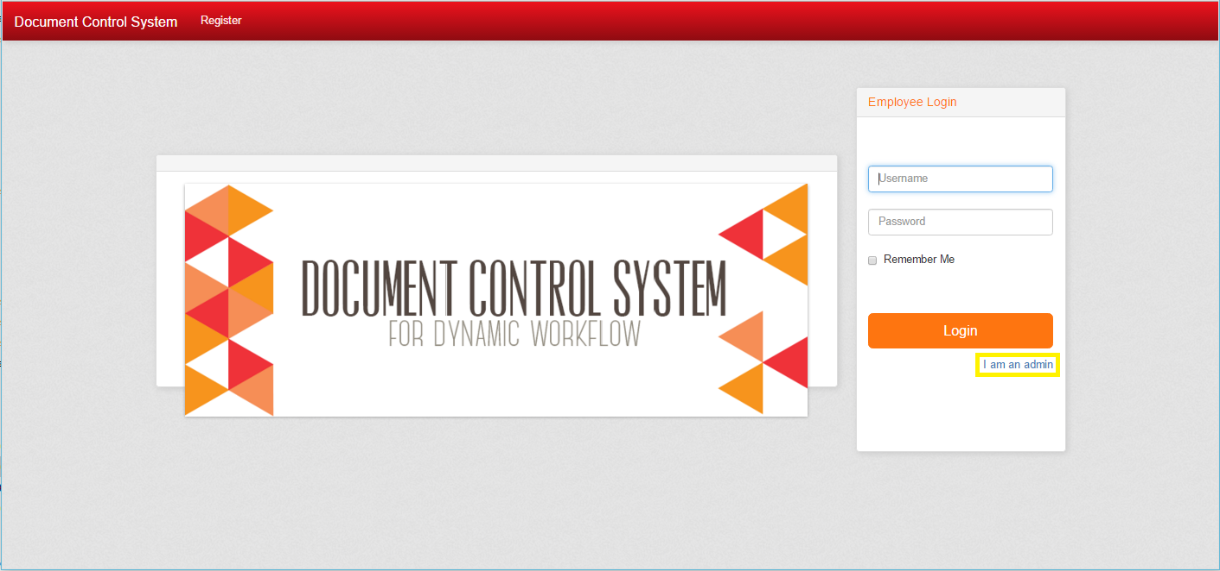

Figure 3. Current workflows page

When the admin logs in to the system, the first page he/she sees is the current workflows for the different departments.

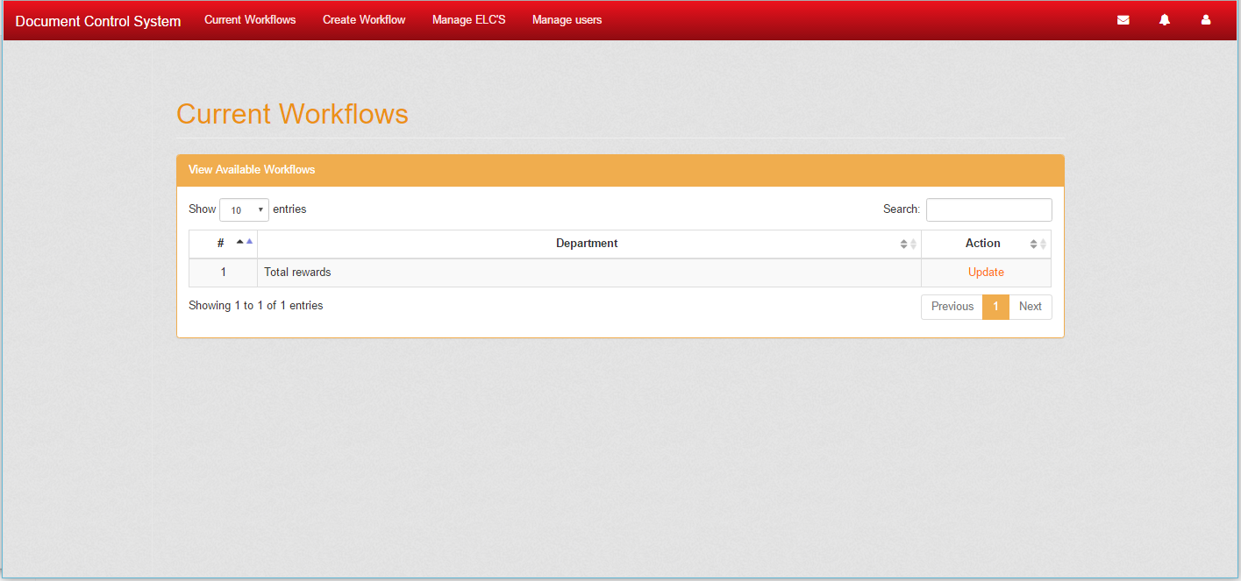

Figure 3. Update workflow page

Clicking the link in figure three which is ‘Update’. The admin is redirected to a page where he/she can add,edit,delete the approvers in a workflow.

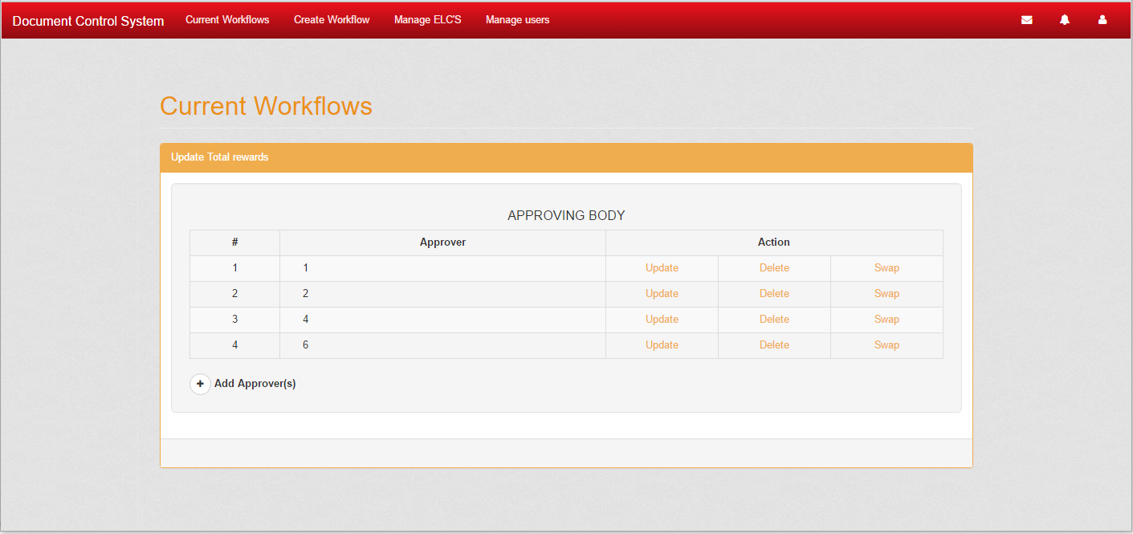

Figure 4. Create workflow

When the admin clicks the ‘Create workflow’ button from the menu bar, the admin is redirected to this page where he/she can create a workflow for a department.

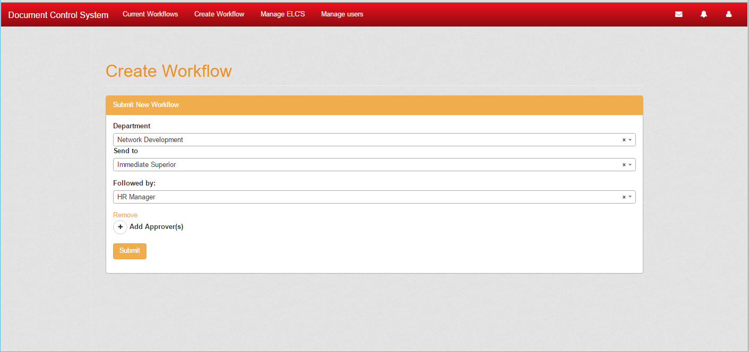

Figure 5. Manage ELC’s

When the admin clicks the ‘Manage ELC’s’ button from the menu bar, the admin is redirected to this page where he/she can view,add,edit, and delete the ELC’s the will be used in the system.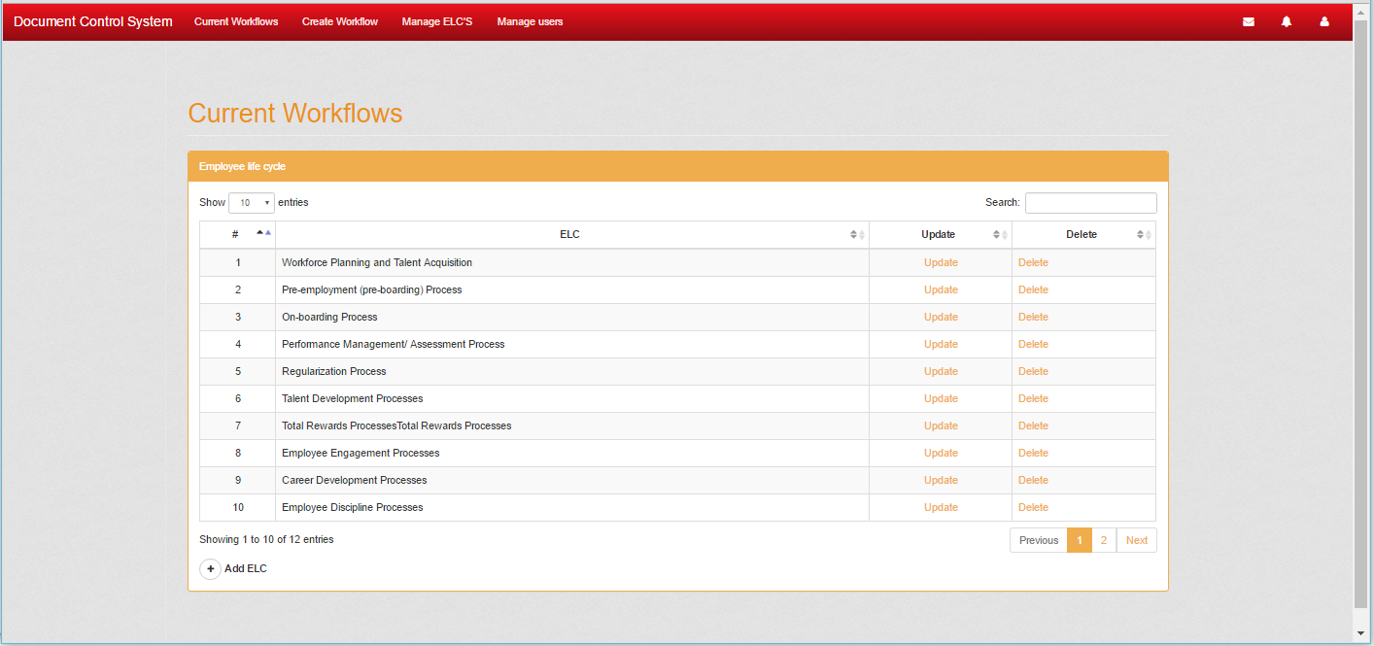

Figure 6. Manage users.

When the admin clicks the ‘Manage users’ button from the menu bar, the admin is redirected to this page where he/she can view,add,edit, and delete the users the will be used in the system.

Three tabs are in this page, first is View users, second is Import users, Third is Joining users. The first tab only shows the users, second tab uses a CSV file to import users, third is accepting users that are registering in the system.

