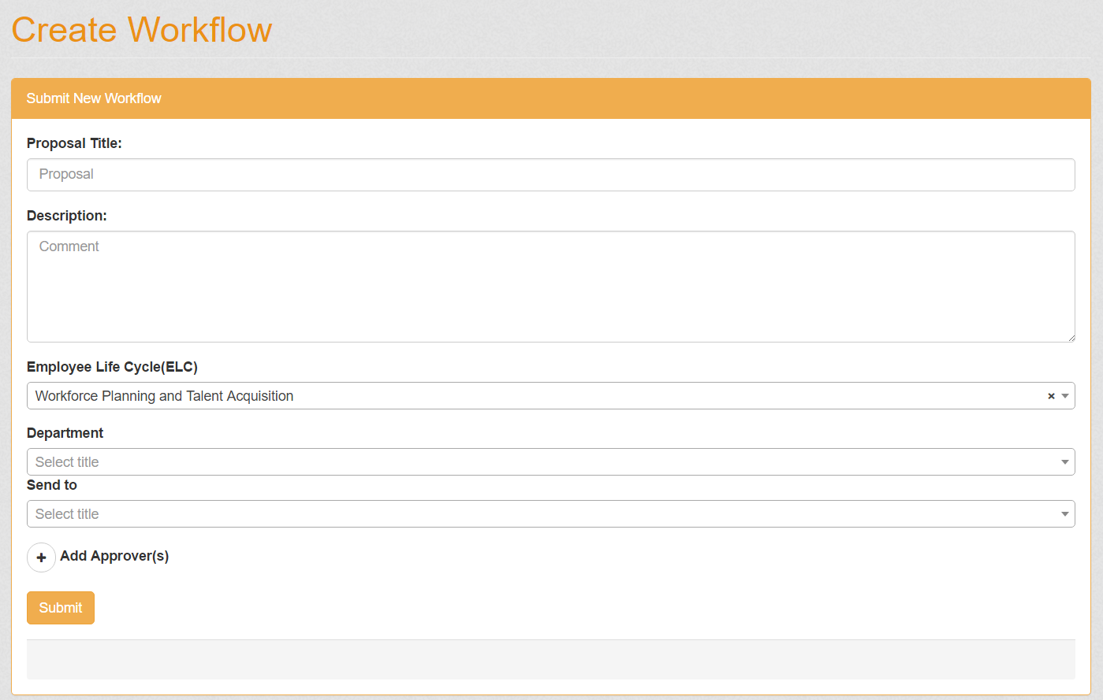

**Creating workflows –** The system is capable of creating a workflow for the system, The proposal title, description, ELC, and Department are inserted into a table of the workflow, then the “Send to” and following added approvers are inserted into another table that will be joined with the workflow.

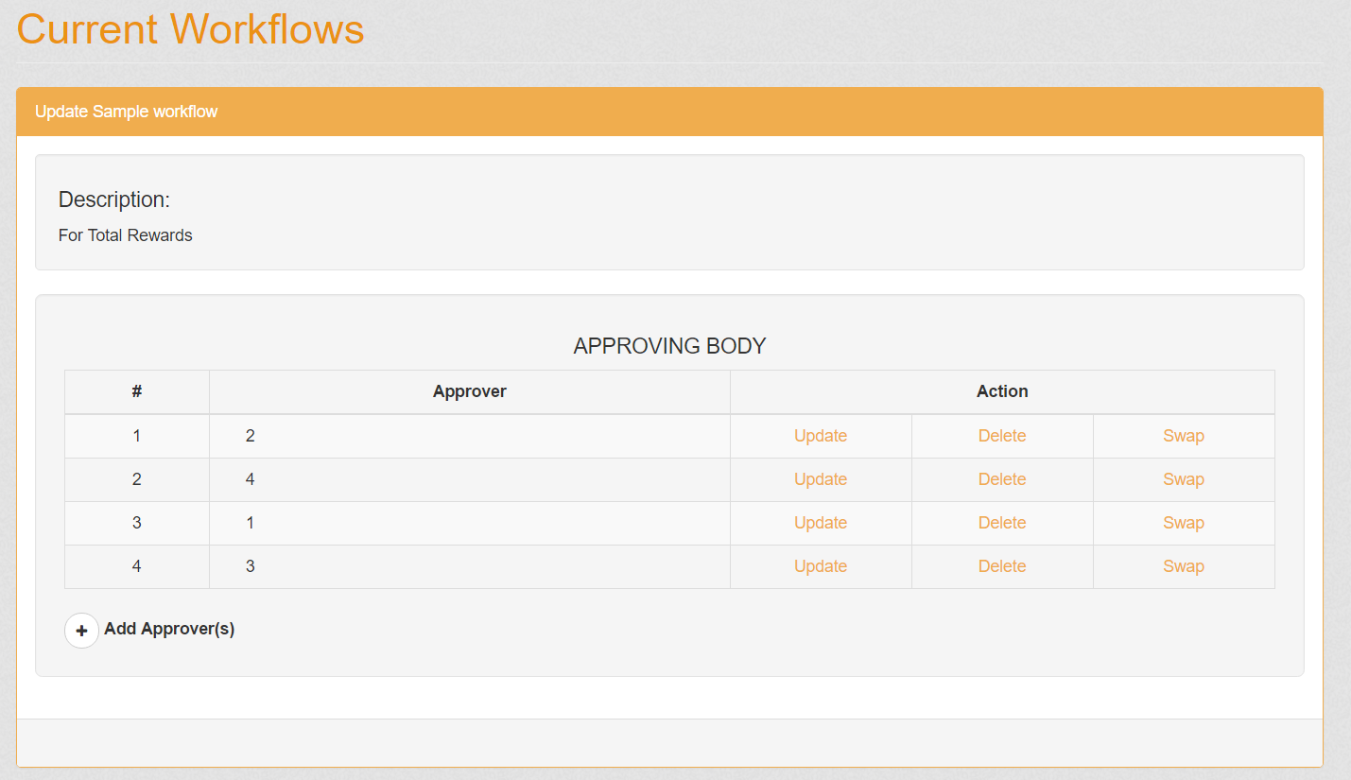

**Updating workflow –** When a workflow is made, the system is also capable of Adding approvers, updating, deleting, and swapping them.

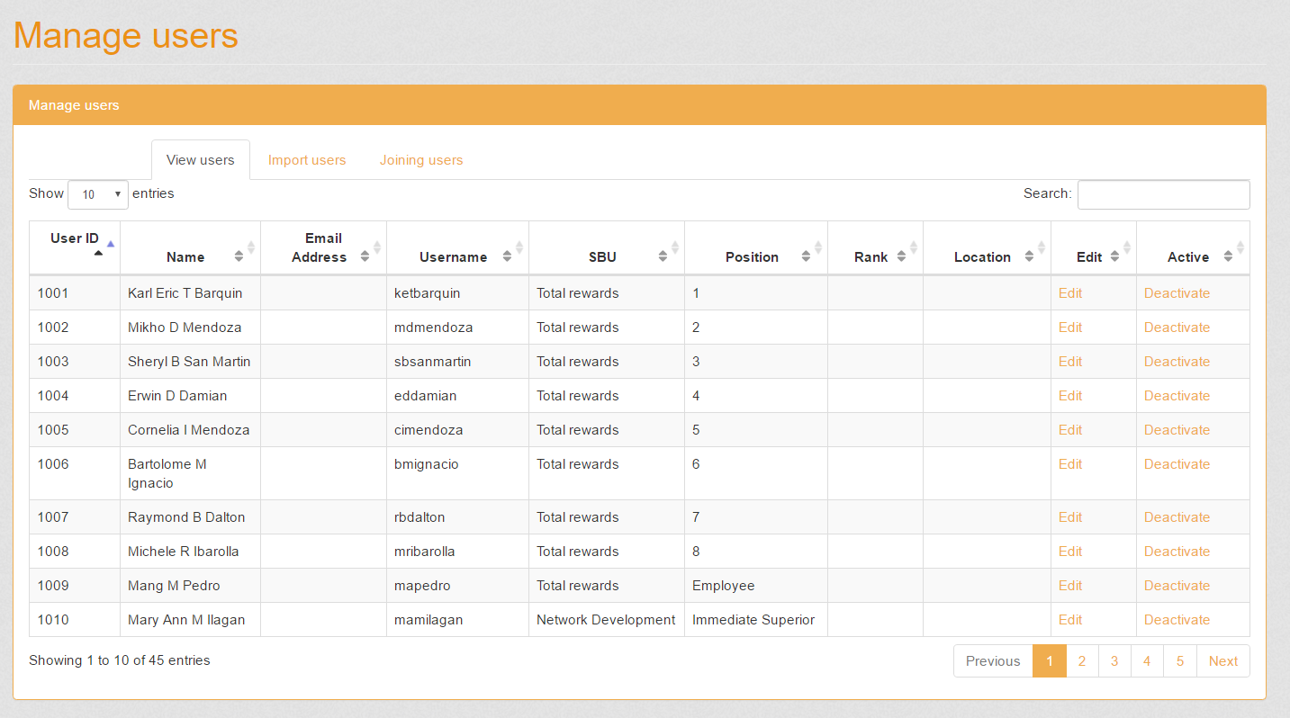

**Managing users –** This part takes care of the Users table in the database, it can edit a database row. It is also capable of activating/deactivating a user.

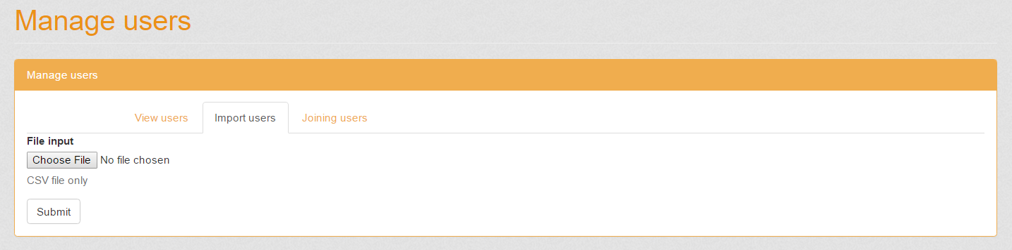

**Importing users –** Using a defined CSV file, the system can read the CSV file then insert all of it into the users table.

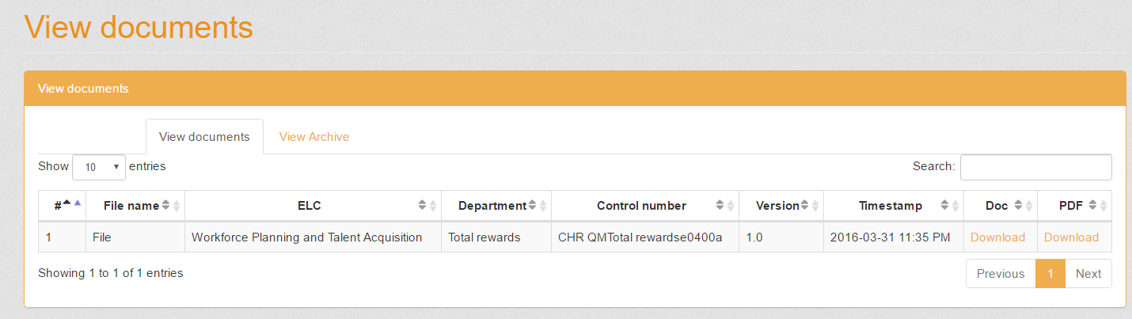

**Viewing of documents –** The system is also capable of selecting all documents that are in the system and displaying it.

