**Name : Mohamed Hazem**

**ID : 18107076**

**Huffman**

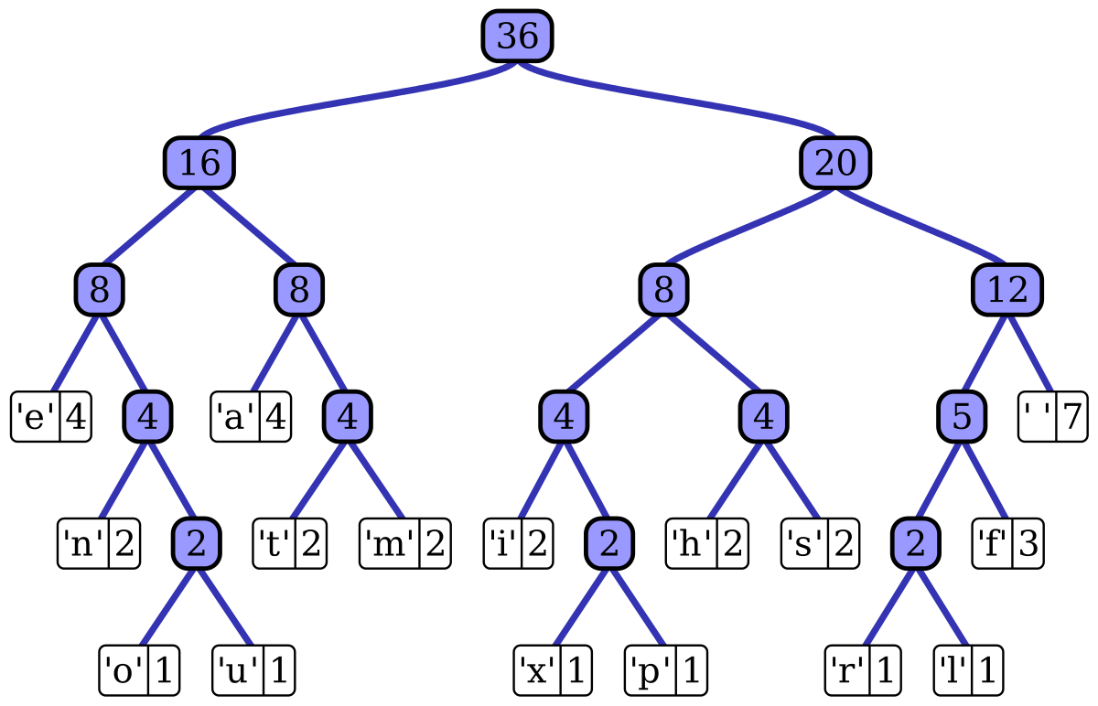

**First** read the input file by using

**🡺Scanner sc = new Scanner(new File("huffman.txt"));**

**Second** Create ArrayList called Character to be used later to hold the file data "things inside it (^-^)"

**🡺ArrayList<Character> Character = new ArrayList<Character>();**

**Third** get the character used, and number of characters in the String

**🡺for (int i = 0; i < mnmxar.length; i++) {**

**if (!(Character.contains(mnmxar[i]))) {**

**Character.add(mnmxar[i]);**

**}**

**}**

**Fourth** output it

🡺**System.out.println("Character : "+Character);**

**System.out.println("Number of Characters "+mnmxar.length);**

**Fifth** count letters in ArrayList then output the counter on each element

🡺**System.out.println("Character "+Character.get(x) + " has written " +countOfChar[x]+" times from total Characters text of "+mnmxar.length );**

**Sixth** give tiny numbers (Start from zero) for each character depends on how many time it repeated in the ArrayList(More repeats = less number)

**🡺while (true) {**

**if (current.left.value.toCharArray()[0] == checker) {**

**code += 0;**

**else {**

**code += 1;**

**if (current.right != null) {**

**if (current.right.value.toCharArray()[0] == Character**

**.get(countOfChar.length - 1)) {**

**current = current.right;**

**Seventh and last (^-^)**

Write output into two text files codegr.cm & code.huf

By using

🡺 FileWriter writer = new FileWriter("code.huf", true);

writer.write(codedString);

🡺 FileWriter writer = new FileWriter("codegr.cm", true);

**Output e.g**

