Class Diagram

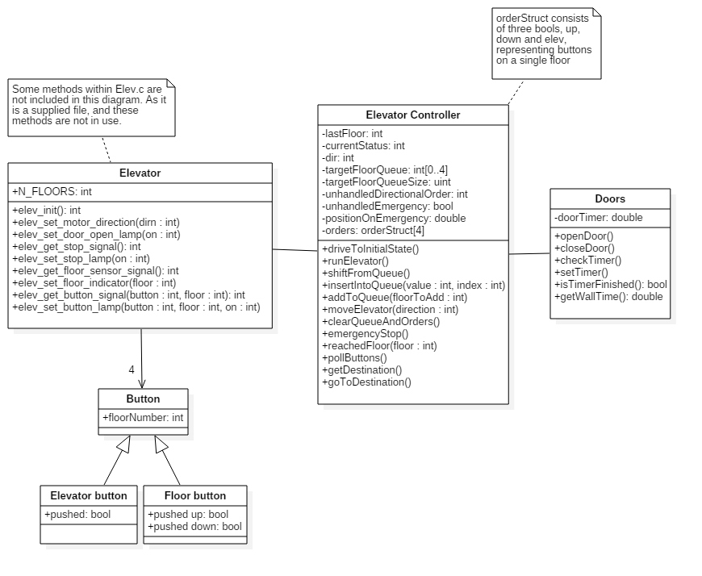

Sequence Diagram 1

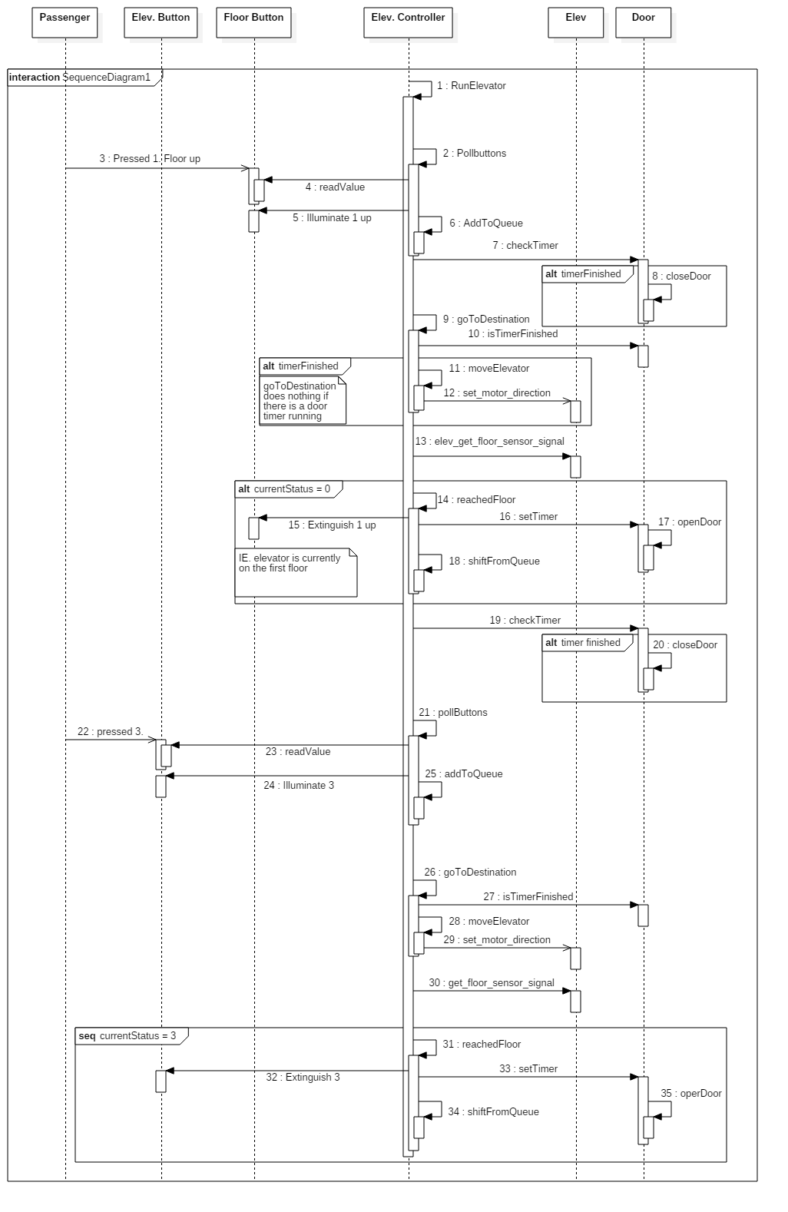

Description of Sequence Diagram 1

* The scenario begins with the elevator being empty and standing still on the second floor with door open.
* A person summons elevator from the 1. floor indicating that she/he wants to go upward.
* After the elevator has arrived she orders transport to the 3. floor.
* The scenario ends when elevator arrives at the 3. floor and the door open.
* For simplicity we assume that no other persons interact with the system during this scenario.

Sequence Diagram 2

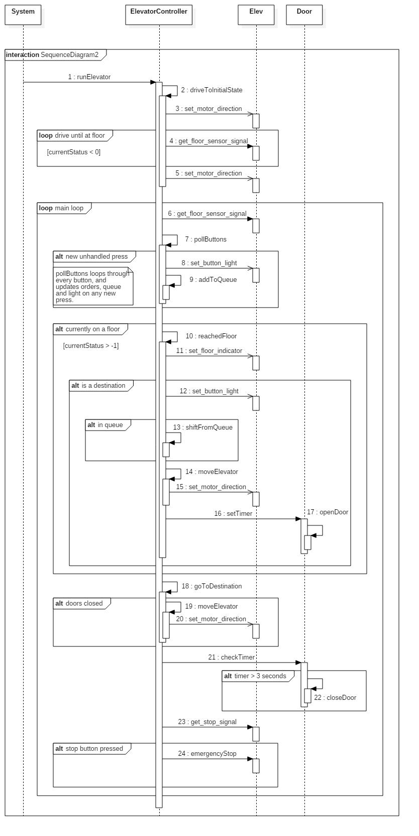

Use Case Diagram

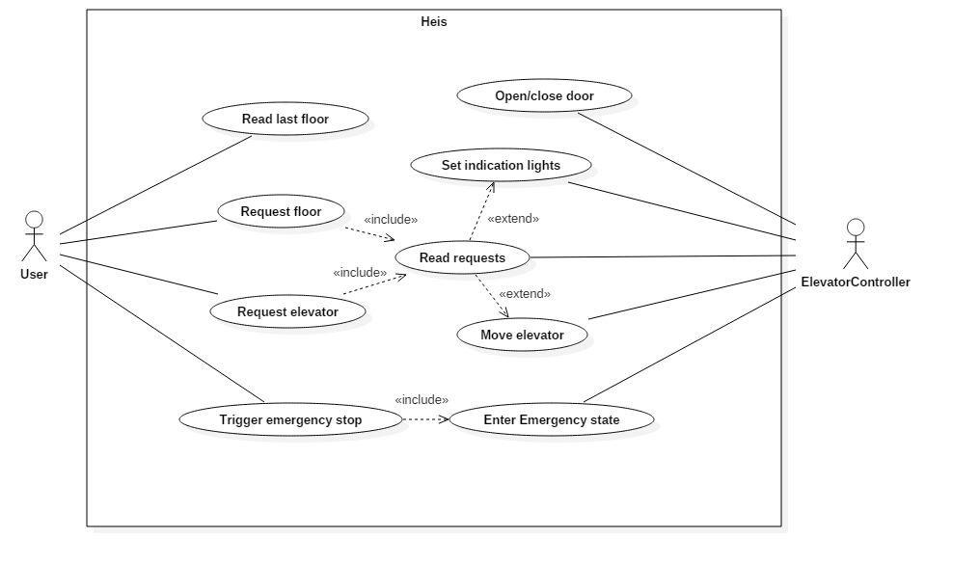

Description of Use Case Diagram

1. User request elevator.
2. Elevator Controller reads requests.
3. Elevator Controller sets indication lights.
4. Elevator Controller closes door.
5. Elevator Controller moves elevator.
6. Elevator Controller sets indication lights
7. Elevator Controller opens door.
8. User requests floor.
9. Elevator Controller reads requests.
10. Elevator Controller sets indication lights.
11. Elevator Controller closes door.
12. Elevator Controller moves elevator.
13. Elevator Controller sets indication lights.
14. Elevator Controller opens door.

Sequence finished, now in standby until further requests.

State-chart Diagram

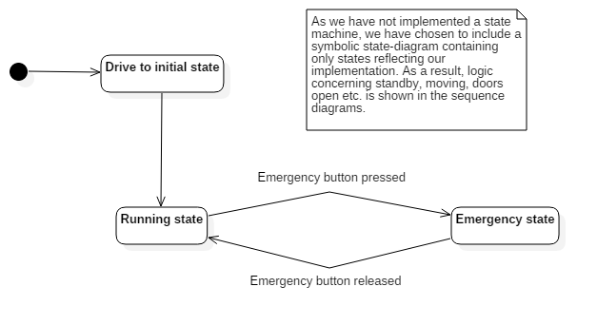

Activity Diagram

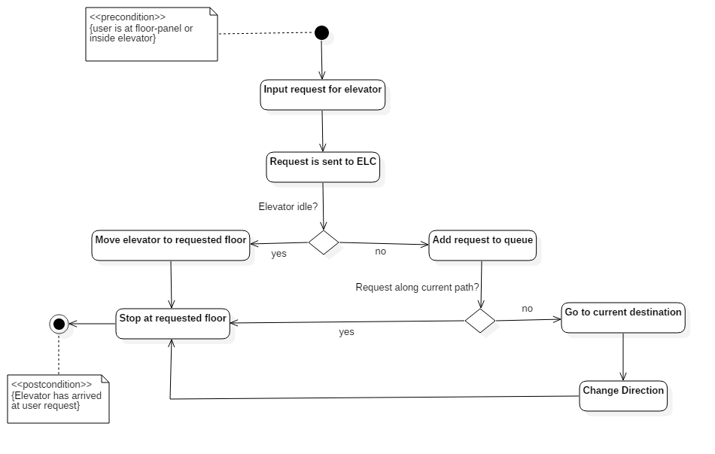

Communicaton Diagram

