Rtos Compile tools
Gcc

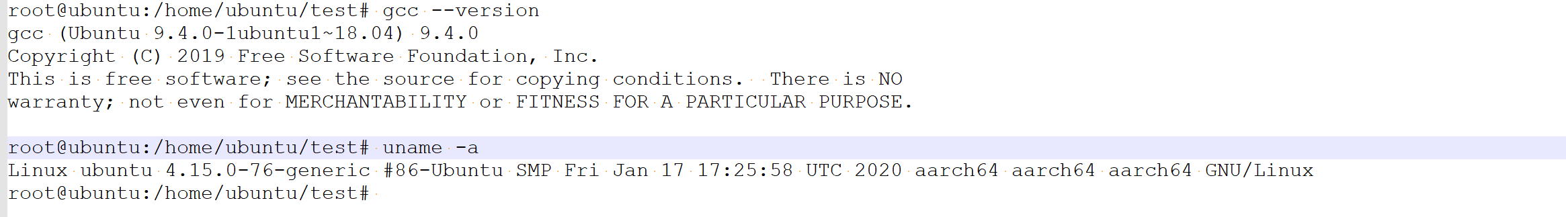
- riscv64-linux toolchain for Linux
- riscv64-unknown-elf toolchains for baremetal and RTOS;

1.1 linux Compile tools
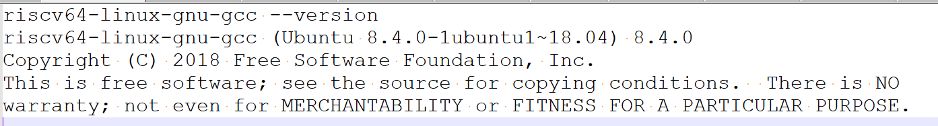

1.2 Rtos Compile tools

riscv64-unknown-elf-gcc --version
riscv64-unknown-elf-gcc () 9.3.0
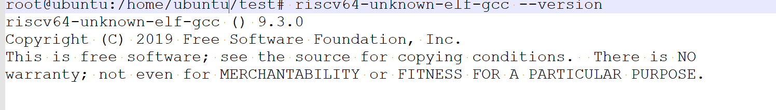

2、Compile qemu

2.1 Qemu version
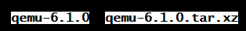

2.2 Patches
for f in `ls ../../qemu/qemu-patches/*.patch`; do patch -p1 < $f; done

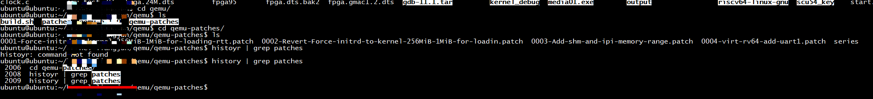

3、Compile Kernel

3.1 compile
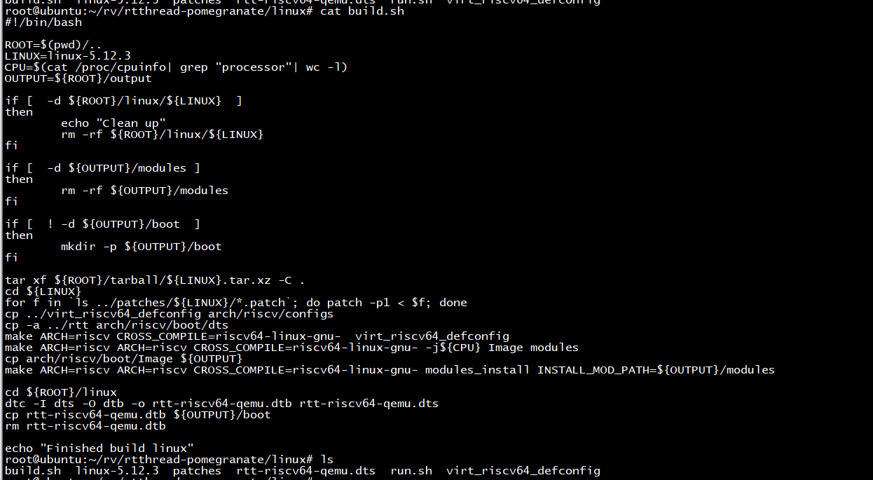

3.2 Run

./qemu-system-riscv64 -M virt -m 512M -smp 2 -bios fw_jump.bin -kernel Image -append "rootwait root=/dev/vda console=ttyS0" -drive file=rootfs.ext2.bak,format=raw,id=hd0 -device virtio-blk-device,drive=hd0 -netdev user,id=net0,hostfwd=::2222-:22 -device virtio-net-device,netdev=net0 -nographic -dtb qemu-riscv64-virt.dtb
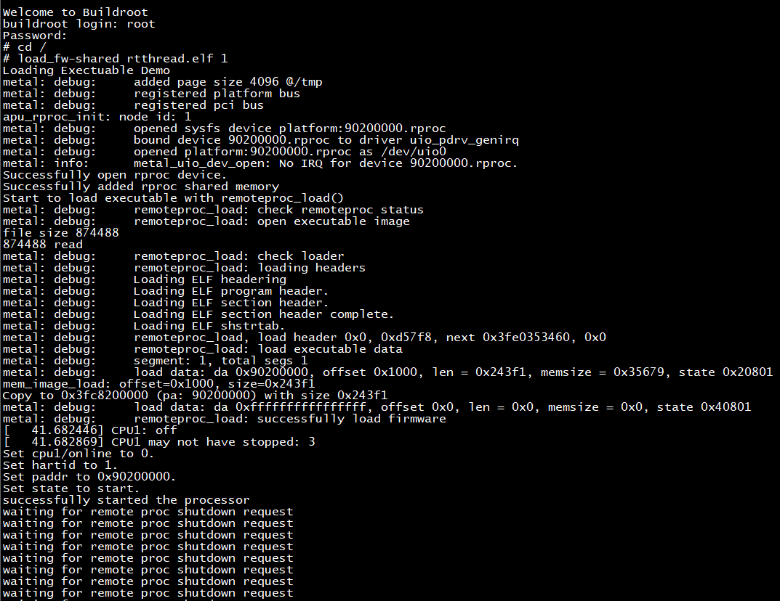

4、Device tree
metal: error: device platform:90200000.rproc not found
metal: error: device platform:90200000.rproc not found
ERROR: ERROR: failed to open shm device: -19.
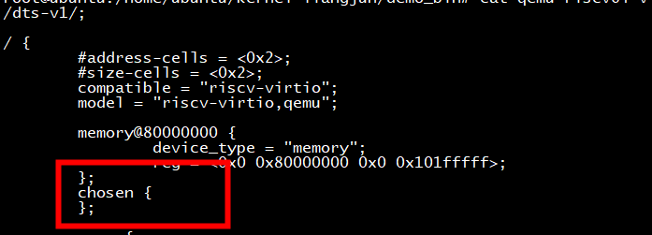

5、compile rtt

5.1 No module named building
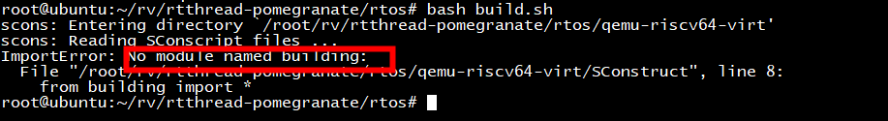
Need to put rt-thread under this folder as name rt-thread
- git clone https://github.com/RT-Thread/rt-thread.git
root@ubuntu:/home/ubuntu# cd rtos/
root@ubuntu:/home/ubuntu/rtos# ls
build.sh env.sh qemu-riscv64-virt README.md rt-thread run.sh
root@ubuntu:/home/ubuntu/rtos# bash build.sh
scons: Entering directory `/home/ubuntu/rtos/qemu-riscv64-virt'
scons: Reading SConscript files ...
Newlib version:unknown
scons: done reading SConscript files.
scons: Building targets ...
scons: building associated VariantDir targets: build
CC build/applications/main.o
CC build/driver/board.o
CC build/driver/drv_uart.o
CC build/driver/plic.o
CC build/driver/sbi.o
CC build/kernel/components/dfs/filesystems/devfs/devfs.o
CC build/kernel/components/dfs/filesystems/romfs/dfs_romfs.o
CC build/kernel/components/dfs/filesystems/romfs/romfs.o
CC build/kernel/components/dfs/src/dfs.o
CC build/kernel/components/dfs/src/dfs_file.o
CC build/kernel/components/dfs/src/dfs_fs.o
CC build/kernel/components/drivers/ipc/completion.o
CC build/kernel/components/drivers/ipc/dataqueue.o
CC build/kernel/components/drivers/ipc/pipe.o
CC build/kernel/components/drivers/ipc/ringblk_buf.o
CC build/kernel/components/drivers/ipc/ringbuffer.o
CC build/kernel/components/drivers/ipc/waitqueue.o
CC build/kernel/components/drivers/ipc/workqueue.o
CC build/kernel/components/drivers/misc/pin.o
CC build/kernel/components/drivers/serial/serial.o
CC build/kernel/components/finsh/cmd.o
CC build/kernel/components/finsh/msh.o
CC build/kernel/components/finsh/shell.o
CC build/kernel/components/libc/compilers/common/stdlib.o
CC build/kernel/components/libc/compilers/common/time.o
CC build/kernel/components/libc/compilers/newlib/syscalls.o
CC build/kernel/src/clock.o
CC build/kernel/src/components.o
CC build/kernel/src/device.o
CC build/kernel/src/idle.o
CC build/kernel/src/ipc.o
CC build/kernel/src/irq.o
CC build/kernel/src/kservice.o
CC build/kernel/src/mem.o
CC build/kernel/src/mempool.o
CC build/kernel/src/object.o
CC build/kernel/src/scheduler.o
CC build/kernel/src/thread.o
CC build/kernel/src/timer.o
CC /home/ubuntu/rtos/rt-thread/libcpu/risc-v/virt64/interrupt.o
CC /home/ubuntu/rtos/rt-thread/libcpu/risc-v/virt64/tick.o
AS /home/ubuntu/rtos/rt-thread/libcpu/risc-v/virt64/startup_gcc.o
AS /home/ubuntu/rtos/rt-thread/libcpu/risc-v/virt64/context_gcc.o
AS /home/ubuntu/rtos/rt-thread/libcpu/risc-v/virt64/interrupt_gcc.o
CC /home/ubuntu/rtos/rt-thread/libcpu/risc-v/virt64/cpuport.o
LINK rtthread.elf
riscv64-unknown-elf-objcopy -O binary rtthread.elf rtthread.bin
riscv64-unknown-elf-size rtthread.elf
text data bss dec hex filename
120334 2889 69736 192959 2f1bf rtthread.elf
scons: done building targets.

3、load

3.1 load_exectuable_block failed
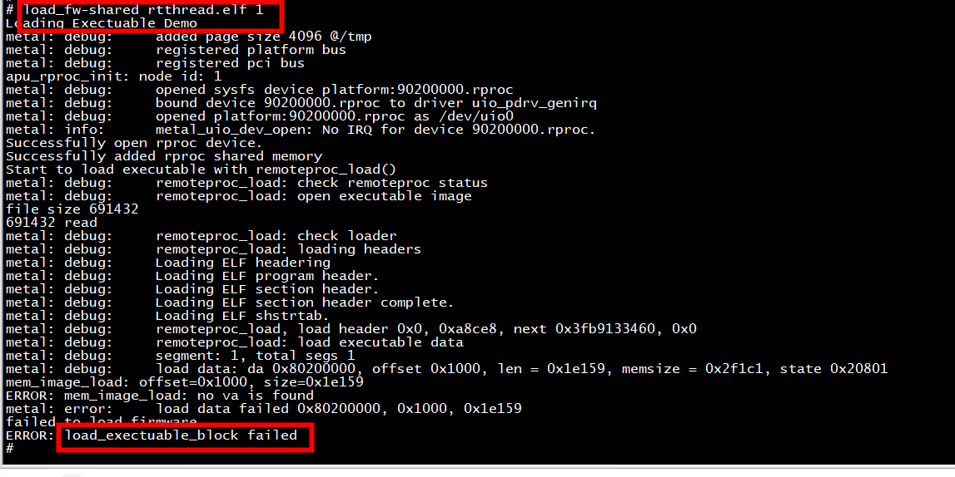
The correct add of rtos is 0x90200000, but in the above The add of rtos is 0x80200000.
You can execute the following steps: 3.2 change branch

3.1.1 change branch
Patch：https://gitee.com/bamvor/rt-thread/commit/f7e38f66bd8f37e2e8a93a0e157fe3c1a3cdea27

- git checkout remotes/origin/open-amp-port-new

3.1.2 compile
root@ubuntu:/home/ubuntu/rtos/rt-thread/bsp/qemu-riscv-virt64# export RTT_EXEC_PATH=/usr/bin
root@ubuntu:/home/ubuntu/rtos/rt-thread/bsp/qemu-riscv-virt64# scons
scons: Reading SConscript files ...
scons: done reading SConscript files.
scons: Building targets ...
scons: building associated VariantDir targets: build
CC build/applications/main.o
CC build/driver/board.o
CC build/driver/drv_uart.o
CC build/driver/plic.o
CC build/driver/sbi.o
CC build/kernel/components/dfs/filesystems/devfs/devfs.o
CC build/kernel/components/dfs/filesystems/romfs/dfs_romfs.o
CC build/kernel/components/dfs/filesystems/romfs/romfs.o
CC build/kernel/components/dfs/src/dfs.o
CC build/kernel/components/dfs/src/dfs_file.o
CC build/kernel/components/dfs/src/dfs_fs.o
CC build/kernel/components/dfs/src/dfs_posix.o
CC build/kernel/components/dfs/src/poll.o
CC build/kernel/components/dfs/src/select.o
CC build/kernel/components/drivers/misc/pin.o
CC build/kernel/components/drivers/serial/serial.o
CC build/kernel/components/drivers/src/completion.o
CC build/kernel/components/drivers/src/dataqueue.o
CC build/kernel/components/drivers/src/pipe.o
CC build/kernel/components/drivers/src/ringblk_buf.o
CC build/kernel/components/drivers/src/ringbuffer.o
CC build/kernel/components/drivers/src/waitqueue.o
CC build/kernel/components/drivers/src/workqueue.o
CC build/kernel/components/finsh/cmd.o
CC build/kernel/components/finsh/msh.o
CC build/kernel/components/finsh/msh_file.o
CC build/kernel/components/finsh/shell.o
CC build/kernel/components/libc/compilers/common/delay.o
CC build/kernel/components/libc/compilers/common/stdlib.o
CC build/kernel/components/libc/compilers/common/time.o
CC build/kernel/components/libc/compilers/common/unistd.o
CC build/kernel/components/libc/compilers/newlib/libc.o
CC build/kernel/components/libc/compilers/newlib/stdio.o
CC build/kernel/components/libc/compilers/newlib/syscalls.o
CC build/kernel/src/clock.o
CC build/kernel/src/components.o
CC build/kernel/src/device.o
CC build/kernel/src/idle.o
CC build/kernel/src/ipc.o
CC build/kernel/src/irq.o
CC build/kernel/src/kservice.o
CC build/kernel/src/mem.o
CC build/kernel/src/mempool.o
CC build/kernel/src/object.o
CC build/kernel/src/scheduler.o
CC build/kernel/src/thread.o
CC build/kernel/src/timer.o
AS /home/ubuntu/rtos/rt-thread/libcpu/risc-v/virt64/context_gcc.o
AS /home/ubuntu/rtos/rt-thread/libcpu/risc-v/virt64/interrupt_gcc.o
CC /home/ubuntu/rtos/rt-thread/libcpu/risc-v/virt64/cpuport.o
CC /home/ubuntu/rtos/rt-thread/libcpu/risc-v/virt64/interrupt.o
CC /home/ubuntu/rtos/rt-thread/libcpu/risc-v/virt64/tick.o
AS /home/ubuntu/rtos/rt-thread/libcpu/risc-v/virt64/startup_gcc.o
LINK rtthread.elf
riscv64-unknown-elf-objcopy -O binary rtthread.elf rtthread.bin
riscv64-unknown-elf-size rtthread.elf
text data bss dec hex filename
145599 2865 70280 218744 35678 rtthread.elf
scons: done building targets.

3.2 remote proc start failed with error: Unknown error -1failed to start processor

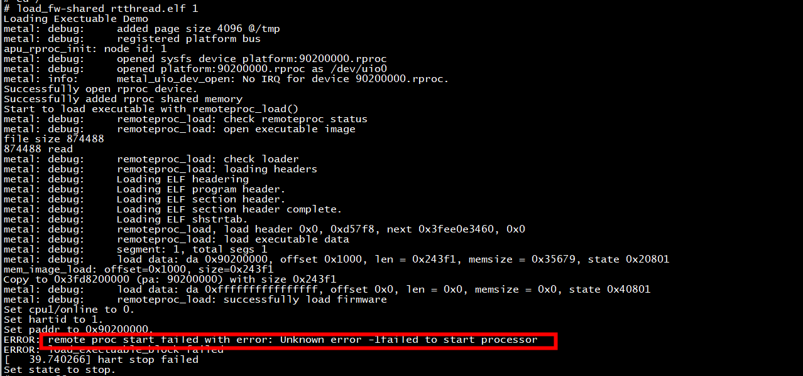
retry

3.3 successfully Run
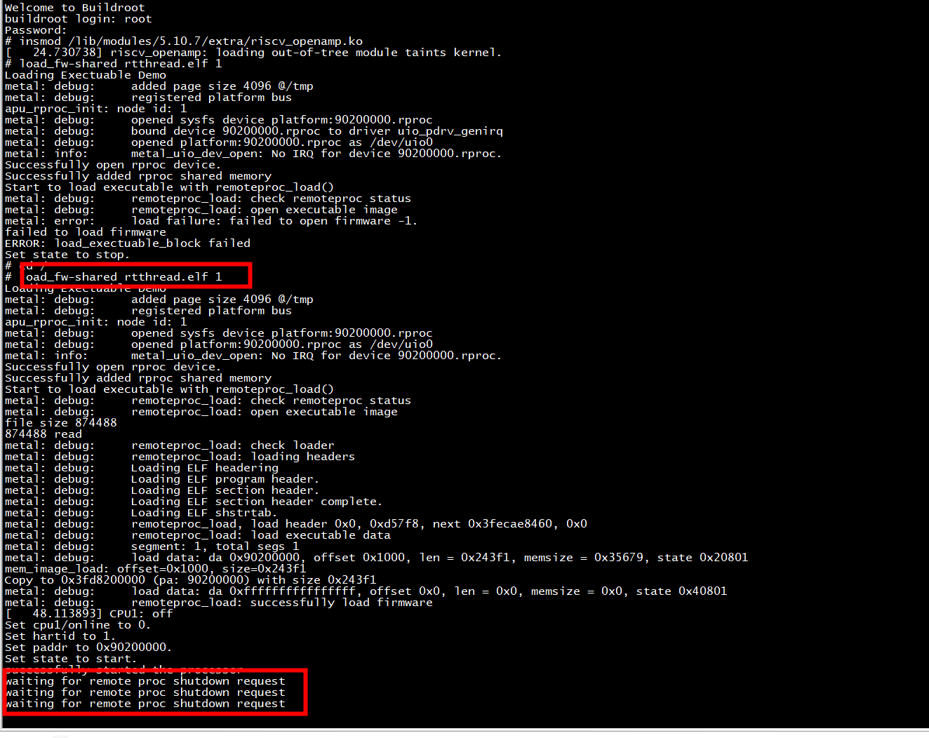

4、Others

4.1 Addr of rttos
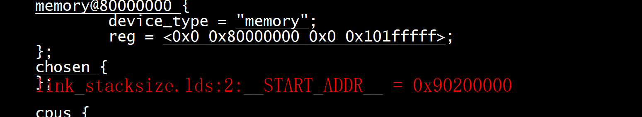

4.2 scons --menuconfig
