Shell显示
仅显示最后一个目录
export PS1='[\u@\h \W]$'

添加新的kernel module

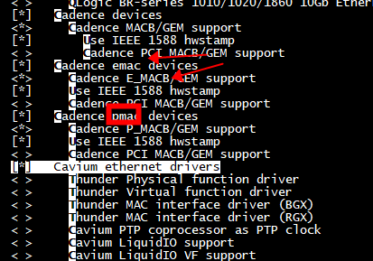

代码结构
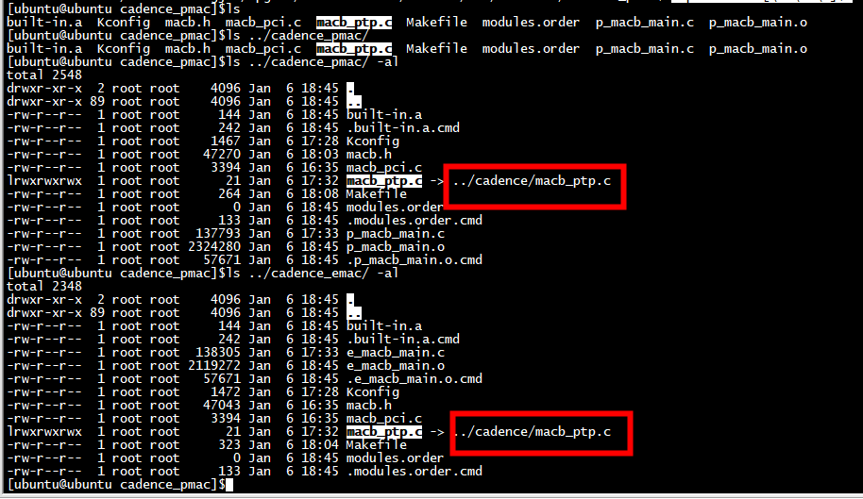

父 Kconfig
1）、添加新的子Kconfig
source "drivers/net/ethernet/cadence/Kconfig"
source "drivers/net/ethernet/cadence_emac/Kconfig"
source "drivers/net/ethernet/cadence_pmac/Kconfig"

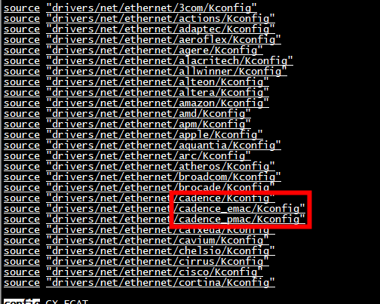

父 Makefile
obj-$(CONFIG_NET_VENDOR_CADENCE) += cadence/
obj-$(CONFIG_NET_VENDOR_P_CADENCE) += cadence_pmac/
obj-$(CONFIG_NET_VENDOR_E_CADENCE) += cadence_emac/
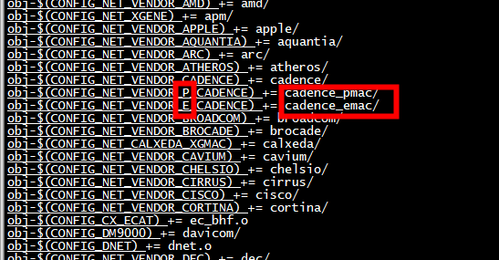

子Kconfig-pmac

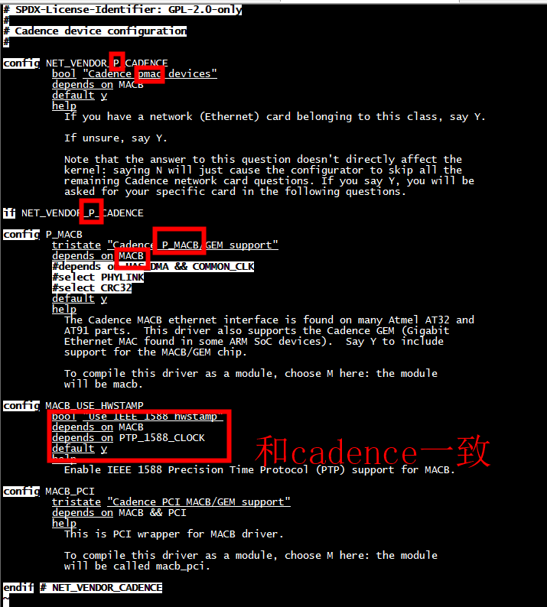
cadence | cadence_pmac
Config NET_VENDOR_CADENCE | Config NET_VENDOR_P_CADENCE
Cadence mac devices | Cadence pmac devices
config MACB | config P_MACB
tristate "Cadence MACB/GEM support"  depends on HAS_DMA && COMMON_CLK  select PHYLINK  select CRC32 | tristate "Cadence P_MACB/GEM support"  depends on MACB  #depends on HAS_DMA && COMMON_CLK  #select PHYLINK  #select CRC32  default y

子Makefile-pmac

