测试方法
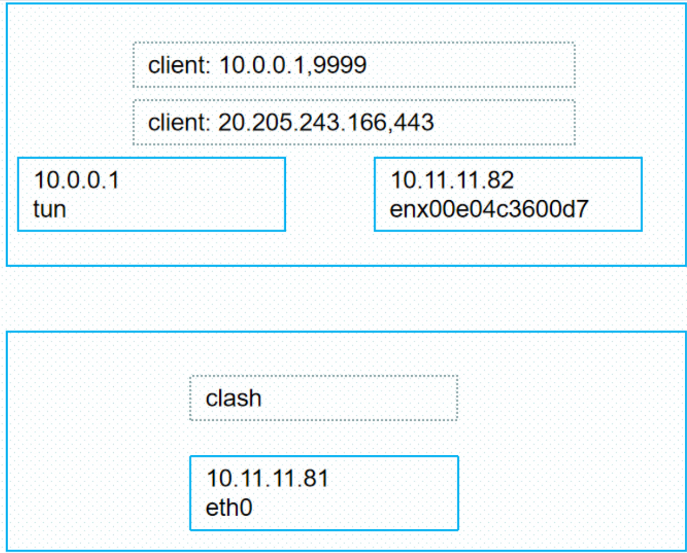
1）网络配置
ip tuntap add dev tun0 mode tun
ifconfig tun0 10.0.0.1 netmask 255.255.255.0
route add default gw 10.0.0.2 metric 6
route add -host 10.10.16.82 gw 10.0.0.2 metric 6
2） 运行
./install/bin/badvpn-tun2socks --tundev tun0 --netif-ipaddr 10.0.0.1 --netif-netmask 255.255.255.0 --socks-server-addr 10.11.11.81:7890 --udpgw-remote-server-addr 21.2.2.151:2999
3）发起ssh请求
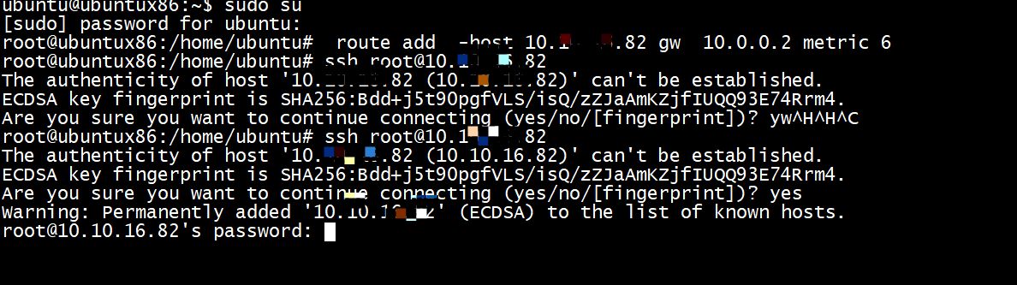

tcp_output_alloc_header
(gdb) bt
#0 0x000055b051963534 in tcp_output_alloc_header ()
#1 0x000055b0519649a1 in tcp_send_empty_ack ()
#2 0x000055b051964bd2 in tcp_output ()
#3 0x000055b05196a848 in tcp_input ()
#4 0x000055b051973397 in ip_input ()
#5 0x000055b0519386dc in netif_input_func ()
#6 0x000055b051937d88 in device_read_handler_send ()
#7 0x000055b0519537dd in _PacketPassInterface_job_operation ()
#8 0x000055b0519bbfc5 in BPendingGroup_ExecuteJob ()
#9 0x000055b051950bee in BReactor_Exec ()
#10 0x000055b051936302 in main ()

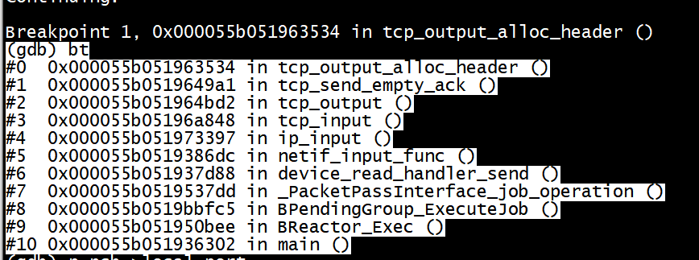

BSocksClient socks_client
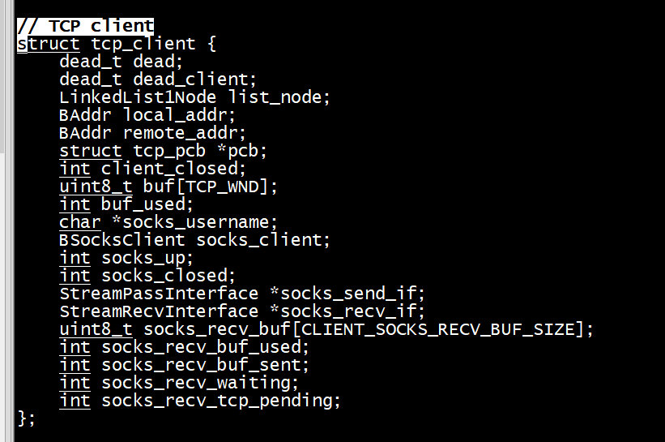
./socksclient/BSocksClient.h
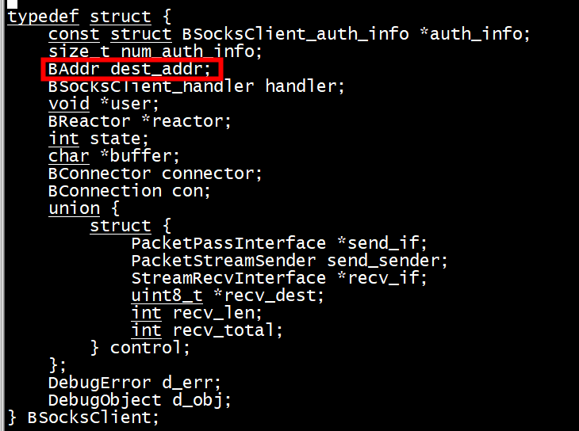

发送socks_request_header 报文

