# Shell显示

仅显示最后一个目录

export PS1='[\u@\h \W]$'

# 添加新的kernel module

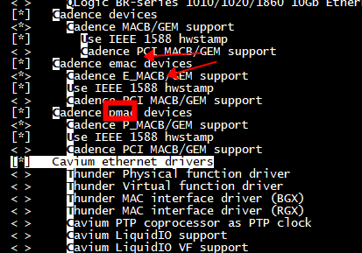

## 代码结构

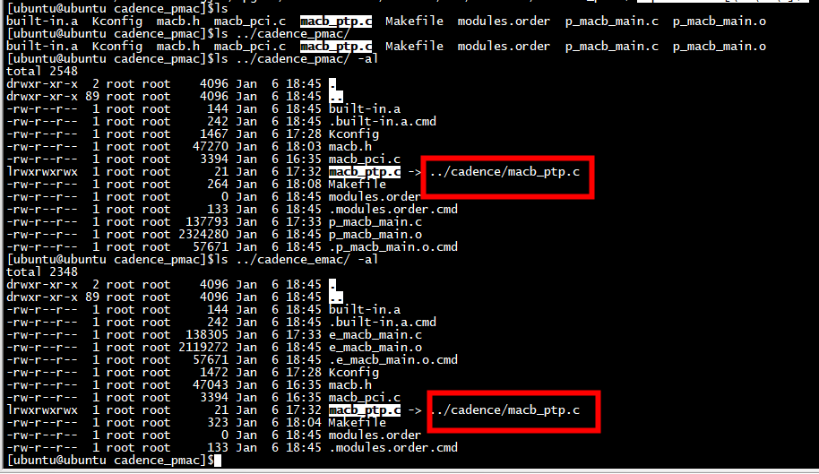

## 父 Kconfig

1）、添加新的子Kconfig

source "drivers/net/ethernet/cadence/Kconfig"

source "drivers/net/ethernet/cadence_emac/Kconfig"

source "drivers/net/ethernet/cadence_pmac/Kconfig"

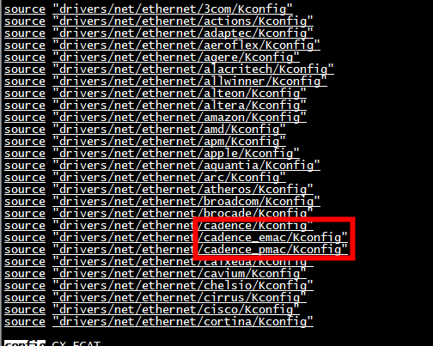

## 父 Makefile

obj-$(CONFIG_NET_VENDOR_CADENCE) += cadence/

obj-$(CONFIG_NET_VENDOR_P_CADENCE) += cadence_pmac/

obj-$(CONFIG_NET_VENDOR_E_CADENCE) += cadence_emac/

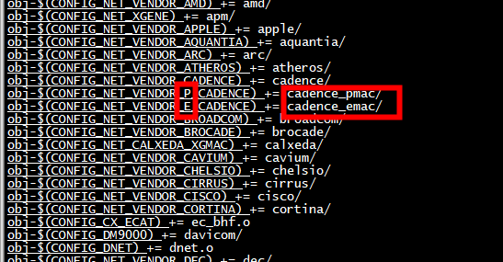

## 子Kconfig-pmac

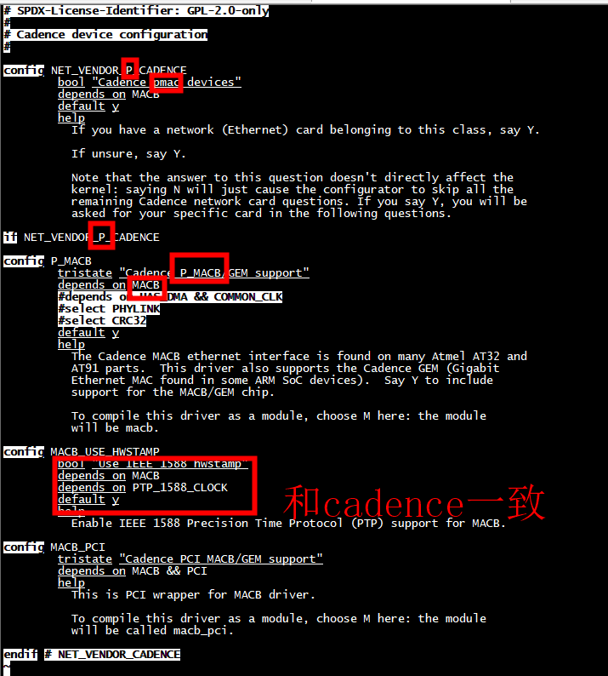

|  |  |
| --- | --- |
| cadence | cadence_pmac |
| Config NET_VENDOR_CADENCE | Config NET_VENDOR_P_CADENCE |
| Cadence mac devices | Cadence pmac devices |
| config MACB | config P_MACB |
| tristate "Cadence MACB/GEM support"  depends on HAS_DMA && COMMON_CLK  select PHYLINK  select CRC32 | tristate "Cadence P_MACB/GEM support"  depends on MACB  #depends on HAS_DMA && COMMON_CLK  #select PHYLINK  #select CRC32  default y |

## 子Makefile-pmac

