# Pci

## Multi-function device

Having multiple functions can be useful when the same device does multiple things. For instance my NVIDIA GPU is a single PCIe device with 4 functions. The output of lspci for that device on my PC looks like this:

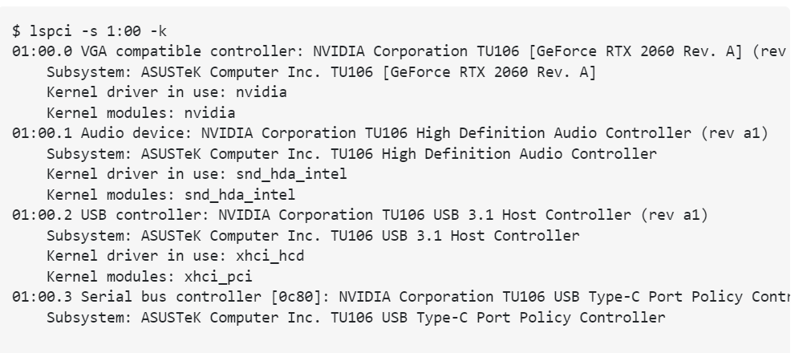

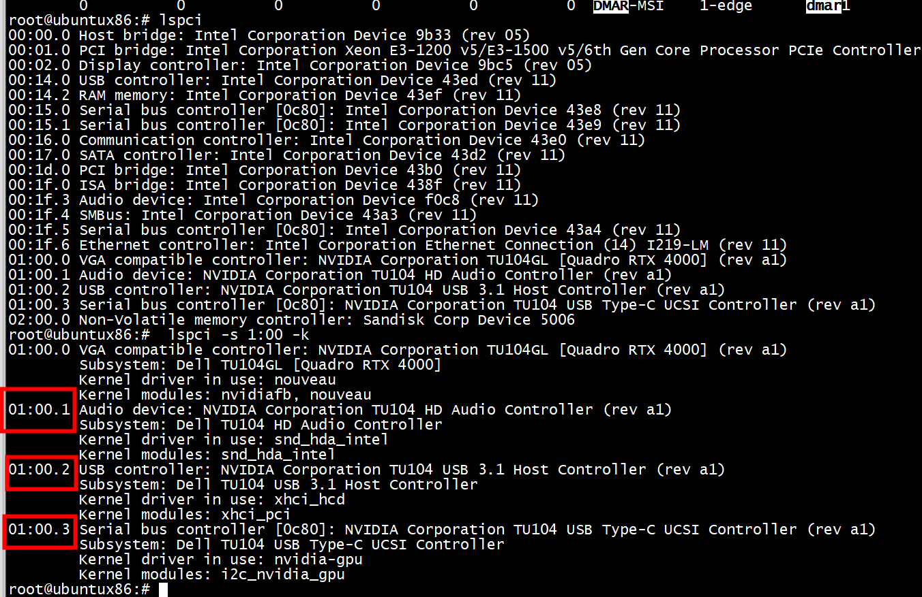

01:00.0 VGA compatible controller: NVIDIA Corporation TU104GL [Quadro RTX 4000] (rev a1)

Subsystem: Dell TU104GL [Quadro RTX 4000]

Kernel driver in use: nouveau

Kernel modules: nvidiafb, nouveau

01:00.1 Audio device: NVIDIA Corporation TU104 HD Audio Controller (rev a1)

Subsystem: Dell TU104 HD Audio Controller

Kernel driver in use: snd_hda_intel

Kernel modules: snd_hda_intel

01:00.2 USB controller: NVIDIA Corporation TU104 USB 3.1 Host Controller (rev a1)

Subsystem: Dell TU104 USB 3.1 Host Controller

Kernel driver in use: xhci_hcd

Kernel modules: xhci_pci

01:00.3 Serial bus controller [0c80]: NVIDIA Corporation TU104 USB Type-C UCSI Controller (rev a1)

Subsystem: Dell TU104 USB Type-C UCSI Controller

Kernel driver in use: nvidia-gpu

Kernel modules: i2c_nvidia_gpu

i2c_nvidia_gpu模块

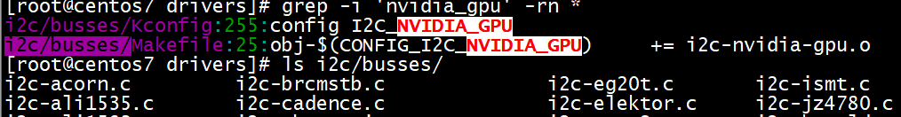

All four of these functions are located within the same PCIe device (and chip!) but they get separated. In fact, you can see from the output above that all four functions have different kernel modules ("drivers") attached to them. In this case, having the function field just means that all four of these devices get to share the same PCIe infrastructure.

Another example I've seen where this is used is for multi-port network cards. This effectively allows the user to work with each port separately. In the specific case of network cards, this makes it really easy to pass one network card to a virtual machine in a server, for instance. The now ancient Intel 82571EB takes advantage of this, for instance.

What's really happening here is something like this:

The main processor (or root port, technically) is able to see each of the far-end "functions", while only one PCIe connection is needed.

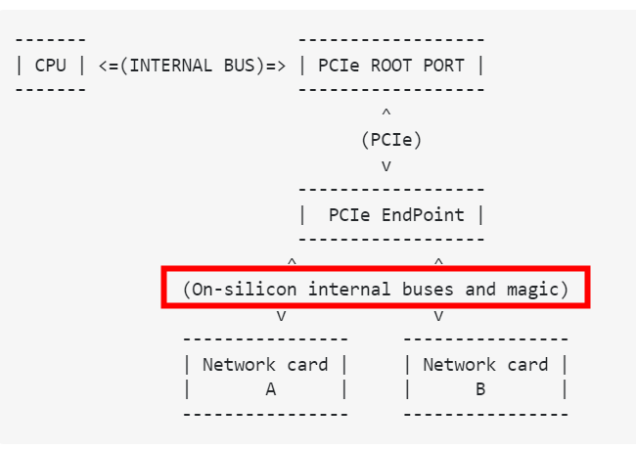

## Probe

### Pci Header

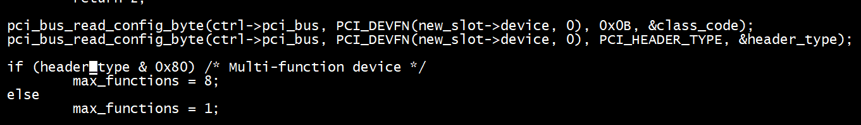

### dev->multifunction

