|  |  |  |  |
| --- | --- | --- | --- |
| **SEARCH AND SELECTION CRITERIA** | | | |
| **IDENTIFICATION** | **RECORDS IDENTIFIED**  **Web of Science** N=95  **Scopus** N=144  “variability” AND (fluctuations* OR fluctuating* OR changes*), “fluctuations” AND (fluctuating* OR changes*) e “fluctuating” AND “changes”  **Web of Science and Scopus** | | |
| **SCREENING** | Full texts excluded N=23  Records excluded N=99  Recorded screening (Full texts) N= 70  Records identified N=239  Recorded screening (titles and abstract) N= 169  Duplicates removed N=70 | | |
| **STUDIES INCLUDED IN THE META-ANALYSIS**  + =  **N = 47**  (Cabrerizo & Marañón, 2022) **N = 66**  **NT = 113** | | | |
| **DATA EXTRACTION** | | | |
| **Numeric Variables** | | **Categorical Variable** | |
| Mean Effect  Mean Control  Standard Deviation of Effect  Standard Deviation of Control  Number of Replicates | | Biome  Ecosystem  Kingdom  Group | Species  Response Variable  Category |

Figure 1. Schematic representation of the search and selection process following the Preferred Reporting Items for Systematic Reviews and Meta-Analyses (PRISMA) guidelines.

Table 1. environmental stressors and their corresponding descriptions

|  |  |
| --- | --- |
| **Code** | **Description** |
| **F_hypoxia** | Fluctuations in low oxygen concentration |
| **Hypoxia** | Low oxygen concentration |
| **Hyperoxia** | High oxygen concentration |
| **F_hyperoxia** | Fluctuations in high oxygen concentration |
| **F_light** | Fluctuations in light |
| **F_nut** | Fluctuations in nutrients |
| **F_water** | Fluctuations in water level |
| **F_pCO2** | Fluctuations in partial pressure of CO₂ |
| **F_temp** | Fluctuations in temperature |
| **W** | Warming |
| **F_W** | Fluctuations in heated temperature |
| **F_A** | Fluctuations in high pH |
| **F_pH** | Fluctuations in pH |
| **A** | Acidification |

Table 2. moderator test (General dataset). When a moderator has a high F value and p < 0.05, it indicates that there is significant variation in the effect of the treatment within that moderator.

|  |  |  |  |  |  |  |
| --- | --- | --- | --- | --- | --- | --- |
| Moderator | | Treatment | LnRR | | LnCVR | |
| F | P-val | F | P-val |
| Kingdom | Fluctuation | | 6.66 | < .0001 | 4.20 | 0.0003 |
| Intensified Stressor fluctuating | | 5.99 | < .0001 | 9.35 | <.0001 |
| Stressor | | 4.18 | 0.0029 | 4.97 | 0.0008 |
| Ecosystem | Fluctuation | | 7.84 | <.0001 | 4.73 | 0.0009 |
| Intensified Stressor fluctuating | | 11.28 | <.0001 | 2.59 | 0.0530 |
| Stressor | | 3.65 | 0.0135 | 1.26 | 0.2894 |
| Type | Fluctuation | | 39.61 | < .0001 | 6.31 | 0.0019 |
| Intensified Stressor fluctuating | | 0.80 | 0.4497 | 3.91 | 0.0209 |
| Stressor | | 3.27 | 0.0399 | 3.30 | 0.0388 |
| Response Category | Fluctuation | | 5.16 | 0.0001 | 2.10 | 0.0622 |
| Intensified Stressor fluctuating | | 3.33 | 0.0060 | 2.83 | 0.0162 |
| Stressor | | 1.12 | 0.3474 | 2.71 | 0.0213 |
| Taxonomic Group | Fluctuation | | 3.01 | < .0001 | 3.13 | <.0001 |
| Intensified Stressor fluctuating | | 4.63 | < .0001 | 1.65 | 0.0638 |
| Stressor | | 3.72 | < .0001 | 0.66 | 0.7698 |
| Biome | Fluctuation | | 41.10 | <.0001 | 2.53 | 0.0387 |
| Intensified Stressor fluctuating | | 0.19 | 0.8969 | 0.62 | 0.5979 |
| Stressor | | 0.88 | 0.4164 | 1.61 | 0.2015 |

Table 2. Results of the test of moderators performed using the Linear Mixed Effects Model to meta-regression.

|  | **τ² (Tau²)** | **I² (%)** | **QE (Cochran's Q)** | **p-valor (QE)** |
| --- | --- | --- | --- | --- |
| **lnRR** | | | | |
| Stressor/Type | 0.4455 | 100.00% | 7447589469758.8984 | < 0.0001 |
| Stressor/Ecosystem | 0.4527 | 100.00% | 7447589469758.8984 | < 0.0001 |
| Stressor/Kingdom | 0.4670 | 100.00% | 7483107487643.5371 | < 0.0001 |
| Stressor/Category | 0.4397 | 100.00% | 621218757483.7502 | < 0.0001 |
| Stressor/Biome | 0.4039 | 100.00% | 621218757483.7502 | < 0.0001 |
| **lnCVR** | | | | |
| Stressor/Type | 2.9021 | 88.98% | 9119.2084 | < 0.0001 |
| Stressor/Ecosystem | 2.8579 | 88.83% | 8994.7043 | < 0.0001 |
| Stressor/Kingdom | 2.6560 | 88.06% | 8321.9503 | < 0.0001 |
| Stressor/Category | 2.6094 | 87.84% | 8002.1066 | < 0.0001 |
| Stressor/Biome | 2.8756 | 88.88% | 8992.1732 | < 0.0001 |

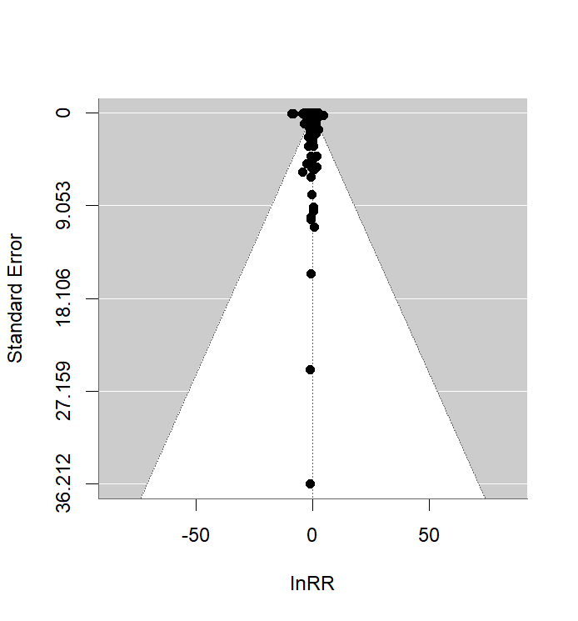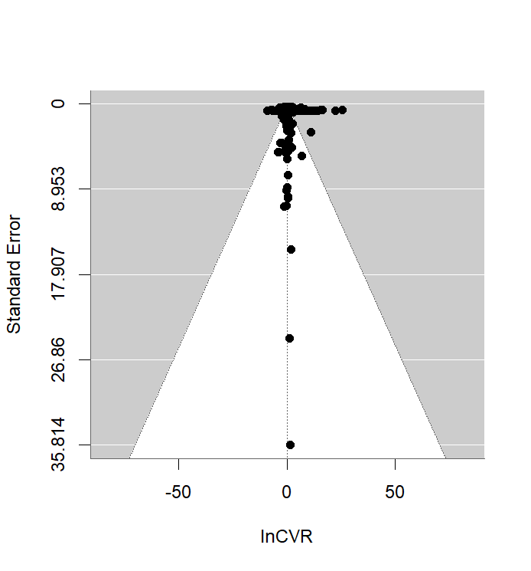

Figure 4. Publication bias uplighting the results of lnRR effect sizes and lnCVR response variability



