Guidelines for Submitting Online Applications – Academic Posts
- Registering and Creating a New User Account at UL
Whether you are an internal or external applicant, you must register with the University of Limerick’s E-Recruitment system before you can apply online for academic posts. You register by creating a user account on the UL E-Recruitment webpage
To create a user account, click on the Register link in the Navigation section on the left of the screen. Fill in all the fields in the Register New User section. (All correspondence relating to your application will be sent to the email address you enter here.) When you have filled in all fields and clicked on the Terms & Conditions check box at the bottom of the section, click on Register.
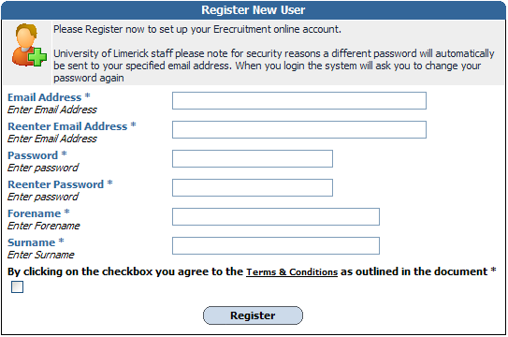
If you are an external applicant, the password you entered remains your password for this site. Take note of it and the email address you entered because you will need both to log in to the E-Recruitment website in the future to track your current application, apply for other vacancies or view your application history.
If you are an internal applicant, the system will email you a new password. The first time you try to log in after registering, you will be asked to change your password in the Change Password section. Once you have set your own password, you will have secure access to your user account on the system and will be able to apply for vacancies online.
- Logging In if Already Registered
Once you have created a user account with E-Recruitment, the next time you wish to log in to the system you simply click on the Login link in the Navigation section. In the Login section, enter your email address and password and click on Login.
Should you forget your password, enter your email address and click on the Forgotten Password? link, and a new password will be emailed to you.
- Vacancies List
The first screen you will see contains the University of Limerick Vacancies section, which lists current vacancies.
By clicking on the Details link pertaining to the vacancy you wish to apply for, you will be presented with the job specification of the position. Clicking on the Job description link at the bottom of this section will give you access to a detailed job description document, which you can either open or save.
- Applying for the Position
You can begin your online application from the University of Limerick Vacancies section or from the Job Specification section. In the University of Limerick Vacancies section, click on the Apply link associated with the position you wish to apply for. If you had already opened the Job Specification section for that position, click on the Apply for Job button. Either way, you will be brought to the first of 11 screens, all of which must be completed to apply for the position. Fields with asterisks are mandatory.
Click on the Save and Next button as you proceed through the application. Doing this ensures that your inputted data will be stored in the Application History section of your user account should you accidentally be logged out before completing your application or should you simply not wish to submit your application straight away. (Refer to section 5 at the end of this document for details on how to access your application history.)
The only time you should use the Next button instead of the Save and Next button to proceed to the next screen is when you are updating or reviewing a previously saved application and you do not wish to make any changes to that screen.
Step 1 of 11: Personal Details
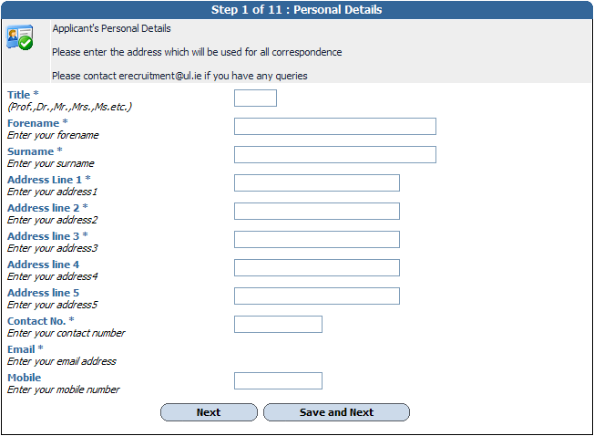
Enter the requested personal details on this screen. Fields with asterisks must be completed. Your email address will be the same as the one you used to register. Click on Save and Next to proceed to the next screen.
Step 2 of 11: Questionnaire Section
This section requests information relating to EEA citizenship, legal entitlement to work in Ireland and proficiency in English, where applicable. When ready to proceed, click on Save and Next.
Step 3 of 11: Third Level Education
You may enter as many qualifications as you wish by clicking on Save and Add. If your qualification or institute does not appear in the Academic Institute drop-down list, please select Other and give details in the Institute Other field. When ready to proceed, click on Save and Next.
Step 4 of 11: Publications/Research/Teaching
This screen asks you for details relating to your publications, postgraduate supervision, research funding and teaching. (You will be asked to attach a full list of your publications on screen 8.)
In the Teaching table at the bottom of the screen, you are asked to enter the number of classes you have taught with respect to class size. The ranges of numbers along the top row relate to numbers of students. In each box under the range of student numbers, you are asked to fill in the number of classes you have taught within that category of class size over the period of your third-level teaching career. Teaching a particular class size for an entire semester should be recorded as 1, not as the actual number of times you taught that class within the semester. For example, let’s say you taught a group of less than 20 students once a week in the autumn and spring semesters of 2009/10, in the autumn semester of 2008/9 and in the spring semester of 2007/8, you would record 4 in the <20 box. The term ‘teaching’ covers lectures, labs, tutorials, etc., i.e. any scheduled contact time with a group of students.
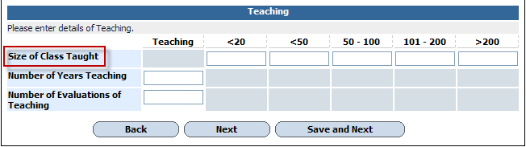
When ready to proceed, click on Save and Next.
Step 5 of 11: Employment History
You may enter details for as many previous employments as you wish by clicking on Save and Add. When ready to proceed, click on Save and Next.
Step 6 of 11: Professional and Academic Referees
You give referee details in this section, including your current employer (minimum of three). Enter referee details separately by using the Save and Add button. HR may contact referees before or after your interview to add to or validate the references provided. Your current employer will not be contacted without your permission.
When details for all your referees have been added, proceed by clicking on Save and Next.
Step 7 of 11: Professional Membership
You are asked to give professional membership details in this section. If such membership does not apply to you, click on the Section Not Applicable check box. You may enter additional details by clicking on Save and Add. When ready to proceed, click on Save and Next.
Step 8 of 11: University of Limerick Document Downloads
You can download this guidelines document and the job description for the advertised post from the top of this screen – click on the relevant View button to the right of the document filename and then either open or save the document.
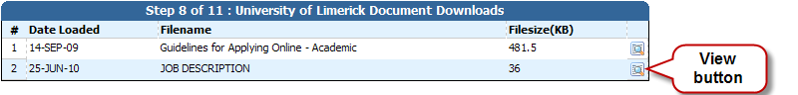
You use the Applicant Documentation section of this screen to attach your cover letter, CV and list of publications. All attachments must be in the required file format as specified on the screen, and your publications must be listed using the Harvard referencing style.
Documents uploaded to the Applicant Documentation section can be removed by using the Remove button.
When ready to proceed, click on Next.
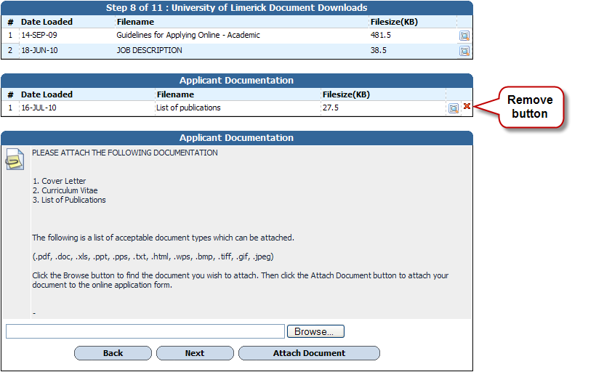
Step 9 of 11: Source of Advertisement
This screen asks you to indicate how you became aware of the vacancy. When ready to proceed to the next screen, click on Save and Next.
Step 10 of 11: Equal Opportunities Monitoring
The University of Limerick confirms its commitment to a policy of equal opportunities in employment in which individuals are selected, trained, appraised, promoted and otherwise treated on the basis of their relevant merits and abilities and are given equal opportunities within the University.
To enable UL to monitor the operation of its equal opportunities policy, you are invited to answer questions relating to personal data on this screen. It is important to note that this section will be removed from your application and will not be used for the purpose of selection. The information obtained will be used for statistical monitoring to give the Human Resources Division a fuller picture of UL’s recruitment pattern.
When ready to proceed to the final screen, click on Save and Next.
Step 11 of 11: Application Form
This final screen presents you with your entire application form, which you can review before submitting to ensure you are satisfied that the details you provided are full and correct. Please bear in mind that once you submit your application, you will not be able to edit any of your details.
Before submitting your application, please ensure you are applying for the correct position, read the statement at the end of the form and click on the check box provided. By ticking this box, you are certifying that the information you provided is correct to the best of your knowledge and you are agreeing to be bound by the terms of UL’s recruitment policies. You can either save the application for later or submit it there and then. You can also print a copy of it.
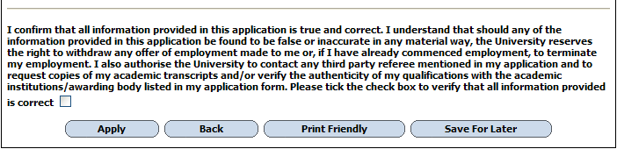
To submit the application, click on the Apply button. If any required information has been omitted from your application, a red-text error message will appear at the top of the screen.
A message stating “Application Successful” appears when your application has been successfully submitted.
Normally within 30 minutes of submitting your application, you will receive an email acknowledging that it has been received.
- Further Information
Application History
If you decide to save your application for later, the details will be held in the Application History section of your user account. All your partially completed applications are listed here. To finalise and ultimately submit an application, log in and click on the Application History link in the Navigation section on the left of the screen. From here, click on the View button associated with the particular application that you wish to complete.
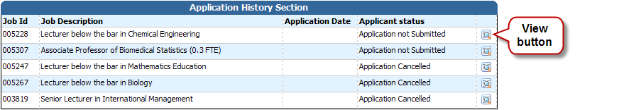
Clicking on the View button brings you back to the final screen of the application process, where you can review and update your application form in its entirely before submitting it.
Closing Dates and Times
The closing date and time for the submission of online applications for the position is specified in the list of vacancies. You will be unable to submit your application after this date and time.
Contact E-Recruitment
If you experience any difficulties using the online E-Recruitment system, please send us an email to erecruitment@ul.ie outlining the nature of your problem and quoting the reference number and title of the post you are applying for.

