TMA4268 - Project 1

## Libraries used throughout the exercise

library(ggplot2)  
library(palmerpenguins) # Contains the data set 'penguins'.  
library(ggfortify)  
library(tidyverse)

## -- Attaching packages --------------------------------------- tidyverse 1.3.1 --

## v tibble 3.1.6 v dplyr 1.0.7  
## v tidyr 1.2.0 v stringr 1.4.0  
## v readr 2.1.2 v forcats 0.5.1  
## v purrr 0.3.4

## -- Conflicts ------------------------------------------ tidyverse_conflicts() --  
## x dplyr::filter() masks stats::filter()  
## x dplyr::lag() masks stats::lag()

library(GGally)

## Registered S3 method overwritten by 'GGally':  
## method from   
## +.gg ggplot2

library(MASS)

##   
## Attaching package: 'MASS'

## The following object is masked from 'package:dplyr':  
##   
## select

library(class)  
library(base)  
library(ROSE)

## Loaded ROSE 0.0-4

## Problem 1

### a)

If we have that $y_{0}=f\left(x_{0}\right)+ϵ$, where $ϵ$ is a random error independent of $x$ with 0 mean. And $x_{0}$ is a unseen test observation we find,

$$\begin{matrix}E\left[{\left(y_{0}−\hat{f}\left(x_{0}\right)\right)}^{2}\right] & =E\left[{\left(f\left(x_{0}\right)−\hat{f}\left(x_{0}\right)\right)}^{2}\right]+E\left[ϵ^{2}\right]+2E\left[\left(f\left(x_{0}\right)−\hat{f}\left(x_{0}\right)\right)⋅ϵ\right] \\ & =E\left[f{\left(x_{0}\right)}^{2}−2f\left(x_{0}\right)\hat{f}\left(x_{0}\right)+\hat{f}{\left(x_{0}\right)}^{2}\right]+E\left[ϵ^{2}\right]+2E\left[\left(f\left(x_{0}\right)−\hat{f}\left(x_{0}\right)\right)\right]⋅E\left[ϵ\right] \\ & =f{\left(x_{0}\right)}^{2}−2f\left(x_{0}\right)E\left[\hat{f}\left(x_{0}\right)\right]+E\left[\hat{f}{\left(x_{0}\right)}^{2}\right]+Var\left[ϵ\right] \\ & ={\left(f\left(x_{0}\right)−E\left[\hat{f}\left(x_{0}\right)\right]\right)}^{2}+Var\left[\hat{f}\left(x_{0}\right)\right]+Var\left[ϵ\right] \\ & ={\text{Bias}}^{2}+\text{Variance}+\text{Irreducible error}\end{matrix}$$

### b)

The irreducible error is a term that can’t be reduced by fitting the data well. The variance is a term describing how much uncertainty our statistical model $\hat{f}$, how much $\hat{f}$ changes if we change the training data. The bias is the expected difference between the true model $f$ and our statistical model $\hat{f}$.

### c)

1. True
2. False
3. True
4. False

### d)

1. False
2. False
3. True
4. False

### e)

1. 0.76

$$ρ_{x_{1},x_{2}}=\frac{\text{cov}\left(x_{1},x_{2}\right)}{σ_{x_{1}}σ_{x_{2}}}=\frac{33}{\sqrt{50}\sqrt{38}}=0.76$$

## Problem 2

### a)

One error made is excluding sex because of a low p-value, the p-value is the probability to observe a result equal or more extreme than the one we did, given that the null hypothesis $H_{0}:β=0$, so a lower p-value means the result is more statistically significant.

Another error made is deciding whether to reject the null hypothesis that the species coefficient overall is actually zero based on the p-values of the coefficients. Since the null hypothesis in this case is $H_{0}:β_{Chinstrap}=β_{Gentoo}=0$ at the same time. We need to do a F-test.

A third error made is claiming that chinstrap penguins are the largest since they have the largest coefficient. Having a large coefficient only means that for a given set of parameters a chinstrap penguin is going to be heavier than another type of penguin. And when we include interaction terms which changes the the slopes, a large coefficient only guarantees it is larger for a range of parameters near zero. And by looking at body mass of the penguins in the data set we find that in fact gentoo penguins have the highest mean body mass.

### b)

data(penguins)  
  
Penguins <- subset(penguins, select = -c(island, year))  
Penguins <- na.omit(Penguins)  
  
ggplot(data = Penguins) +  
 geom_histogram(binwidth = 40, mapping = aes(x = body_mass_g)) +  
 facet_wrap(~ sex, nrow = 2)

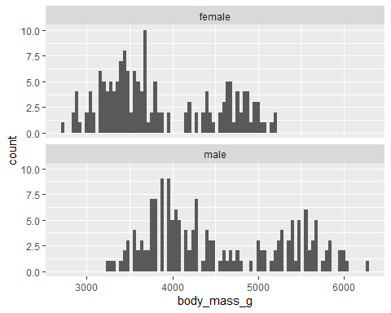

ggplot(data = Penguins) +  
 geom_histogram(binwidth = 40, mapping = aes(x = body_mass_g)) +  
 facet_wrap(~ species, nrow = 3)

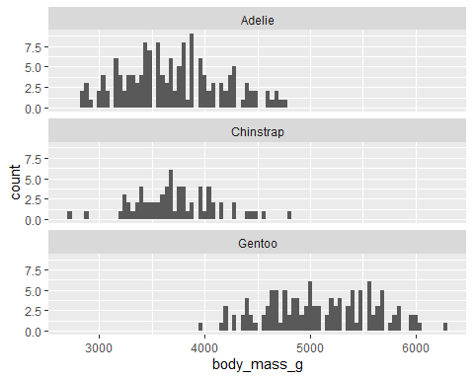

### c)

Penguins <- subset(penguins, select = -c(island, year))  
  
penguin.model <- lm(body_mass_g ~ flipper_length_mm + sex + bill_depth_mm * species,  
 data = Penguins)  
summary(penguin.model)

##   
## Call:  
## lm(formula = body_mass_g ~ flipper_length_mm + sex + bill_depth_mm *   
## species, data = Penguins)  
##   
## Residuals:  
## Min 1Q Median 3Q Max   
## -751.2 -183.8 -9.8 191.1 906.9   
##   
## Coefficients:  
## Estimate Std. Error t value Pr(>|t|)   
## (Intercept) -1336.58 646.92 -2.066 0.039615 *   
## flipper_length_mm 17.38 2.91 5.971 6.17e-09 ***  
## sexmale 432.90 44.63 9.699 < 2e-16 ***  
## bill_depth_mm 82.98 22.32 3.717 0.000237 ***  
## speciesChinstrap 1460.15 680.39 2.146 0.032610 *   
## speciesGentoo 644.88 542.57 1.189 0.235481   
## bill_depth_mm:speciesChinstrap -83.53 37.01 -2.257 0.024666 *   
## bill_depth_mm:speciesGentoo 36.17 34.48 1.049 0.294955   
## ---  
## Signif. codes: 0 '***' 0.001 '**' 0.01 '*' 0.05 '.' 0.1 ' ' 1  
##   
## Residual standard error: 286.8 on 325 degrees of freedom  
## (11 observations deleted due to missingness)  
## Multiple R-squared: 0.8758, Adjusted R-squared: 0.8732   
## F-statistic: 327.5 on 7 and 325 DF, p-value: < 2.2e-16

anova(penguin.model)

## Analysis of Variance Table  
##   
## Response: body_mass_g  
## Df Sum Sq Mean Sq F value Pr(>F)   
## flipper_length_mm 1 164047703 164047703 1994.7424 < 2.2e-16 ***  
## sex 1 9416589 9416589 114.5013 < 2.2e-16 ***  
## bill_depth_mm 1 3667377 3667377 44.5936 1.051e-10 ***  
## species 2 10670525 5335262 64.8743 < 2.2e-16 ***  
## bill_depth_mm:species 2 729458 364729 4.4349 0.01258 *   
## Residuals 325 26728014 82240   
## ---  
## Signif. codes: 0 '***' 0.001 '**' 0.01 '*' 0.05 '.' 0.1 ' ' 1

autoplot(penguin.model, smooth.colour = NA)

## Warning: Removed 333 row(s) containing missing values (geom_path).  
## Removed 333 row(s) containing missing values (geom_path).  
## Removed 333 row(s) containing missing values (geom_path).

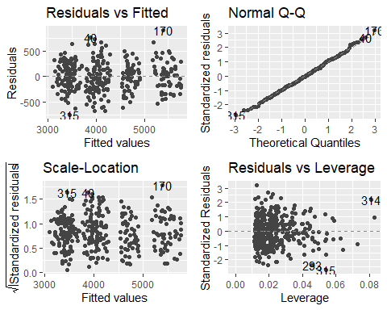

## Problem 3.

Now, the main idea is to classify the species of the penguins for a given body mass and flipper length. The dataset contains 3 type of penguin species, yet, classifying 3 penguin species is not straightforward. So, for simplicity, we define our goal to classify a penguin belonging to the species - Adelie, or not Adelie. This will give us two-class classification problem instead of three.

Since, we will use only three parameters from the dataset, it is wise to create a small dataset, and work with it. First, the variables should be converted to numeric (because knn function cannot handle the int class, and generates errors) and removes any missing observsations.

penguins$adelie <- ifelse(penguins$species == "Adelie", 1, 0)  
  
# Select only relevant variables and remove all rows with missing values in body  
# mass, flipper length, sex or species.  
Penguins_reduced <- penguins %>% dplyr::select(body_mass_g, flipper_length_mm,  
 adelie) %>% mutate(body_mass_g = as.numeric(body_mass_g),  
 flipper_length_mm = as.numeric(flipper_length_mm)) %>% drop_na()

Now, we need two datasets: the one to train the model, then to test the model. It is common to divide 70% of dataset as a training dataset, and the rest will be a test dataset.

set.seed(4268)  
  
# 70% of the sample size for training set  
training_set_size <- floor(0.7 * nrow(Penguins_reduced))  
train_ind <- sample(seq_len(nrow(Penguins_reduced)), size = training_set_size)  
train <- Penguins_reduced[train_ind, ]  
test <- Penguins_reduced[-train_ind, ]

### a)

#### i) Logistic regression

log_reg = glm(adelie ~ body_mass_g + flipper_length_mm, data = train, family =   
 "binomial")  
  
summary(log_reg)$coef

## Estimate Std. Error z value Pr(>|z|)  
## (Intercept) 37.7618776 5.1761640773 7.295340 2.979055e-13  
## body_mass_g 0.0007120 0.0004619996 1.541127 1.232859e-01  
## flipper_length_mm -0.2055804 0.0324291723 -6.339367 2.307116e-10

Here, we train the model using train dataset, and the result is available above.

prob_test_lr <- predict(log_reg, newdata = test, type = "response")  
  
pred_test_lr <- ifelse(prob_test_lr > 0.5, 1, 0)

predict() gives the probabilities of the species = Adelie (class = 1). Then, we apply a cutoff value of 0.5 to those probabilities, to get predicted classes.

adelie_lr_df = bind_rows(mutate(test, pred_test_lr))  
adelie_lr_df$pred_test_lr = as.factor(adelie_lr_df$pred_test_lr)  
  
gg_p = ggplot(test, aes(x = body_mass_g, y=flipper_length_mm, color=adelie)) +   
 geom_point(aes(x = body_mass_g, y=flipper_length_mm, colour=pred_test_lr),   
 data=adelie_lr_df, size=2) + xlab("Flipper Length of a penguin (mm)") +   
 labs(color = "Adelie") +  
 ylab("Body Mass of a penguin (g)") +   
 ggtitle("The classification of species using logistic regression") + theme_bw() + theme(plot.title = element_text(hjust = 0.5))   
gg_p

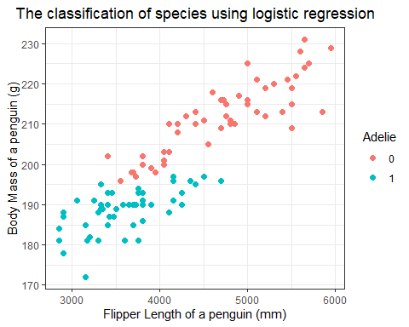

Then, we use test dataset for testing the model. The plot illustrates the testing result.

#### ii) Quadratic Discriminant Analysis

We do the same for classification using Quadratic Discriminant Analysis

qda_reg = qda(adelie ~ body_mass_g + flipper_length_mm, data = train)  
  
prob_test_qda <- predict(qda_reg, newdata = test, type = "response")$posterior  
pred_test_qda <- predict(qda_reg, newdata = test, type = "response")$class

Because QDA identifies the probabilities of having species = Adelie (class = 1), and having species = not Adelie (class = 0), predict() function will give both probabilities and already cut-off value (0.5) applied predictions. So, $\$$ posteriors will give the probabilities, $\$$ class will give 0.5 cut-off value applied corresponding classes.

adelie_qda_df = bind_rows(mutate(test, pred_test_qda))  
adelie_qda_df$pred_test_qda = as.factor(adelie_qda_df$pred_test_qda)  
  
qda_plot = ggplot(test, aes(x=body_mass_g, y=flipper_length_mm, color=adelie)) +  
 geom_point(aes(x = body_mass_g, y=flipper_length_mm, colour=pred_test_qda),   
 data=adelie_qda_df, size=2) + xlab("Flipper Length of a penguin (mm)") +   
 ylab("Body Mass of a penguin (g)") +  
 labs(shape = "Adelie", color = "Adelie") +  
 ggtitle("The classification of species using Quadratic Discriminat Analysis") + theme_bw() + theme(plot.title = element_text(hjust = 0.5))  
  
qda_plot

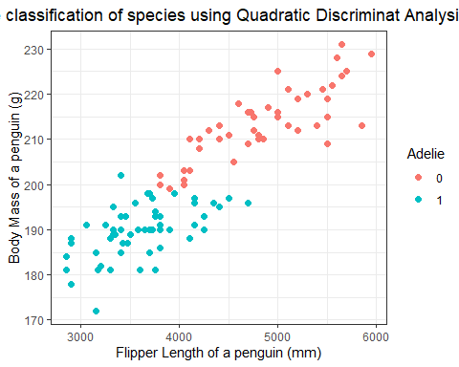

Again, this plot illustrates the testing result.

#### iii) K-nearest Neighbors

knnMod = knn(train = train, test = test, cl = train$adelie, k = 25, prob = T)  
  
knn_r <- data.frame(data.matrix(knnMod), attributes(knnMod)$prob)

After having the model, we put the result in matrix form for better usage.

probKNN = ifelse(knnMod == 0, 1 - attributes(knnMod)$prob, attributes(knnMod)$prob)  
predKNN = ifelse(probKNN > 0.5, 1, 0)

This is the way to get the probabilities of species = Adelie (class = 1). Then, again we apply 0.5 cut-off value to get the predictions.

adelie_knn_df = bind_rows(mutate(test, probKNN, predKNN))  
adelie_knn_df$predKNN = as.factor(adelie_knn_df$predKNN)  
  
gg_knn = ggplot(test, aes(x=body_mass_g, y=flipper_length_mm,  
 colour=adelie))+geom_point(aes(x=body_mass_g, y=flipper_length_mm,  
 colour=predKNN), data=adelie_knn_df, size=2) +   
 xlab("Flipper Length of a penguin (mm)") + ylab("Body Mass of a penguin (g)") +  
 labs(shape = "Adelie", color = "Adelie") + ggtitle("The classification of species using \n K-nearest Neighbors") +  
 theme_bw() + theme(plot.title = element_text(hjust = 0.5))   
  
gg_knn

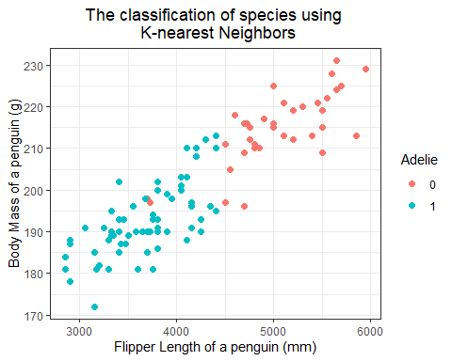

#### iv) Sensitivity $\&$ specificity

For Logistic regression

predictions_log_reg = data.frame(prob_test_lr, pred_test_lr, test[, "adelie"])  
colnames(predictions_log_reg) = c("Estim. prob. of Y=1", "Predicted class",  
 "True class")  
head(predictions_log_reg)

## Estim. prob. of Y=1 Predicted class True class  
## 1 0.9616473 1 1  
## 2 0.9028693 1 1  
## 3 0.6321050 1 1  
## 4 0.7859021 1 1  
## 5 0.9324308 1 1  
## 6 0.7688126 1 1

conf_mat_log_r = table(predicted = predictions_log_reg["Predicted class"][,1], true =   
 predictions_log_reg["True class"][,1] )  
  
print("The confusion matrix is:")

## [1] "The confusion matrix is:"

conf_mat_log_r

## true  
## predicted 0 1  
## 0 52 1  
## 1 8 42

test_error_rate_lr = (conf_mat_log_r[1, 2] + conf_mat_log_r[2, 1])/sum(conf_mat_log_r)  
print(paste( "The test error for Logistic regression -", signif(test_error_rate_lr, digits = 4)))

## [1] "The test error for Logistic regression - 0.08738"

sensitivity_lr = conf_mat_log_r[2, 2]/(conf_mat_log_r[1, 2]+conf_mat_log_r[2, 2])  
specificity_lr = conf_mat_log_r[1, 1]/(conf_mat_log_r[2, 1]+conf_mat_log_r[1, 1])  
  
print(paste( "The sensitivity - ", signif(sensitivity_lr, digits=4)))

## [1] "The sensitivity - 0.9767"

print(paste( "The specificity - ", signif(specificity_lr, digits=4)))

## [1] "The specificity - 0.8667"

For Quadratic Discriminant Analysis

predictions_qda = data.frame(pred_test_qda, test[, "adelie"])  
colnames(predictions_qda) = c("Predicted class","True class")  
head(predictions_qda)

## Predicted class True class  
## 1 1 1  
## 2 1 1  
## 3 1 1  
## 4 1 1  
## 5 1 1  
## 6 1 1

conf_mat_qda = table(predicted = predictions_qda["Predicted class"][,1], true =   
 predictions_qda["True class"][,1] )  
print("The confusion matrix is:")

## [1] "The confusion matrix is:"

conf_mat_qda

## true  
## predicted 0 1  
## 0 46 1  
## 1 14 42

test_error_rate_qda = (conf_mat_qda[1, 2] + conf_mat_qda[2, 1])/sum(conf_mat_qda)  
print(paste( "The test error for Quadratic Discriminant Analysis -", signif(test_error_rate_qda, digits = 4)))

## [1] "The test error for Quadratic Discriminant Analysis - 0.1456"

sensitivity_qda = conf_mat_qda[2, 2]/(conf_mat_qda[1, 2]+conf_mat_qda[2, 2])  
specificity_qda = conf_mat_qda[1, 1]/(conf_mat_qda[2, 1]+conf_mat_qda[1, 1])  
  
print(paste( "The sensitivity - ", signif(sensitivity_qda, digits=4)))

## [1] "The sensitivity - 0.9767"

print(paste( "The specificity - ", signif(specificity_qda, digits=4)))

## [1] "The specificity - 0.7667"

For K-nearest Neighbors

predictions_knn = data.frame(knn_r[, 2], knn_r[, 1], test[, "adelie"])  
colnames(predictions_knn) = c("Estim. prob. of Y=1","Predicted class","True class")  
head(predictions_knn)

## Estim. prob. of Y=1 Predicted class True class  
## 1 0.6000000 1 1  
## 2 0.6666667 1 1  
## 3 0.6800000 1 1  
## 4 0.6400000 1 1  
## 5 0.6800000 1 1  
## 6 0.6400000 1 1

conf_mat_knn = table(predicted = predictions_knn["Predicted class"][,1], true =   
 predictions_knn["True class"][,1] )  
print("The confusion matrix is:")

## [1] "The confusion matrix is:"

conf_mat_knn

## true  
## predicted 0 1  
## 0 35 2  
## 1 25 41

test_error_rate_knn = (conf_mat_knn[1, 2] + conf_mat_knn[2, 1])/sum(conf_mat_knn)  
print(paste( "The test error for K-nearest Neighbors -", signif(test_error_rate_knn, digits = 4)))

## [1] "The test error for K-nearest Neighbors - 0.2621"

sensitivity_knn = conf_mat_knn[2, 2]/(conf_mat_knn[1, 2]+conf_mat_knn[2, 2])  
specificity_knn = conf_mat_knn[1, 1]/(conf_mat_knn[2, 1]+conf_mat_knn[1, 1])  
  
print(paste( "The sensitivity - ", signif(sensitivity_knn, digits=4)))

## [1] "The sensitivity - 0.9535"

print(paste( "The specificity - ", signif(specificity_knn, digits=4)))

## [1] "The specificity - 0.5833"

### b) ROC $\&$ AUC

#### i)

lr_roc = roc.curve(test$adelie, prob_test_lr, col = "blue", lwd=3,   
 xlab = "1 - specificity", ylab = "sensitivity")  
  
qda_roc = roc.curve(test$adelie, prob_test_qda[,2], col = "red", lwd=3, add = T)  
  
probKNN = ifelse(knnMod == 0, 1 - attributes(knnMod)$prob, attributes(knnMod)$prob)  
  
knn_roc = roc.curve(test$adelie, probKNN, col = "green", lwd=3, add = T)  
  
legend("bottomright", legend = c("Logistic Regression", "Quadradic Discriminant \nAnalysis", "K-nearest Neighbors"), cex=0.8, lwd = 3,   
 col = c("blue", "red", "green"))

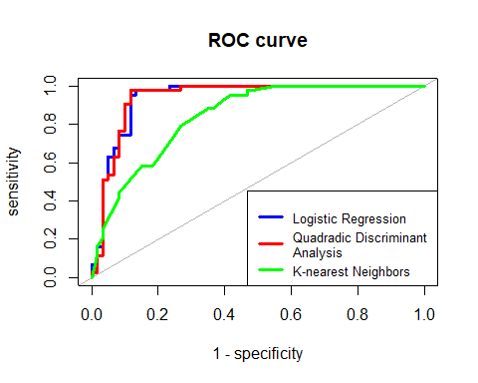

Areas Under Curves:

print(paste( "AUC of Logistic Regression ", signif(lr_roc$auc, digits = 4)))

## [1] "AUC of Logistic Regression 0.9391"

print(paste( "AUC of Quadradic Discriminant Analysis ", signif(qda_roc$auc, digits = 4)))

## [1] "AUC of Quadradic Discriminant Analysis 0.938"

print(paste( "AUC of K-nearest Neighbors ", signif(knn_roc$auc, digits = 4)))

## [1] "AUC of K-nearest Neighbors 0.8417"

#### ii)

ROC curve - Receiver operating characteristics curve displays the relation between False Positive rate and True Positive rate for all possible threshold values (0 to 1). Since True Positive rate is $\frac{True Positives}{All Positives}$, it is expressed as sensitivity, and False Positive rate as 1 - Specificity. If the model is ideal model, the sensitivity = 1, and specificity = 1, so, the curve will be on the top left. While a straight line will represent a model with random guesses on the outcome.

In order to check the overall performance of the model, AUC (Area Under Curve) values are compared, meaning that if AUC value is high, that means the curve is closer to the ideal situation.

The comparison of the models we have: Logistic regression, Quadratic Discriminant Analysis, K-nearest Neighbors

When we look at the ROC Curves, we clearly see that the model that performs worse than others is K-nearest Neighbors. This is proved by AUC area. (AUC area of KNN = 0.8417).

The performances of Logistic regression and Quadratic Discriminant Analysis are almost the same. Yet, there is a slight difference in AUC areas. Based on AUC areas, Logistic regression performs a bit better than Quadratic Discriminant Analysis (AUC area of LogReg = 0.9391, AUC area of QDA = 0.938). However, the overall conclusion is Logistic Regression and Quadratic Discriminant Analysis are similarly good models for interpreting the data.

#### iii)

If the task is to create an interpretable model, the model that has to be chosen is Logistic Regression. The reason is Logistic Regression outputs a table that contains all the necessary information to analyze the relation between two variable. The features like Intercept, p-value, t-value have key roles in interpretation.

### c)

$odds=\frac{p_{i}}{1−p_{i}}=\frac{\text{P}\left(Y_{i}=1∣X=x\right)}{\text{P}\left(Y_{i}=0∣X=x\right)}=exp\left(β_{0}\right)⋅exp\left(β_{1}x_{1}\right)⋅exp\left(β_{2}x_{2}\right)$

$odds ratio=\frac{odds\left[Y_{i}=1∣X=x_{1}+1000\right]}{odds\left[Y_{i}=1∣X=x_{1}\right]}=\frac{exp\left(β_{0}\right)⋅exp\left(β_{1}\left(x_{1}+1000\right)\right)⋅exp\left(β_{2}x_{2}\right)}{exp\left(β_{0}\right)⋅exp\left(β_{1}x_{1}\right)⋅exp\left(β_{2}x_{2}\right)}=exp\left(β_{1}*1000\right)$

We find $β_{1}$ from coefficient table of Logistic regression

summary(log_reg)$coef

## Estimate Std. Error z value Pr(>|z|)  
## (Intercept) 37.7618776 5.1761640773 7.295340 2.979055e-13  
## body_mass_g 0.0007120 0.0004619996 1.541127 1.232859e-01  
## flipper_length_mm -0.2055804 0.0324291723 -6.339367 2.307116e-10

So, $β_{1}=0.000712$

print(paste( "The odds will be multiplied by ", signif(exp(coef(log_reg)[2]*1000), digits = 4)))

## [1] "The odds will be multiplied by 2.038"

The answer is III.

### d)

prob_whole_lr <- predict(log_reg, newdata = Penguins_reduced, type = "response")  
  
pred_whole_lr <- ifelse(prob_whole_lr > 0.5, 1, 0)  
  
pred_whole_lr_sh = pred_whole_lr  
   
whole_lr_df = bind_rows(mutate(Penguins_reduced, pred_whole_lr, pred_whole_lr_sh))  
whole_lr_df$pred_whole_lr = as.factor(whole_lr_df$pred_whole_lr)  
whole_lr_df$pred_whole_lr_sh = as.factor(whole_lr_df$pred_whole_lr_sh)  
Penguins_reduced$adelie = as.factor(Penguins_reduced$adelie)   
  
  
data = ggplot(Penguins_reduced, aes(x=body_mass_g, y=flipper_length_mm, color=adelie)) +   
 geom_point(size=1) + theme_bw()  
  
  
data_plot = data +  
 geom_point(aes(x = body_mass_g, y=flipper_length_mm, colour = pred_whole_lr,  
 shape = pred_whole_lr_sh), data=whole_lr_df,  
 size=2.5, alpha = 1/2) + scale_shape_manual(values=c(1, 0))+  
 labs(shape = "Predicted classes", color = "True classes") +   
 xlab("Flipper Length of a penguin (mm)") +   
 ylab("Body Mass of a penguin (g)") +   
 ggtitle("The classification of species (Logistic Regression used)") +   
 theme_bw() + theme(plot.title = element_text(hjust = 0.5))   
  
data_plot

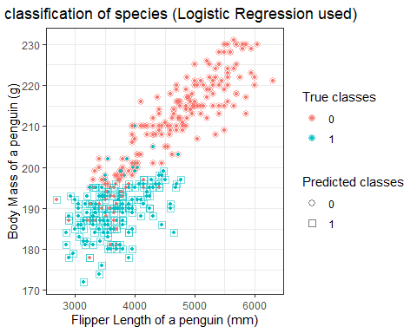

### Problem 4

### a)

Answers for the questions are as follows: (i) True; (ii) False; (iii) True; (iv) False;

### b)

Heart disease (chd) probability for a non-smoking male with systolic blood pressure (sbp) 150 is 0.10096. The R code for the problem solution is provided below:

#Accessing the data  
  
id<-"1chRpybM5cJn4Eow3-_xwDKPKyddL9M2N"  
d.chd<-read.csv(sprintf("https://docs.google.com/uc?id=%s&export=download",id))  
  
#Creating a predicting model  
  
glm_fit = glm(chd~sex+sbp+smoking, data = d.chd, family = binomial)  
  
#Predicting the disease probability  
  
temp_d <- data.frame(sex=1, sbp=150, smoking=0)  
predict(glm_fit,temp_d,type = 'response')

## 1   
## 0.10096

### c)

The R code generating solution for the first problem can be found below. As one can see most of the prediction values are between 0.05 and 0.15.

#Create function of interest   
func_interest <- function(used_data){  
 glm_fit = glm(chd~sex+sbp+smoking, data = used_data, family = binomial)  
 predict(glm_fit,data.frame(sex=1, sbp=150, smoking=0),type = 'response')  
}  
  
#Implement bootstrap for 1000 iterations and save the results in A  
B = 1000  
A = replicate(B,0)  
for (i in 1:B){  
 A[i]=func_interest(d.chd[sample(1:nrow(d.chd), 500, replace = T),])  
}  
  
hist(A, main = 'Estimated probability for "chd"', xlab = 'Estimated probability values for "chd"')

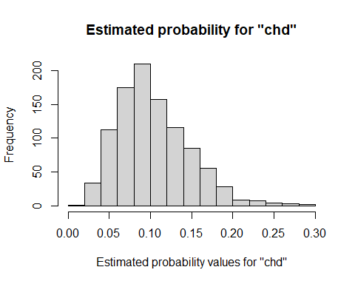 The standard error derived from predictions above equals to 0.00134.

One can find the R code generated for solving the problem here.

#Calculating standard error  
std_error_func <- function(x) sd(x) / sqrt(length(x))  
Std_error <- std_error_func(A)  
print(Std_error)

## [1] 0.001387751

The 95 % quantile interval for the bootstrap samples lies between 0.03915905 and 0.20153356. One can see how they distributed in the histogram below.

#Deriving quantiles and sorting bootstrap results within them  
q = quantile(A,probs = c(0.025, 0.975))  
  
After_q <-A[A<q[2]]  
After_q <-After_q[After_q>q[1]]  
  
hist(After_q, main = 'Quantile of estimated probability of "chd"', xlab = 'Quatiled estimated probability values of "chd"')

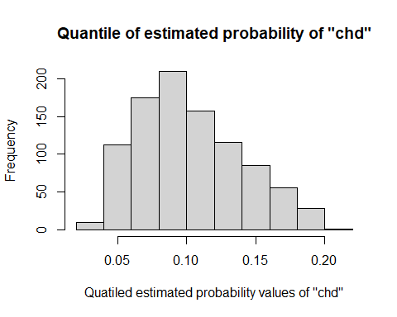

The expected probability value is 0.1036039. In my opinion the range of plausib- le values are from 0.06 to 0.12. The R code for solving this problem is here

#Calculating values probabilities and expected probability value  
  
EP = 0  
for(i in 1:length(After_q)){  
 EP = EP+After_q[i]*((1/950))  
}  
print(EP)

## [1] 0.1025979

### d)

The answers for the questions in problem d) are as follows. (i) True, (ii) False, (iii) True, (iv) False.