|  |  |
| --- | --- |
| **DOKUMENTASI EKSTERNAL**  External Documentation |  |
| **[PROYEK]**  **[ *Project*]** |
| **MATAKULIAH < COMP 6176 > – < Human and Computer Interaction >**  ***Human and Computer Interaction*** |
| SEMESTER [GENAP] 2019/2020 ***[Evet] Semester Year2019/2020*** |

## Judul Proyek

## RX PLAYER

## Pendahuluan

RX Player is a website that provides music from all over the world, all genres.  
Aat the RxPlayer Website consists of 5 pages consisting of Home, List, Premium, Top 10 Asian Music, Music by Genre. RX-Player is also available on the web or mobile web page.

Homepage occurs at the max with of screen size is 765px (Mobile); 1024px(Tabversion).

**Documentation**

**Homepage – Web Versopn**

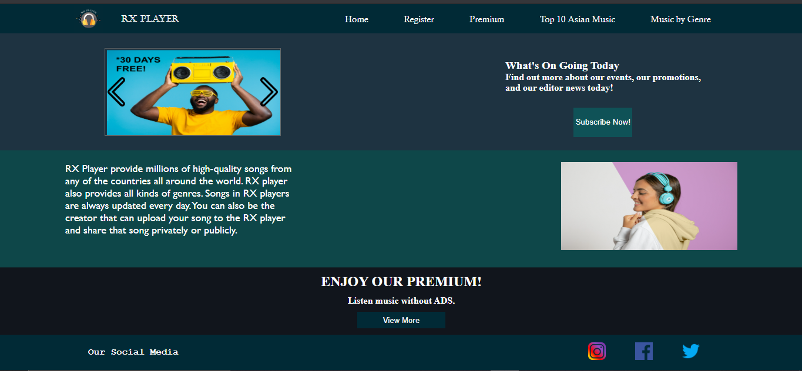

**Homepage – Mobile Version**

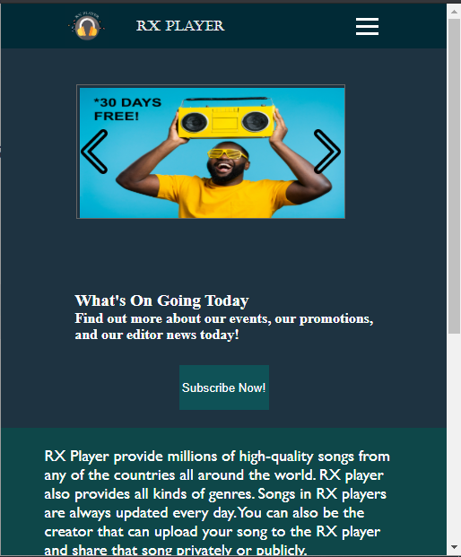

At the Home there are a image slider, subscribe button that link to register page, and view more button that links to premium page

**Registerpage – Web version**

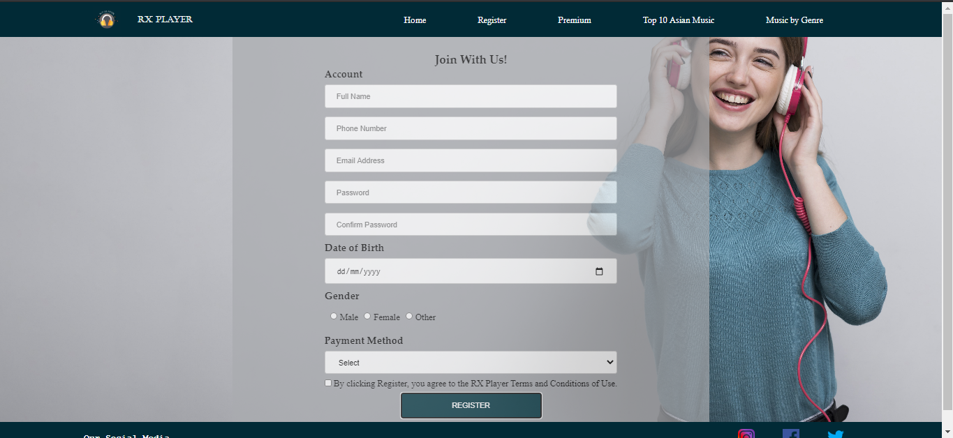

Registerpage- Mobileversion

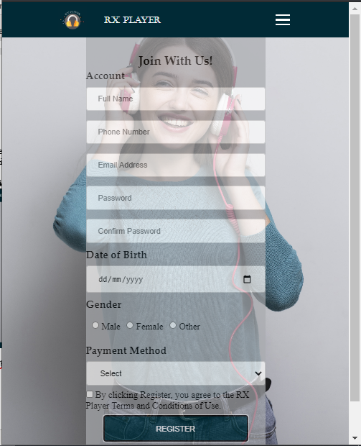At the register page for create account ther Full Name, Phone Number,Email Address, Password, Confirm Password, Date of Birth, Gender, Payment Method. This page use validation at full name, phone number, email address, password, and confirm password

**Top 10 Asian Music Page - Web version**

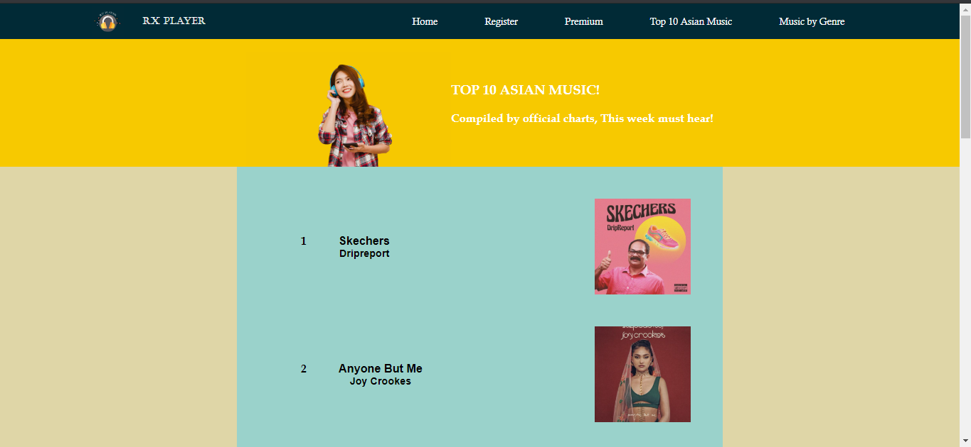

**Top 10 Asian Music Page - Mobile version**

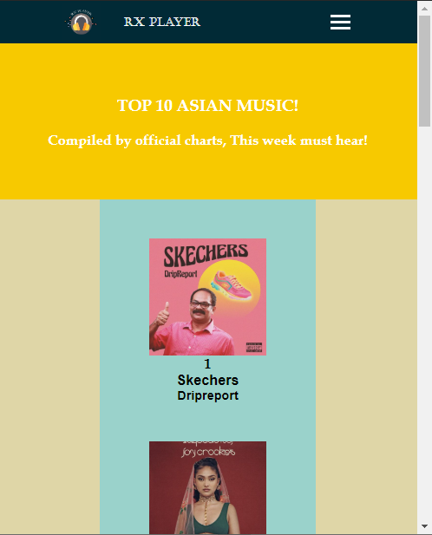

At Top 10 Asian Music Page we use <https://www.bbc.co.uk/programmes/articles/4KtcNbK96k0T6mRy2YnxMy1/asian-music-chart> for the references because its updated.

Premium Page – Web version

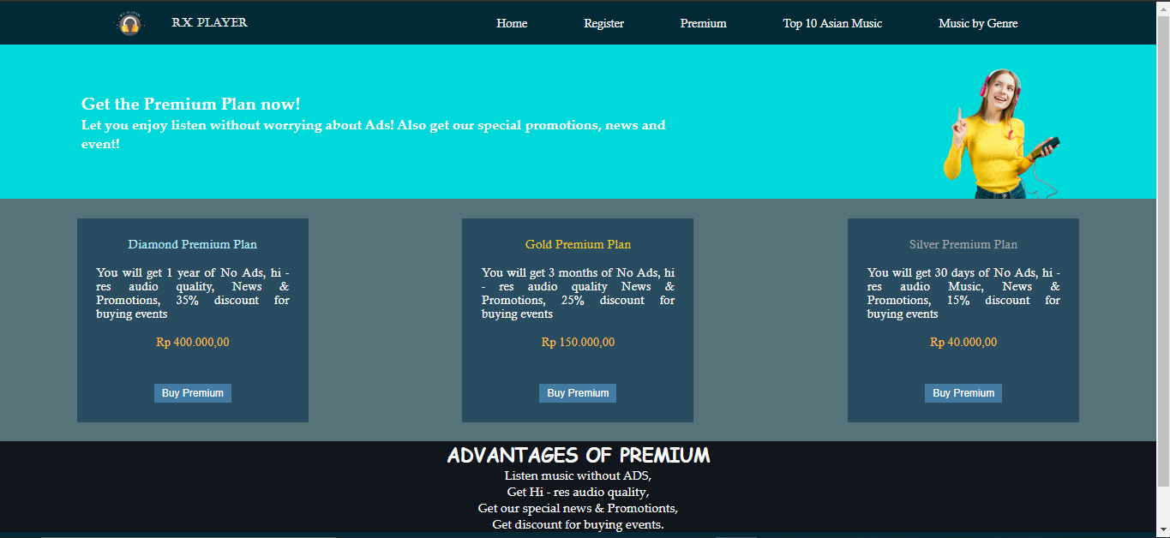

Premium Page – mobile version

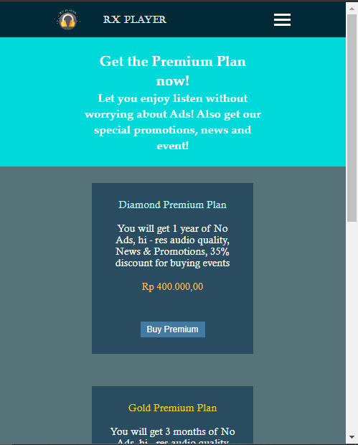At the premium package we have 3 different package there diamond premium plan, gold premium plan, silver premium plan. After click buy premium user are linked to homepage.

**Music by Genre – Web version**

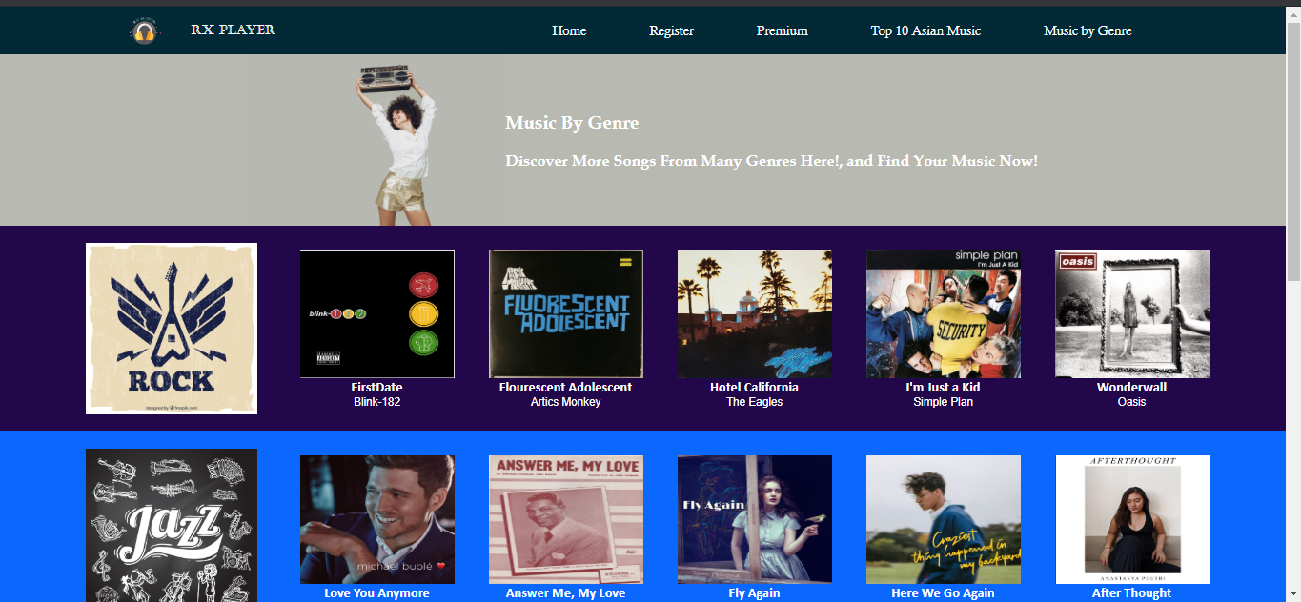

**Music by Genre – Mobile Version**

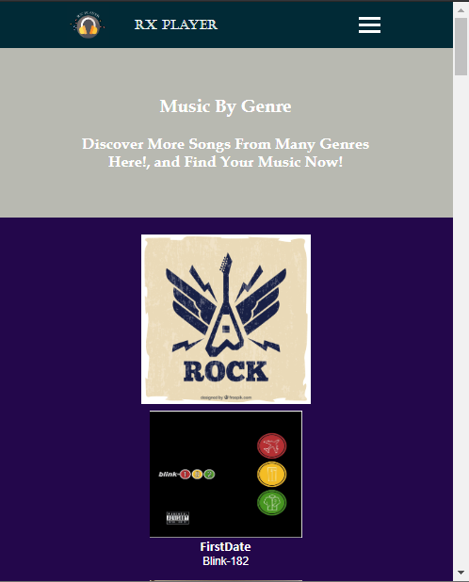

At the Music by Genres we provided genre Rock, Jazz, HipHop, Electronic, and Pop with 5 different music every genres who in top listening.

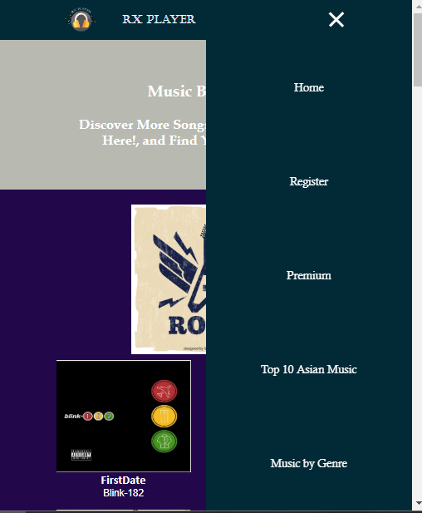The Drop Down Menu are available when web in mobile version

Example in Music By genre (mobile version) there is nav bar button , when clicked the drop down comes out.

## References

Website Asset

* Icons made by <a href="https://www.flaticon.com/authors/freepik" title="Freepik">Freepik</a> from <a href="https://www.flaticon.com/" title="Flaticon"> www.flaticon.com</a>
* Photo

<a href="http://www.freepik.com">Designed by Freepik</a>

* Icons made by <a href="https://www.flaticon.com/authors/freepik" title="Freepik">Freepik</a> from <a href="https://www.flaticon.com/" title="Flaticon"> www.flaticon.com</a>

Asian Chart

* <a href="http://www.freepik.com">Designed by Freepik</a>
* Skechers

https://ichef.bbci.co.uk/images/ic/480xn/p08b9kfc.jpg

* Anyone But Me

https://ichef.bbci.co.uk/images/ic/480xn/p089p2k7.jpg

* Early

https://i.kfs.io/album/global/46829816,1v1/fit/500x500.jpg

* Genda Phool

https://ichef.bbci.co.uk/images/ic/480xn/p0894dnr.jpg

* Humraah

https://ichef.bbci.co.uk/images/ic/480xn/p0836ytj.jpg

* Jannat

https://ichef.bbci.co.uk/images/ic/480xn/p084zfzl.jpg

* Malang

https://ichef.bbci.co.uk/images/ic/480xn/p0819293.jpg

* Ptola

https://ichef.bbci.co.uk/images/ic/480xn/p084z43b.jpg

* Shayad

https://ichef.bbci.co.uk/images/ic/480xn/p081t6h5.jpg

* Tum Hi Aana

https://1.bp.blogspot.com/-B28CDyckPO4/XZcosHXmkDI/AAAAAAAAW5U/l-5IpvzWIF4U1GCQiWlpU_Uf9HwAymW9wCLcBGAsYHQ/s1600/939x0w.jpg

Footer

* Icons made by <a href="https://www.flaticon.com/authors/freepik" title="Freepik">Freepik</a> from <a href="https://www.flaticon.com/" title="Flaticon"> www.flaticon.com</a>

Homepage

* <a href="http://www.freepik.com">Designed by Freepik</a>

Image Slider

* <a href="http://www.freepik.com">Designed by Freepik</a>
* Icons made by <a href="https://www.flaticon.com/authors/freepik" title="Freepik">Freepik</a> from <a href="https://www.flaticon.com/" title="Flaticon"> www.flaticon.com</a>

Electronic

* electronic

https://d1csarkz8obe9u.cloudfront.net/posterpreviews/electronic-music-album-cover-template-design-12b51a1ad56ef5851bc8068dd8c79aaf_screen.jpg?ts=1579265130

* heaven - avicii

https://img.discogs.com/bLdZEps09_yydW_hMKgA2Tz5vmU=/fit-in/600x534/filters:strip_icc():format(jpeg):mode_rgb():quality(90)/discogs-images/R-13733167-1560004025-7949.jpeg.jpg

* faded - alan walker

https://static.qobuz.com/images/covers/81/19/0886446321981_600.jpg

* my way - calvin harris

https://i.pinimg.com/originals/c7/f5/20/c7f520109299121c41af57b167d33d05.jpg

* holy water - galantis

https://img.discogs.com/NKWsisVm5csfxiU1K5YxZjaxyD0=/fit-in/600x600/filters:strip_icc():format(jpeg):mode_rgb():quality(90)/discogs-images/R-14203236-1569788468-7283.jpeg.jpg

* the one - W&W

https://img.discogs.com/LoN8E2JD1O6kWVqIOnCm7kGmMC8=/fit-in/600x600/filters:strip_icc():format(jpeg):mode_rgb():quality(90)/discogs-images/R-7319111-1447442908-4008.jpeg.jpg

HIP HOP

* goosebumps - travis scott

https://blog.patrickstereocap.com/wp-content/uploads/edd/2020/04/ab67616d0000b2733cdcaa1045106a5767aa79d9.

* Life is Good (feat. Drake)

https://is3-ssl.mzstatic.com/image/thumb/Music113/v4/0f/59/b8/0f59b874-d61d-7e6d-384c-f3a5b3845c47/source/1200x630bb.jpg

* Toosie slide

https://static.stereogum.com/uploads/2020/04/drake-toosie-slide-1585763946-608x609.png

* Stand by Me g-eazy

https://i1.wp.com/360media.com.ng/wp-content/uploads/2020/06/Download-G-Eazy-Stand-By-Me-Mp3-Download.jpg?fit=750%2C750&ssl=1

* beautiful pain - polo g

https://images.genius.com/a9285fc01f80d571c83fc38f91f10acf.1000x1000x1.png

JAZZ

-love you anymore

https://creativedisc.com/web/wp-content/uploads/2018/11/michaelbublelove.jpg

-Answer Me

https://donnasgeneralstore.com/wp-content/uploads/AnswerLove.jpg

-here we go again

https://public.urbanasia.com/images/post/2020/uploads/b3ee6c6c5c654767ba8ce50efa52e820.jpeg

-After Thought

https://i.ytimg.com/vi/sT_u63TxDGE/maxresdefault.jpg

-FLy AGain

https://images.squarespace-cdn.com/content/v1/5dcec99a2335133037a6b8d3/1587044406735-YYT9V6BQ8ZE3U1JFJTO9/ke17ZwdGBToddI8pDm48kItkxrqiC92NxVTFcKMNj7J7gQa3H78H3Y0txjaiv_0fDoOvxcdMmMKkDsyUqMSsMWxHk725yiiHCCLfrh8O1z5QHyNOqBUUEtDDsRWrJLTmmV5_8-bAHr7cY_ioNsJS_3HXeDDtNicEc45TWqaCTj4qRJvdqshpV7o-Z9SuE_6j/IMG_5474.JPG

Pop

-pop music

https://miro.medium.com/max/552/1*UFvb-4a9eNkh75SPAcUnHQ.jpeg

-Memories - Marron V

https://i.scdn.co/image/ab67616d0000b273b8c0135a218de2d10a8435f5

-Perfect - Ed Sheran

https://www.edsheeran.com/sites/g/files/g2000006291/f/201703/Pack-Shot_0.jpg

-I'm Yours - Jason Marz

https://content-images.p-cdn.com/images/public/rovi/albumart/3/5/7/4/075678994753_1080W_1080H.jpg

-Let Her Go - Passenger

https://images-na.ssl-images-amazon.com/images/I/81iXPzKeepL._SL1500_.jpg

-Fix You - ColdPlay

https://img.discogs.com/58mgsEsNUAvG6At2wOsPEhZMJuM=/fit-in/600x544/filters:strip_icc():format(jpeg):mode_rgb():quality(90)/discogs-images/R-1681561-1236542760.jpeg.jpg

ROCK

- <a href="http://www.freepik.com">Designed by Freepik</a>

-wonderwall

https://img.discogs.com/ek4PPXkKxADp4sUfShdDc9yyrNk=/fit-in/542x467/filters:strip_icc():format(jpeg):mode_rgb():quality(90)/discogs-images/R-793251-1418503943-4475.jpeg.jpg

-hotelcalifornia

https://tonimarino.co.uk/wp-content/uploads/2019/11/hotel-california-album-cover.png

-FlourescentA..

https://www.amoeba.com/sized-images/max/500/500/uploads/albums/covers/other//ArcticMonkeys_FlourescentAdolescent.jpg

-firstdate

https://images-na.ssl-images-amazon.com/images/I/61ny3RDFYpL._AC_SL1400_.jpg

-imjustakid

https://img.discogs.com/UFGnwDBMy1mpUhBiArex1m9Ffuo=/fit-in/600x510/filters:strip_icc():format(jpeg):mode_rgb():quality(90)/discogs-images/R-3937093-1349902582-2997.jpeg.jpg

# Logo Asset

* Icons made by <a href="https://www.flaticon.com/authors/freepik" title="Freepik">Freepik</a> from <a href="https://www.flaticon.com/" title="Flaticon"> www.flaticon.com</a>

Disiapkan Oleh,

*Prepared by,*

* **< 220181657 > - < Magnus Galih Wijaya >**
* **< 2201740754 > - < Jose Felivino >**
* **< 2201730356 > - < Hengky >**
* **< 2201736486 > - < Lim Kervan >**