|  |  |
| --- | --- |
| TALLINN UNIVERSITY OF TECHNOLOGY | |
| School of Information Technologies | |
|  | |
|  | |
| Magnus Muru IAIB184912 | |
| Five Minute Mindfulness - UX oriented Mindfulness application | |
| ASP.NET Web Applications project | |
| Supervisor: | Andres Käver |
|  |  |
|  |  |
|  |  |
|  |  |
|  |  |
|  |  |
|  |  |
|  |  |
|  |  |

Contents

1 Application overview 3

1.1 Introduction 3

1.2 Courses 3

1.3 Development 4

1.3.1 Initial stage 4

1.3.2 Further development 6

1.4 UX Prototype 6

# Application overview

## Introduction

The goal of this project is to create an application for increasing mindfulness practices in people’s everyday lives. With the onset of COVID this need has skyrocketed with more unrest and complaints of dissatisfaction in overall life quality. Current applications are overly focused on meditation in the most traditional form and in this I see a potential avenue of innovation in the space. This approach, while effective for some, completely leaves out huge parts of people. These applications are focused on guided meditation via audio, which already implies we are excluding those who are hearing impaired.

Guided meditation that forces people to listen and participate in only certain ways pigeonholes people into thinking that meditation is limited to this. The application will be focusing on breaking the limiting barriers while allowing for experimentation via journaling and allowing users to experiment via curating their own journey. Instead of providing the users detailed directions on how to do something specific, the goal is to provide them with a map and letting them figure out their own journey.

An analogy to a real-world product would be a journal that is infinitely customizable but at the same checks in and aids once the user needs or wants it. This will require theming and designing the application in modules that the user can add and extend into their experience without overcomplicating it for them.

## Courses

Five Minute Mindfulness is a combined project between two TalTech courses - ASP.NET Web Applications (ICD0015) and User Interfaces (ITI0209). In ASP.NET Web Applications, the goal will be to create a usable application that relays the full intent of the user functions. This will be the most complete application function-wise and will try to but might not include all the user interface and user experience ideas from the other course.

The application’s user interface and user experience will be the focus in the User Interfaces course, making the application overall approachable to all audiences. This will be the full implementation of the prototype and the style guide of the website that infers user flow on what they should do. This will be the most interface complete side of the application with the fewest functions.

The goal will be to infer from both course projects to unify them into one usable experience.

## Development

Since mindfulness is very much tied to what an individual person experiences, the overall development is also tied to putting user experience first. Thus, the development goals of this project will align with the user experience. As such, this document is not final and will be updated as the core ideas of the user experience get realized.

### Initial stage

Application is currently planned to be created in different stages and since two course deadlines and goals don’t always align, there will be constant reworking of the function and user experience. Initial stage function plans are as follows:

* Users can interface with the webpage to a certain extent without needing to sign up, learning the basics of mindfulness
* Users can create accounts
* Users can customize their account/application via theming
* Users can create journals to write down ideas and thoughts
* Admins can add content to the application that the users can consume
* The content which is not written has transcription for it for hard of hearing users
* The content can be given categories and put in sections for users to more easily find
* The users can set notifications via email or push to remind them of things

In addition, the User Interfaces goals for the initial stage are:

* Figure out the first-time flow for the app that goes over the basics that will get users attention
* Figure out the theming for the application such as it can be reusable and forces the user to slow down naturally instead of telling them to do so
* Focus on the user persona that would be seeking this kind of service and cater the user flow towards them
* Reduce the amount of information noise and simplify user experience
* Teach the user how to use the application by walking them through the basics

The initial entity relationship diagram is shown on the next page.

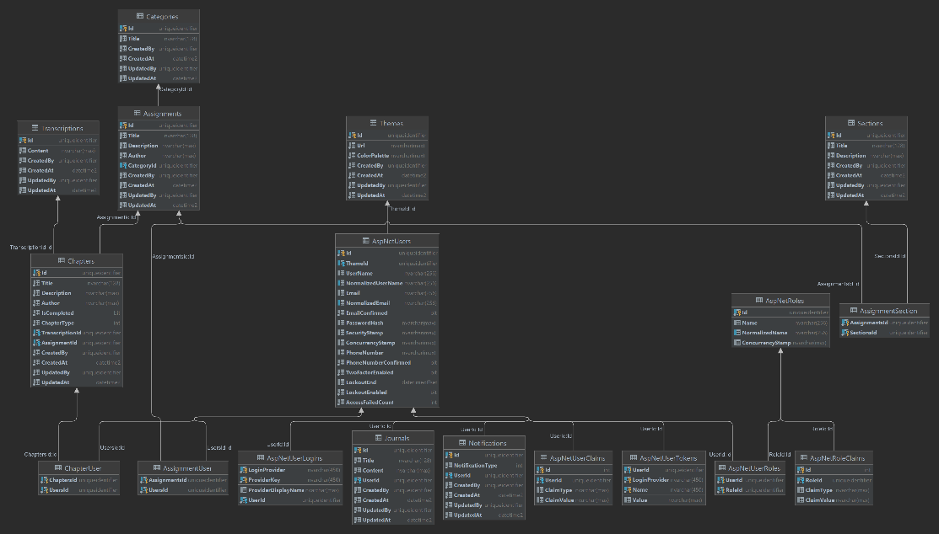

Figure 1 Initial stage Entity Relationship Diagram

### Further development

Since the project is concurrently developed in two courses there are plenty of features and user interface decisions that might or might not be implemented after the initial stage is complete. An assortment of features that are in consideration are as follows:

* Audio content
* Video content
* Users can consume the application properly in mobile
* User flows that are curated and react to how users interface with them
* Reward users that generate regular habits of using the application in a way that is natural and doesn’t force them to do so

## UX Prototype

A user experience prototype will be attached to this file once completed in the User Interfaces course. This file will be updated in the course pages accordingly.