P2 Substances

The investigation of substance use by sex workers and participation in sex work by substance users is irresistable. This work assumes that sex work and substance use go hand-in-hand, because sex work and substance use are both perceived to be harmful. One theory is that participation in sex work causes substance use, because sex work is thought to be stressful, oppressive, and stigmatized, and so sex workers use substances to cope. Another theory is that substance use causes sex work, because the increasing financial demands of feeding an addiction encourage increasingly desperate strategies for acquiring funds. A third theory is that the relationship is bi-directional, that is, sex work and substance use go together.

The evidence for these ideas is difficult to acquire, since the activities are illegal in most jurisdictions and accessing a good sample is challenging. That may be why many studies begin with substance users, and then study sex workers who are members of this population. Similarly, some studies begin with those who have multiple challenges, such as street-entrenched substance users. Other samples begin with those vulnerable to H.I.V. infection. A smaller number of studies begin with a sample of sex workers, and then study those who use substances. The origin of the samples is important, because it suggests which conclusions can be drawn about the extent of the connection between substance use and sex work, including the causal relationship.

*Establishing a Relationship, Causal and Otherwise, between Substance Use and Sex Work*

The classic methods of establishing the likelihood of a causal relationship are a) association, b) time order, c) nonspuriousness, d) mechanism, and e) context (Chambliss, & Schutt, 2016). If these things are causal, substance use and sex work ought to covary, either positively or negatively. We want to demonstrate that sex work precedes substance use or substance use precedes sex work, and the connection between these is nonrandom. If the mechanism is that the misery of sex work causes substance use or if the mechanism is that substance users resort to sex work to pay for their addiction, we want evidence for these.This relationship ought to be direct, not dependent on a random third variable. There ought to be a plausible explanation for the relationship. Finally, an accurate understanding of the context is important, because the context may contribute to the direction of the causal relationship, and because the context may help us understand where and when the causal relationship functions and where and when it does not. The context of sex work and substance use is complex, and so it is likely that it is sometimes true that one causes or is associated with the other and sometimes not.

The ability to claim these conditions of causality are hampered by a) troubles operationalizing the terms, b) sampling substance users rather than sex workers, c) reductionism and circular reasoning, and d) misinterpretation of the findings.

*Operationalizing the terms*. The measurement of substance use is a sophisticated field with many useful measurement instruments of addiction, frequency, extent, and impact on one’s life. Yet the measurement of sex work participation is *ad hoc*. Some studies do not define it at all, simply asking participants whether they have ever participated. “Self-report data on “direct” sex work involved asking women whether they had ever engaged in “prostitution,” and the answer was rated as yes or no” (Edwards, 2016). Edwards did not distinguish between a one-time experience and someone who pursues sex work as an occupation.

Some studies equate every type of exchange, such as trading sex for drugs or being paid for sex and equating what is sometimes called survival sex to the pursuit of sex work as an occupation. Matusiewicz (2016) asked, “How often have you used condoms when you have been paid for sex in the last month before treatment?” (p. 25). The response options were: no paid sex/no penetrative sex, never, rarely, sometimes, often, every time. Any frequency at any time of their life was classified as the “sex trade” group. Clarke (2012) equated being arrested for prostitution with being a sex worker. Yu, et al (2016) said, “We did not disentangle the range and variety of exchange and transactional sex within our sample, including but not limited to sex-for-cash payments, drug-sex encounters, survival sex exchanges to more emotional, and romantic benefits (such as dinner dates, escort services, and travel companionship).” These are a wide range of experiences. It seems likely to be important to take into account, if possible, frequency, recency, timing, motivation, and type of service.

The importance of considering the measurement of sex work is illustrated by Salina (2016), whose sample was from drug prevention sites. Fifteen percent reported sex work as their primary occupation, while 68% reported having at some point engaged in survival sex, trading sex for drugs. What we infer or conclude from the 68% or from 15% will be meaningfully different, and the legitimacy of doing so is determined by our operationalization of sex work. In many studies, the choice of measurement seems random.

Because the idea of sex work is troubling to many, it is easy to assume that it is a traumatic experience, as Salina (2016) did, and it is easy to assume that participants are likely to participate in other troubling activities, like drug use. These assumptions restrict the range of possible outcomes that are measured. Edwards (2016) focused on “psychopathic traits” as characteristic of sex workers. Floyd et al (2010) said that substance use and “sexual risk-taking” are connected, and in doing so conflated sexual risk-taking and sex work. Similarly, Edwards said that an erratic lifestyle is related to the “number of sexual partners in adult men and in women. But having a lot of sexual partners is probably not the same thing as sex work, even though sex workers have a lot of sexual partners. In these studies no measures of health and well-being are included, and so only troubling and troubled dimensions of their lives are discussed. Without other variables, it is difficult to tell if these associations are spurious or not.

El-Bassel (2001) began with a sample composed entirely of sex workers and then compared those who had a history of abuse to those who did not, with 27 statistical tests of the relationship between drug use and abuse. Even so, conclusions were drawn about the association of abuse and sex work, even though everyone in the sample was a sex worker. What was really being tested was the connection between abuse and drug user, not drug use and sex work or abuse and sex work.

*Sampling substance users:* If we want to make definitive—if not causal—claims about sex workers, we want to begin with a representative sample of sex workers and then collect data about their substance use. Under current conditions this is difficult in most jurisdictions. If we cannot do this, we want to be careful about our interpretations. Sallman (2010) collected data from only 14 women and is cited in several places as a source of the idea that sex work and substance use are related. It is more likely that Sallman recruited, accidentally or not, sex workers who were substance users, and small samples, by definition and experience, are almost always extreme.

A more serious challenge to our ability to understand the diversity of sex work is that many, many studies require participants to be substance users and sex workers or require participants to be substance users and then report only on those participants who are sex workers. Surrat, et al, (2004) studied the subculture of violence and interviewed 314 women, all of whom were required to be crack- and heroin-using sex workers. Hoffman et al (2000) used a sample of crack users. Duff (2012) used a prospective cohort of street-based SWs restricted to those who smoke crack cocaine. Not surprisingly, sharing a crack pipe was correlated with sex-for-crack exchanges, defined as having said “yes” to “exchange sex directly for your next rock” sometime in the previous 6 months.

Marchand (2012) recruited participants “… with a minimum of 5 years of opioid dependence, current daily injection of opioids, at least two prior treatment attempts for opioid dependence (including at least one OAT)…. “ A total of 52 (53.6%) women receiving oral and injectable medications reported being involved in sex work in at least one of the seven research visits” (p. 2). In this case it does seem plausible that the sex work is a result of drug dependence, but their question was whether the participant “had ever” exchanged sex for drugs, and over the seven data collection periods, the frequencies of participation in sex work started at 43% and went down to 17.5% by the last visit. In Marchand’s view, it is the sex work that is the risky activity, even though it was not a study of the riskiness—or not—of sex work.

Rash (2016) had a sample of 493 women with cocaine use disorders for a study of “contingency management.” Rash asked participants whether they “ever” participated in prostitution, and then compared sex workers to non-sex workers. The problem is that the comparison is really heavy cocaine users who have never traded sex for money or drugs to heavy cocaine users who have—whether one time or many times. Rash could generalize to cocaine users who occasionally trade sex for drugs but should not generalize to sex workers more generally. Floyd (2012) also had a large sample, 389 female attendees of a diversion program for adults arrested for prostitution. Floyd argued that delaying drug use delays onset of prostitution, even though the study was cross-sectional and everyone in the study had been arrested for prostitution.

Debeck (2007) interviewed 275 injection drug users, finding that 37% of the women and 2% of the men had engaged in sex work. They argued that involvement in injection drug use is made more risky by engaging in sex work. It may be true, but it is an assumption rather than an empirical finding. It is just as or more plausible that sex work is made more risky by engaging in injection drug use. Croxford’s (2015) design was somewhat better. All participants were injection drug users, but they compared sex worker males to non-sex worker males and sex worker females to non-sex worker females. Only 3 of 28 risk behaviours were significant (5 were duplicates), and these three may be random findings. Despite this, they still claimed that injecting drug users who were engaged in sex work were more vulnerable.

Rigg (2010) illustrates the sharp difference that a sample makes on the results. The sample was several hundred people, and the study was about reasons for using prescription drugs. For some, coping with stress was a reason for drug use, but no one mentioned sex work. Another example of the logical consequences of the sample is Widom (2010) from a longitudinal, prospective study that compared matched samples of abused and non-abused participants to each other, with 520 in the control group and 676 who were abused. 10.73% of those abused tried prostitution, as compared to 5.6% of those who were not abused. This is a statistically significant difference; at the same time, 89% of abused did not try prostitution.

It is also possible to use many of these same sample criteria without violating the logic of the research design. Mehrabadi (2007, 2008) also required the use of illegal substances and in this sample compared those involved in sex work to those who were not. They drew conclusions about their own sample rather than about the population of injection drug users or the population of sex workers.

*Reductionism and circular reasoning.*  Reid (2014) said, “Researchers have consistently linked commercial sexual exploitation of youth and involvement in prostitution with substance dependency and delinquency” (p. 247). This is circular reasoning, and in their own study they conflated commercial sexual exploitation and prostitution and did not parse out the differences between delinquency and prostitution and the temporal order of substance dependency and prostitution. Edwards (2016) reported that an “erratic lifestyle” is related to the “… number of sexual partners in adult men and in women, even though having a lot of sexual partners is not the same thing as sex work.

*Over- or misinterpretation of findings.* Edwards (2016) reported statistically significant differences between women in sex work and those not in sex work on measures of psychopathy, but the mean psychopathy are not very high for sex workers or non-sex workers: 12.8 compared to 9.2, when 12 and above is considered a “middle” score. On drug dependency the difference was 5.36 to 3.31, but the scale was not provided. More problematic for their interpretation is that the participants in one study were all offenders and the participants in Study 2 were women with histories of drug use and violence, and to identify sex work as the cause of these scores is not plausible.

Floyd (2010) asked participants from a sample of drug users about their motivation for drug use, with one question assessing the degree from 1 to 4, to which they used drugs to cope with their problems. But they did not ask whether those problems were related to sex work. They also did a logistic regression for those who used drugs to cope, and for these the use of drugs was associated with participation in the drug trade. The other logistic regression was for those who did not use drugs to cope, and for these there was no association between drug use and participation in the sex trade. This is a curious analysis, because everyone in both groups was a drug user, and they have no sex trade workers who are not substance users. Further, their category of those in the “sex trade” includes both buyers and sellers.

Clarke (2012) confused a correlational model with a causal model. In their sample of 389 females arrested for prostitution, they found a significant relationship between age at first drug use and age at entry into prostitution. Then they argued that delaying age of entry into prostitution delays first drug use by .4 years, even though the age of prostitution explained only 10.4 percent of the variance and it was a cross-sectional study.

Matusiewicz (2016) gathered a sample of substance users, 90 percent of whom were seeking treatment because of a referral from criminal justice, and in this study they report that sex workers are 7 times more likely to report the “non-medical use of prescription opiods” than non-sex workers. The problem is that 74% of non-sex workers used, and only 85 of 588 participants reported sex work, so the odds ratio is not persuasive as an account of sex work. Like other studies, they equated sex work and sex trading.

In contrast, Picos et al (2018) documented a connection between psychological health and well-being with a convenience sample of 146 sex workers. Unlike these other studies, they used measures of well-being and psychological health, finding a connection between psychological health and loneliness and drug use. It is one of the few studies whose analytic design considered the possibility that sex workers may experience well-being, even though the findings are applicable only to that sample.

*Considerations for Study Designs*

We have noted that many studies equate all types of activity, from trading sex for a place to stay to organized sex work. There is reason to think that sex work and trading sex or bartering sex for goods have different trajectories and those who participate may be from different populations. There is certainly the assumption of this in some of the studies, where a criterion for participation was, say, trading sex for crack. More study of the context and conditions of these would be helpful and more careful definition of the characteristics of those who participate.

A second consideration is the base rate for drug and alcohol use, which is usually igniored. We noted that studies of the relationship between sex work and drug use often have drug using samples rather than samples of sex workers or comparisons of sex workers to the general population. The usage rates of the general population are not insignificant. In 2016, 19% of Canadian adults were “heavy drinkers,” having 5 or more drinks on one occasion at least once per month (Statistics Canada, 2017). In 2017 3.7% of Canadian males used cocaine and 1.3% of females used cocaine (Statistics Canada, 2018).

A third consideration is the contribution of time. When usage is measured matters. For example, in 2008 6.5% of Canadian youth used ecstasy but by 2013 the rate declined to 2% (Canadian Centre on Substance Use and Addiction, 2017). Fourth, there is a geographic contribution. In 2013 almost 70% of recreational drug users used ecstasy in Toronto, but in Winnipeg this rate was a little over 30% (S). Further, this statistic shows what happens to the usage rates when you start with a sample of drug users.

Fourth, another context is the comparison to other occupations. There is an occupational contribution to drug use. From 2008 to 2012 the Accommodations and Food Service Industry in Canada had the highest proportion of employees using illicit drugs—19% of adults aged 18-64— and 16.9% of these adults had a substance use disorder (Bush & Lipari, 2015).

It is possible—and we think likely—that the association between sex work and substance use is more like the rest of the Canadian population, and when we select a sample appropriate for the study that the close link between substance use and sex work will be less significant. To test that hypothesis, with our sample we compared a) rates of substance use, b) rates of use by years of work, c) rates of use by the intensity of sex work, measured as the number of clients, and d) we compared those who used substances regularly with those who did not to see if there were meaningful differences.

*Methods*

Like other researchers we had to manage the challenges of obtaining samples from a population that is difficult to reach. Because the study was of sex workers, not substance users, substance use was not a criterion for participation.

*Participants*

This study used a nonrandom purposive sampling strategy to recruit 218 Canadian sex workers. To be eligible to for this study, participants had to be at least 19 years of age, be legally able to work in Canada, and have performed in person sex services at least 15 times in the last 12 months. Participants were sampled from six Canadian metropolitan centers: Victoria, British Columbia; Calgary, Alberta; Wood Buffalo (Fort McMurray), Alberta; Kitchener-Waterloo-Cambridge, Ontario; Montreal, Quebec; and St. John’s, Newfoundland. These cities were selected because of their geographical, economical, and population variation (medium and large cities).

Multiple recruitment strategies were employed to find participants at each site including contacting potential participants by phone or email found through online advertising for personal and escort services; advertising the study in local newspapers, participant related websites, local sex worker organizations; through posters at social support offices and health clinics, presentation at collaborating sex worker organizations, and peer recruitment.

When compared to the general Canadian population participants were more likely to identify as women and Indigenous, have experience in government care and receive income assistance, and were younger than other Canadians. They were less likely to have finished high school, to own their own home and to be married/living common law (See Table 1). Fewer participations were visible minority, and personal income was slightly higher than the general population.

Table 1

Overview of sex workers’ characteristics

|  |  |  |  |  |
| --- | --- | --- | --- | --- |
|  | | | | |
|  | | | Adults in the sex industry (N=218) | Canadian population data* (N=29,312,160) |
|  | | |  |  |
| Characteristics | | | % | % |
| Gender | | |  |  |
|  | Women | | 76% | 51% |
|  | Men | | 17% | 49% |
|  | Trans Inclusive | | 7% | - |
| Age (mean) | | | 34 years | 41 years |
| Ethnicity | | |  |  |
|  | Visible Minority | | 12% | 22% |
|  | Indigenous | | 19% | 5% |
|  | Other | | 69% | 73% |
|  | | |  |  |
| Foster Care Experience | | | 29% | 1% |
| Education | | |  |  |
|  | High School | | 52% | 82% |
| Income Assistance | | |  |  |
|  | | Lifetime | 68% | - |
|  | | Current | 35% | 7% |
| Married/Common Law | | | 30% | 58% |
| Own Home | | | 11% | 67% |
| Annual Personal Income (median) | | | $39,500 | $34,204 |
| *(Statistics Canada, 2015) | | | | |
|  | | | | |

*Procedure*

Participants were asked to participate in a one-time interview face-to-face interview. Respondents received a honourariam of $60 CAN for participation in this study. The interview consisted of closed- and open-ended questions and lasted approximately one and a half to two hours. The interview took place in a setting chosen by the interviewee, including coffee shops, restaurants, the participants’ home, and offices at the university. All interviews were audio recorded and later transcribed. Interviews that were conducted in French were translated into English. All analysis took place in English. This study was approved through the University of Victoria Human Research Ethics Review Board.

*Measures*

*Substance Use.* Participants were asked several questions about substance use. For the comparison of our sample to others we used participant answers to the question of whether they have Ever Used, with answers scored 1 (Yes) or 2 (No). They were also asked how many days in the past month they had used; the number of days was recorded.

For other analyses we used the answers to these questions: In the past 12 months, on average, how often do you use cocaine/crack, crystal meth/speed, club drugs, or heroin just prior to serving a client? This was scored from 1 (Never) to 6 (Every time). If they answered 2 (Rarely) to 6 (Every time) they were asked a follow-up question: Why do you use these drugs just prior to serving a sex client? They were allowed to check more than one option, and these included 1 (Relaxes me), 2 (Relaxes the client); 3 (To be social), 4 (Paid sex partner requests it), 5 (Helps me cope), and 6 (I use drugs regularly so I often incidentally use drugs prior to serving a client). If they indicated that they used drugs regularly they were classified as substance users, and everyone else was classified as a non-user.

*Years Worked.* Participants were asked, When Did You First Start Working in the Sex Industry/Begin Selling Sexual Services? The month and year was recorded. To obtain the years worked this date was substracted from the date of the interview.

*Transactions in the Past Month and Year.* Participants were asked, How Many Sexual Transactions (times you were paid for any sex activities; not exclusive to sexual intercourse) Did You Have in the Past Month and In the Past Year. Those participants who did not meet the study requirement that they have at least 15 transactions in the past 12 months were screened out.

*Demographics.* Demographics included age (year of birth), Indigeneity (1 = yes, 2 = no), and gender. Due to the small number of respondents in some categories, gender was collapsed into three categories (1 = man, 2 = woman, 3 = trans inclusive).

*Income Assistance.* Participants were asked Have You Ever Been a Recipient of Income Assistance (1 = yes, 2 = no) and Are You Currently Receiving Income Assistance (1 = yes, 2 = no).

*Current marital status*. Their marital status was coded as follows: 1 = married, 2 = common law, 3 = single, 4 = widowed, 5 = separated or divorced, and 6 = other. Because of of small numbers 4, 5, and 6 were collapsed into one category (4).

*Grade level.*  Participants were asked to indicate the highest grade they had completed in school, and the answers ranged from grade 5 to post-secondary.

*Health and mental health.* The following domains were assessed with a single question on a 4-point scale from excellent to poor: General health, mental health, sense of community belonging (1 = very strong, 4 = very weak). Workplace stress and general stress were each assessed with a single question from 1 (not at all stressful) to 5 (extremely stressful).

*Disability.*  Disability was assessed the through two questions: Have You Ever Suffered From an Occupational Injury?” (1 = yes, 2 = no) and Do You have Difficulty Hearing, Seeing, Communicating, Walking, Learning, etc?” (1 = never to 6 = all of the time).

*Data Analysis*

Odds and percentages were used for the analysis of lifetime and last 30 days of substance used. T-tests were used to examine differences between the non-users and the users on the demographic, employment, personal life, childhood disadvantage, and health and mental health variables. T-tests were also used to calculate the differene between groups on years worked and transactions in the last month and year.

Binary logistic regression was used to model group membership (users versus non-users). We created 3 models. Model 1 included all variables. Model 2 included only variables that showed significant differences between users and non-users using t-tests. Model 3 included all the significant variables from the Model 1 and 2.

*Results*

*Group Comparisons*

Two-way independent samples t-test were conducted on scale variables showed that substance users (*M* = 10.35, *SD*  = 1.73) had lower grade completion t(216) = 5.43 p = .000 than non-users (*M* = 11.39, *SD*  = 1); had more difficulty seeing, hearing, communicating, walking, learning, etc (*M* = 2.56, *SD*  = 1.68 vs. *M* = 1.83, *SD*  = 1.3) t(215) = 3.27 p = .001. Moreover, substance users (*M* = 3.24, *SD*  = 0.8) experience higher levels of sex work related stress in the past 12 months t(215) = 4.45 p = .047 than non-users (*M* = 2.59, *SD*  = 0.97); and users (*M* = 2.85, *SD*  = 1.09) experience poorer overall general health t(90) = 2.44 p = .017 non-users (*M* = 2.44, *SD*  = 1.09) and mental health t(93) = 3.21 p = .002 (*M* = 3.24, *SD*  = 1.12 vs. *M* = 2.67, *SD*  = 1.14 respectively).

A chi square test of goodness of fit was performed to determine if there was a difference between groups on categorical variables. Substance users were more likely to have ever received income assistance *X2* (1, *N* = 217) = 12.94, *p* = .000 and to be currently receiving income assistance *X2* (1, *N* = 155) = 10.72, *p* = .001, have spent time in foster care *X2* (1, *N* = 218) = 5.70, *p* = .02, and are less likely to have paid work other than sex work *X2* (1, *N* = 218) = 7.51, *p* = .006. There was no significant difference between groups for indigeneity, stress outside of sex work, sense of community belonging, age, personal income, number of sexual transactions, gender, occupational injury, marital status.

*Comparisons of Our Sample to Others*

Table 1

*Examples from Research*

|  |  |  |  |  |
| --- | --- | --- | --- | --- |
| **Authors** | **Sample Size** | **Frequency** | **Percentage** | **Sample Type** |
| **Inciardi & Surrat (2001)** |  |  | 94 |  |
| **Edwards (2016)** | 171 | Unsure | 59—cocaine  59—cannabis  13—opiod  9—poly | Offenders, including some from substance use treatment |
| **Matusiewicz** | 588 | All | 100 | Users in a treatment program. |
| **Clark (2012)** | 389 | All | 100 | All were arrested for prostitution. |
| **Yu (2016)** | 710 | Unsure | 84—alcohol  10-cannabis  17-amphetamines  12-MDMA  2.8-heroin  3—ketamine  2—opium | Male sex workers in Viet Nam |
| **Sallman (2010)** | 14 | All | 100 | All sex workers |
| **Surrat (2004)** | 314 | 314 | 100 | Required to be crack and heroin users |
| **Duff (2012)** | 206 | 206 | 100 | Required to smoke crack |
| **Marchand** | 97 | All | 100 | All had cocaine use disorders |

Table 2 shows the percentages and odds for several substances for participants in our sample. This illustrates our point that the sample you begin with determines where you end. Like us, Yu (2016) recruited sex workers, finding that some of them used substances.

Table 2

*Percentages and Odds of Lifetime and Last Month Substance Use*

|  |  |  |
| --- | --- | --- |
|  | Percentage | Odds |
| Alcohol  Lifetime  Last 30 days | 100  6 | 1  .06 |
| Cocaine/Crack  Lifetime  Last 30 days | 7  18 | 2.35  .22 |
| Heroin  Lifetime  Last 30 days | 24  02 | .31  .02 |
| Marijuana  Lifetime  Last 30 days | 93  22 | 12.63  .22 |
| Methamphetamine/speed  Lifetime  Last 30 days | 42  6 | .72  .06 |
| Club Drugs  Lifetime  Last 30 days | 53  1.4 | 1.11  .014 |
| Hallucinogens  Lifetime  Last 30 days | 58  1.4 | 1.4  .014 |
| Prescription Pain  Lifetime  Last 30 days | 47  7 | .90  .08 |
| Sedatives  Lifetime  Last 30 days | 43  6 | .74  .06 |

*Years Worked*

Next we examined the relationship between years worked and substance use. Figure 1 shows the relationship between cocaine and other “hard” drug use in response to two questions: Whether they used these drugs to cope with the demands of the job and whether they used drugs regularly. One relationship was significant: the relationship between years worked and the regular use of cocaine and other “hard” drugs. The t-test of these means is significant, *t*(218 = 2.24, p , .028, 95% CI[.4, 6.6], and the difference between the means of years worked is 13.2 for those who used cocaine regularly and 9 for those who do not. The other drugs, for the questions about whether it helps them cope with the work or whether they use drugs regularly, were not significant, except for alcohol, for which those participants who reported using had worked fewer rather than more years.

Figure 1

*Used Drugs Regularly by Years Worked*

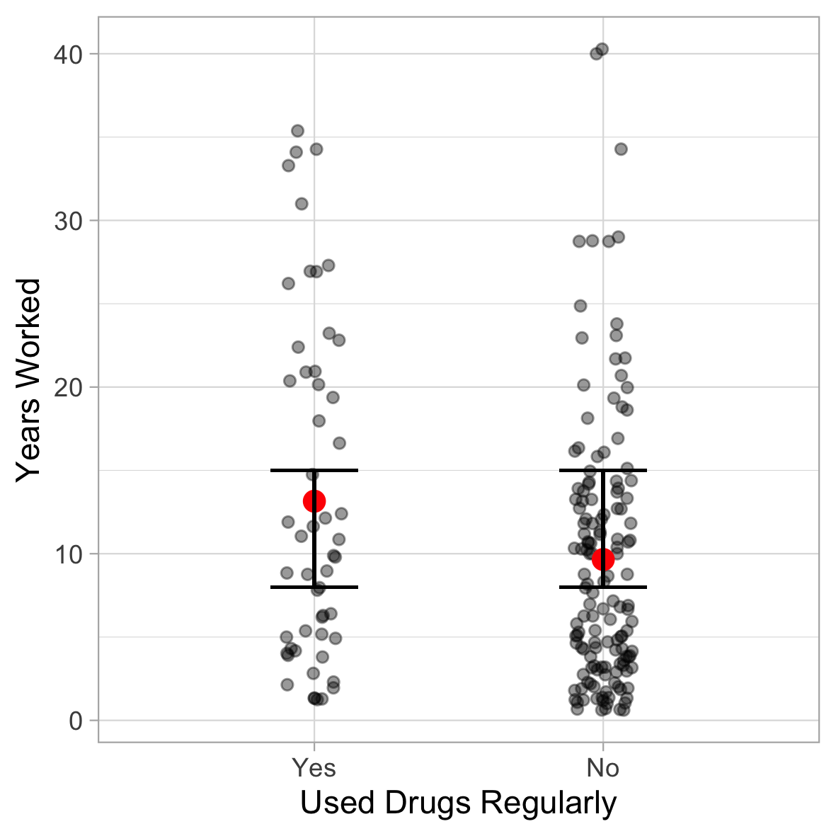

Figure 1 shows the confidence interval for the t-test, shown here as the difference in means.

Figure 2 shows the comparison between years worked and whether they use drugs prior to serving a client. A group of 38 participants has a mean above 10, and the remainder show no differences.

Figure 2

*Years Worked by How Often Use Drugs Prior to Serving Client*

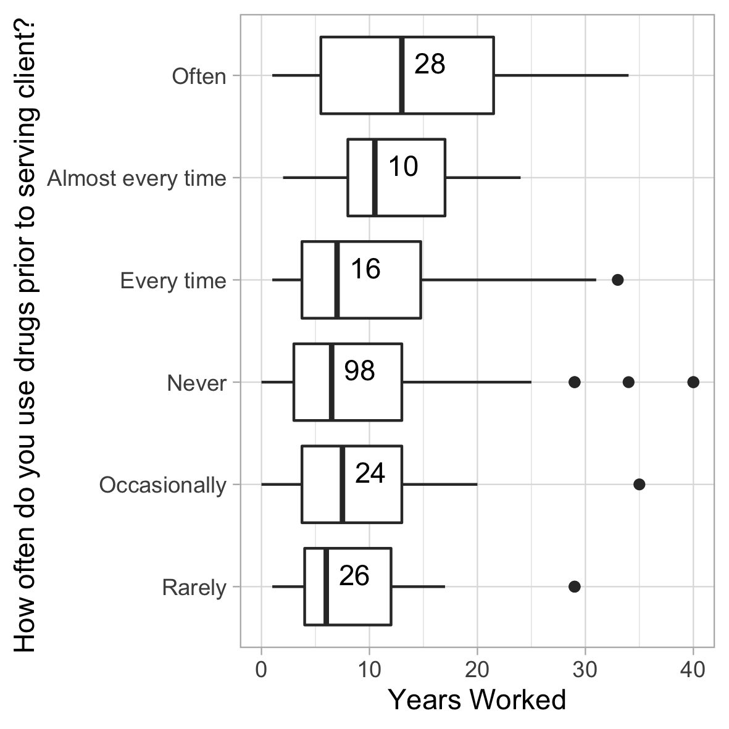

*Frequency of Transactions*

If drug use is caused by sex work, the greater the number of clients the more drug use ought to ensue. Figure 3 shows the relationship between clients in the last month and used drugs regularly. The means are almost the same.

Figure 3

*Used Drugs Regularly and Clients in the Past Month*

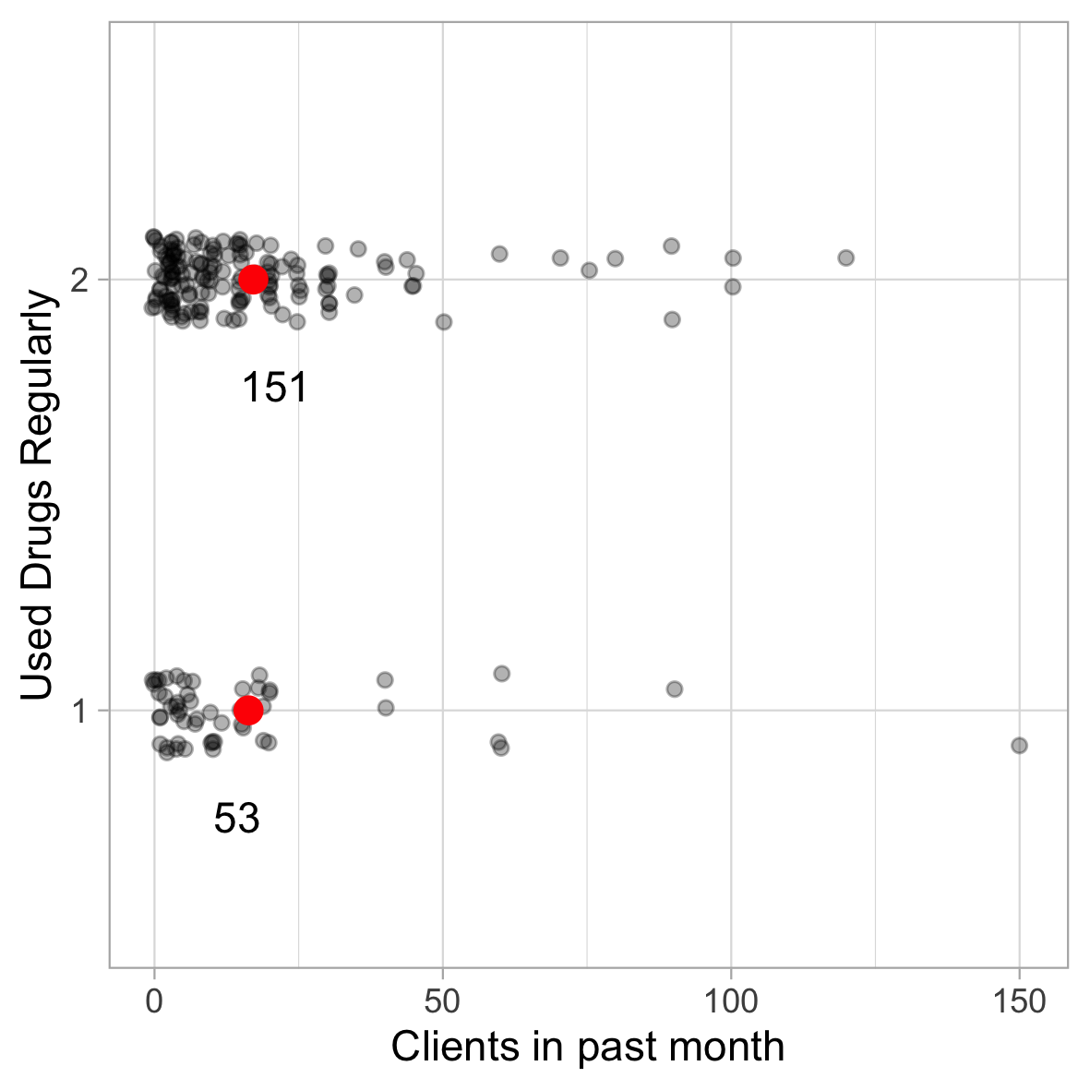

Figure 4 shows the relationship between transactions in the past month to their response on whether they use cocaine prior to serving a client to help them cope.

Figure 4

*Transactions in Past Month Compared to Cocaine Helps Me Cope*.

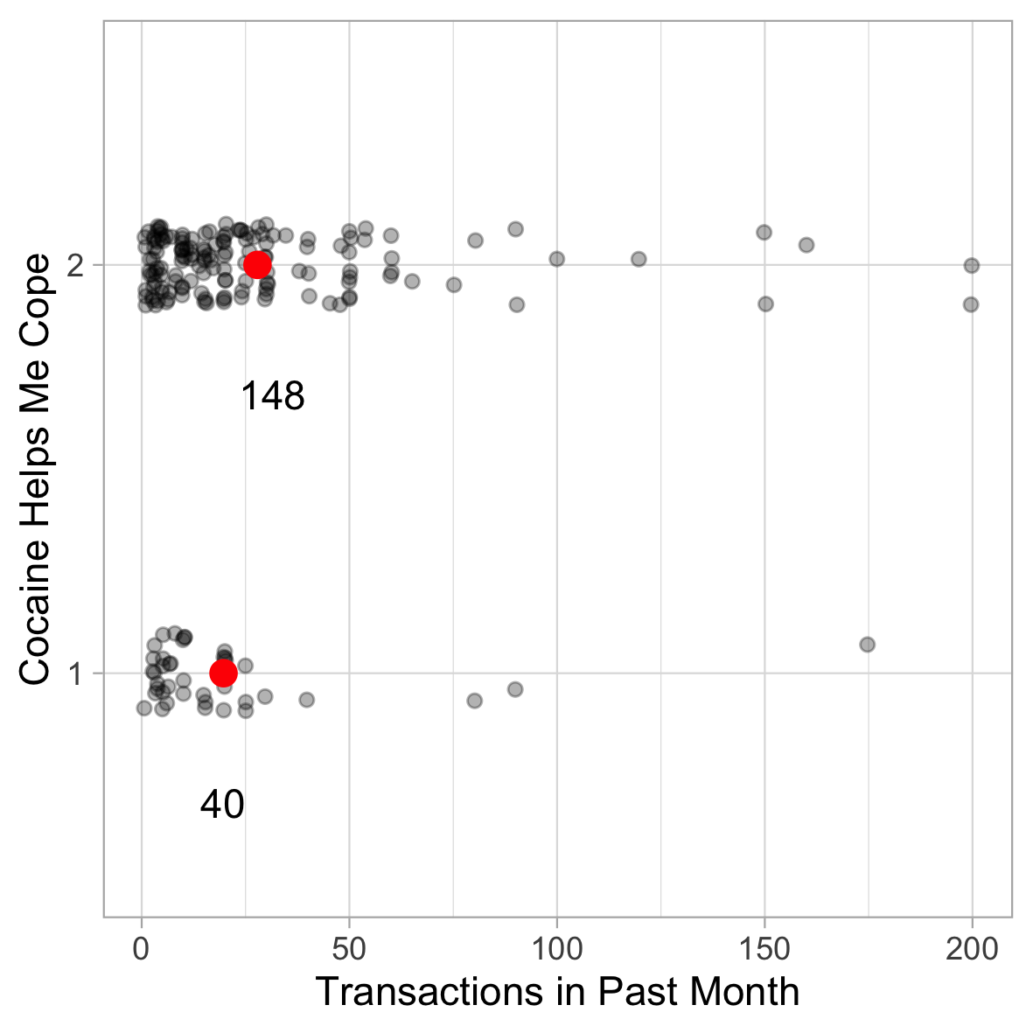

This relationship is not statistically significant [insert t-test here].

*Logistic Regression*

Logistic regression analysis was employed to predict the probability that a participant would engage in substance use while working. Three logistic regression models were tested to assess which set of variables was better at predicting group membership.

Model 1: The predictor variables were participant’s gender, age, indigeneity, personal income in last year, sexual transaction in last year, last school grade completed, experience in government care prior to age 18, ever received income assistance, current recipient of income assistance, marital status, paid work other than sex work, general health, mental health, stressful sex work in last 12 months, sense of community belonging over last 12 months, ever experiences occupational health injury, difficulty hearing, seeing, and communicating, walking, or learning. Only last grade completed and paid work other than sex work were significant predictors in the model. The model was able correctly to classify 67% of those who use non-normative substances and 88% of those who did not, for an overall success rate of 81%. See Table 3 for the logistic regression coefficient, Wald test, and odds ratio for each of the predictors.

Model 2: This model used only the predictors that showed statistical difference via t-test and chi-square: Last school grade completed, experience in government care prior to age 18, current recipient of income assistance, paid work other than sex work, general health, mental health, stressful sex work in last 12 months, and difficulty hearing, seeing, and communicating, walking, or learning, etc. In this model three out of the eight variables were significant: Last grade completed, current income assistance, and sex work related stress. Model 2 was able correctly to classify 55% of those who use non-normative substances and 90% of those who did not, for an overall success rate of 78%.

*Insert Table 4

Model 3: This model combined the significant predictors from model 1 and 2. The predictor variables were participant’s last grade completed, current income assistance, sex work related stress, paid work other than sex work, and difficulty hearing, seeing, and communicating, walking, or learning, etc. Difficulty hearing, seeing, and communicating, walking, or learning, etc. included because it was approaching significance in Model 2. In model 3 all variables were significant except paid work other than sex work. See Table 5 for statistical breakdown. Model 3 was able correctly to classify 51% of those who use substances and 90% of those who did not, for an overall success rate of 78%. Results across models are presented in Table 6.

Table 6

*Model summary.*

Model 1 Model 2 Model 3

Predictor OR (95% CI) OR (95% CI) OR (95% CI)

Gender .54 (.14 – 2.12)

Age 1.03 (.96 – 1.10)

Indigeneity .62 (.20 – 3.82)

Marital status

Married/common law .21 (.02 – 2.48)

Divorce/separate/widow .59 (.04 – 7.84)

Single .90 (.09 – 8.79)

Personal income 1.00 (1.00 – 1.00)

Ever income assistance .37 (.03 – 4.56)

Current income assistance .44 (.15 – 1.28) .40 (.12 – .92)*

Number of sexual transactions 1.00 (1.00 – 1.00)

Last grade completed 1.67 (1.16 – 2.35)** 1.476 (1.112 – 1.960)** 1.50 (1.14 – 1.98)**

Government care .77 (.27 – 2.22) .88 (.38 – 2.05)

Ever income assistance .37 (.03 – 4.56)

Current income assistance .44 (.15 – 1.28) .40 (.12 – .92)* .42 (.19 - .93)*

Paid work other than sex work 4.04 (1.01 – 13.14)* 1.82 (.64 – 5.16) 1.75 (.64 – 4.80)

General health .99 (.64 – 1.55) .89 (.61 – 1.30)

General Mental health .71 (.46 – 1.09) 7.46 (.52 – 1.08)

Stressful sex work .66 (.38 – 1.13) .54 (.33 – .86)** .52 (.33 - .82)**

Life stress outside sex work .79 (.46 – 1.36)

Sense of community belonging .88 (.52 – 1.53)

Suffered occupational injury .98 (.36 – 2.72)

Difficult hear/see/com/walk/lean/etc.92 (.66 – 1.27) .80 (.62 – 1.0) .78 (.60 – 1.00)*

-2 log ML 121.037 148.714 152.676

x2, (*df)*, *p* 9.991 (8); .271 13.387 (8); .099 5.337 (8); .721

Cox & Snell R2 .314 .248 .229

Nagelkerke R2 .436 .348 .320

MPS 81% 78% 78%

*Note.* OR = odds ration; CI = confidence interval; AUC = area under the curve; ML = maximum likelihood, MPS = group prediction success.

*p < .05 ** p< .01 ***p < .001

*References*

Bush, D. M., Lipari, R. N. (2015). Substance use and substance use disorder by industry. Substance Use and Mental Health Services Administration. Available from: https://www.ncbi.nlm.nih.gov/books/NBK343542/

Canadian Centre on Substance Use and Addiction. (2017). Ecstacy or Molly (MMDA).

Available from: https://www.ccsa.ca/ecstasy-or-molly-mdma-canadian-drug-summary

Chambliss, D. F., & Schutt, R. K. (2016). *Making sense of the social world.* Sage.

Statistics Canada. (2017). Health fact sheets: heavy drinking, 2016. Available from: https://www150.statcan.gc.ca/n1/pub/82-625-x/2017001/article/54861-eng.htm

Statistics Canada (2017). Canada tobacco, alcohol and drugs survey. Available from: https://www150.statcan.gc.ca/n1/daily-quotidien/181030/dq181030b-eng.htm