Intro
By looking at 2D flat earth on map, we know that earth is divided at equator and as we go towards south or north pole from equator, climate gets change (gets hotter); obvious reason for that is, earth rotates at its equator and revolves around the Sun. But, that’s not the only thing to consider.
Since earth it tilted at an angle of 23.5 degree relative to our orbital plane, climate at different parts around latitude changes based on time as well. E.g. particularly in month of December, North pole of earth is farther from Sun and South pole is near to Sun – which results into much colder temperature at North during December;
While analyzing the climate change data based on earth’s longitude, it is important to consider time factor as well – as data may get change based on month.
For this analysis, I am using OpenWeatherMap data by calling their APIs for ard 1400 different cities which are on different parts of latitude – in a month of start of October.

Latitude Vs Max Temperature
As stated earlier, as we move away from equator, temperature becomes colder; but particularly in Oct, cities towards north pole are much colder than cities near south pole.
As per following line and scatter plots, max temperature goes below 20F as we move towards north pole; whereas its in 40s near to south pole – in month of October.
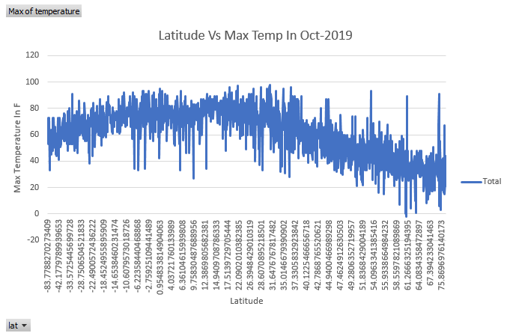
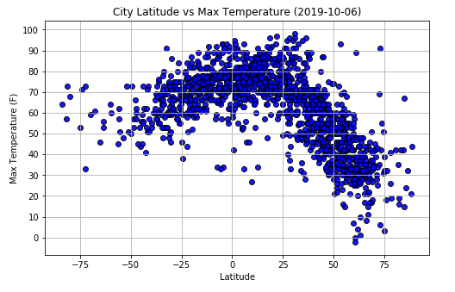
Data obviously tells that, temperature is between 50F to 85F when we are at latitude -50 to 50; but when we move towards north pole, it drops significantly even below 20F or 10F as on 06-Oct-2019. It will drop further in next 2 months or so.

Latitude Vs Humidity
As per following scatter plot, in a month of Oct-2019, cities which are near to North pole i.e. cities which are beyond latitude of 60, has more humidity than other cities which are near to equator or south pole. However, it doesn’t have that significant co-relation as we can in case of temperature.
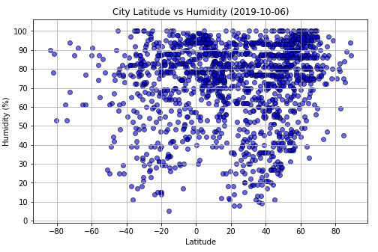

Latitude Vs Cloudiness
Following scatter plot shows there is no co-relation between Latitude and Cloudiness. Cities near to equator has same Cloudiness % as near to North or South pole.
