After observing the data provided, one thing which is ambiguous is – data doesn’t say for what reason mice treatment got stopped. As you can see in following image, data shows for many mice treatment stopped after 15 days or so. It is not clear if mice died during the treatment or some other reason the data is not available. Considering this ambiguity in data, following is my analysis.

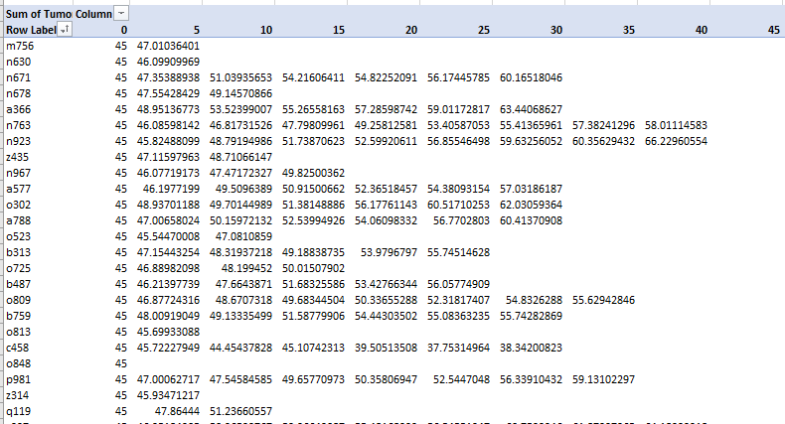

## Tumor Response To Treatment

As you can see in following image, only 1 drug - Capomulin is effective and working against cancer treatment on mice. Results shows drug - Capomulin is working immediately within first 5 days and by end of 45 days average tumor volume got reduced by almost 10 mm3 (-19%). Remaining all 3 drugs are equally in-effective against the treatment as tumor volume got increased more than 45% at end of 45 days of treatment.

Another observation is, error bar shows, results are almost correct with very less vulnerability.

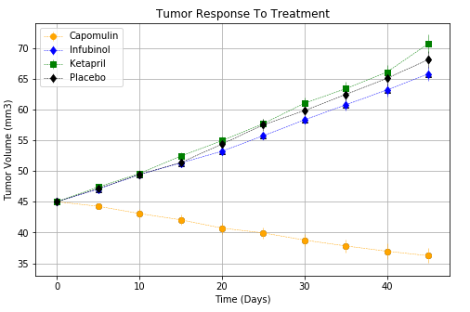

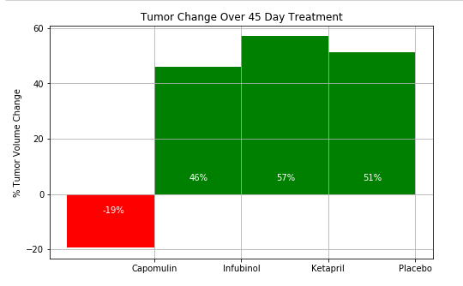

## Metastatic Spread During Treatment

As you can see in following image, except Drug Capomulin for remaining all drugs Metastatic Sites got increased more than 2 times. Error bar also shows that, this data may not be 100% accurate particularly after 20 days of treatment.

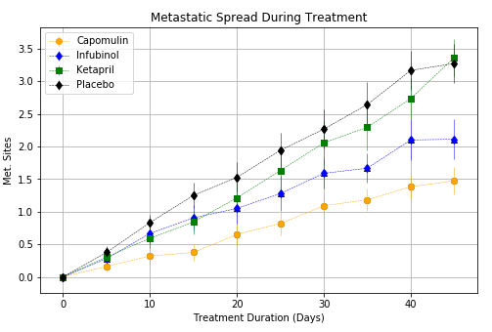

## Survival Rate

Data also signifies, Drug- Capomulin working on mice treatment as their survival rate got increased. This is in direct co-relation with prior observations, wherein we saw same drug has reduced average tumor volume significantly and MetaStatic sites were less.

At end of 45 days, survival rate for drug- Capomulin is almost 85%; whereas for remaining drugs the survival rate is less than 45%

