**Modelo BBDD**

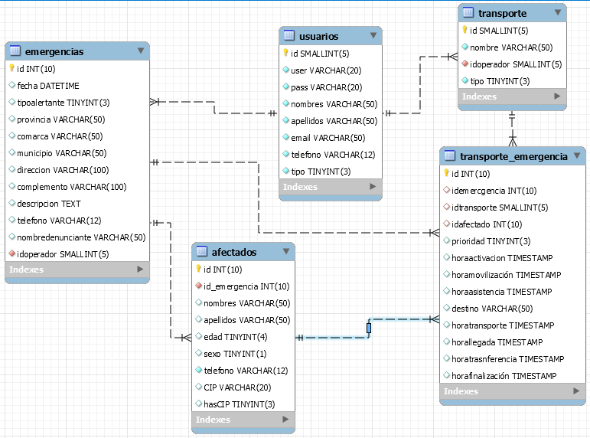

--

-- Table structure for table `afectados`

--

DROP TABLE IF EXISTS `afectados`;

SET character_set_client = utf8mb4 ;

CREATE TABLE `afectados` (

`id` int(10) unsigned NOT NULL AUTO_INCREMENT,

`id_emergencia` int(10) unsigned NOT NULL,

`nombres` varchar(50) CHARACTER SET utf8mb4 COLLATE utf8mb4_general_ci DEFAULT NULL,

`apellidos` varchar(50) CHARACTER SET utf8mb4 COLLATE utf8mb4_general_ci DEFAULT NULL,

`edad` tinyint(4) DEFAULT NULL,

`sexo` tinyint(1) DEFAULT NULL,

`telefono` varchar(12) CHARACTER SET utf8mb4 COLLATE utf8mb4_general_ci NOT NULL,

`CIP` varchar(20) CHARACTER SET utf8mb4 COLLATE utf8mb4_general_ci DEFAULT NULL,

`hasCIP` tinyint(3) unsigned DEFAULT NULL,

PRIMARY KEY (`id`)

) ENGINE=InnoDB DEFAULT CHARSET=utf8mb4 COLLATE=utf8mb4_0900_ai_ci;

--

-- Table structure for table `emergencias`

--

DROP TABLE IF EXISTS `emergencias`;

SET character_set_client = utf8mb4 ;

CREATE TABLE `emergencias` (

`id` int(10) unsigned NOT NULL AUTO_INCREMENT,

`fecha` datetime DEFAULT NULL,

`tipoalertante` tinyint(3) unsigned DEFAULT NULL,

`provincia` varchar(50) CHARACTER SET utf8mb4 COLLATE utf8mb4_general_ci DEFAULT NULL,

`comarca` varchar(50) CHARACTER SET utf8mb4 COLLATE utf8mb4_general_ci DEFAULT NULL,

`municipio` varchar(50) CHARACTER SET utf8mb4 COLLATE utf8mb4_general_ci DEFAULT NULL,

`direccion` varchar(100) CHARACTER SET utf8mb4 COLLATE utf8mb4_general_ci DEFAULT NULL,

`complemento` varchar(100) CHARACTER SET utf8mb4 COLLATE utf8mb4_general_ci DEFAULT NULL,

`descripcion` text CHARACTER SET utf8mb4 COLLATE utf8mb4_general_ci,

`telefono` varchar(12) CHARACTER SET utf8mb4 COLLATE utf8mb4_general_ci DEFAULT NULL,

`nombredenunciante` varchar(50) CHARACTER SET utf8mb4 COLLATE utf8mb4_0900_ai_ci DEFAULT NULL,

`idoperador` smallint(5) unsigned NOT NULL,

PRIMARY KEY (`id`)

) ENGINE=InnoDB DEFAULT CHARSET=utf8mb4 COLLATE=utf8mb4_0900_ai_ci;

--

-- Table structure for table `transporte_emergencia`

--

DROP TABLE IF EXISTS `transporte_emergencia`;

SET character_set_client = utf8mb4 ;

CREATE TABLE `transporte_emergencia` (

`id` int(10) unsigned NOT NULL AUTO_INCREMENT,

`idemercgencia` int(10) unsigned DEFAULT NULL,

`idtransporte` smallint(5) unsigned DEFAULT NULL,

`idafectado` int(10) unsigned DEFAULT NULL,

`prioridad` tinyint(3) unsigned DEFAULT NULL,

`horaactivacion` timestamp NULL DEFAULT NULL,

`horamovilización` timestamp NULL DEFAULT NULL,

`horaasistencia` timestamp NULL DEFAULT NULL,

`destino` varchar(50) CHARACTER SET utf8mb4 COLLATE utf8mb4_general_ci DEFAULT NULL,

`horatransporte` timestamp NULL DEFAULT NULL,

`horallegada` timestamp NULL DEFAULT NULL,

`horatrasnferencia` timestamp NULL DEFAULT NULL,

`horafinalización` timestamp NULL DEFAULT NULL,

PRIMARY KEY (`id`)

) ENGINE=InnoDB DEFAULT CHARSET=utf8mb4 COLLATE=utf8mb4_0900_ai_ci;

--

-- Table structure for table `transporte`

--

DROP TABLE IF EXISTS `transporte`;

SET character_set_client = utf8mb4 ;

CREATE TABLE `transporte` (

`id` smallint(5) unsigned NOT NULL AUTO_INCREMENT,

`nombre` varchar(50) CHARACTER SET utf8mb4 COLLATE utf8mb4_general_ci NOT NULL,

`operadores` tinyint(3) unsigned NOT NULL,

`tipo` tinyint(3) unsigned NOT NULL,

PRIMARY KEY (`id`)

) ENGINE=InnoDB DEFAULT CHARSET=utf8mb4 COLLATE=utf8mb4_0900_ai_ci;

--

-- Table structure for table `usuarios`

--

DROP TABLE IF EXISTS `usuarios`;

SET character_set_client = utf8mb4;

CREATE TABLE `usuarios` (

`id` smallint(5) unsigned NOT NULL AUTO_INCREMENT,

`user` varchar(20) CHARACTER SET utf8mb4 COLLATE utf8mb4_general_ci NOT NULL,

`pass` varchar(20) CHARACTER SET utf8mb4 COLLATE utf8mb4_general_ci NOT NULL,

`nombres` varchar(50) CHARACTER SET utf8mb4 COLLATE utf8mb4_general_ci NOT NULL,

`apellidos` varchar(50) CHARACTER SET utf8mb4 COLLATE utf8mb4_general_ci NOT NULL,

`email` varchar(50) CHARACTER SET utf8mb4 COLLATE utf8mb4_general_ci NOT NULL,

`telefono` varchar(12) CHARACTER SET utf8mb4 COLLATE utf8mb4_general_ci NOT NULL,

`tipo` tinyint(3) unsigned NOT NULL,

PRIMARY KEY (`id`)

) ENGINE=InnoDB DEFAULT CHARSET=utf8mb4 COLLATE=utf8mb4_0900_ai_ci;

--

-- Dumping data for table `usuarios`

--