RALPH MAGO

CPE301 – SPRING 2016

Design Assignment 0

**DO NOT REMOVE THIS PAGE DURING SUBMISSION:**

The student understands that all required components should be submitted in complete for grading of this assignment.

|  |  |  |  |
| --- | --- | --- | --- |
| **NO** | **SUBMISSION ITEM** | **COMPLETED (Y/N)** | **MARKS**  **(/MAX)** |
| 1. | INITIAL CODE OF TASK 1/A |  |  |
| 2. | INCREMENTAL / DIFFERENTIAL CODE OF TASK 2/B |  |  |
| 3. | SCREENSHOTS OF EACH TASK OUTPUT |  |  |
| 4. | GITHUB LINK OF THE DA |  |  |

|  |  |  |  |
| --- | --- | --- | --- |
| 1. | INITIAL CODE OF TASK 1/A |  |  |

/*

* MagoDA0.asm

*

* Created: 2/11/2016 1:27:37 PM

* Author: magor

* ATMega328P

* - Write an assembly code to add five random numbers >30 and <60. If the sum produces

* an overflow set PORTB.2 pin = HIGH else PORTB.2 pin = LOW.

*/

; No overflow example

LDI R17, 37 ; 1st integer

LDI R18, 38 ; 2nd integer

ADD R17, R18 ; R20 = sum of 1st and 2nd integer

LDI R18, 57 ; 3rd integer

ADD R17, R18 ; add 3rd integer to sum

LDI R18, 46 ; 4th integer

ADD R17, R18 ; add 4th integer to sum

LDI R18, 49 ; 5th integer

ADD R17, R18 ; add 5th integer to sum

BRCC noCarry ; branch if carry clear [bit in status register is 0 (no overflow)]

SBI PORTB, 2 ; if there is an overflow, then set pin PB2 = 1

jmp done

noCarry:

CBI PORTB, 2 ; if there is no overflow, then clear pin PB2 (PB2 = 0)

done:

5 Integers => 37 + 38 + 57 + 46 + 49 = 227 in decimal (0xE3)

No overflow since 227 < 256

; Overflow example

LDI R17, 56 ; 1st integer

LDI R18, 56 ; 2nd integer

ADD R17, R18 ; R20 = sum of 1st and 2nd integer

LDI R18, 56 ; 3rd integer

ADD R17, R18 ; add 3rd integer to sum

LDI R18, 56 ; 4th integer

ADD R17, R18 ; add 4th integer to sum

LDI R18, 56 ; 5th integer

ADD R17, R18 ; add 5th integer to sum

BRCC noCarry ; branch if carry clear [bit in status register is 0 (no overflow)]

SBI PORTB, 2 ; if there is an overflow, then set pin PB2 = 1

jmp done

noCarry:

CBI PORTB, 2 ; if there is no overflow, then clear pin PB2 (PB2 = 0)

done:

5 integers => 56 + 56 + 56 + 56 + 56 = 280 in decimal (0x118 actual, 0x18 with overflow)

|  |  |  |  |
| --- | --- | --- | --- |
| 2. | INCREMENTAL / DIFFERENTIAL CODE OF TASK 2/B |  |  |

* - Determine the execution time / # cycles of your algorithm using the simulation, set

* CLOCK speed = 8MHz.

; No overflow example

Clock Speed = 8Mhz, Stop Watch Time = 2,047.75 µs, Cycle Counter = 16382

2,047.75 µs / 16382 ≈ **0.125 ms**

; Overflow example

Clock Speed = 8Mhz, Stop Watch Time = 2,048.00 µs, Cycle Counter = 16384

2,048.00 µs / 16384 ≈ **0.125 ms**

|  |  |  |  |
| --- | --- | --- | --- |
| 7. | SCREENSHOTS OF EACH TASK OUTPUT |  |  |

; No overflow example

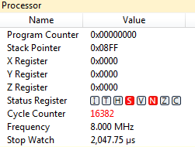





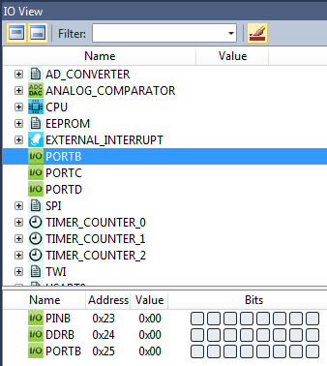

Bit 2 of PINB is 0 because there is no overflow.

; Overflow example

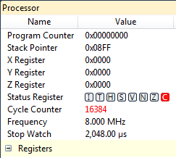



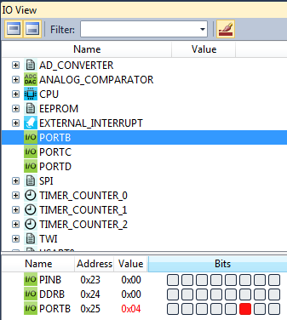

Bit 2 of PINB is 1 because there is overflow.

|  |  |  |  |
| --- | --- | --- | --- |
| 10. | GITHUB LINK OF THE DA |  |  |
| https://github.com/magor1/embedded-design.git | | | |

**Student Academic Misconduct Policy**

<http://studentconduct.unlv.edu/misconduct/policy.html>

“This assignment submission is my own, original work”.

RALPH MAGO