**Project Selection: CPE 301 SPR2016**

|  |  |
| --- | --- |
| Name: | Ralph Mago |
| L#: | 1008210657 |
| Project Title: | Muscle Movement Detection Unit |

**Project Goal / Objectives:**

This device will gather activity levels of body movement using IMU and Single (or Dual Accelerometer). It can be strapped on an individual’s hand to track muscle spasms in order to detect early signs of carpal tunnel syndrome or arthritis. If not bulky enough, the device can also be strapped on the foot to track motor patterns with each step to determine whether an individual has normal or stiff ankle walking patterns. The main goal of the project is to program an AVR microcontroller (in this case the ATMega328P) to provide a graphical reading for muscle movement.

Decided method is **Bluetooth**. The circuit will have Velcro tape for strapping on the wrist or ankle.

This project will be referencing [Yifan Jiang’s C code](https://github.com/YifanJiangPolyU/MPU6050) for communication between ATMega328P and MPU-6050 gyro/accelerometer.

**Design Flow:**

1. Enable and implement **interrupts**
2. Setup wireless Serial Port using **I2C** and **UART** and initialize
3. Create **RAM** data array to store gyro & accelerometer data
4. Read accelerometer data in X, Y, Z axis
5. Read gyro data in X, Y, Z axis
6. Transfer data serially and infinite loop

**Remaining Timeline:**

4th week of April - Debugging and Simulation with Atmel Studio, Gyro/Accelerometer calibration, Bluetooth or WiFi implementation

1st week of May - Finalize code, schematics, PCB layout

2nd week of May - In-class presentation and demo of function

**Hardware Components:**

* Atmel ATMega328P Microcontroller
* InvenSense MPU-6050 Sensor (Accelerometer + Gyro)
* InvenSense MPU-9150 has a magnetometer if I want to implement a compass for the device
* Guangzhou HC HC-06 Bluetooth Module (Wireless Implementation with Mobile Device for an oscilloscope-type app)
* Li-Ion Battery (5V, 2A output)

**Updated Schematic:**

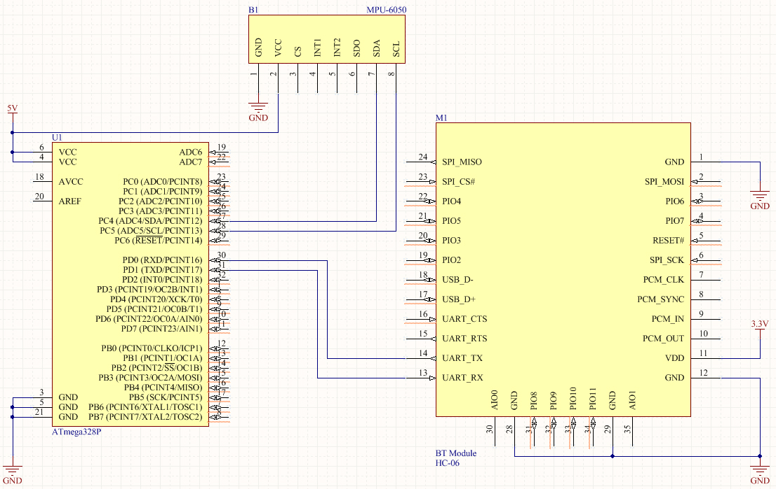

**Reference:**

InvenSense - Datasheet for MPU-6000 and MPU-6050

<http://43zrtwysvxb2gf29r5o0athu.wpengine.netdna-cdn.com/wp-content/uploads/2015/02/MPU-6000-Datasheet1.pdf>

Guangzhou HC - Datasheet for HC-06

<https://www.olimex.com/Products/Components/RF/BLUETOOTH-SERIAL-HC-06/resources/hc06.pdf>

Yifan Jiang – HK Polytechnic University – Interface for ATMega328P <-> MPU-6050

<https://github.com/YifanJiangPolyU/MPU6050>