RALPH MAGO

CPE301 – SPRING 2016

Design Assignment FINAL

**DO NOT REMOVE THIS PAGE DURING SUBMISSION:**

The student understands that all required components should be submitted in complete for grading of this assignment.

|  |  |  |  |
| --- | --- | --- | --- |
| **NO** | **SUBMISSION ITEM** | **COMPLETED (Y/N)** | **MARKS**  **(/MAX)** |
| 0. | GOAL OF THE PROJECT | Y |  |
| 1. | DELIVERABLES | Y |  |
| 2. | LITERATURE SURVEY | Y |  |
| 3. | COMPONENTS | Y |  |
| 4. | SCHEMATICS | Y |  |
| 5. | INITIAL PCB | Y |  |
| 6. | IMPLEMENTATION | Y |  |
| 7. | SCREENSHOTS AND VIDEO | Y |  |
| 8. | CODE | Y |  |
| 9. | REFERENCES | Y |  |
|  |  |  |  |
|  |  |  |  |

|  |  |  |  |
| --- | --- | --- | --- |
| 0. | GOAL OF THE PROJECT |  |  |

* Attribute I2C and UART experience in AVR to create a functional circuit design
* Implement wireless serial communication using Bluetooth
* Capture accelerometer movement in the X, Y, and Z axes
* Display the captured data in a graphical setting

|  |  |  |  |
| --- | --- | --- | --- |
| 1. | DELIVERABLES |  |  |

This project is expected to deliver data from the gyro/accelerometer into a graphical output:

* Gyro X-axis data graphical representation of rotation (roll)
* Gyro Y-axis data graphical representation of rotation (pitch)
* Gyro Z-axis data graphical representation of rotation (yaw)
* AVR MAIN C code + referenced .c and header files
* Schematics, PCB
* Demonstration of BT serial communication

|  |  |  |  |
| --- | --- | --- | --- |
| 2. | LITERATURE SURVEY |  |  |

The current state of the project allows a functional graphical representation of gyro/accelerometer movement by the user, by wrist or ankle movement. Wireless transmission using Bluetooth to send the captured accelerometer data will be useful in observing movement data over time and finding rotational movement patterns along the X, Y, and Z axes.

|  |  |  |  |
| --- | --- | --- | --- |
| 3. | COMPONENTS |  |  |

|  |  |
| --- | --- |
| Atmel Xplained Mini (328P) | 1 |
| MPU6050 Gyro/Accelerometer | 1 |
| HC-06 Bluetooth Module | 1 |
| Power Supply (3.3V, 5V) | 1 |

|  |  |  |  |
| --- | --- | --- | --- |
| 4. | SCHEMATICS |  |  |

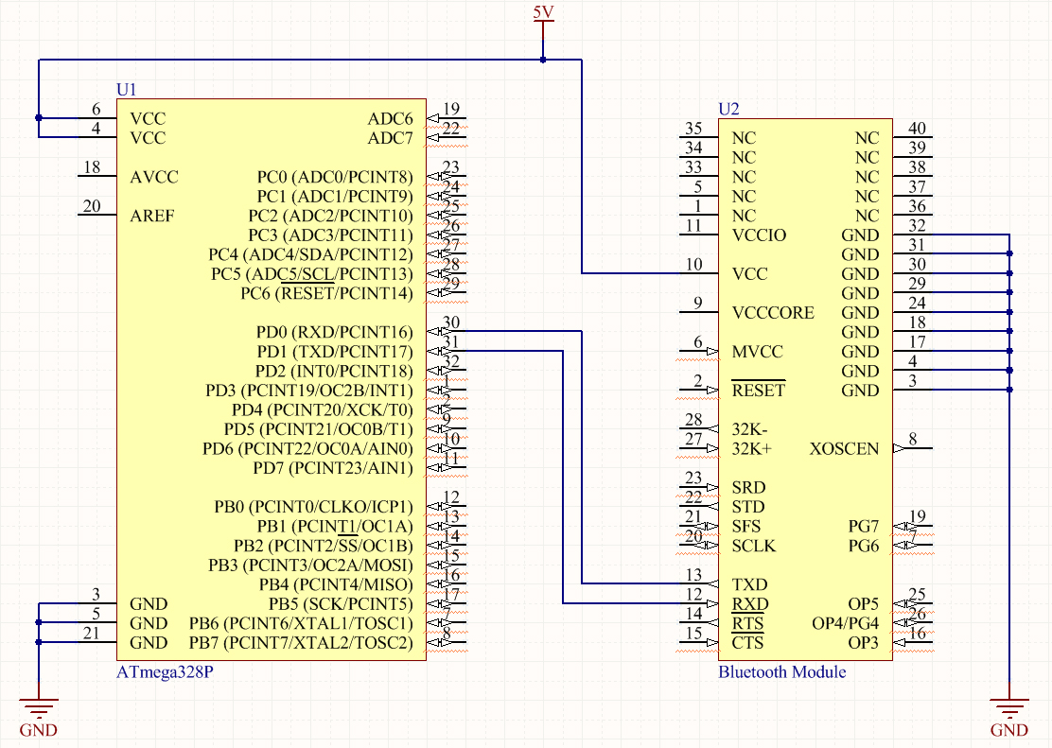

|  |  |  |  |
| --- | --- | --- | --- |
| 5. | INITIAL PCB |  |  |

|  |  |  |  |
| --- | --- | --- | --- |
| 6. | IMPLEMENTATION |  |  |

* Prepare a Bluetooth capable device that can run a serial terminal to transmit and receive between the HC-06 Bluetooth Module and the microcontroller
* Make necessary conversions to gyro/accelerometer captured data in order for the serial terminal to get a correct output.
* Establish proper wireless connection through Bluetooth
* Enable graphs for X, Y, and Z axes.
* Rotate accelerometer around and observe changes in output data.

|  |  |  |  |
| --- | --- | --- | --- |
| 7. | SCREENSHOTS AND VIDEO |  |  |

|  |  |  |  |
| --- | --- | --- | --- |
| 8. | CODE |  |  |

* The header files are refenced from [1]
  + **I2c.h** / **i2c.**

|  |  |  |  |
| --- | --- | --- | --- |
| 9. | REFERENCES |  |  |

[1]P. Jan. (Apr 2013). Reading a IMU Without Kalman: The Complementary Filter (1st ed.)[Online]. Available: <http://www.pieter-jan.com/node/11>

[2]Y. Jiang. (Dec 2014). MPU6050, GitHub repository [Online].

Available: <https://github.com/YifanJiangPolyU/MPU6050>

**Student Academic Misconduct Policy**

<http://studentconduct.unlv.edu/misconduct/policy.html>

“This assignment submission is my own, original work”.

RALPH MAGO