When selecting the blockchain.com payment methor, or any other method called “Card to…” you will get redirected to a third-party payment provider. The process is usually quite similar. You register first time, or login if you already have an account. First time users often need to do a KYC (know your customer) process. Do as instructed and important, do not change any thing else in the pages. The blockchain address shown is important it remains unchanged.
Here is an example of a first time use of blockchain.com payment gateway.

- You are presented with a screen for the amount. Accept it and press preview buy
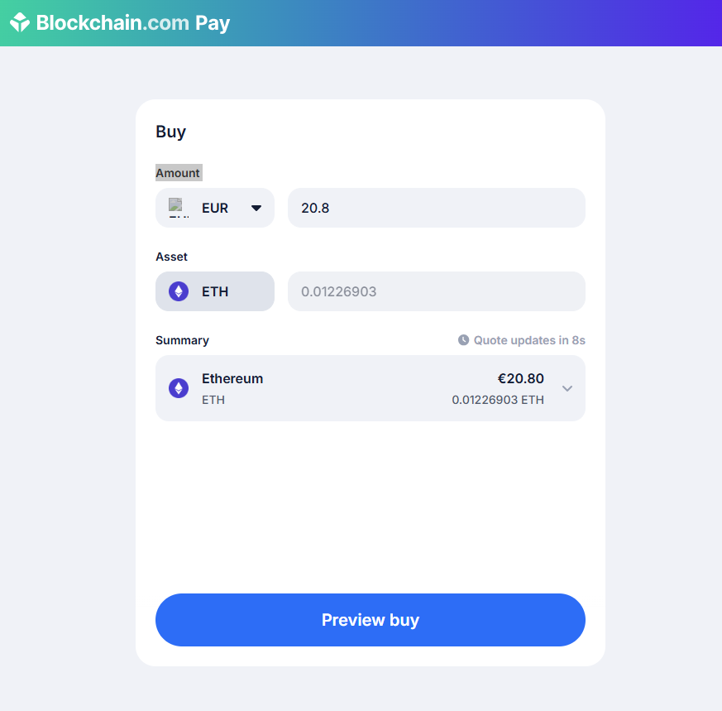
- You are asked to login/supply emil address.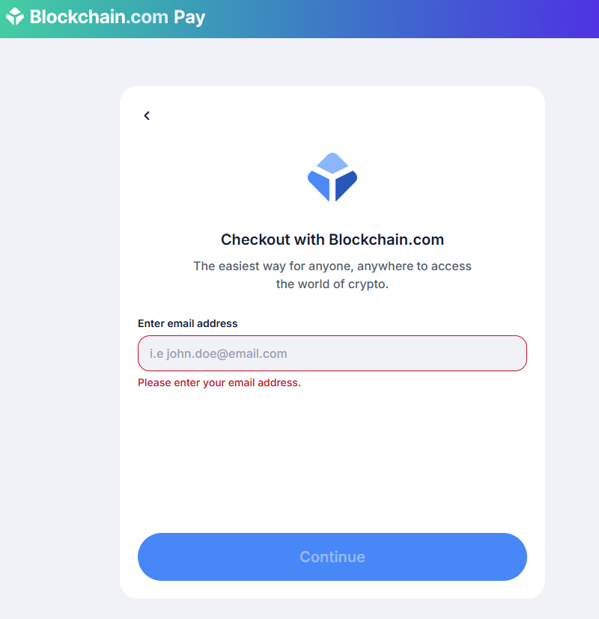
- And veryfy this address.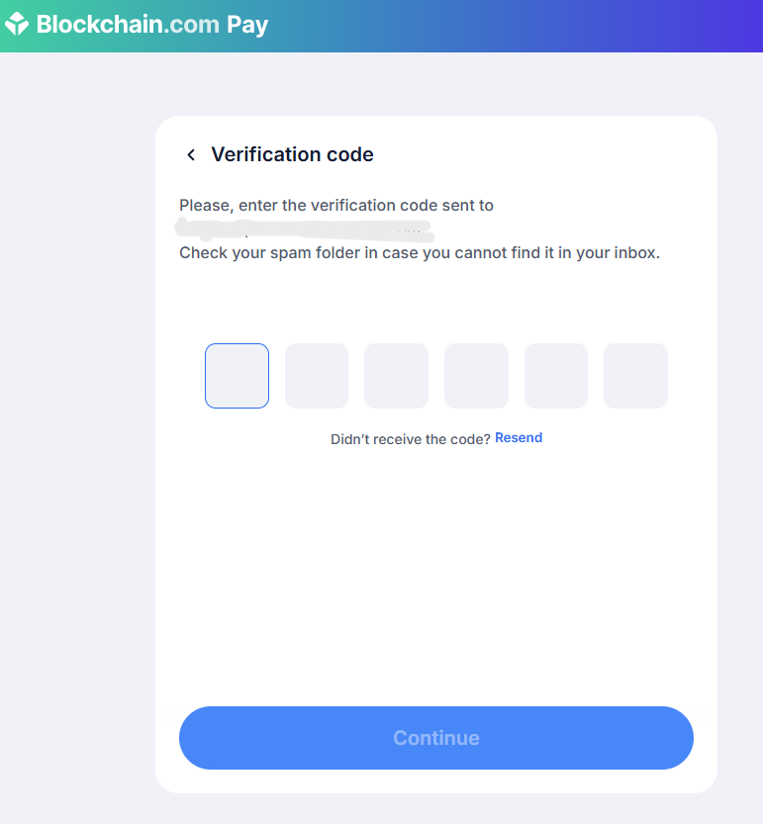
- You are instructed to fill out the KYC information. None of this information is sent to the store. This is between you and the payment gateway only.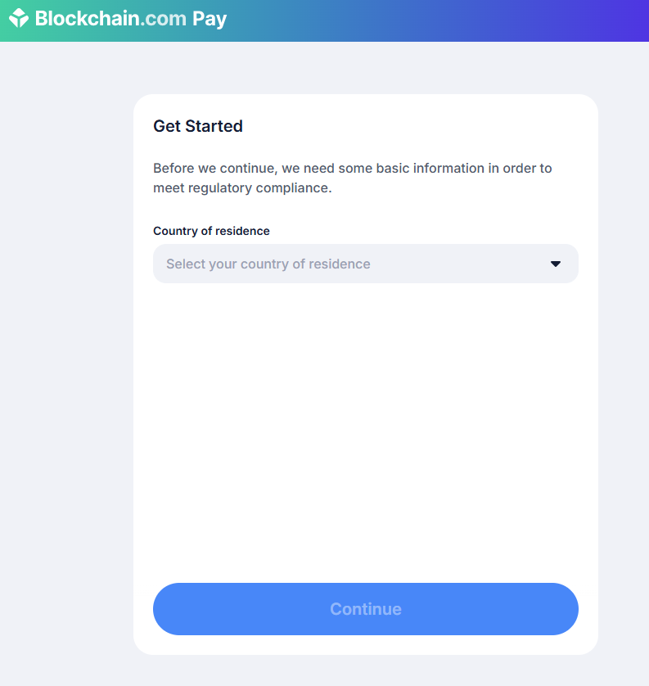

- If instructed to go through the KYC process. Do so. You will need a government identification, like passport or similar.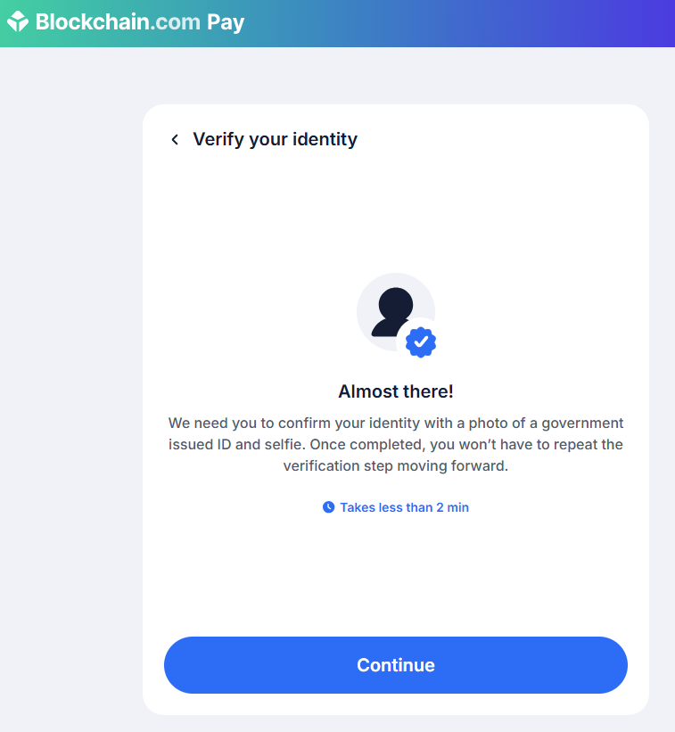
- When KYC is performed, you can select payment option. In this example “Google pay” is used.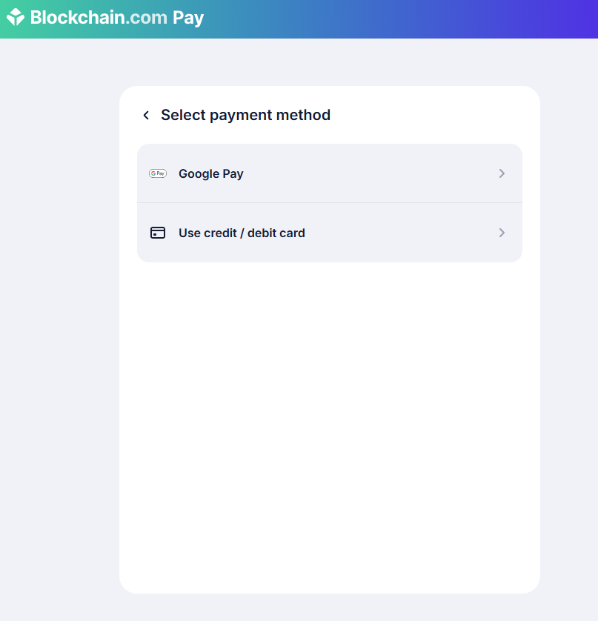

- Finally, you can complete the purshase. The blockchain address is supplied by our broker, it is correct, the cryptocurrency selected is also selected by our broker, do not try and change it.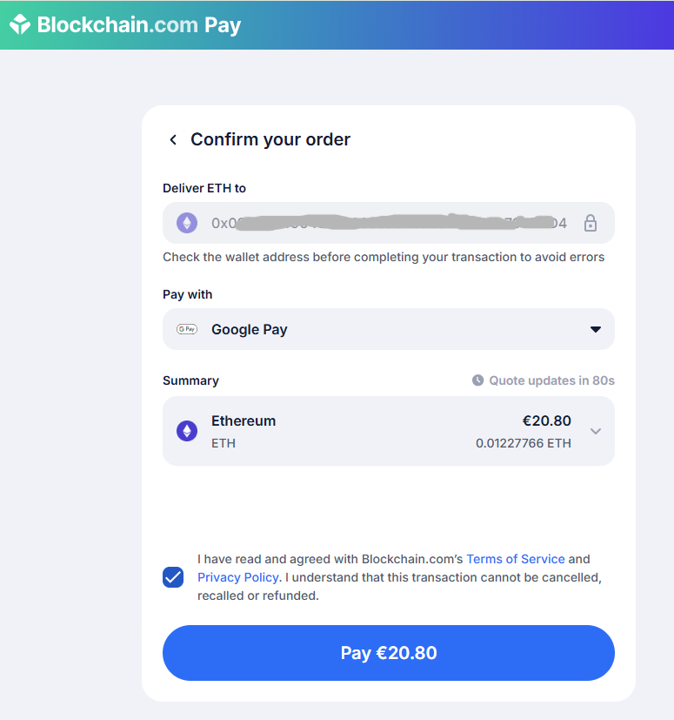
- The payment has been completed. If you are presented with subsequent pages. Ignore them. You are done. The transfer of crypto assets will take a few minutes, could take 10 minutes.
- IMPORTANT: You will not be redirected back to the shop. Please just trust the process. If you return to the shop, your order will probably look unpaid, while crypto assets are beeing transferred. Even your shoping cart will remain visible, but eventually, when assets are finalized, the order will change to processing status. You will receive a mail, and your cart will be cleared.
In the store, order looks like this until it is settled in backend.. just wait.
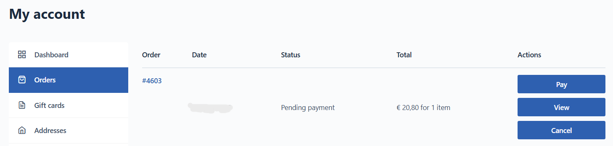
After just a few minutes, it changes to
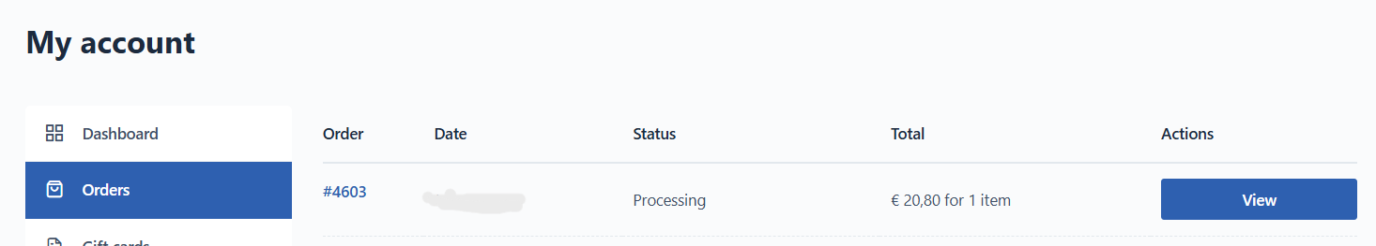

- As mentioned, when backend has registered the payment, you will receive an email. Your order will be processed and you will revieve a new email when sent.