Foundation

Color Palette

Brand Colors



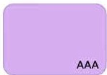
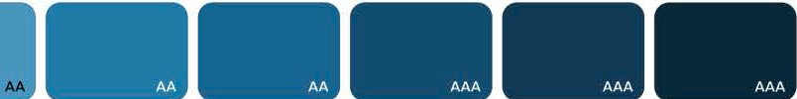
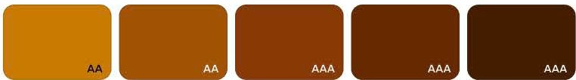



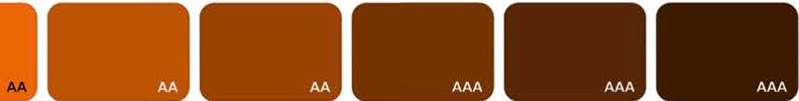
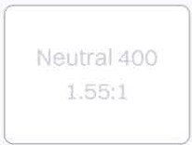
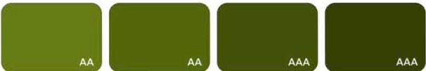
AAA

color/brand/blue #OA46E6


color/brand/black #000000


color/brand/white #FFFFFF

Color Palettes

Neutrals
,,.
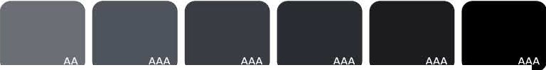

AAA AAA AAA AAA AAA AAA AAA

color/neutral/  white | color/  neutral/50 | color/  neutral/100 | color/  neutral/200 | color/  neutral/300 | color/  neutral/400 | color/  neutral/500 | color/  neutral/600 | color/  neutral/700 | color/  neutral/BOO | color/  neutral/900 | color/  neutral/950 | color/neutral/  black
#FFFFFF | #F8FAFD | #F3F5FA | #E7EAFO | #D6DAE1 | #COC4CC | #9DA2AA | #6A6E76 | #50545B | #3A3D44 | #2A2D32 | #lAlClF | #000000
 |  |  |  |  |  |  | Secondary text |  |  |  | Primary text

Primary

AA

AAA

AAA AAA

AAA
FIE
LD. AA

color/primary/50 color/primary/100 color/primary/200 color/primary/300 color/primary/400 color/primary/500 color/primary/600 color/primary/700 color/primary/800 color/primary/900 colorlprimary/950 #EBFlFF #D9E6FF #BCD4FF #90B3FF #5D91FB #296DFO #OA46E6 #0936D0 #OA31AA #OA266F #0B1B4C
Background (low Hyper/inks, actions
emphasis)

Red

AAA

AAA

AAA
AAA
AAA

color/red/50 | color/red/100 | color/red/200 | color/red/300 | color/red/400 | color/red/500 | color/red/600 | color/red/700 | color/red/800 | color/red/900 | color/red/950
#FFFlFO  Background (low | #FFE2EO | #FFCFCB | #FFA199  Background | #FF6C5F | #F83F2E | #EE2513 | #D22416  Errorcext, | #A91E12 | #861911 | #4B0B07
emphasis) |  |  | (medium |  |  |  | background (high
 |  |  | emphasis) |  |  |  | emphasis)

Amber
, ....

AAA

AAA
AAA
AAA AAA
AAA

color/amber/50 #FFF9EB

color/amber/100 color/amber/200 color/amber/300 color/amber/400 color/amber/500 color/amber/600 color/amber/700 color/amber/BOO color/amber/900 color/amber/950 #FFEFCA #FFE39E #FFD469 #F7BF39 #E6A100 #C97900 #A15300 #873905 #662900 #451COO

Background (low emphasis)

Green
Background (medium emphasis)
Background (high emphasis)
Warning text

AAA

AAA

AAA

AAA " AA-A
'
'
( .. .�.1_' "\;
,

color/green/50 #EDFCF4
color/green/100 color/green/200 color/green/300 color/green/400 color/green/500 color/green/600 color/green/700 color/green/800 color/green/900 color/green/950 #D7F7E9 #B8F2D8 #9BEOC1 #76C4Al #39A273 #248056 #JF6645 #1A4F36 #153C2A #OE2318

Background (low emphasis)

Blue
Background (medium emphasis)
Success text, background (high emphasis)

AAA
AAA
AAA
AAA ,.-,_
----AA-A

color/blue/50 | color/blue/100 | color/blue/200 | color/blue/300 | color/blue/400 | color/blue/500 | color/blue/600 | color/blue/700 | color/blue/800 | color/blue/900 | color/blue/950
#F2FBFE  Background (low | #D5FOFD | #B8ElF6 | #9ACDE5  Background | #7FB8D4 | #47968D | #1E7BA8  Background (high | #176591 | #124D70 | #OE3A57 | #082739
emphasis) |  |  | (medium |  |  | emphasis)
 |  |  | emphasis)

Purple

AAA
AAA
AAA

"-"

AAA
----^{A}

-color/purple/50 #F8F2FD
color/purple/100 color/purple/200 color/purple/300 color/purple/400 color/purple/500 color/purple/600 color/purple/700 color/purple/800 color/purple/900 color/purple/950 #F2DFFF #E8C5FF #07AEF2 #C78EED #AE77D3 #9657BF #7F45Al #673982 #4E2A63 #311942

Background (low emphasis)

Orange

AAA

AAA AAA
Background (medium emphasis)
Background (high emphasis)

color/orange/SO color/orange/100 color/orange/200 color/orange/300 color/orange/400 color/orange/500 color/orange/600 color/orange/700 color/orange/800 color/orange/900 color/orange/950 #FFF5ED #FFE2CC #FFC395 #FFA764 #FF8325 #EC6600 #805200 #9A4300 #753300 #572707 #3DlAOO

AAA

Background (low emphasis)

Lime
Background (medium emphasis)
Background (high emphasis)

,,. ...

AAA AAA AAA AAA AAA AAA AA

color/lime/50 | color/lime/100 | color/lime/200 | color/lime/300 | color/lime/400 | color/lime/500 | color/lime/600 | color/lime/700 | color/lime/800 | color/lime/900 | color/lime/950
#F9FFE8  Background (low | #FOFAC8 | #E4F792 | #CFE37A  Background | #B7C965 | #9D6149  Background (high | #85963C | #677Al6 | #546608 | #435206 | #344004
emphasis) |  |  | (medium |  | emphasis)
 |  |  | emphasis)

Color accessibility- WCAG 2.1

Guidelines
A great way to make sure your designs are accessible is to check the Web Content Accessibility Guidelines (WCAG) 2.1contrast ratio for all text elements in components. At the most basic level WCAG 2.1 guidelines are categorized into three different levels based on how accessible they are.
Asa good general rule, maintain at least a 4:5:1 contrast ratio (WCAG AA) for all of your most crucial UI elements (text, buttons, forms etc.). Meeting the AA requirement is sufficient for the majority of users and compensates for the loss of contrast sensitivity by users with a 20/40 vision loss.
There are some handy Figma plugins to check contrast ratios right in Figma as you design. Our favorite is the Stark which allows you to check the color contrast ratio of all visible text in a frame.

Level A - low contrast - less than 4.5:1
Not suitable any text elements. You can ignore the contrast on decorations and non-important parts.

Level AA- med contrast - more than 4.5:1

Neutral 600
4.83:1
A minimum level of accessibility for all your most crucial UI elements (text, buttons, forms etc.).

Level AAA - high contrast - more than 7:1

Neutral 1000
17.73:1
Super-high contrast isn't arequirement, but it's a nice-to have - strive for it where possible!

